|  |
| --- |
|  |
|  |

**FPT UNIVERSITY**

|  |  |
| --- | --- |
| Capstone Project Document | |
| Ordering and Order Fulfilment System for Self-service Counter-less Food-courts | |
| Group 16 - IS | |
| **Group members** | Ngô Nhật đô – SE62522 (Leader)  Phạm Hưng Thịnh – SE62039  Nguyễn Đức Huy– SE62266  Nguyễn Mạnh Khang – SE62197 |
| **Supervisor** | Trần Tuấn Anh |
| **Ext. Supervisor** | N/A |
| **Project Code** | CFOS |

**Table of Contents**

1. [Introduction21](#_Introduction)
2. **[Project information](#_5.2_Advantages_and)**[21](#_5.2_Advantages_and)
3. **[Introduction](#_5.2_Advantages_and)** [21](#_5.2_Advantages_and)
4. **[Current Situation](#_5.2_Advantages_and)** [21](#_5.2_Advantages_and)
5. **[Problem Definition](#_5.2_Advantages_and)** [21](#_5.2_Advantages_and)
6. **[Proposed Solution](#_5.2_Advantages_and)** [21](#_5.2_Advantages_and)
   1. [Feature functions22](#_5.2_Advantages_and)
   2. [Advantages and disadvantages22](#_5.2_Advantages_and)
7. **[Functional Requirements](#_Functional_Requirements)** [23](#_Functional_Requirements)
8. [**Roles & Responsibility** 25](#_Role_&_Responsibility)
9. [Software Project Management Plan](#_Software_Project_Management) 25
10. **[Problem Definition](#_Problem_Definition)** [25](#_Problem_Definition)
    1. [Name of this Capstone Project25](#_Name_of_this)
    2. [Problem Abstract25](#_Problem_Abstract)
    3. [Project Overview26](#_1.3._Project_Overview)
11. [**Problem Organization** 29](#_Project_Organization)
    1. [Software Process Model 29](#_Software_Process_Model)
    2. [Roles and responsibilities 29](#_Roles_and_responsibilities)
    3. [Tools and techniques 31](#_Tools_and_Techniques)
12. [**Project Management Plan** 32](#_Project_Management_Plan)
    1. [Product backlog 32](#_Product_Backlog)
    2. [Sprint backlog 32](#_Sprint_Backlog)
    3. [Deliverables 32](#_Deliverables)
    4. [All meeting minutes 32](#_All_Meeting_Minutes)
13. [**Coding convention** 32](#_Coding_Convention)

1. [Software Requirement Specification 33](#_Software_Requirement_Specification)
2. [**User Requirement Specification** 33](#_User_Requirement_Specification)
   1. [Guest Requirement 33](#_Guest_requirement)
   2. [Customer Requirement 3](#_Member_requirement)3
   3. [Staff Requirement 34](#_Staff_requirement:)
   4. [Food court admin Requirement 34](#_Food-court_Admin_requirement:)
   5. [Store Requirement 34](#_Store_Admin_requirement:)
   6. [Chef Requirement 34](#_Chef_requirement:)
   7. [System admin Requirement 35](#_System_Admin_requirement:)
3. [**System Requirement Specification** 35](#_System_Requirement_Specification)
   1. [External interface requirement 35](#_External_Interface_Requirement)
   2. [System Overview Use case 36](#_System_Overview_Use)
   3. [List of Use Case 38](#_List_of_use)
4. [**Software System Attribute**166](#_3._Software_System)
   1. [Usability166](#_3.1._Usability)
   2. [Reliability166](#_3.1._Usability)
   3. [Availability 166](#_3.1._Usability)
   4. [Security 166](#_3.1._Usability)
   5. [Maintainability 166](#_3.1._Usability)
   6. [Portability 167](#_3.1._Usability)
   7. [Performance 167](#_3.1._Usability)
5. [**Conceptual Diagram**167](#_4._Conceptual_Diagram)
6. [Software Design Description 168](#_D._Software_Design)
7. [**Design Overview**168](#_1._Design_Overview)
8. [**System Architectural Design**169](#_2._System_Architecture)
9. [**Component Diagram**171](#_3._Component_Diagram)
10. [**Detailed Diagram**173](#_4._Detailed_Description)
    1. [Class Diagram 173](#_4.1._Class_Diagram)
    2. [Interaction Diagram 175](#_4.3_Interaction_Diagram)
11. [**User Interface Design**188](#_5._Interface)
12. [**Database Design**279](#_6._Database_)
    1. [Entity Relational Diagram280](#_6.1._Entity_Relationship)
    2. [Data Dictionary281](#_6.2.Data_Dictionary)
13. [**Algorithms**282](#_7.__Algorithms)
14. [System Implementation & Test 290](#_E._System_implementation)
15. **[Introduction](#_1._Introduction)**[290](#_1._Introduction)
    1. [Overview290](#_1._Introduction)
    2. [Test Approach.291](#_1._Introduction)
16. [**Data Relationship Diagram**291](#_2._Data_Relationship)
17. **[Test plan](#_3._Test_Plan)**[300](#_3._Test_Plan)
    1. [Features to be tested300](#_3._Test_Plan)
    2. [Features not to be tested300](#_3._Test_Plan)
18. [**System testing Test case** 302](#_4._System_Testing)
19. [Software’s User Manual 312](#_F._Software_User’s)
20. **[Installation Guide](#_1._Installation_Guide)**[312](#_1._Installation_Guide)
    1. [Setting up environment at server side312](#_1._Installation_Guide)
    2. [Deployment at server side313](#_1.1.1_Hardware_requirements)
21. [**User Guide**316](#_2._User_Guide)
    1. [Web application316](#_2.1_Web_Application)
    2. [Android application319](#_2.1_Web_Application)

**List of tables**

[Table 1 - Roles and Responsibilities 25](#_Toc17329302)

[Table 2- Hardware Requirements for Server 27](#_Toc17329303)

[Table 3 - Hardware requirement for PC 28](#_Toc17329304)

[Table 4 - Hardware requirement for the mobile 28](#_Toc17329305)

[Table 5 - Hardware requirement for kiosk 28](#_Toc17329306)

[Table 6 - Software requirement 28](#_Toc17329307)

[Table 7 - Roles and responsibilities 31](#_Toc17329308)

[Table 8 - Tools and techniques 32](#_Toc17329309)

[Table 9 - Deliverables 32](#_Toc17329310)

[Table 10 - <System Admin> Create food court 40](#_Toc17329311)

[Table 11 <System Admin> View list food court 41](#_Toc17329312)

[Table 12 <System Admin> Edit food court 43](#_Toc17329313)

[Table 13 <System Admin> Add new food court manager 45](#_Toc17329314)

[Table 14 <System Admin> Update food court manager 47](#_Toc17329315)

[Table 15 <System Admin> Search food court manager 49](#_Toc17329316)

[Table 16 < Food court manager > Add staff 52](#_Toc17329317)

[Table 17 < Food court manager > Edit staff 53](#_Toc17329318)

[Table 18 <System Admin> Search staff 55](#_Toc17329319)

[Table 19 <System Admin> Add store 57](#_Toc17329320)

[Table 20 <System Admin> View list store 59](#_Toc17329321)

[Table 21 <System Admin> Edit store 60](#_Toc17329322)

[Table 22 <System Admin> Disable store 62](#_Toc17329323)

[Table 23 <System Admin> Add new category 64](#_Toc17329324)

[Table 24 <System Admin> Edit category 66](#_Toc17329325)

[Table 25 <System Admin> View list category 68](#_Toc17329326)

[Table 26 <System Admin> Disable category 70](#_Toc17329327)

[Table 27 <System Admin> View static 71](#_Toc17329328)

[Table 28 <System Admin> Payable 72](#_Toc17329329)

[Table 29 <Store manager> Add new category 75](#_Toc17329330)

[Table 30 <Store manager> View list category 76](#_Toc17329331)

[Table 31 <Store manager> Edit category 78](#_Toc17329332)

[Table 32 <Store manager> Disable category 79](#_Toc17329333)

[Table 33 <Store manager> Add food 82](#_Toc17329334)

[Table 34 <Store manager> View list food 83](#_Toc17329335)

[Table 35 <Store manager> Edit food 85](#_Toc17329336)

[Table 36 <Store manager> Disable food 87](#_Toc17329337)

[Table 37 <Store manager> Add food’s option 89](#_Toc17329338)

[Table 38 <Store manager> View list food’s option 90](#_Toc17329339)

[Table 39 <Store manager> Edit food’s option 93](#_Toc17329340)

[Table 40 <Store manager> View food’s feedback 94](#_Toc17329341)

[Table 41 <Store manager> View static 95](#_Toc17329342)

[Table 42 <Store manager> Receivable 96](#_Toc17329343)

[Table 43 <Chef> View order list 98](#_Toc17329344)

[Table 44 <Chef> Submit completed order 99](#_Toc17329345)

[Table 45 <Chef> Cancel order 101](#_Toc17329346)

[Table 46 < Staff> Add new member 104](#_Toc17329347)

[Table 47 <Staff> Edit member 105](#_Toc17329348)

[Table 48 <Staff> Disable member 107](#_Toc17329349)

[Table 49 <Staff> Search member 109](#_Toc17329350)

[Table 50 <Staff> Recharge member 111](#_Toc17329351)

[Table 51 <Staff> View transaction history 112](#_Toc17329352)

[Table 52 <Staff> Search transaction 114](#_Toc17329353)

[Table 53 <Staff> View guest’s order 116](#_Toc17329354)

[Table 54 <Staff> Submit guest’s order 117](#_Toc17329355)

[Table 55 <Staff> Search guest’s order 119](#_Toc17329356)

[Table 56 <Staff> View cancelled order 121](#_Toc17329357)

[Table 57 <Staff> > Edit cancelled order 122](#_Toc17329358)

[Table 58 <Staff > View static 123](#_Toc17329359)

[Table 59 < Customer > View Personal Transaction History 125](#_Toc17329360)

[Table 60 < Customer > View Personal Order History 127](#_Toc17329361)

[Table 61 < Customer > Check order status 129](#_Toc17329362)

[Table 62 < Customer > Submit order – Schedule Order 132](#_Toc17329363)

[Table 63 < Customer > Customer submit feedback 134](#_Toc17329364)

[Table 64 < Customer > View app category 135](#_Toc17329365)

[Table 65 < Customer > Member manipulate the cart 137](#_Toc17329366)

[Table 66 < Scheduler> Reset order number 139](#_Toc17329367)

[Table 67 < Scheduler> Record statistic for each store. 141](#_Toc17329368)

[Table 68 < Scheduler> Record food popular. 142](#_Toc17329369)

[Table 69 < Scheduler> Reset block. 143](#_Toc17329370)

[Table 70 < Guest> Register 147](#_Toc17329371)

[Table 71 < Guest> Login 149](#_Toc17329372)

[Table 72 < Guest> View food. 150](#_Toc17329373)

[Table 73 < Guest> Add to Kiosk’s cart 152](#_Toc17329374)

[Table 74 < Guest> View Kiosk’s cart 154](#_Toc17329375)

[Table 75 < Guest> Remove cart. 155](#_Toc17329376)

[Table 76 < Guest> Submit cart. 157](#_Toc17329377)

[Table 77 < Authorize Guest > Logout 159](#_Toc17329378)

[Table 78 < Authorize Guest > Change Password 161](#_Toc17329379)

[Table 79 < Authorize Guest > View profile 163](#_Toc17329380)

[Table 80 < Authorize Guest > Edit profile. 165](#_Toc17329381)

[Table 81 Component dictionary 172](#_Toc17329382)

[Table 82 Class dictionary: describe class 174](#_Toc17329383)

[Table 83 Class diagram – Food court attribute 174](#_Toc17329384)

[Table 84 Class diagram – Food court method 174](#_Toc17329385)

[Table 85 Class diagram – Employee attribute 175](#_Toc17329386)

[Table 86 Class diagram – Employee method 175](#_Toc17329387)

[Table 87 Class diagram – User attribute 175](#_Toc17329388)

[Table 88 Class diagram – User method 175](#_Toc17329389)

[Table 89 Class diagram – Customer attribute 176](#_Toc17329390)

[Table 90 Class diagram – Customer method 176](#_Toc17329391)

[Table 91 Class diagram – Wallet attribute 176](#_Toc17329392)

[Table 92 Class diagram – Wallet method 176](#_Toc17329393)

[Table 93 Class diagram – Transaction attribute 176](#_Toc17329394)

[Table 94 Class diagram – Transaction method 176](#_Toc17329395)

[Table 95 Class diagram – Store attribute 177](#_Toc17329396)

[Table 96 Class diagram – Store method 177](#_Toc17329397)

[Table 97 Class diagram – Category attribute 177](#_Toc17329398)

[Table 98 Class diagram – Category method 177](#_Toc17329399)

[Table 99 Class diagram – Food attribute 178](#_Toc17329400)

[Table 100 Class diagram – Food method 178](#_Toc17329401)

[Table 101 Class diagram – Feedback attribute 178](#_Toc17329402)

[Table 102 Class diagram – Feedback method 178](#_Toc17329403)

[Table 103 Class diagram – Order attribute 178](#_Toc17329404)

[Table 104 Class diagram – Order method 178](#_Toc17329405)

[Table 105 <Fields> Login 189](#_Toc17329406)

[Table 106 < Buttons/Hyperlinks > Login 189](#_Toc17329407)

[Table 107 <Fields> Forget password 190](#_Toc17329408)

[Table 108 < Buttons/Hyperlinks > Forget password 190](#_Toc17329409)

[Table 109 <Fields> Header Web Admin 191](#_Toc17329410)

[Table 110 < Buttons/Hyperlinks > Header Web Admin 191](#_Toc17329411)

[Table 111 <Fields> Profile 192](#_Toc17329412)

[Table 112 < Buttons/Hyperlinks > Profile 193](#_Toc17329413)

[Table 113 <Fields> Change Password 194](#_Toc17329414)

[Table 114 < Buttons/Hyperlinks > Change Password 194](#_Toc17329415)

[Table 115 < Buttons/Hyperlinks > System admin menu 195](#_Toc17329416)

[Table 116 <Fields> Manage Food Court Manager 196](#_Toc17329417)

[Table 117 < Buttons/Hyperlinks > Manage Food Court Manager 197](#_Toc17329418)

[Table 118 <Fields> Create food court manager 197](#_Toc17329419)

[Table 119 < Buttons/Hyperlinks > Create food court manager 198](#_Toc17329420)

[Table 120 < Buttons/Hyperlinks > Update food court manager 198](#_Toc17329421)

[Table 121 <Fields> Manage food court 199](#_Toc17329422)

[Table 122 < Buttons/Hyperlinks > Manage food court 199](#_Toc17329423)

[Table 123 <Fields> Create food court 200](#_Toc17329424)

[Table 124 < Buttons/Hyperlinks > Create food court 201](#_Toc17329425)

[Table 125 <Fields> Update food court 201](#_Toc17329426)

[Table 126 < Buttons/Hyperlinks > Update food court 202](#_Toc17329427)

[Table 127 < Buttons/Hyperlinks > Menu food court admin 203](#_Toc17329428)

[Table 128 <Fields> Manage staff 204](#_Toc17329429)

[Table 129 < Buttons/Hyperlinks > Manage staff 204](#_Toc17329430)

[Table 130 <Fields> Create staff 205](#_Toc17329431)

[Table 131 < Buttons/Hyperlinks > Create staff 206](#_Toc17329432)

[Table 132 < Buttons/Hyperlinks > Update staff 206](#_Toc17329433)

[Table 133 <Fields> Manage store 207](#_Toc17329434)

[Table 134 < Buttons/Hyperlinks > Manage store 207](#_Toc17329435)

[Table 135 <Fields> Create store 209](#_Toc17329436)

[Table 136 < Buttons/Hyperlinks > Create store 209](#_Toc17329437)

[Table 137 <Fields> Update store 211](#_Toc17329438)

[Table 138 < Buttons/Hyperlinks > Update store 211](#_Toc17329439)

[Table 139 <Fields> Manage categories 212](#_Toc17329440)

[Table 140 < Buttons/Hyperlinks > Manage categories 213](#_Toc17329441)

[Table 141 <Fields> Create categories 213](#_Toc17329442)

[Table 142 < Buttons/Hyperlinks > Create categories 214](#_Toc17329443)

[Table 143 <Fields> Update categories 215](#_Toc17329444)

[Table 144 < Buttons/Hyperlinks > Update categories 215](#_Toc17329445)

[Table 145 <Fields> Home page 217](#_Toc17329446)

[Table 146 < Buttons/Hyperlinks > Home page 217](#_Toc17329447)

[Table 147 < Buttons/Hyperlinks > Menu store manager 218](#_Toc17329448)

[Table 148 <Fields> Manage food 219](#_Toc17329449)

[Table 149 < Buttons/Hyperlinks > Manage food 219](#_Toc17329450)

[Table 150 <Fields> Create category 220](#_Toc17329451)

[Table 151 < Buttons/Hyperlinks > Create category 220](#_Toc17329452)

[Table 152 <Fields> Update category 221](#_Toc17329453)

[Table 153 < Buttons/Hyperlinks > Update category 221](#_Toc17329454)

[Table 154 <Fields> Create food 223](#_Toc17329455)

[Table 155 < Buttons/Hyperlinks > Create food 223](#_Toc17329456)

[Table 156 <Fields> Update food 224](#_Toc17329457)

[Table 157 < Buttons/Hyperlinks > Update food 224](#_Toc17329458)

[Table 158 <Fields> Manage food option 225](#_Toc17329459)

[Table 159 < Buttons/Hyperlinks > Manage food option 225](#_Toc17329460)

[Table 160 <Fields> Create food option category 226](#_Toc17329461)

[Table 161 < Buttons/Hyperlinks > Create food option category 226](#_Toc17329462)

[Table 162 <Fields> Update food option category 227](#_Toc17329463)

[Table 163 < Buttons/Hyperlinks > Update food option category 227](#_Toc17329464)

[Table 164 <Fields> Create option 228](#_Toc17329465)

[Table 165 < Buttons/Hyperlinks > Create option 228](#_Toc17329466)

[Table 166 <Fields> Update option 229](#_Toc17329467)

[Table 167 < Buttons/Hyperlinks > Update option 230](#_Toc17329468)

[Table 168 <Fields> View feedback 230](#_Toc17329469)

[Table 169 < Buttons/Hyperlinks > View feedback 230](#_Toc17329470)

[Table 170 <Fields> Home Page 232](#_Toc17329471)

[Table 171 < Buttons/Hyperlinks > Menu staff 233](#_Toc17329472)

[Table 172 <Fields> Manage member 234](#_Toc17329473)

[Table 173 < Buttons/Hyperlinks > Manage member 234](#_Toc17329474)

[Table 174 <Fields> Create member 236](#_Toc17329475)

[Table 175 < Buttons/Hyperlinks > Create member 236](#_Toc17329476)

[Table 176 <Fields> Update member 237](#_Toc17329477)

[Table 177 < Buttons/Hyperlinks > Update member 237](#_Toc17329478)

[Table 178 <Fields> Deposit 239](#_Toc17329479)

[Table 179 < Buttons/Hyperlinks > Deposit 239](#_Toc17329480)

[Table 180 <Fields> Mange Order Guest 240](#_Toc17329481)

[Table 181 < Buttons/Hyperlinks > Mange Order Guest 240](#_Toc17329482)

[Table 182 <Fields> Submit Order Guest 241](#_Toc17329483)

[Table 183 < Buttons/Hyperlinks > Submit Order Guest 242](#_Toc17329484)

[Table 184 <Fields> History transaction 243](#_Toc17329485)

[Table 185 < Buttons/Hyperlinks > History transaction 243](#_Toc17329486)

[Table 186 <Fields> Guest food cancelled 244](#_Toc17329487)

[Table 187 < Buttons/Hyperlinks > Guest food cancelled 244](#_Toc17329488)

[Table 188 <Fields> Pay back to guests 246](#_Toc17329489)

[Table 189 <Fields> Pay back to guests 246](#_Toc17329490)

[Table 190 <Fields> Home page 247](#_Toc17329491)

[Table 191 <Fields> Chef screen 248](#_Toc17329492)

[Table 192 < Buttons/Hyperlinks > Chef screen 248](#_Toc17329493)

[Table 193 <Fields> Cancel dish 250](#_Toc17329494)

[Table 194 < Buttons/Hyperlinks > Cancel dish 250](#_Toc17329495)

[Table 195 <Fields> Submit order 251](#_Toc17329496)

[Table 196 < Buttons/Hyperlinks > Submit order 252](#_Toc17329497)

[Table 197 < Buttons/Hyperlinks > Kiosk – Home Page 252](#_Toc17329498)

[Table 198 < Buttons/Hyperlinks > Kiosk - Check order 253](#_Toc17329499)

[Table 199 < Field > Kiosk - Check order 254](#_Toc17329500)

[Table 200 < Buttons/Hyperlinks > Kiosk - View list food 256](#_Toc17329501)

[Table 201 <Fields> Kiosk - View list food 256](#_Toc17329502)

[Table 202 < Buttons/Hyperlinks > Kiosk - View list food 258](#_Toc17329503)

[Table 203 <Fields> Kiosk - View list food 259](#_Toc17329504)

[Table 204 < Buttons/Hyperlinks > Kiosk - View bastket 260](#_Toc17329505)

[Table 205 <Fields> Kiosk - View bastket 261](#_Toc17329506)

[Table 206 < Buttons/Hyperlinks > Kiosk - View dish info 262](#_Toc17329507)

[Table 207 <Fields> Kiosk - View dish info 262](#_Toc17329508)

[Table 208 < Buttons/Hyperlinks > Kiosk - View dish feedback 263](#_Toc17329509)

[Table 209 <Fields> Kiosk - View dish feedback 264](#_Toc17329510)

[Table 210 < Buttons/Hyperlinks > Kiosk - Choose payment method 265](#_Toc17329511)

[Table 211 <Fields> Kiosk - Choose payment method 266](#_Toc17329512)

[Table 212 < Buttons/Hyperlinks > Kiosk - Payment by membership card 267](#_Toc17329513)

[Table 213 < Buttons/Hyperlinks > Kiosk - Complete order 267](#_Toc17329514)

[Table 214 <Fields> Kiosk - Complete order 267](#_Toc17329515)

[Table 215 Flash 268](#_Toc17329516)

[Table 216 Onboaring 268](#_Toc17329517)

[Table 217 Last onboarding 269](#_Toc17329518)

[Table 218 Welcome 269](#_Toc17329519)

[Table 219 Field Login 270](#_Toc17329520)

[Table 220 Button sign up 271](#_Toc17329521)

[Table 221 Field ‘Đăng nhập’ 271](#_Toc17329522)

[Table 222 Button Login 272](#_Toc17329523)

[Table 223 Field Forget Password 272](#_Toc17329524)

[Table 224 Button Reset Password 272](#_Toc17329525)

[Table 225 Butoon “Kiểm tra” 273](#_Toc17329526)

[Table 226 Buttons “danh mục” 273](#_Toc17329527)

[Table 227 Button Strores 274](#_Toc17329528)

[Table 228 Button tab bar 274](#_Toc17329529)

[Table 229 Search Food 275](#_Toc17329530)

[Table 230 Button Search food 275](#_Toc17329531)

[Table 231 Button Search Order 276](#_Toc17329532)

[Table 232 Add cart 277](#_Toc17329533)

[Table 233 Cart Screen 277](#_Toc17329534)

[Table 234 Fileds Feedback 278](#_Toc17329535)

[Table 235 Button Post Feedback 278](#_Toc17329536)

[Table 236 Food option 279](#_Toc17329537)

[Table 237 Order History 280](#_Toc17329538)

[Table 238 Account Screen 281](#_Toc17329539)

[Table 239 Physical Diagram Dictionary 298](#_Toc17329540)

[Table 240 - Attribute Data Dictionary 304](#_Toc17329541)

[Table 241 - Test case login 307](#_Toc17329542)

[Table 242 Order food Kiosk 310](#_Toc17329543)

[Table 243 - Order food mobile 311](#_Toc17329544)

[Table 244 - Recharge member 312](#_Toc17329545)

[Table 245 - Request a guest’s transaction 312](#_Toc17329546)

[Table 246 - Test case confirm order in kitchen 313](#_Toc17329547)

[Table 247 - Test case notification 314](#_Toc17329548)

[Table 248 - Test case check order status 315](#_Toc17329549)

[Table 249 - Test case send password to email 315](#_Toc17329550)

[Table 250 - Hardware Requirements for Server 316](#_Toc17329551)

[Table 251 - Hardware requirement for web admin 316](#_Toc17329552)

[Table 252 - Hardware requirement for the mobile 317](#_Toc17329553)

[Table 253 Hardware requirement for Kiosk’s web ordering application 317](#_Toc17329554)

[Table 254 - Software requirement 317](#_Toc17329555)

**List of Figures**

[Figure 1 - Scrum Framework 29](#_Toc17329556)

[Figure 2: Overview use case 37](file:///C:\Users\Adnub\Downloads\Full-CFOS-Counter-less-Food-court-Ordering-System-2.docx#_Toc17329557)

[Figure 3 < System Admin > Overview Use Case 38](#_Toc17329558)

[Figure 4: <System admin> Create food-court 38](#_Toc17329559)

[Figure 5: <System admin> View list food court 40](#_Toc17329560)

[Figure 6: <System admin> Edit food court 41](#_Toc17329561)

[Figure 7: <System admin> Add new food court manager 43](#_Toc17329562)

[Figure 8: <System admin> Update food court manager 45](#_Toc17329563)

[Figure 9 : <System admin> Search food court manager 47](#_Toc17329564)

[Figure 10: <Food court manager> Overview Use case 49](#_Toc17329565)

[Figure 11: <Food court manager> Add staff 50](#_Toc17329566)

[Figure 12: <Food court manager> Edit staff 52](#_Toc17329567)

[Figure 13: <Food court manager> Search staff 54](#_Toc17329568)

[Figure 14: <Food court manager> Add store 56](#_Toc17329569)

[Figure 15: <Food court manager> View list store 58](file:///C:\Users\Adnub\Downloads\Full-CFOS-Counter-less-Food-court-Ordering-System-2.docx#_Toc17329570)

[Figure 16: <Food court manager> Edit store 59](#_Toc17329571)

[Figure 17: <Food court manager> Disable store 61](#_Toc17329572)

[Figure 18: <Food court manager> Add new category 63](#_Toc17329573)

[Figure 19: <Food court manager> Edit category 65](#_Toc17329574)

[Figure 20: <Food court manager> View list category 67](file:///C:\Users\Adnub\Downloads\Full-CFOS-Counter-less-Food-court-Ordering-System-2.docx#_Toc17329575)

[Figure 21: <Food court manager> Delete category 68](#_Toc17329576)

[Figure 22: <Food court manager> View static 70](#_Toc17329577)

[Figure 23: <Food court manager> Payable 71](#_Toc17329578)

[Figure 24: < Store manager> Overview use case 73](file:///C:\Users\Adnub\Downloads\Full-CFOS-Counter-less-Food-court-Ordering-System-2.docx#_Toc17329579)

[Figure 25: < Store manager> Add new category 74](#_Toc17329580)

[Figure 26: <Store manager> View list category 75](file:///C:\Users\Adnub\Downloads\Full-CFOS-Counter-less-Food-court-Ordering-System-2.docx#_Toc17329581)

[Figure 27: <Store manager> Edit category 76](#_Toc17329582)

[Figure 28: <Store manager> Disable category 78](#_Toc17329583)

[Figure 29: <Store manager> Add food 80](#_Toc17329584)

[Figure 30: <Store manager> View list food 82](#_Toc17329585)

[Figure 31: <Store manager> Edit food 83](#_Toc17329586)

[Figure 32: <Store manager> Disable food 86](#_Toc17329587)

[Figure 33: <Store manager> Add food’s option 87](#_Toc17329588)

[Figure 34: < Store manager> View list food’s option 89](#_Toc17329589)

[Figure 35: <Store manager> Edit food’s option 91](#_Toc17329590)

[Figure 36: <Store manager> View food’s feedback 93](#_Toc17329591)

[Figure 37: < Store manager> View static 94](#_Toc17329592)

[Figure 38: <Store manager> Receivable 95](#_Toc17329593)

[Figure 39: <Chef> Overview use case 97](#_Toc17329594)

[Figure 40: <Chef> View order list 97](#_Toc17329595)

[Figure 41: <Chef> Submit completed order 98](#_Toc17329596)

[Figure 42: <Chef> Cancel order 100](#_Toc17329597)

[Figure 43: <Staff> Overview use case 101](#_Toc17329598)

[Figure 44: <Staff> Add new member 102](#_Toc17329599)

[Figure 45: <Staff> Edit member 104](#_Toc17329600)

[Figure 46: <Staff> Disable member 106](#_Toc17329601)

[Figure 47: <Staff> Search member 107](#_Toc17329602)

[Figure 48: <Staff> Recharge member 109](#_Toc17329603)

[Figure 49: <Staff> View transaction history 111](#_Toc17329604)

[Figure 50: <Staff> Search transaction 113](#_Toc17329605)

[Figure 51: <Staff> Search transaction 115](#_Toc17329606)

[Figure 52: <Staff> Submit guest’s order 116](#_Toc17329607)

[Figure 53: < Staff> Search guest’s order 118](#_Toc17329608)

[Figure 54: <Staff> View cancelled order 120](#_Toc17329609)

[Figure 55: <Staff> Rollback’s guest order 121](#_Toc17329610)

[Figure 56: <Staff> View static 122](#_Toc17329611)

[Figure 57: <Customer> Overview use case 124](#_Toc17329612)

[Figure 58 < Customer > View Personal Transaction History 124](#_Toc17329613)

[Figure 59 < Customer > View Personal Order History 126](#_Toc17329614)

[Figure 60: < Customer > Check order status 127](#_Toc17329615)

[Figure 61 < Customer > Submit order – Schedule Order 129](#_Toc17329616)

[Figure 62: < Customer > Customer submit feedback 132](#_Toc17329617)

[Figure 63: < Customer > View app category 134](#_Toc17329618)

[Figure 64: < Customer > Member manipulate the cart 135](#_Toc17329619)

[Figure 65: < Scheduler> Overview use case 138](file:///C:\Users\Adnub\Downloads\Full-CFOS-Counter-less-Food-court-Ordering-System-2.docx#_Toc17329620)

[Figure 66: < Scheduler> Reset order number 138](#_Toc17329621)

[Figure 67: < Scheduler> Record statistic for each store 139](#_Toc17329622)

[Figure 68: < Scheduler> Record food popular 141](#_Toc17329623)

[Figure 69: < Scheduler> Reset block. 142](#_Toc17329624)

[Figure 70: < Guest> Overview use case 144](#_Toc17329625)

[Figure 71: < Guest> Register 145](file:///C:\Users\Adnub\Downloads\Full-CFOS-Counter-less-Food-court-Ordering-System-2.docx#_Toc17329626)

[Figure 72: < Guest> Login 147](file:///C:\Users\Adnub\Downloads\Full-CFOS-Counter-less-Food-court-Ordering-System-2.docx#_Toc17329627)

[Figure 73: < Guest> View food 149](file:///C:\Users\Adnub\Downloads\Full-CFOS-Counter-less-Food-court-Ordering-System-2.docx#_Toc17329628)

[Figure 74: < Guest> Add to Kiosk’s cart 151](file:///C:\Users\Adnub\Downloads\Full-CFOS-Counter-less-Food-court-Ordering-System-2.docx#_Toc17329629)

[Figure 75: < Guest> View Kiosk’s cart 153](#_Toc17329630)

[Figure 76: < Guest> Remove cart 154](file:///C:\Users\Adnub\Downloads\Full-CFOS-Counter-less-Food-court-Ordering-System-2.docx#_Toc17329631)

[Figure 77: < Guest> Submit cart 156](file:///C:\Users\Adnub\Downloads\Full-CFOS-Counter-less-Food-court-Ordering-System-2.docx#_Toc17329632)

[Figure 78: < Authorize Guest > Overview use case 158](file:///C:\Users\Adnub\Downloads\Full-CFOS-Counter-less-Food-court-Ordering-System-2.docx#_Toc17329633)

[Figure 79: < Authorize Guest > Logout 158](file:///C:\Users\Adnub\Downloads\Full-CFOS-Counter-less-Food-court-Ordering-System-2.docx#_Toc17329634)

[Figure 80: < Authorize Guest > Change Password 160](file:///C:\Users\Adnub\Downloads\Full-CFOS-Counter-less-Food-court-Ordering-System-2.docx#_Toc17329635)

[Figure 81: < Authorize Guest > View profile 162](#_Toc17329636)

[Figure 82: < Authorize Guest > Edit profile 163](#_Toc17329637)

[Figure 83: Conceptual diagram 166](#_Toc17329638)

[Figure 84: System Architecture Design diagram 168](#_Toc17329639)

[Figure 85: Component Diagram 170](file:///C:\Users\Adnub\Downloads\Full-CFOS-Counter-less-Food-court-Ordering-System-2.docx#_Toc17329640)

[Figure 86: Class Diagram 173](file:///C:\Users\Adnub\Downloads\Full-CFOS-Counter-less-Food-court-Ordering-System-2.docx#_Toc17329641)

[Figure 87: <Store\_Manager> Create food – Sequence diagram – Sequence diagram 179](file:///C:\Users\Adnub\Downloads\Full-CFOS-Counter-less-Food-court-Ordering-System-2.docx#_Toc17329642)

[Figure 88: <Store\_Manager> Get detail food – Sequence diagram 180](file:///C:\Users\Adnub\Downloads\Full-CFOS-Counter-less-Food-court-Ordering-System-2.docx#_Toc17329643)

[Figure 89: <Store\_Manager> Update food– Sequence diagram 180](file:///C:\Users\Adnub\Downloads\Full-CFOS-Counter-less-Food-court-Ordering-System-2.docx#_Toc17329644)

[Figure 90: <Store\_Manager> Delete food – Sequence diagram 181](file:///C:\Users\Adnub\Downloads\Full-CFOS-Counter-less-Food-court-Ordering-System-2.docx#_Toc17329645)

[Figure 91: Authencation – Activity diagram 182](#_Toc17329646)

[Figure 92: Order - Activity diagram 183](file:///C:\Users\Adnub\Downloads\Full-CFOS-Counter-less-Food-court-Ordering-System-2.docx#_Toc17329647)

[Figure 93: Account - Activity diagram 184](#_Toc17329648)

[Figure 94: <Guest> View list food by category – Sequence diagram 185](file:///C:\Users\Adnub\Downloads\Full-CFOS-Counter-less-Food-court-Ordering-System-2.docx#_Toc17329649)

[Figure 95: < Guest > Order kiosk processing – Sequence diagram 186](file:///C:\Users\Adnub\Downloads\Full-CFOS-Counter-less-Food-court-Ordering-System-2.docx#_Toc17329650)

[Figure 96: < Guest > Get detail food – Sequence diagram 187](file:///C:\Users\Adnub\Downloads\Full-CFOS-Counter-less-Food-court-Ordering-System-2.docx#_Toc17329651)

[Figure 97: State chart of order detail. 188](#_Toc17329652)

[Figure 98: < UI Interface > Login 189](#_Toc17329653)

[Figure 99: < UI Interface > Forget password 190](#_Toc17329654)

[Figure 100: < UI Interface > Header Web Admin 191](#_Toc17329655)

[Figure 101: < UI Interface > Profile 192](#_Toc17329656)

[Figure 102: < UI Interface > Change Password 193](#_Toc17329657)

[Figure 103: < UI Interface > System admin menu 195](#_Toc17329658)

[Figure 104: < UI Interface > Manage Food Court Manager 196](#_Toc17329659)

[Figure 105: < UI Interface > Create food court manager 198](#_Toc17329660)

[Figure 106: < UI Interface > Update food court manager 199](#_Toc17329661)

[Figure 107: < UI Interface > Manage food court 200](#_Toc17329662)

[Figure 108: < UI Interface > Create food court 201](#_Toc17329663)

[Figure 109: < UI Interface > Update food court 202](#_Toc17329664)

[Figure 110: < UI Interface > Menu food court admin 203](#_Toc17329665)

[Figure 111: < UI Interface > Manage staff 204](#_Toc17329666)

[Figure 112: < UI Interface > Create staff 206](#_Toc17329667)

[Figure 113: < UI Interface > Update staff 207](#_Toc17329668)

[Figure 114: < UI Interface > Manage store 207](#_Toc17329669)

[Figure 115: < UI Interface > Create store 209](#_Toc17329670)

[Figure 116: < UI Interface > Update store 211](#_Toc17329671)

[Figure 117: < UI Interface > Manage categories 213](#_Toc17329672)

[Figure 118: < UI Interface > Create categories 214](#_Toc17329673)

[Figure 119: < UI Interface > Update categories 215](#_Toc17329674)

[Figure 120: < UI Interface > Home page 217](#_Toc17329675)

[Figure 121: < UI Interface > Menu store manager 218](#_Toc17329676)

[Figure 122: < UI Interface > Manage food 219](file:///C:\Users\Adnub\Downloads\Full-CFOS-Counter-less-Food-court-Ordering-System-2.docx#_Toc17329677)

[Figure 123: < UI Interface > Create category 221](file:///C:\Users\Adnub\Downloads\Full-CFOS-Counter-less-Food-court-Ordering-System-2.docx#_Toc17329678)

[Figure 124: < UI Interface > Update category 222](file:///C:\Users\Adnub\Downloads\Full-CFOS-Counter-less-Food-court-Ordering-System-2.docx#_Toc17329679)

[Figure 125: < UI Interface > Create food 223](#_Toc17329680)

[Figure 126: < UI Interface > Update food 224](#_Toc17329681)

[Figure 127: < UI Interface > Manage food option 225](#_Toc17329682)

[Figure 128: < UI Interface > Create food option category 226](#_Toc17329683)

[Figure 129: < UI Interface > Update food option category 227](#_Toc17329684)

[Figure 130: < UI Interface > Create option 228](#_Toc17329685)

[Figure 131: < UI Interface > Update option 230](#_Toc17329686)

[Figure 132: < UI Interface > View feedback 231](#_Toc17329687)

[Figure 133: < UI Interface > Home Page 232](#_Toc17329688)

[Figure 134: < UI Interface > Menu staff 233](#_Toc17329689)

[Figure 135: < UI Interface > Manage member 234](#_Toc17329690)

[Figure 136: < UI Interface > Create member 236](#_Toc17329691)

[Figure 137: < UI Interface > Update member 237](#_Toc17329692)

[Figure 138: < UI Interface > Deposit 238](#_Toc17329693)

[Figure 139: < UI Interface > Confirm Password - Deposit 239](#_Toc17329694)

[Figure 140: < UI Interface > Mange Order Guest 240](#_Toc17329695)

[Figure 141: < UI Interface > Submit Order Guest 241](file:///C:\Users\Adnub\Downloads\Full-CFOS-Counter-less-Food-court-Ordering-System-2.docx#_Toc17329696)

[Figure 142: < UI Interface > Confirm print bill for guest 242](#_Toc17329697)

[Figure 143: < UI Interface > History transaction 243](#_Toc17329698)

[Figure 144: < UI Interface > Guest food cancelled 244](#_Toc17329699)

[Figure 145: < UI Interface > Pay back to guests 246](#_Toc17329700)

[Figure 146: < UI Interface > Confirm invoice pay back to guests 246](#_Toc17329701)

[Figure 147: < UI Interface > Home page 248](#_Toc17329702)

[Figure 148: < UI Interface > Chef screen 248](#_Toc17329703)

[Figure 149: < UI Interface > Cancel dish 250](#_Toc17329704)

[Figure 150: < UI Interface > Confirm print invoice for cancel dish 250](#_Toc17329705)

[Figure 151: < UI Interface > Submit order 252](#_Toc17329706)

[Figure 152: < UI Interface > Kiosk – Home Page 253](#_Toc17329707)

[Figure 153: < UI Interface > Kiosk - Check order 254](file:///C:\Users\Adnub\Downloads\Full-CFOS-Counter-less-Food-court-Ordering-System-2.docx#_Toc17329708)

[Figure 154: < UI Interface > Kiosk - View list food 256](#_Toc17329709)

[Figure 155: < UI Interface > Kiosk - View each store with food 258](#_Toc17329710)

[Figure 156: < UI Interface > Kiosk - View bastket 260](#_Toc17329711)

[Figure 157: < UI Interface > Kiosk - View dish info 262](#_Toc17329712)

[Figure 158: < UI Interface > Kiosk - View dish feedback 264](#_Toc17329713)

[Figure 159: < UI Interface > Kiosk - Choose payment method 266](#_Toc17329714)

[Figure 160: < UI Interface > Kiosk - Payment by membership card 267](#_Toc17329715)

[Figure 161: < UI Interface > Kiosk - Complete order 268](#_Toc17329716)

[Figure 162: Flash screen 269](#_Toc17329717)

[Figure 163: Onboarding 1 screen 269](#_Toc17329718)

[Figure 164: Button "Bắt đầu bửa ăn" 269](#_Toc17329719)

[Figure 165: Sign Up 270](#_Toc17329720)

[Figure 166 Sign Up 271](#_Toc17329721)

[Figure 167 Login 272](#_Toc17329722)

[Figure 168 Forget screen 273](#_Toc17329723)

[Figure 169 Search 274](#_Toc17329724)

[Figure 170 Danh mục 274](#_Toc17329725)

[Figure 171: List store 275](#_Toc17329726)

[Figure 172: Bottom tab bar 275](#_Toc17329727)

[Figure 173 Search Food 276](#_Toc17329728)

[Figure 174: Search Order 277](#_Toc17329729)

[Figure 175: Add cart 277](#_Toc17329730)

[Figure 176: Cart screen 278](#_Toc17329731)

[Figure 177: Feed back 279](#_Toc17329732)

[Figure 178: Food Option 280](#_Toc17329733)

[Figure 179: Order History 280](#_Toc17329734)

[Figure 180: Account 281](#_Toc17329735)

[Figure 181: Entity Relation Diagram 284](#_Toc17329736)

[Figure 182: Block algorithm 5 293](file:///C:\Users\Adnub\Downloads\Full-CFOS-Counter-less-Food-court-Ordering-System-2.docx#_Toc17329737)

[Figure 183: Physical Diagram 297](#_Toc17329738)

[Figure 184: Web Server Deployment Process 320](#_Toc17329739)

[Figure 185: Web admin & Kiosk’s web ordering application deployment prrocess 321](file:///C:\Users\Adnub\Downloads\Full-CFOS-Counter-less-Food-court-Ordering-System-2.docx#_Toc17329740)

[Figure 186: View menu 322](file:///C:\Users\Adnub\Downloads\Full-CFOS-Counter-less-Food-court-Ordering-System-2.docx#_Toc17329741)

[Figure 187: Choose payment method 323](file:///C:\Users\Adnub\Downloads\Full-CFOS-Counter-less-Food-court-Ordering-System-2.docx#_Toc17329742)

[Figure 188: Confirm payment when payment by membership card 324](#_Toc17329743)

[Figure 189: Android Application 325](#_Toc17329744)

# **Introduction**

1. **Project Information**

* Project name: **Ordering and Order Fulfilment System for Self-service Counter-less Food-courts**
* Project Code: **CFOS**
* Product Type: Website Application / Mobile Application
* Start Date: **May 13th 2019**
* End Date: N / A

1. **Introduction**

This document introduces a solution for restaurants in the food court that will save the cost of hiring staff and billing devices, customers will not spend too much time queuing up to order and pay. Currently, in the food court, restaurants will have to hire cashiers at each counter to take care of ordering and paying customers. At the same time during peak hours, the number of customers is very high, so there is a big problem of queuing for payment. So our system sets the criteria “Cut the line”.

We built a system to assist restaurants to solve this problem, called Ordering and Order Fulfilment System for Self-service Counter-less Food-courts. The system helps customers to order and pay easily via their phone device or through kiosk machines located in the food court.

This document also describes our work for 4 months including our views on the system, component design and detailed core workflow. We hope our system will help people.

1. **Current Situation**

Queuing order is relatively uncomfortable for customers when coming to some milk tea brands or restaurants. Queuing order is sometimes up to 30-45 minutes. And every time the store has a promotion, to buy a product many customers have to take advantage of the "reservation" early, if it is late, it may take a long time. By the way, each store has to pay money to hire cashiers to receive orders from customers and collect money. And posting promotions often costs a lot of money to pay for commissions for advertisers.

1. **Problem Definition**

Below are disadvantages of current situation:

* It takes a lot of time to queue for order.
* Must spend a lot of money to hire staff.
* It’s hard to store advertise their promotions to customers.

1. **Proposed Solution**

Our proposed solution is to build a system to assist restaurants to solve this problem, called Ordering and Order Fulfilment System for Self-service Counter-less Food-courts. The system helps customers to order and pay easily on their phone device or through ordering machines located in the food court.

To achieve the "Cut the line" criterion, the most optimal way is to make customers make orders remotely via mobile application. Therefore, it is very important to optimize the application and demand stimulus to use the application:

* We study UI / UX design, how business rules give customers the best experience.
* Customers can order with a timer for their food.
* Memorability and suggestions for customer needs are applied.
* Promotions only apply to customers using the phone application.

The CFOS system consists of two web applications and one mobile applications that have the following functions:

### **5.1 Function:**

Management system (Web application):

For Food Court Manager:

* **Managing staff:** Managing staff and adjusting employee information.
* **Manage restaurant:** Administrators manage and adjust restaurant information.
* **Statistics management system**: See overall home statistics.

For Restaurant Manager:

* **Manage dish**: Restaurant staff can adjust the restaurant's own list of dishes.
* **Manage order:** View store order history.
* **Statistics management:** See overall statistics.

For Food Court Cashier:

* **Charge money and rollback**: who is in direct contact with customers when there is a request for money delivery

For Customer (Mobile application):

* **Login:** Customer login to use system.
* **Order**: Users add their food to Cart and then make payment.
* **Notification**: When the dish is ready, it will be notified from the application
* **Manage Personal Information**: customer call manage their personal information.

For Guest (Kiosk Web application):

* **Order**: Guest and customer order.

### **5.2 Advantages and disadvantages:**

* Advantage:
  + **Save time queuing:** Users will easily order and pay without having to go to the restaurant to order.
  + **Reduce the cost of hiring employees**: reduce the number of employees standing at each counter to receive orders.
  + **Increase store’s revenue:** with customers having easy access to promotions, contributing to increased sales for the store.
  + **Consistent with the food court business model.**
* Disadvantages:
  + **Can’t serve all cases**: For customers who do not use the phone, they cannot use the application.
  + **No waiters**: Customers must be proactive in taking their food.

## **Functional Requirements**

Function requirements of the system are listed as below:

All actors of system can login logout and change account’s password.

* System admin:
  + Admin can manage personal profile
  + Admin can manage, activate, deactivate food court manager
  + Admin can search food court manager account
* Admin can manage food court
* Food court manager:
  + Food court manager can manage personal profile
  + Food court manager can manage, activate, deactivate staff
  + Food court manager can search staff
  + Food court manager can manage, activate, deactivate store and profile of it
  + Food court manager can manage, activate, deactivate category and sub-category
  + Food court manager can view static: number of staff, revenue of this day, revenue of store each month, money collected from cashier of this day
  + Food court manager can manage food court’s banner
* Store manager:
  + Store manager can manage personal profile
  + Store manager can manage, activate, deactivate category
  + Store manager can manage, activate, deactivate food by category
  + Store manager can manage food option and sub-food option
  + Store manager can view store’s food’s feedback
  + Store manager can view statistic: revenue of this day, number of order success and canceled of this day, view revenue of each day by each month
* Cashier:
  + Cashier can manage personal profile
  + Cashier can manage view static: revenue of this day, deposit money of this day, money collected from guest, money rollback for guest
  + Cashier can manage, activate, deactivate customer
  + Cashier can search customer by name or card id
  + Cashier can deposit for customer
  + Cashier can view history transaction: deposit, rollback for customer, rollback for guest
  + Cashier can search transaction
  + Cashier can manage guest’s order
* Scheduler component: Support some server functions to run properly
* Chef:
  + Chef can view list orders in TV screen
  + Chef can cancelled dish when have trouble
  + Chef can submit completed order after completed
* Customer:
  + Customer can manage personal profile in application
  + Customer can view history in application
  + Customer can check order’s status on this day
  + Customer can manage transaction in application
  + Customer can order food:
    - Application:
      * Customer can view food by category, by store
      * Customer can search food
      * Customer can add to cart, remove from cart
      * Customer can custom food
      * Customer can payment for this order
    - Kiosk:
      * Customer can view food by category, by store
      * Customer can add to cart, remove from cart
      * Customer can custom food
      * Customer can payment cart customer’s card is issued by the food court
  + Customer can feedback food in application
* Guest:
  + Guest can register
  + Guest can order food at kiosk

## **Role & Responsibility**

|  |  |  |  |  |
| --- | --- | --- | --- | --- |
| **No** | **Full Name** | **Role** | **Position** | **Contact** |
| 1 | Trần Tuấn Anh | Project Owner | Supervisor | anhtt94@fe.edu.vn |
| 2 | Ngô Nhật Đô | Developer | Leader | donnse62522@fpt.edu.vn |
| 3 | Phạm Hưng Thịnh | Developer | Member | thinhphse62039@fpt.edu.vn |
| 4 | Nguyễn Đức Huy | Developer | Member | huyndse62266@fpt.edu.vn |
| 5 | Nguyễn Mạnh Khang | Developer | Member | khangnmse62197@fpt.edu.vn |

Table 1 - Roles and Responsibilities

# **Software Project Management Plan**

## **Problem Definition**

### **Name of this Capstone Project**

**English**: Ordering and Order Fulfilment System for Self-service Counter-less Food-courts

**Vietnamese**: Hệ thống đặt món ăn và đáp ứng đơn hàng cho các Khu ẩm thực tự phục vụ không có nhân viên bán hàng

**Abbreviation**: CFOS – Counter-less Food-court Ordering System

### **Problem Abstract**

This project aims to reimagine food-courts that can be found in most shopping centers. In the traditional setup, a food-court consists of a common dining area filled with tables and chairs, and an array of “restaurants” serving various kinds of dishes. Each restaurant has its own order counter with at least one counter staff equipped with a POS machine for taking and managing orders.

The new design in this project will eliminate the need for separate counters, or any counter at all. Instead, there will a series of ordering terminals with touch screens on which customers can navigate the menus, choose dishes and related options, and make payment using printed QR code when order.

The orders will then be diverted to the right restaurants where they will be fulfilled by their kitchen staffs. The foods, once ready, are tagged with order number so they can be picked up by the appropriate customers. Customers can also quickly order food through the phone application and make payment using the balance available in their account.

### **1.3.** **Project Overview**

#### **1.3.1. Current Situation**

• **Limited time and human resource**. The team only has 4 members and 13 weeks to execute the project from requirement analytics, design structure, implement and testing.

• **Lack of business view**. Team members’ major is Software engineering, leading to little experience in general business fields, especially in the service business field. Therefore, research and training effort would be made to adjust and improve the business model.

• **Lack of experience.** Team members do not have much experience in applying new technology into real projects. There would be new problems arise that require research time and expertise.

• **Schedule conflict**. Team members have different schedule arrangement and lack of co-working time, leading to lack of synchronization of the team.

• **The schedule depends on the graphics team.** This project is done in parallel with the graphics team. The screen must be approved by the graphics team. And disagreement about UI / UX views.

#### **1.3.2. The Proposed System**

Along with electronic commerce is growing. The implementation of ordering food, online payment is increasingly popular. Therefore, applying an online ordering system to replace the traditional method is an urgent requirement.

The basic idea is to create a food-court store management system, create an application on mobile phones and POS machines. Help customers and store communicate with each other in the most convenient way. In addition, we also build a management web for store owners to manage menus, perform statistics for our business operations.

#### **1.3.3. Boundaries of the System**

- The language of the system is Vietnamese

- The system only helps customers to order items provided by the restaurant first.

- For phone applications, only members of the new system can order.

- The system only supports the store to carry out the food that the customer has ordered, the theft and the wrong system does not solve.

- The system only returns money to customers when an incident occurs at the store.

#### **1.3.4. Future plan:**

- Currently our system is only developed for Android devices. In the near future will support IOS devices.

- In front of the system we can only manage for food-court. The future we will edit later to suit other management systems such as shopping centers, fast food store...

- Currently we can only let customers pay via internal accounts. With the development of electronic wallets such as MOMO, Zalopay, Viettelpay... we will develop more functions to receive payment from popular electronic wallets.

### **1.3.5. Development environment**

#### **1.3.5.1. Hardware requirements**

For server

|  |  |  |
| --- | --- | --- |
| Hardware | Minimum Requirement | Recommended |
| Internet Connection | Cable, Wi-Fi (50 Mbps) | Cable, Wi-Fi (120 Mbps or more) |
| Operation System | XP, Vista, 7, 10, Window Server 2012, Linux | Window 10, Window server 2016 |
| Computer Processor | Intel® Xeon ® 1.4GHz 64-bit Processor | Intel® Xeon® Quad Core Nehalem-EP X5550 2.66GHz 8MB cache, 6.4GT/s Intel QPI, Turbo Boost, Hyper-Threading. |
| Computer memory | 4GB RAM | 16 GB RAM or more |
| Storage space | 32GB | 256GB |

Table 2- Hardware Requirements for Server

|  |  |  |
| --- | --- | --- |
| PC | Minimum Requirements | Recommended |
| Internet Connection | Cable, Wi-Fi (4 Mbps) | Cable, Wi-Fi (16 Mbps) |
| Operating System | Window 7 | Window 7 or more. |
| Computer Processor | Intel® Core i3 1.4GHz | Intel® Core i5 2.50GHz |
| Computer Memory | 1GB RAM | 2GB RAM or more |
| Web Browser | Chromes (v69 or higher) | Chrome latest stable version |

Table 3 - Hardware requirement for PC

For Mobile

|  |  |  |
| --- | --- | --- |
| PC | Minimum Requirements | Recommended |
| Internet Connection | 2 Mbps | 4 Mbps |
| Operating System | Android 5.0 | Android 7.0 or above |
| Memory | 1 GB | 2 GB or more |

Table 4 - Hardware requirement for the mobile

For Kiosk

|  |  |  |
| --- | --- | --- |
| PC | Minimum Requirements | Recommended |
| Internet Connection | 2 Mbps | 4 Mbps |
| Operating System | Window 10 | Window 10 |
| Memory | 4 GB | 8 GB or more |
| Monitor | FHD Touch screen | FHD Touch screen |
| Printer |  |  |
| RFID reader |  |  |

Table 5 - Hardware requirement for kiosk

#### **1.3.5.2. Software requirement**

|  |  |  |
| --- | --- | --- |
| Software | Name / Version | Description |
| Operation System | Windows Server 2016 | Operating system and platform for development |
| Environment | Java EE 8.0, Node v10, expo 33.0.7, | Specification for developing web application |
| Modeling tool | StarUML, Draw.io, miro.com | Used to design diagram |
| IDE | IntelliJ IDEA 2018.1.3, Visual Studio Code 1.36.1 | Programming tools |
| DBMS | MYSQL 8.0 | Used to create & manage the database for system |
| Source control | Git (Github server) | Used for source control |
| Web browser | Chrome 69 or above | Testing and running browser |

Table 6 - Software requirement

## **Project Organization**

### **Software Process Model**

This project is developed using Scrum model – part of an agile framework for Software development project. Scrum model is chosen because of the following reasons:

* Scrum is the most suitable model for small and medium project, and we only have 4 members.
* The React Library is new to the team and there would be many trial-and-error tests with the system design before applying to the official release.
* There are many new technologies that team members have to learn and develop at the same time, so SCRUM would allow u s to do that.
* The business model may not be fully tested in real market condition so changes are highly possible. Using Scrum team members can adapt to changes better.

Figure 1 - Scrum Framework

### **Roles and responsibilities**

|  |  |  |  |
| --- | --- | --- | --- |
| No | Full name | Role in Group | Responsibilities |
| 1 | Trần Tuấn Anh | Product Owner | * Specify user requirement * Control the development process * Managing project * Give out technique and business analysis support * Risk Management * Arrange Meeting |
| 2 | Ngô Nhật Đô | Scrum Master | * Designing databases * Managing project * Clarifying requirements * Prepare documents * Create test plan * Coding * Testing * Arrange Meeting * Handling business related problems * Design APIS schema |
| 3 | Phạm Hưng Thịnh | Scrum team member | * Clarifying requirements * Preparing documents * Contract team GUI Design * Designing databases * Design Web Amin * Mobile GUI Design * Coding * Testing |
| 4 | Nguyễn Đức Huy | Scrum team member | * Clarifying and refining requirements * Designing databases * Design Web Order UI * Preparing documents * Contract team GUI Design * Create test plan * Coding * Testing * Mobile GUI Design |
| 5 | Nguyễn Mạnh Khang | Scrum team member | * Clarifying requirements * Designing databases * Handling business related problems * Preparing documents * Deployment * Create test plan * Coding * Testing |

Table 7 - Roles and responsibilities

### **Tools and Techniques**

|  |  |
| --- | --- |
| Tool/Technique | Name |
| Front-end | HTML, CSS, JavaScript, jQuery, ReactJs, React Native |
| Back-end | J2EE, Spring Boot, JPA, Hibernate, MapStruct |
| IDE | IntelliJ IDEA Ultimate, Visual Studio Code |
| DBMS | MySQL, workbench |
| Source Control | Source Tree, Github |
| Modelling tool | StarUML, Draw.io, Miro.com |

Table 8 - Tools and techniques

## Project Management Plan

### **Product Backlog**

[Product Backlog could be found](https://docs.google.com/spreadsheets/d/1vrUTm0YJkMhOqZoJFf27Y06imOtgALKvX8a2tBZ9myY/edit?fbclid=IwAR3Fokk0df3I_Ibk3xX7hVypiY_PvXUbAvB6fqqcASf4LkZO2GuLOwMQZUs#gid=0) [here](https://drive.google.com/drive/u/0/folders/19Ia7lhIJzYLF_Jscr8Bmn6BWvFtk3Oef?fbclid=IwAR0vtAPelOQdJQAeJoP1YWdeg6ZjqSHGNJ5veYx06yt6F3MWmGaZ1cXgso0)

### **Sprint Backlog**

Sprint Backlog can be found [here](https://drive.google.com/drive/u/0/folders/19Ia7lhIJzYLF_Jscr8Bmn6BWvFtk3Oef?fbclid=IwAR0vtAPelOQdJQAeJoP1YWdeg6ZjqSHGNJ5veYx06yt6F3MWmGaZ1cXgso0)

### **Deliverables**

|  |  |  |
| --- | --- | --- |
| No | Deliverable | Note |
| 0 | Introduction, get requirement. |  |
| 1 | Entity Relationship Diagram, Business model detail, web admin, server API | Sprint 1 |
| 2 | Use case Overview , Conceptual Diagram, First deployment, Kiosk UI, server API | Sprint 2 |
| 3 | Class Diagram, server API, app mobile | Sprint 3 |
| 4 | Testing | Sprint 4 |

Table 9 - Deliverables

### **All Meeting Minutes**

All sprint meeting minutes could be found.

## **Coding Convention**

Summary:

* Naming Convention:
  + Variable names should be short yet meaningful. The choice of a variable name should be designed to indicate to the casual observer the intent of its use.
  + Methods should be verbs, in mixed case with the first letter lowercase, with the first letter of each internal word capitalized.
* Indentation:
  + One declaration per line is recommended since it encourages commenting.
  + In absolutely no case should variables and functions be declared on the same line.
  + Do not put different types on the same line.
* Declarations Convention:
  + One declaration per line is recommended since it encourages commenting.
  + Using Java Code Convention from:
* Design REST API
  + **Self-documenting: Look at the API we can guess what it is do for.**
  + **Flexible: API extension and customization.**
  + **Unified structure and attribute names: Structural consistency for resources as well as naming attributes.**
  + **Clear error message: When the system fails, the message must be clear and detailed to serve the bug fix bug.**

**Source:**

<http://www.oracle.com/technetwork/java/codeconvtoc-136057.html>

<https://medium.com/eway/nguy%C3%AAn-t%E1%BA%AFc-thi%E1%BA%BFt-k%E1%BA%BF-rest-api-23add16968d7?fbclid=IwAR1SqO10FDcASg8brKuUKcwvpm1eoYExehpKqNEs4yWHdCnsLWptwkBp688>

# **Software Requirement Specification**

## **User Requirement Specification**

### **Guest requirement**

Guest is a person who does not have access to the system. Guest can only use some functions in the system. To use all functions, guest must login. There are functions guest can use:

* Register
* Login
* Forgot Password
* Feedback
* Order

### **Customer requirement**

Member is the main customer of the system. Member is an authorized user who has permission to login into the system. There are functions member can also use:

* Customer can manage personal profile such as change password, view-edit profile.
* Customer can manage personal transaction and order history such as: search, view history transaction.
* Customer can order food via mobile application. To do that, customer must have enough balance in their wallet. Customer can just browse the mobile application for view food, menu, and its description.
* Customer can leave their comment in a food they ordered.
* Customer can view-add-remove food to their cart. Final decision, they can submit cart to order food.
* If customer’s wallet is out of money. They can deposit more at cashier.

### **Staff requirement:**

Staff is the employee of the food-court. Such as cashier… They can see all customer, their order and transaction... There are functions staff can also use:

* Manage member such as search-create-edit customer.
* Manage transaction such as recharge member, view transaction history.
* Manage order such as view order history, view-edit cancelled order and they can paid-back money for guest if dish have been cancel.
* Mange feedback of customer.
* Submit guest order.

### **Food-court Admin requirement:**

Food-court admin can manage staff, store, statistic, and feedback of food of customers. There are functions food-court Admin can also use:

* Manage staff such as search-create-update staff.
* Manage store such as search-create-edit store.
* Manage statistic: view-send confirmation invoice
* View feedback of customer.

### **Store Admin requirement:**

* Store Admin is also owner of store or just some brand management representative. There are functions store admin can also use:
* Manage store’s profile such as view-edit store’s profile.
* Manage store’s food such as search-create-edit food.
* Manage store’s menu such as create-edit-remove menu and add-remove food to menu.
* Manage store’s order such as search-view order history, view statistic and confirm invoice.
* Manage store’s feedback.

### **Chef requirement:**

The chef is responsible for making the dishes that the customer has ordered. If the material runs out or due to any resistance, the chef can cancel the dish. They have to click on the physical button to announce the finished dish. There are three functions that chef can use:

* View order list
* Cancel Order
* Submit completed order.

### **System Admin requirement:**

System admin have the highest authority in the system. There are functions that they can use:

Manage food-court such as create-edit food-court.

Manage food-court manager such as search-create-edit food-court manger.

## **System Requirement Specification**

### **External Interface Requirement**

#### **2.1.1. User Interface**

* GUI should be simple, clear, intuitive, and reminiscent.
* The interface design is an iterate process include design, sketching, prototyping, user assessment.
* The language for User Interface are English and Vietnamese.

#### **2.1.2. Hardware Interface**

* Mobile Device
* Desktop PC or Laptop
* Touch screen
* Large Monitor
* Physical navigation button
* Printer

#### **2.1.3. Software Interface**

* Web application: work with browsers Firefox (v52 or higher), Chromes (v69 or higher), Internet Explorer (v10 or above) or with any web browser that supports HTML5 & CSS3.
* Mobile application: Android (5.0 or higher)

#### **2.1.4. Communication Protocol**

* Use HTTP protocol 1.1 for communication between the web browser and the web server.

### 

### **2.2. System Overview Use Case** **C:\Users\Admin\Desktop\Capstone\CFOS\usecase_diagram_2308.png**

Figure 2: Overview use case

### **2.3 List of use case**

#### **2.3.1. <System Admin> Overview Use Case**

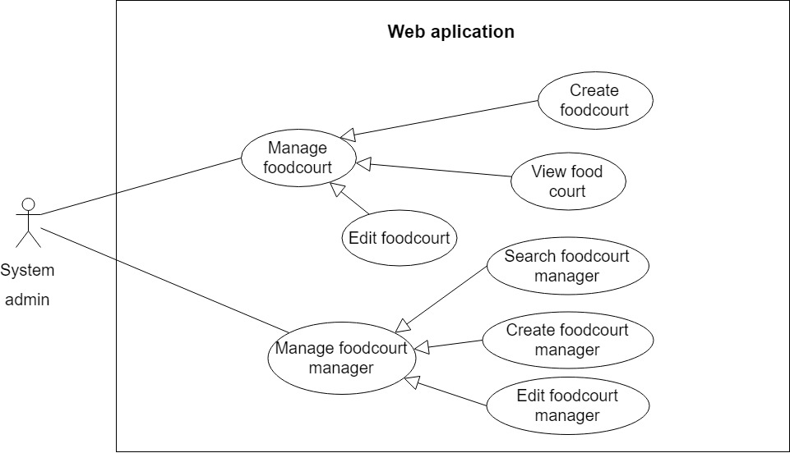

Figure 3 < System Admin > Overview Use Case

##### **<System Admin> Create food court**

**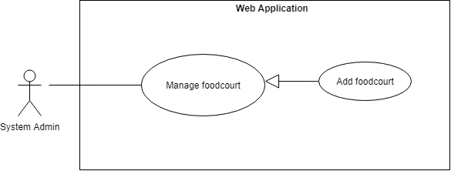**

Figure 4: <System admin> Create food-court

|  |  |  |  |
| --- | --- | --- | --- |
| **USE CASE – CFOS\_UC\_SA\_01** | | | |
| **Use Case No.** | CFOS\_UC\_SA\_01 | **Use Case Version** | 2.0 |
| **Use Case Name** | Create food court | | |
| **Author** | ThinhPH | | |
| **Date** | 23/06/2019 | **Priority** | Normal |
| **Actor:**   * System Admin   **Summary:**   * This use case allows system admin to add new food court to the system.   **Goal:**   * System admin can add new food court to the system**.**   **Triggers:**   * From the side bar:   + Select “Manage Food Court” menu.  + Select “Tạo Mới Food Court” button  **Preconditions:**   * User has to logged in to the system as System admin role   **Post Conditions:**   * **Success**: New food court is added into the system * **Fail**: Show error message, no changes in database.   **Main Success Scenario:**   |  |  |  | | --- | --- | --- | | **Step** | **Actor Action** | **System Response** | | **1** | System admin goes to manage food court page and click “Tạo Mới Food Court” button. | Navigate modal “Tạo Mới Food Court” which contains:   * “Tên Food Court”: text, required, length 1 – 100, required. * “Vị Trí Food Court ”: text, required, length 1 – 100, required. * “Ok”: button. * “Cancel”: button | | **2** | System admin inputs data |  | | **3** | System admin click “Ok” button  [Alternative 1] | * Insert new food court to database and close modal. * Show message: “Tạo Mới Food Court Thành Công”.   [Exception 1 2] |   **Alternative Scenario:**   |  |  |  | | --- | --- | --- | | No | Actor Action | System Response | | 1 | System admin click “Cancel” button | Close modal “Tạo Mới Food Court” |   **Exceptions:**   |  |  |  | | --- | --- | --- | | **Step** | **Cause** | **System Response** | | **1** | Length of “Tên Food Court” is under 1 and over 100 characters | Show error message: “Nhập từ 1-100 kí tự” | | **2** | Length of “Vị Trí Food Court” is under 1 and over 100 characters | Show error message: “Nhập từ 1-100 kí tự” | | **3** | “Tên Food Court” and “Vị Trí Food Court” is existed in the system | Show error message: “Food court đã tồn tại” |   **Relationships:** N/A  **Business Rules:**   * Create a new food court in the system | | | |

Table 10 - <System Admin> Create food court

##### **<System Admin> View list food court**

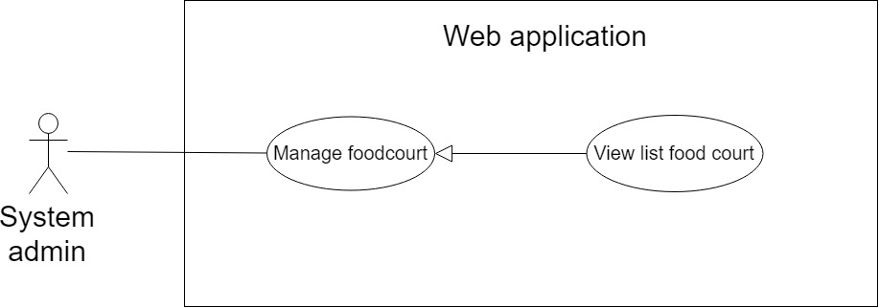

Figure 5: <System admin> View list food court

|  |  |  |  |
| --- | --- | --- | --- |
| **USE CASE – CFOS\_UC\_SA\_02** | | | |
| **Use Case No.** | CFOS\_UC\_SA\_02 | **Use Case Version** | 2.0 |
| **Use Case Name** | View list food court | | |
| **Author** | HuyND | | |
| **Date** | 30/06/2019 | **Priority** | Normal |
| **Actor**:   * System Admin   **Summary**:   * This use case allows system admin to get all list of food court that has been created   **Goal**:   * System admin can view list food court stored in database.   **Triggers**:   * From the side bar:   + Select “Manage Food Court” menu.  **Preconditions**:   * User has to logged in to the system as System admin role   **Post Conditions**:   * **Success**: Display list food court * **Fail**: Show empty list and display “No data”   **Main Success Scenario:**   |  |  |  | | --- | --- | --- | | **Step** | **Actor Action** | **System Response** | | **1** | System admin goes to manage food court page | * System automatically displays list of food court   [Exception 1] |   **Exceptions:**   |  |  |  | | --- | --- | --- | | **No** | **Cause** | **System Response** | | **1** | Data is empty | Show error message: “No data” |   **Relationships**: N/A  **Business Rules**: Only show list food court which managed by this system | | | |

Table 11 <System Admin> View list food court

##### **<System Admin> Edit food court**

**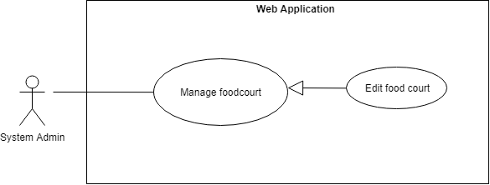**

Figure 6: <System admin> Edit food court

|  |  |  |  |
| --- | --- | --- | --- |
| **USE CASE – CFOS\_UC\_SA\_03** | | | |
| **Use Case No.** | CFOS\_UC\_SA\_03 | **Use Case Version** | 2.0 |
| **Use Case Name** | Edit food court | | |
| **Author** | ThinhPH | | |
| **Date** | 23/06/2019 | **Priority** | Normal |
| **Actor**:   * System Admin   **Summary**:   * This use case allows system admin to update food court to the system.   **Goal**:   * System admin can update food court to the system.   **Triggers**:   * From the side bar:   + Select “Manage Food Court” menu.  + Select “Update” icon.  **Preconditions**:   * User has to logged in to the system as System admin role   **Post Conditions**:   * **Success**: Update food court is update into the system. * **Fail**: Show error message, no changes in database.   **Main Success Scenario:**   |  |  |  | | --- | --- | --- | | **Step** | **Actor Action** | **System Response** | | **1** | System admin goes to manage food court page and click “Update” icon. | Navigate modal “Chỉnh sửa Food Court ” which contains:   * “Tên Food Court”: text, required, length 1 – 100, required. * “Vị Trí Food Court ”: text, required, length 1 – 100, required. * “Ok”: button. * “Cancel”: button | | **2** | System admin Update data food court. |  | | **3** | System admin click “Ok” button.  [Alternative 1] | * Update food court to database and close modal. * Show message: “Chỉnh Sửa Food Court Thành Công”.   [Exception 1 2] |   **Alternative Scenario:**   |  |  |  | | --- | --- | --- | | No | Actor Action | System Response | | 1 | System admin click “Cancel” button | Close modal “ Chỉnh Sửa Food Court” |   **Exceptions:**   |  |  |  | | --- | --- | --- | | **Step** | **Cause** | **System Response** | | **1** | The data will be transmitted to the input if the admin updates the data is length of “Tên Food Court” is under 1 and over 100 characters | Show error message: “Nhập từ 1-100 kí tự” | | **2** | The data will be transmitted to the input if the admin updates the data is length of “Vị Trí Food Court” is under 1 and over 100 characters | Show error message: “Nhập từ 1-100 kí tự” |   **Relationships**: N/A  **Business Rules**:   * Update food court in the system | | | |

Table 12 <System Admin> Edit food court

##### **<System Admin> Add new food court manager**

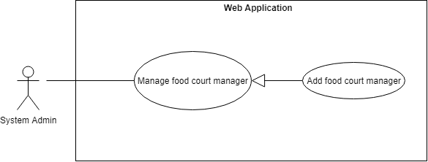

Figure 7: <System admin> Add new food court manager

|  |  |  |  |
| --- | --- | --- | --- |
| **USE CASE –CFOS\_UC\_SA\_04** | | | |
| **Use Case No.** | CFOS\_UC\_SA\_04 | **Use Case Version** | 2.0 |
| **Use Case Name** | Add new food court manager | | |
| **Author** | ThinhPH | | |
| **Date** | 23/06/2019 | **Priority** | Normal |
| **Actor:**   * System Admin   **Summary:**   * This use case allows system admin to add new food court manager to the system.   **Goal:**   * System admin can add new food court manager to the system**.**   **Triggers:**   * From the side bar:   + Select “Manage Food Court Manager” menu.  + Select “Tạo Mới Tài Khoản” button.  **Preconditions:**   * User has to logged in to the system as System admin role   **Post Conditions:**   * **Success**: New food court manager is added into the system. * **Fail**: Show error message, no changes in database.   **Main Success Scenario:**   |  |  |  | | --- | --- | --- | | **Step** | **Actor Action** | **System Response** | | **1** | System admin goes to manage food court manager page and click “Tạo Mới Tài Khoản” button. | Navigate modal “Tạo Mới Tài Khoản” which contains:   * “Username”: text, required, length 1 – 30. * “Họ tên ”: text, required, length 1 – 200. * “Số Điện Thoại”: number, required, phone number format * “Email”: text, required, email format. * “Vai trò”: select box * “Food court”: select box * “Ok”: button. * “Cancel”: button | | **2** | System admin fills data food court manager |  | | **3** | System admin click “Ok” button.  [Alternative 1] | * Insert new food court manager to database and close modal. * Show message: “Tạo Mới Thành Công”.   [Exception 1 2 3 4 5 6 7 8] |   **Alternative Scenario:**   |  |  |  | | --- | --- | --- | | No | Actor Action | System Response | | 1 | System admin click “Cancel” button | Close modal “Tạo Mới Tài Khoản” |   Exceptions:   |  |  |  | | --- | --- | --- | | **Step** | **Cause** | **System Response** | | **1** | Length of “Username” is under 1 and over 100 characters | Show error message: “Nhập từ 1-30 kí tự” | | **2** | Length of “Họ tên” is under 1 and over 100 characters | Show error message: “Nhập từ 1-200 kí tự” | | **3** | “Số Điện Thoại” is empty and wrong format | Show error message: “Chưa Nhập Số Điện Thoại” | | **4** | “Email” is empty | Show error message: “Nhập Email” | | **5** | “Email” is invalid format. | Show error message: “Sai Định Dạng email”. | | **6** | “Vai Trò” is empty | Show error message: “Chọn Vai Trò” | | **7** | “Food court” is empty | Show error message: “Chọn Food court” | | **8** | “Username” is existed in the system | Show error message: “Tài khoản đã tồn tại” |   **Relationships**:N/A  **Business Rules**:   * Create a new food court manager in the system * Password send to mail of food court manager | | | |

Table 13 <System Admin> Add new food court manager

##### **<System Admin>** **Update food court manager**

**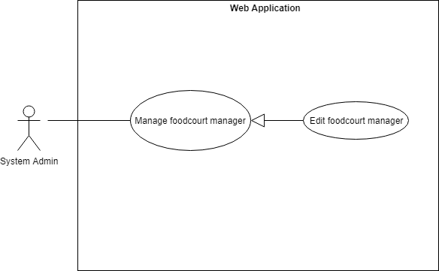**

Figure 8: <System admin> Update food court manager

|  |  |  |  |
| --- | --- | --- | --- |
| **USE CASE – CFOS\_UC\_SA\_05** | | | |
| **Use Case No.** | CFOS\_UC\_SA\_05 | **Use Case Version** | 2.0 |
| **Use Case Name** | Update food court manager | | |
| **Author** | ThinhPH | | |
| **Date** | 23/06/2019 | **Priority** | Normal |
| **Actor:**   * System Admin   **Summary:**   * This use case allows system admin to update food manager access to the system.   **Goal:**   * System admin can update food court manager access to the system.   **Triggers:**   * From the side bar:   + Select “Manage Food Court Manager” menu.  + Select “Update” icon.  **Preconditions:**   * User has to logged in to the system as System admin role   **Post Conditions:**   * **Success**: Update food court manager access is update into the system. * **Fail**: Show error message, no changes in database.   **Main Success Scenario:**   |  |  |  | | --- | --- | --- | | **Step** | **Actor Action** | **System Response** | | **1** | System admin goes to manage food court manager page and click “Update” icon. | Navigate modal “Cấp Quyền” which contains:   * “Content”: “Bạn Muốn Thay Đổi Quyền Truy Cập Từ Cho Phép Sang Không Cho Phép" or “Bạn Muốn Thay Đổi Quyền Truy Cập Từ Không Cho Phép Sang Cho Phép" * “Ok”: button. * “Cancel”: button | | **2** | System admin click “Ok” button.  [Alternative 1] | * Update food court manager access to database and close modal. |   **Alternative Scenario:**   |  |  |  | | --- | --- | --- | | No | Actor Action | System Response | | 1 | System admin click “Cancel” button | Close modal “Cấp Quyền” |   **Exceptions**: **N/A**  **Relationships**: **N/A**  **Business** **Rules**:   * Food court manager access is updated on the system * If the system admin grants food court manager access to the system, the food court manager can access the system and vice versa. | | | |

Table 14 <System Admin> Update food court manager

##### **<System Admin> Search food court manager**

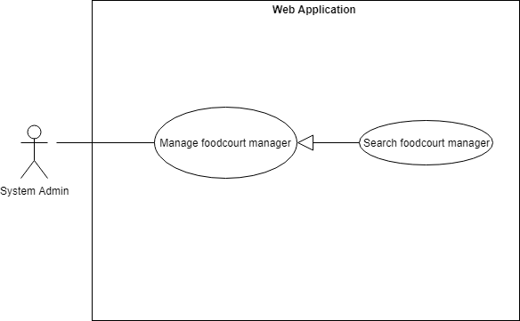

Figure 9 : <System admin> Search food court manager

|  |  |  |  |
| --- | --- | --- | --- |
| **USE CASE – CFOS\_UC\_SA\_06** | | | |
| **Use Case No.** | CFOS\_UC\_SA\_06 | **Use Case Version** | 2.0 |
| **Use Case Name** | Search food court manager | | |
| **Author** | ThinhPH | | |
| **Date** | 23/06/2019 | **Priority** | Normal |
| **Actor:**   * System Admin   **Summary:**   * This use case allows system admin to search the food court manager in the system.   **Goal:**   * System admin view the list of food court manager.   **Triggers:**   * From the side bar:   + Select “Manage Food Court Manager” menu.  + System admin input text and send the search command  **Preconditions:**   * User has to logged in to the system as System admin role   **Post Conditions:**   * **Success:** List of food court manager will be displayed as a list in table UI. * **Fail:** Show error message.   **Main Success Scenario:**   |  |  |  | | --- | --- | --- | | **Step** | **Actor Action** | **System Response** | | **1** | System admin goes to manage food court manager page. | The system requires text input from system admin includes:   * “Search”: input * “Search”: button | | **3** | System admin fill data search input. | * Food court manager name: text | | **2** | System admin click “Search” button.  [Alternative 1] | * All search results will be displayed in table with information includes:   + “STT”  + “Username”  + “Họ Và Tên”  + “Địa Chỉ”  + “Ngày Sinh”  + “Số Điện Thoại”  + “Email”  + “Vai Trò”  + “Quyền Truy Cập” |   **Alternative Scenario**:   |  |  |  | | --- | --- | --- | | No | Actor Action | System Response | | 1 | User enters the wrong equipment keyword | The system shows an warning message “No matched” |   **Exceptions**: **N/A**  **Relationships**: **N/A**  **Business Rules**:   * System admin will get the search results list. * Search result list can be looked up by food court manager name. * User can get a food court manager detail which contains:   + “STT”  + “Username”  + “Họ Và Tên”  + “Địa Chỉ”  + “Ngày Sinh”  + “Số Điện Thoại”  + “Email”  + “Vai Trò”  + “Quyền Truy Cập” | | | |

Table 15 <System Admin> Search food court manager

#### 2.3.2. **<Food court manager> Overview Use case**

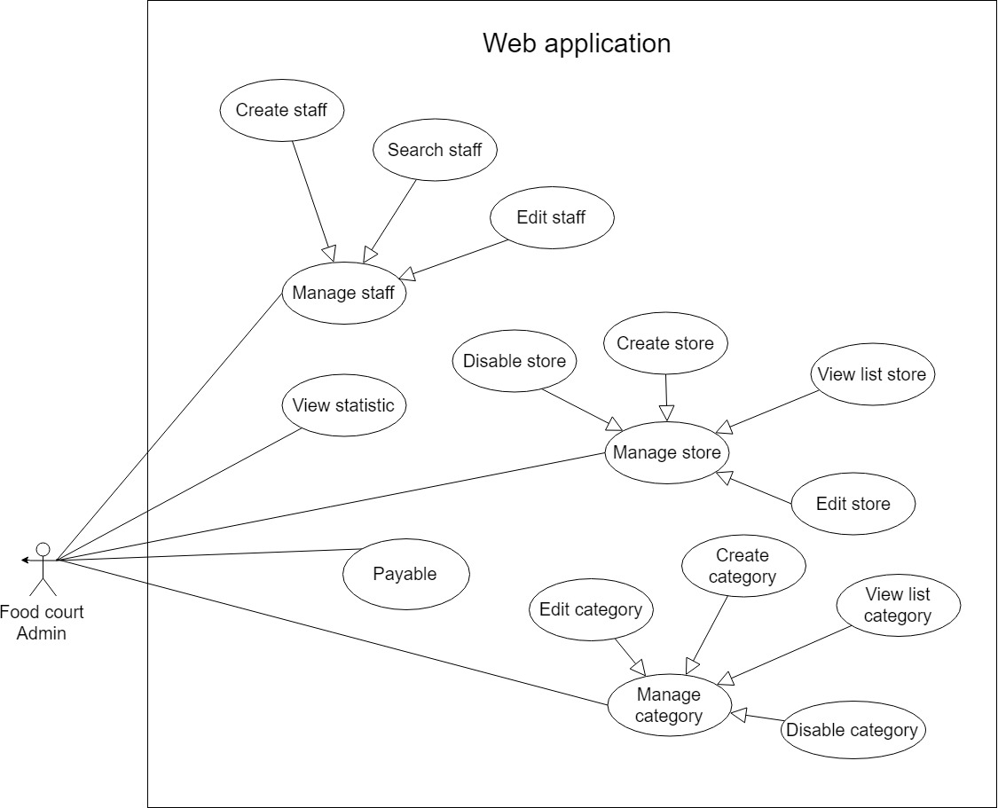

Figure 10: <Food court manager> Overview Use case

##### **2.3.2.1. <Food court manager>** **Add staff**

**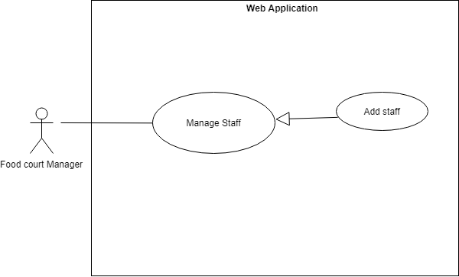**

Figure 11: <Food court manager> Add staff

|  |  |  |  |
| --- | --- | --- | --- |
| **USE CASE – CFOS\_UC\_FCM\_01** | | | |
| **Use Case No.** | CFOS\_UC\_FCM\_01 | **Use Case Version** | 2.0 |
| **Use Case Name** | Add staff | | |
| **Author** | ThinhPH | | |
| **Date** | 23/06/2019 | **Priority** | Normal |
| **Actor**:   * Food court manager   **Summary**:   * This use case allows food court manager to add new staff to the system. * List staff included : store manager, chef, cashier   **Goal**:   * Food court manager can add new staff to the system.   **Triggers**:   * From the side bar:   + Select “Manage Staff” menu.  + Select “Tạo Mới Nhân Viên” button  **Preconditions**:   * User has to logged in to the system as Food court manager role   **Post** **Conditions**:   * **Success:** New staff is added into the system * **Fail:** Show error message, no changes in database.   **Main Success Scenario:**   |  |  |  | | --- | --- | --- | | **Step** | **Actor Action** | **System Response** | | **1** | Food court manager goes to manage staff page and click “Tạo Mới Nhân Viên” button. | Navigate modal “Tạo Mới Nhân Viên” which contains:   * “Username”: text, required, length 1 – 50. * “Họ Và Tên”: text, required, length 1 – 200. * “Số Điện Thoại”: number, required * “Email”: email, required. * “Vai Trò”: select box, required. * “Cửa Hàng”: select box, required. * “Ok”: button. * “Cancel”: button | | **2** | Food court manager inputs data | * If the food court manager chooses "Vai Trò" as "STORE\_MANAGER" and "CHEF" then the select box "Cửa Hàng" will appear. | | **3** | Food court manager click “Ok” button.  [Alternative 1] | * Insert new staff to database and close modal. * Show message: “Tạo mới thành công”.   [Exception 1 ,2 ,3 ,4 ,5 ,6 ,7 ,8 ] |   **Alternative Scenario:**   |  |  |  | | --- | --- | --- | | No | Actor Action | System Response | | 1 | Food court manager click “Cancel” button | Close modal “Tạo Mới Nhân Viên” |   Exceptions:   |  |  |  | | --- | --- | --- | | **Step** | **Cause** | **System Response** | | **1** | Length of “Username” is under 1 and over 50 characters | Show error message: “Nhập từ 1-50 kí tự” | | **2** | “Username” is existed in the system. | Show error message: “Tài khoản đã tồn tại!” | | **3** | Length of “Họ Và Tên” is under 1 and over 200 characters | Show error message: “Nhập từ 1-200 kí tự” | | **4** | Length of “Số Điện Thoại” is empty and wrong format phone number | Show error message: “Nhập Số Điện Thoại” | | **5** | Length of “Email” is empty | Show error message: “Nhập Mail” | | **6** | “Email” wrong format email | Show error message: “Sai Định Dạng Mail” | | **7** | “Vai Trò” is empty | Show error message: “Chọn Vai Trò” | | **8** | “Cửa Hàng” is empty | Show error message: “Chọn Cửa Hàng” |   **Relationships:** N/A  **Business Rules:**   * Create a new staff in the system * Password send to mail of staff (store manager, chef, cashier) | | | |

Table 16 < Food court manager > Add staff

##### **2.3.2.2. <Food court manager> Edit staff**

**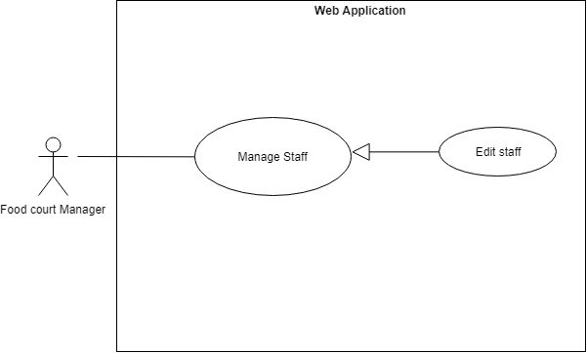**

Figure 12: <Food court manager> Edit staff

|  |  |  |  |
| --- | --- | --- | --- |
| **USE CASE – CFOS\_UC\_FCM\_02** | | | |
| **Use Case No.** | CFOS\_UC\_FCM\_02 | **Use Case Version** | 2.0 |
| **Use Case Name** | Update staff access | | |
| **Author** | ThinhPH | | |
| **Date** | 23/06/2019 | **Priority** | Normal |
| **Actor**:   * Food court manager   **Summary**:   * This use case allows food court manager to update staff access to the system. * List staff included : store manager, chef, cashier   **Goal**:   * Food court manager can update staff access to the system.   **Triggers**:   * From the side bar:   + Select “Manage Staff” menu.  + Select “Chỉnh sửa quyền truy cập” icon.  **Preconditions**:   * User has to logged in to the system as food court manager role   **Post Conditions:**   * **Success**: Update staff access is update into the system. * **Fail**: Show error message, no changes in database.   **Main Success Scenario:**   |  |  |  | | --- | --- | --- | | **Step** | **Actor Action** | **System Response** | | **1** | Food court manager goes to manage staff page and click “Chỉnh sửa quyền truy cập” icon. | Navigate modal “Cấp Quyền” which contains:   * “Content”: “Bạn Muốn Thay Đổi Quyền Truy Cập Từ Cho Phép Sang Không Cho Phép" or “Bạn Muốn Thay Đổi Quyền Truy Cập Từ Không Cho Phép Sang Cho Phép" * “Ok”: button. * “Cancel”: button | | **2** | System admin click “Ok” button.  [Alternative 1] | * Update staff access to database and close modal. |   **Alternative Scenario:**   |  |  |  | | --- | --- | --- | | No | Actor Action | System Response | | 1 | Food court manager click “Cancel” button | Close modal “Cấp Quyền” |   **Exceptions**: N/A  **Relationships**:N/A  **Business Rules**:   * Staff access is updated on the system * If the food court manager grants staff access to the system, the staff can access the system and vice versa. | | | |

Table 17 < Food court manager > Edit staff

##### **2.3.2.3. <Food court manager> Search staff**

**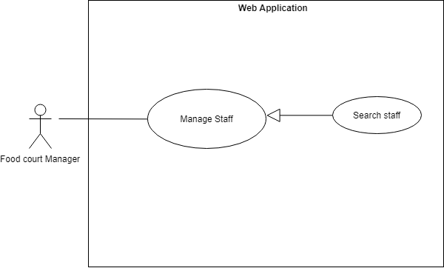**

Figure 13: <Food court manager> Search staff

|  |  |  |  |
| --- | --- | --- | --- |
| **USE CASE – CFOS\_UC\_FCM\_03** | | | |
| **Use Case No.** | CFOS\_UC\_FCM\_03 | **Use Case Version** | 2.0 |
| **Use Case Name** | Search staff | | |
| **Author** | ThinhPH | | |
| **Date** | 23/06/2019 | **Priority** | Normal |
| **Actor**:   * Food court manager   **Summary**:   * This use case allows food court manager to search the staff in the system. * List staff included : store manager, chef, cashier   **Goal**:   * Food court manager view the list of staff.   **Triggers**:   * From the side bar:   + Select “Manage Staff” menu.  + Food court manager input text and send the search command  **Preconditions**:   * User has to logged in to the system as Food court manager role   **Post Conditions:**   * Success: List of staff will be displayed as a list in table UI. * Fail: Show error message.   **Main Success Scenario:**   |  |  |  | | --- | --- | --- | | **Step** | **Actor Action** | **System Response** | | **1** | Food court manager goes to manage staff page. | The system requires text input from food court manager includes:   * “Search”: input * “Search”: button | | **3** | Food court manager fill data search input. | * Staff name: text | | **2** | Food court manager click “Search” button.  [Alternative 1] | * All search results will be displayed in table with information includes:   + “STT”  + “Username”  + “Họ Và Tên”  + “Địa Chỉ”  + “Ngày Sinh”  + “Số Điện Thoại”  + “Email”  + “Vai Trò”  + “Quyền Truy Cập” |   **Alternative Scenario:**   |  |  |  | | --- | --- | --- | | No | Actor Action | System Response | | 1 | User enters the wrong equipment keyword | The system shows an warning message “No matched” |   **Exceptions**: N/A  **Relationships:** N/A  **Business Rules:**   * Food court manager will get the search results list. * Search result list can be looked up by staff name. * User can get a staff detail which contains:   + “STT”  + “Username”  + “Họ Và Tên”  + “Địa Chỉ”  + “Ngày Sinh”  + “Số Điện Thoại”  + “Email”  + “Vai Trò”  + “Quyền Truy Cập” | | | |

Table 18 <System Admin> Search staff

##### **2.3.2.4. <Food court manager> Add new store**

**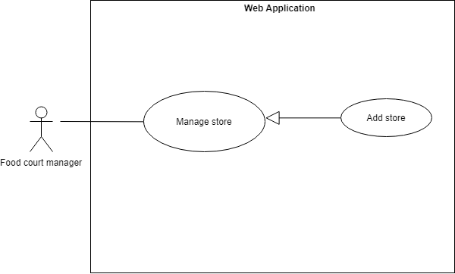**

Figure 14: <Food court manager> Add store

|  |  |  |  |
| --- | --- | --- | --- |
| **USE CASE – CFOS\_UC\_FCM\_04** | | | |
| **Use Case No.** | CFOS\_UC\_FCM\_04 | **Use Case Version** | 2.0 |
| **Use Case Name** | Add store | | |
| **Author** | ThinhPH | | |
| **Date** | 23/06/2019 | **Priority** | Normal |
| **Actor**:   * Food court manager   **Summary**:   * This use case allows food court manager to add new store to the system.   **Goal**:   * Food court manager can add new store to the system.   **Triggers**:   * From the side bar:   + Select “Manage Store” menu.  + Select “Tạo Mới Cửa Hàng” button  **Preconditions**:   * User has to logged in to the system as Food court manager role   **Post Conditions**:   * **Success**: New store is added into the system * **Fail**: Show error message, no changes in database.   **Main Success Scenario:**   |  |  |  | | --- | --- | --- | | **Step** | **Actor Action** | **System Response** | | **1** | Food court manager goes to manage store page and click “Tạo Mới Cửa Hàng” button. | Navigate modal “Tạo Mới Cửa Hàng” which contains:   * “Tên Cửa Hàng”: text, required, length 1 – 100. * “Mô Tả”: text, required, length 1 – 100. * “Ok”: button. * “Cancel”: button | | **2** | Food court manager inputs data |  | | **3** | Food court manager click “Ok” button.  [Alternative 1] | * Insert new store to database and close modal. * Show message: “Tạo mới cửa hàng thành công!”.   [Exception 1 2] |   Alternative Scenario:   |  |  |  | | --- | --- | --- | | No | Actor Action | System Response | | 1 | Food court manager click “Cancel” button | Close modal “Tạo Mới Food Court” |   Exceptions:   |  |  |  | | --- | --- | --- | | **Step** | **Cause** | **System Response** | | **1** | Length of “Tên Cửa Hàng” is under 1 and over 100 characters | Show error message: “Nhập từ 1-100 kí tự” | | **2** | Length of “Mô Tả” is under 1 and over 100 characters | Show error message: “Nhập từ 1-100 kí tự” |   **Relationships**:N/A  **Business Rules**:   * Create a new store in the system | | | |

Table 19 <System Admin> Add store

Table 19 <System Admin> Add store

##### **2.3.2.5 <Food court manager> View list store**

Figure 15: <Food court manager> View list store

|  |  |  |  |
| --- | --- | --- | --- |
| **USE CASE – CFOS\_UC\_FCM\_05** | | | |
| **Use Case No.** | CFOS\_UC\_FCM\_05 | **Use Case Version** | 2.0 |
| **Use Case Name** | View list store | | |
| **Author** | HuyND | | |
| **Date** | 30/06/2019 | **Priority** | Normal |
| **Actor**:   * Food court manager   **Summary**:   * This use case allows food court manager to get all list store information   **Goal**:   * Food court manager can view list store information   **Triggers**:   * From the side bar:   + Select “Manage Store” menu.  **Preconditions**:   * User has to logged in to the system as food court manager role   **Post** **Conditions**:   * **Success**: Show successfully list of store * **Fail**: Show empty list and display “No data”.   **Main Success Scenario**:   |  |  |  | | --- | --- | --- | | **Step** | **Actor Action** | **System Response** | | **1** | Food court manager goes to manage store page | * System automatically displays list of stores   [Exceptions 1] |   **Exceptions:**   |  |  |  | | --- | --- | --- | | **No** | **Cause** | **System Response** | | **1** | Data is empty | Show error message: “No data” |   **Relationships**:N/A  **Business** **Rules**: Only show list store which managed by this food court | | | |

Table 20 <System Admin> View list store

##### **2.3.2.6. <Food court manager> Edit store**

**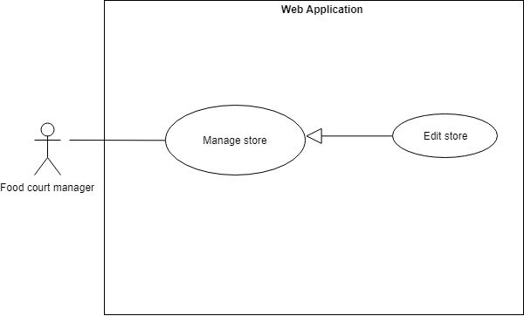**

Figure 16: <Food court manager> Edit store

|  |  |  |  |
| --- | --- | --- | --- |
| **USE CASE – CFOS\_UC\_FCM\_06** | | | |
| **Use Case No.** | CFOS\_UC\_FCM\_06 | **Use Case Version** | 2.0 |
| **Use Case Name** | Edit store | | |
| **Author** | ThinhPH | | |
| **Date** | 23/06/2019 | **Priority** | Normal |
| **Actor**:   * **Food court manager**   **Summary**:   * **This use case allows food court manager to update store information to the system.**   **Goal**:   * **Food court manager can update store information to the system.**   **Triggers**:   * **From the side bar:**   **+ Select “Manage Store” menu.**  **+ Select “Chỉnh thông tin cửa hàng” icon.**  **Preconditions**:   * **User has to logged in to the system as food court manager role**   **Post** **Conditions**:   * **Success**: Edit store is update into the system. * **Fail**: Show error message, no changes in database.   **Main Success Scenario**:   |  |  |  | | --- | --- | --- | | **Step** | **Actor Action** | **System Response** | | **1** | Food court manager goes to manage store page and click “Chỉnh sửa thông tin cửa hàng” icon. | Navigate modal “Chỉnh Sửa Cửa Hàng” which contains:   * “Tên Cửa Hàng”: text, required, length 1 – 100. * “Mô Tả”: text, required, length 1 – 100. * “Trạng Thái”: radio button * “Ok”: button. * “Cancel”: button | | **2** | Food court manager click “Ok” button.  [Alternative 1] | * Update store to database and close modal. |   **Alternative Scenario:**   |  |  |  | | --- | --- | --- | | No | Actor Action | System Response | | 1 | Food court manager click “Cancel” button | Close modal “Chỉnh Sửa Cửa Hàng” |   **Exceptions:**   |  |  |  | | --- | --- | --- | | **Step** | **Cause** | **System Response** | | **1** | Length of “Tên Cửa Hàng” is under 1 and over 100 characters | Show error message: “Nhập từ 1-100 kí tự” | | **2** | Length of “Mô Tả” is under 1 and over 100 characters | Show error message: “Nhập từ 1-100 kí tự” | | **3** | “Tên Cửa Hàng” is existed in the system | Show error message: “Tên cửa hàng đã tồn tại” |   **Relationships**:N/A  **Business** **Rules**:   * Store information is updated on the system | | | |

Table 21 <System Admin> Edit store

##### **2.3.2.7 <Food court manager> Disable store**

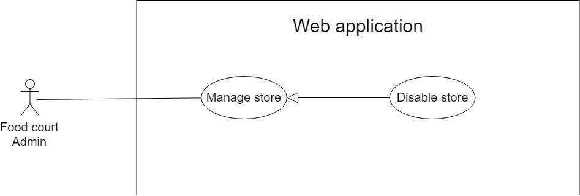

Figure 17: <Food court manager> Disable store

|  |  |  |  |
| --- | --- | --- | --- |
| **USE CASE – CFOS\_UC\_FCM\_07** | | | |
| **Use Case No.** | CFOS\_UC\_FCM\_07 | **Use Case Version** | 2.0 |
| **Use Case Name** | Disable store | | |
| **Author** | HuyND | | |
| **Date** | 23/06/2019 | **Priority** | Normal |
| **Actor**:   * Food court manager   **Summary**:   * **T**his use case allows food court manager to disable store**.**   **Goal**:   * Food court manager can disable store.   **Triggers**:   * From the side bar:   + Select “Manage Store” menu.  + Select “Chỉnh thông tin cửa hàng” icon.  **Preconditions**:   * User has to logged in to the system as food court manager role   **Post** **Conditions**:   * **Success**: Disable store successfully and store information and food of store disappear in order food application   **Fail**: Show error message, no changes in database.  **Main Success Scenario**:   |  |  |  | | --- | --- | --- | | **Step** | **Actor Action** | **System Response** | | **1** | Food court manager goes to manage store page and click “Chỉnh sửa thông tin cửa hàng” icon. | Navigate modal “Chỉnh Sửa Cửa Hàng” which contains:   * “Tên Cửa Hàng”: text, required, length 1 – 100. * “Mô Tả”: text, required, length 1 – 100. * “Trạng Thái”: radio button * “Ok”: button. * “Cancel”: button | | **2** | Food court manager choose status “Ẩn” |  | | **3** | Food court manager press [OK] button.  [Alternative 1] | Category is updated and disappear in menu  [Alternative 1]  [Exception 1]  [Exception 2] |   **Alternative 1:**   |  |  |  | | --- | --- | --- | | **No** | **Cause** | **System Response** | | **1** | Category is already disable | Show error message: “Danh mục này đã bị ẩn” |   **Exceptions 1:**   |  |  |  | | --- | --- | --- | | **No** | **Cause** | **System Response** | | **1** | Store isn’t exist | Show error message: “Không tìm thấy mã cửa hàng này” |   **Exception 2:**   |  |  |  | | --- | --- | --- | | **No** | **Cause** | **System Response** | | 1 | When the connection to the server is lost | System shows message the "Vui lòng kiểm tra kết nối của bạn. |   **Relationships**:N/A  **Business** **Rules**:  After disable store successfully and store information and food of store disappear in order food application | | | |

Table 22 <System Admin> Disable store

##### **2.3.2.8. <Food court manager> Add new category**

**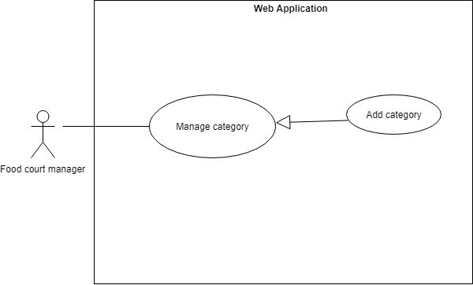**

Figure 18: <Food court manager> Add new category

|  |  |  |  |
| --- | --- | --- | --- |
| **USE CASE – CFOS\_UC\_FCM\_08** | | | |
| **Use Case No.** | CFOS\_UC\_FCM\_08 | **Use Case Version** | 2.0 |
| **Use Case Name** | Add new category | | |
| **Author** | ThinhPH | | |
| **Date** | 23/06/2019 | **Priority** | Normal |
| **Actor:**   * Food court manager   **Summary:**   * Thisuse case allows food court manager to add new category to the system.   **Goal:**   * Food court manager can add new category to the system.   **Triggers:**   * From the side bar:   + Select “Manage Categories” menu.  + The screen will show three main categories: "Thức ăn", "Đồ uốn", "Combo".  + Select “Tạo Danh Mục Món Ăn” icon in categories main.  **Preconditions:**   * User has to logged in to the system as Food court manager role   **Post Conditions:**   * Success: New category is added into the system * Fail: Show error message, no changes in database**.**   **Main Success Scenario:**   |  |  |  | | --- | --- | --- | | **Step** | **Actor Action** | **System Response** | | **1** | Food court manager goes to manage categories page and click “Tạo Danh Mục Món Ăn” icon. | Navigate modal “Tạo Danh Mục Món Ăn” which contains:   * “Danh Mục Food Court”: text, disabled * “Danh Mục Món Ăn”: text, required, length 1 – 100. * “Hình Ảnh”: file select. * “Ok”: button. * “Cancel”: button | | **2** | Food court manager inputs data |  | | **3** | Food court manager click “Ok” button.  [Alternative 1] | * Insert new food category to database and close modal. * Show message: “Tạo mới thành công!”.   [Exception 1 2] |   **Alternative Scenario:**   |  |  |  | | --- | --- | --- | | No | Actor Action | System Response | | 1 | Food court manager click “Cancel” button | Close modal “Tạo Danh Mục Món Ăn” |   Exceptions:   |  |  |  | | --- | --- | --- | | **Step** | **Cause** | **System Response** | | **1** | Length of “Danh Mục Food Court” is under 1 and over 100 characters | Show error message: “Nhập từ 1-100 kí tự” | | **2** | “Danh Mục Món Ăn” is existed in the system | Show error message: “Danh mục món ăn đã tồn tại” |   **Relationships**: N/A  **Business Rules**:   * Create a new category in the system | | | |

Table 23 <System Admin> Add new category

##### **2.3.2.9. <Food court manager> Edit category**

**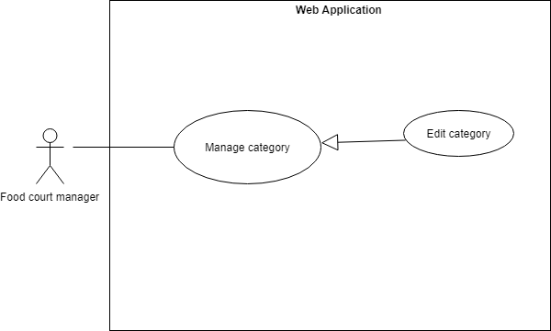**

Figure 19: <Food court manager> Edit category

|  |  |  |  |
| --- | --- | --- | --- |
| **USE CASE – CFOS\_UC\_FCM\_09** | | | |
| **Use Case No.** | CFOS\_UC\_FCM\_09 | **Use Case Version** | 2.0 |
| **Use Case Name** | Edit category | | |
| **Author** | ThinhPH | | |
| **Date** | 23/06/2019 | **Priority** | Normal |
| **Actor:**   * Food court manager   **Summary:**   * This use case allows food court manager to update food category to the system.   **Goal:**   * Food court manager can update food category to the system.   **Triggers:**   * From the side bar:   + Select “Manage Categories” menu.  + The screen will show three main categories: "Thức ăn", "Đồ uốn", "Combo".  + Select “Tạo Danh Mục Món Ăn” icon in categories main.  **Preconditions:**   * User has to logged in to the system as food court manager role   **Post Conditions:**   * Success: Edit food category is update into the system. * Fail: Show error message, no changes in database.   **Main Success Scenario:**   |  |  |  | | --- | --- | --- | | **Step** | **Actor Action** | **System Response** | | **1** | Food court manager goes to manage categories page and click “Chỉnh Sửa Danh Mục” icon. | Navigate modal “Chỉnh Sửa Danh Mục Món Ăn” which contains:   * “Danh Mục Food Court”: text, disabled * “Danh Mục Món Ăn”: text, required, length 1 – 100. * “Hình Ảnh”: file select * “Trạng Thái”: radio button * “Ok”: button. * “Cancel”: button | | **2** | Food court manager inputs data |  | | **3** | Food court manager click “Ok” button.  [Alternative 1] | * Update food category to database and close modal.   [Exception 1 2] |   **Alternative Scenario:**   |  |  |  | | --- | --- | --- | | No | Actor Action | System Response | | 1 | Food court manager click “Cancel” button | Close modal “Chỉnh Sửa Danh Mục Món Ăn” |   **Exceptions:**   |  |  |  | | --- | --- | --- | | **Step** | **Cause** | **System Response** | | **1** | Length of “Danh Mục Món Ăn” is under 1 and over 100 characters | Show error message: “Nhập từ 1-100 kí tự” | | **2** | “Danh Mục Món Ăn” is existed in the system | Show error message: “Danh mục món ăn đã tồn tại!” |   **Relationships**: **N/A**  **Business Rules:**   * Food court category is updated on the system | | | |

Table 24 <System Admin> Edit category

##### **2.3.2.10 <Food court manager> View list category**

Figure 20: <Food court manager> View list category

|  |  |  |  |
| --- | --- | --- | --- |
| **USE CASE – CFOS\_UC\_FCM\_10** | | | |
| **Use Case No.** | CFOS\_UC\_FCM\_10 | **Use Case Version** | 2.0 |
| **Use Case Name** | View list category | | |
| **Author** | HuyND | | |
| **Date** | 30/06/2019 | **Priority** | Normal |
| **Actor**:   * Food court manager   **Summary**:   * This use case allows food court manager to get all parent category and child category   **Goal**:   * Food court manager can view list category   **Triggers**:   * From the side bar:   + Select “Manage Category” menu.  **Preconditions**:   * User has to logged in to the system as food court manager role   **Post** **Conditions**:   * **Success**: Show successfully list of category * **Fail**: Show empty list and display “No data”.   **Main Success Scenario**:   |  |  |  | | --- | --- | --- | | **Step** | **Actor Action** | **System Response** | | **1** | Food court manager goes to manage store page | System automatically displays list of category  [Exceptions 1] |   **Exceptions:**   |  |  |  | | --- | --- | --- | | **No** | **Cause** | **System Response** | | **1** | Data is empty | Show error message: “Không có dữ liệu” |   **Relationships**:N/A  **Business** **Rules**: Show the list of parent category and child category owned by food court manager | | | |

Table 25 <System Admin> View list category

##### **2.3..2.11 <Food court manager> Disable category**

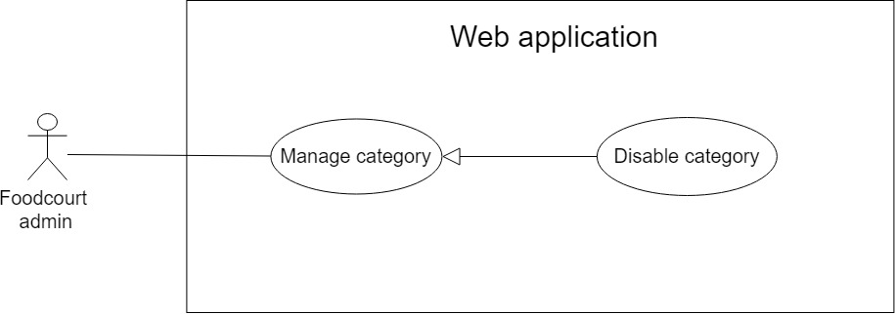

Figure 21: <Food court manager> Delete category

|  |  |  |  |
| --- | --- | --- | --- |
| **USE CASE – CFOS\_UC\_FCM\_11** | | | |
| **Use Case No.** | CFOS\_UC\_FCM\_11 | **Use Case Version** | 2.0 |
| **Use Case Name** | Disable category | | |
| **Author** | HuyND | | |
| **Date** | 30/06/2019 | **Priority** | Normal |
| **Actor:**   * Food court manager   **Summary:**   * This use case allows food court manager to disable food category to the system.   **Goal:**   * Food court manager can disable food category to the system.   **Triggers:**   * From the side bar:   + Select “Manage Categories” menu.  + The screen will show three main categories: "Thức ăn", "Đồ uống", "Combo".  + Select “edit” icon in sub category want to disable.  **Preconditions:**   * User has to logged in to the system as food court manager role   **Post Conditions:**   * Success: Show successful message and category won’t appear in meny of mobile app application or kiosk application * Fail: Show error message, no changes in database.   **Main Success Scenario:**   |  |  |  | | --- | --- | --- | | **Step** | **Actor Action** | **System Response** | | **1** | Food court manager goes to manage categories page and click “Chỉnh Sửa Danh Mục” icon. | Navigate modal “Chỉnh Sửa Danh Mục Món Ăn” which contains:   * “Danh Mục Food Court”: text, disabled * “Danh Mục Món Ăn”: text, required, length 1 – 100. * “Hình Ảnh”: file select * “Trạng Thái”: radio button * “Ok”: button. * “Cancel”: button | | **2** | Food court manager choose status “Ẩn” |  | | **3** | Food court manager press [OK] button.  [Alternative 1] | * Category is updated and disappear in menu   [Alternative1]  [Exception 1]  [Exception 2] |   **Alternative 1:**   |  |  |  | | --- | --- | --- | | **No** | **Cause** | **System Response** | | **1** | Category is already disable | Show error message: “Danh mục này đã bị ẩn” |   **Exceptions 1:**   |  |  |  | | --- | --- | --- | | **No** | **Cause** | **System Response** | | **1** | Category isn’t exist | Show error message: “Không tìm thấy mã danh mục này” |   **Exception 2:**   |  |  |  | | --- | --- | --- | | **No** | **Cause** | **System Response** | | 1 | When the connection to the server is lost | System shows message the "Vui lòng kiểm tra kết nối của bạn. |   **Relationships**: **N/A**  **Business Rules:**   * After disable successfully,category won’t appear in menu of mobile app application or kiosk application | | | |

Table 26 <System Admin> Disable category

##### **2.3.2.12. <Food court manager> View static**

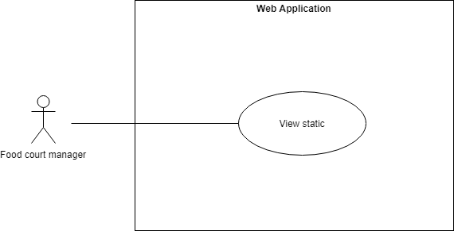

Figure 22: <Food court manager> View static

|  |  |  |  |
| --- | --- | --- | --- |
| **USE CASE – CFOS\_UC\_FCM\_12** | | | |
| **Use Case No.** | CFOS\_UC\_FCM\_12 | **Use Case Version** | 2.0 |
| **Use Case Name** | View static | | |
| **Author** | ThinhPH | | |
| **Date** | 23/06/2019 | **Priority** | Normal |
| **Actor:**   * Food court manager   **Summary:**   * This use case allows food court manager view static.   **Goal:**   * Food court manager can view static.   **Triggers:**   * From the side bar:   + Select “View static” menu.  **Preconditions:**   * User has to logged in to the system as food court manager role   **Post Conditions:**   * Success: Food court manager can view statics. * Fail: Show error message, no changes in database**.**   **Main Success Scenario**:   |  |  |  | | --- | --- | --- | | **Step** | **Actor Action** | **System Response** | | **1** | Food court manager goes to view static page. | The system displays statistics as follows:   * Total number of members. * Total cash collected from cashier. * Total revenue for the day. * Revenue chart of monthly stores |   **Alternative Scenario**:N/A  **Exceptions**: N/A  **Relationships**:N/A  **Business Rules**:   * Food court manager can view list static in day and revenue chart of monthly stores | | | |

Table 27 <System Admin> View static

##### **2.3.2.13. <Food court manager> Payable**

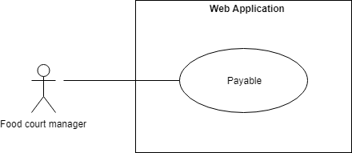

Figure 23: <Food court manager> Payable

|  |  |  |  |
| --- | --- | --- | --- |
| **USE CASE – CFOS\_UC\_FCM\_13** | | | |
| **Use Case No.** | CFOS\_UC\_FCM\_13 | **Use Case Version** | 2.0 |
| **Use Case Name** | View static | | |
| **Author** | ThinhPH | | |
| **Date** | 23/06/2019 | **Priority** | Normal |
| **Actor:**   * Food court manager   **Summary:**   * This use case allows food court manager make payable to the store.   **Goal:**   * Food court manager can make payable to the store.   **Triggers:**   * From the side bar:   + Select “Manage Payable” menu.  **Preconditions:**   * User has to logged in to the system as food court manager role   **Post Conditions:**   * Success: Food court manager can make payable to the store. * Fail: Show error message, no changes in database**.**   **Main Success Scenario**:   |  |  |  | | --- | --- | --- | | **Step** | **Actor Action** | **System Response** | | **1** | Food court manager goes to manage payable page. | Navigate modal “Trả Tiền Cho Cửa Hàng” which contains:   * “Tên Cửa Hàng”: text,disable. * “Nội Dung Giao Dịch”: text, required, length 1 – 200. * “Số Tiền”: number, required * “Ok”: button. * “Cancel”: button. | | **2** | Food court manager inputs data |  | | **3** | Food court manager click “Ok” button.  [Alternative 1] | * Payable successfully and close modal. * Show message: “Giao Dịch Thành Công”.   [Exception 1 ,2] |   **Alternative Scenario**:   |  |  |  | | --- | --- | --- | | No | Actor Action | System Response | | 1 | Food court manager click “Cancel” button | Close modal “Trả Tiền Cho Cửa Hàng” |   **Exceptions**:   |  |  |  | | --- | --- | --- | | **Step** | **Actor Action** | **System Response** | | **1** | Length of “Nội Dung Giao Dịch” is under 1 and over 200 characters. | Show error message: “Nhập từ 1-200 kí tự” | | **4** | Length of “Số Tiền” is empty. | Show error message: “Nhập Số Tiền” |   **Relationships**:N/A  **Business Rules**:  Food court manager can make payable to the store**.** | | | |

Table 28 <System Admin> Payable

#### **2.3.3. <Store manager> Overview Use Case**

Figure 24: < Store manager> Overview use case

##### **2.3.3.1. <Store manager> Add category**

**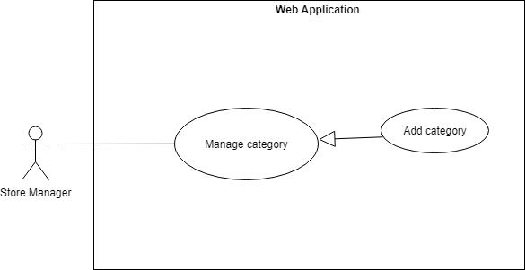**

Figure 25: < Store manager> Add new category

|  |  |  |  |
| --- | --- | --- | --- |
| **USE CASE – CFOS\_UC\_SM\_01** | | | |
| **Use Case No.** | CFOS\_UC\_SM\_01 | **Use Case Version** | 2.0 |
| **Use Case Name** | Add category | | |
| **Author** | ThinhPH | | |
| **Date** | 23/06/2019 | **Priority** | Normal |
| **Actor:**   * Store manager   **Summary:**   * This use case allows store manager to add new category to the system.   **Goal:**   * Store manager can add new category to the system.   **Triggers:**   * From the side bar:   + Select “Manage Food” menu.  + Select “Tạo Danh Mục Món Ăn” button  **Preconditions:**   * User has to logged in to the system as Store manager role   **Post Conditions:**   * Success: New category is added into the system * Fail: Show error message, no changes in database**.**   **Main Success Scenario:**   |  |  |  | | --- | --- | --- | | **Step** | **Actor Action** | **System Response** | | **1** | Store manager goes to manage food page and click “Tạo Danh Mục Món Ăn” button. | Navigate modal “Tạo Mới Danh Mục” which contains:   * “Danh Mục Món Ăn”: text, required, length 1 – 50. * “Ok”: button. * “Cancel”: button | | **2** | Store manager inputs data |  | | **3** | Store manager click “Ok” button.  [Alternative 1] | * Insert new category to database and close modal. * Show message: “Tạo mới thành công”.   [Exception 1,2] |   **Alternative Scenario:**   |  |  |  | | --- | --- | --- | | No | Actor Action | System Response | | 1 | Store manager click “Cancel” button | Close modal “Tạo Mới Danh Mục” |   **Exceptions:**   |  |  |  | | --- | --- | --- | | **Step** | **Cause** | **System Response** | | **1** | Length of “Danh Mục Món Ăn” is under 1 and over 100 characters | Show error message: “Nhập từ 1-100 kí tự” | | **2** | “Danh Mục Món Ăn” is existed in the system | Show error message: “Danh mục đã tồn tại!” |   **Relationships:** N/A  **Business Rules:**   * Create a new category in the system | | | |

Table 29 <Store manager> Add new category

##### **2.3.3.2 <Store manager> View list category**

Figure 26: <Store manager> View list category

|  |  |  |  |
| --- | --- | --- | --- |
| **USE CASE – CFOS\_UC\_SM\_02** | | | |
| **Use Case No.** | CFOS\_UC\_SM\_02 | **Use Case Version** | 2.0 |
| **Use Case Name** | View list category | | |
| **Author** | HuyND | | |
| **Date** | 30/06/2019 | **Priority** | Normal |
| **Actor**:   * Store manager   **Summary**:   * This use case allows store manager to get all list category information   **Goal**:   * Store manager can view list category   **Triggers**:   * From the side bar:   + Select “Manage Category” menu.  **Preconditions**:   * User has to logged in to the system as store manager role   **Post** **Conditions**:   * **Success**: Show successfully list of category * **Fail**: Show empty list and display “No data”.   **Main Success Scenario**:   |  |  |  | | --- | --- | --- | | **Step** | **Actor Action** | **System Response** | | **1** | Store manager goes to manage category page | System automatically displays list of categories  [Exceptions 1] |   **Exceptions:**   |  |  |  | | --- | --- | --- | | **No** | **Cause** | **System Response** | | **1** | Data is empty | Show error message: “No data” |   **Relationships**:N/A  **Business** **Rules**: Show the list of category owned by store | | | |

Table 30 <Store manager> View list category

##### **2.3.3.3. <Store manager> Edit category**

**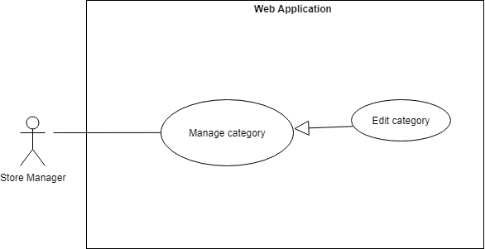**

Figure 27: <Store manager> Edit category

|  |  |  |  |
| --- | --- | --- | --- |
| **USE CASE – CFOS\_UC\_SM\_03** | | | |
| **Use Case No.** | CFOS\_UC\_SM\_03 | **Use Case Version** | 2.0 |
| **Use Case Name** | Edit category | | |
| **Author** | ThinhPH | | |
| **Date** | 23/06/2019 | **Priority** | Normal |
| **Actor:**   * Store manager   **Summary:**   * This use case allows store manager to update food category to the system**.**   **Goal:**   * Store manager can update food category to the system.   **Triggers:**   * From the side bar:   + Select “Manage Food” menu.  + Select “Chỉnh Sửa Danh Mục” icon.  **Preconditions:**   * User has to logged in to the system as store manager role   **Post Conditions:**   * **Success:** Edit food category is update into the system. * **Fail:** Show error message, no changes in database.   **Main Success Scenario:**   |  |  |  | | --- | --- | --- | | **Step** | **Actor Action** | **System Response** | | **1** | Store manager goes to manage food page and click “Chỉnh Sửa Danh Mục” icon. | Navigate modal “Chỉnh Sửa Danh Mục” which contains:   * “Danh Mục Món Ăn”: text, disabled, length 1 – 100 * “Trạng Thái”: radio button * “Ok”: button. * “Cancel”: button | | **2** | Store manager edit data |  | | **3** | Store manager click “Ok” button.  [Alternative 1] | * Update food category to database and close modal.   [Exception 1 2] |   **Alternative Scenario:**   |  |  |  | | --- | --- | --- | | No | Actor Action | System Response | | 1 | Store manager click “Cancel” button | Close modal “Chỉnh Sửa Danh Mục” |   **Exceptions**:   |  |  |  | | --- | --- | --- | | **Step** | **Cause** | **System Response** | | **1** | Length of “Danh Mục Món Ăn” is under 1 and over 100 characters | Show error message: “Nhập từ 1-100 kí tự” | | **2** | “Danh Mục Món Ăn” is existed in the system | Show error message: “Danh mục món ăn đã tồn tại!” |   **Relationships**:N/A  **Business Rules:**   * Food category is updated on the system | | | |

Table 31 <Store manager> Edit category

##### **2.3.3.4. <Store manager> Disable category**

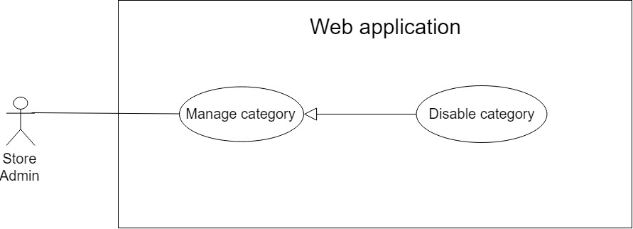

Figure 28: <Store manager> Disable category

|  |  |  |  |
| --- | --- | --- | --- |
| **USE CASE – CFOS\_UC\_SM\_04** | | | |
| **Use Case No.** | CFOS\_UC\_SM\_04 | **Use Case Version** | 2.0 |
| **Use Case Name** | Disable category | | |
| **Author** | HuyND | | |
| **Date** | 30/06/2019 | **Priority** | Normal |
| **Actor:**   * Store manager   **Summary:**   * This use case allows store manager to disable category**.**   **Goal:**   * Store manager can disable food category.   **Triggers:**   * From the side bar:   + Select “Manage Food” menu.  + Select “Chỉnh Sửa Danh Mục” icon.  **Preconditions:**   * User has to logged in to the system as store manager role   **Post Conditions:**   * **Success:** Show successful message and category won’t appear in meny of mobile app application or kiosk application * **Fail:** Show error message, no changes in database.   **Main Success Scenario:**   |  |  |  | | --- | --- | --- | | **Step** | **Actor Action** | **System Response** | | **1** | Store manager goes to manage food page and click “Chỉnh Sửa Danh Mục” icon. | Navigate modal “Chỉnh Sửa Danh Mục” which contains:   * “Danh Mục Món Ăn”: text, disabled, length 1 – 100 * “Trạng Thái”: radio button * “Ok”: button. * “Cancel”: button | | **2** | Store manager choose status “Ẩn” |  | | **3** | Store manager press [OK] button.  [Alternative 1] | Category is updated and disappear in menu  [Alternative 1]  [Exception 1]  [Exception 2] |   **Alternative 1:**   |  |  |  | | --- | --- | --- | | **No** | **Cause** | **System Response** | | **1** | Category is already disable | Show error message: “Danh mục này đã bị ẩn” |   **Exceptions 1:**   |  |  |  | | --- | --- | --- | | **No** | **Cause** | **System Response** | | **1** | Category isn’t exist | Show error message: “Không tìm thấy mã danh mục này” |   **Exception 2:**   |  |  |  | | --- | --- | --- | | **No** | **Cause** | **System Response** | | 1 | When the connection to the server is lost | System shows message the "Vui lòng kiểm tra kết nối của bạn. |   **Relationships**:N/A  **Business Rules:**   * Only store manager owns dishes that can disable. * After disable successfully, food of this category will disappear in order food application | | | |

Table 32 <Store manager> Disable category

##### **2.3.3.5. <Store manager> Add food**

**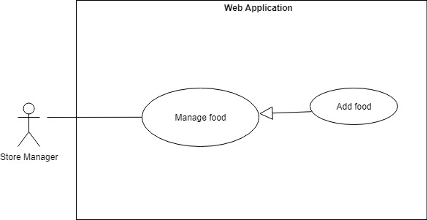**

Figure 29: <Store manager> Add food

|  |  |  |  |
| --- | --- | --- | --- |
| **USE CASE – CFOS\_UC\_SM\_05** | | | |
| **Use Case No**. | CFOS\_UC\_SM\_05 | **Use Case Version** | 2.0 |
| **Use Case Name** | Add food | | |
| **Author** | ThinhPH | | |
| **Date** | 23/06/2019 | **Priority** | Normal |
| **Actor:**   * Store manager   **Summary:**   * This use case allows store manager to add new food to the system**.**   **Goal:**   * Store manager can add new food to the system.   **Triggers:**   * From the side bar:   + Select “Manage Food” menu.  + Select “Tạo Món Ăn Mới” button  **Preconditions:**   * User has to logged in to the system as Store manager role   **Post Conditions:**   * **Success:** New food is added into the system * **Fail:** Show error message, no changes in database.   **Main Success Scenario:**   |  |  |  | | --- | --- | --- | | **Step** | **Actor Action** | **System Response** | | **1** | Store manager goes to manage food page and click “Tạo Món Ăn Mới” button. | Navigate modal “Tạo Mới Món Ăn” which contains:   * “Tên Món Ăn”: text, required, length 1 – 100. * “Mô Tả”: text, required, length 1 – 200. * “Hình Ảnh”: file select * “Đơn Vị Món Ăn”: text, required, length 1 – 30. * “Giá”: number, required. * “Số Lượng”: number, required. * “Danh Mục Food Court”: select box, required. * “Danh Mục Món Ăn”: select box, required. * “Danh Mục Món Ăn Thêm”: select box, required. * “Giảm Giá %”: number * “Ok”: button. * “Cancel”: button | | **2** | Store manager inputs data |  | | **3** | Store manager click “Ok” button.  [Alternative 1] | * Insert new food to database and close modal. * Show message: “Tạo mới thành công”.   [Exception 1,2,3,4,5,6,7,8,9] |   **Alternative Scenario:**   |  |  |  | | --- | --- | --- | | No | Actor Action | System Response | | 1 | Store manager click “Cancel” button | Close modal “Tạo Mới Món Ăn” |   **Exceptions:**   |  |  |  | | --- | --- | --- | | **Step** | **Cause** | **System Response** | | **1** | Length of “Tên Món Ăn” is under 1 and over 100 characters | Show error message: “Nhập từ 1-100 ký tự” | | **2** | “Tên Món Ăn” is existed in the system | Show error message: “Món Ăn Đã Tồn Tại!” | | **3** | Length of “Mô Tả” is under 1 and over 200 characters | Show error message: “Nhập từ 1-200 ký tự” | | **4** | Length of “Đơn Vị Món Ăn” is under 1 and over 30 characters | Show error message: “Nhập từ 1-30 ký tự” | | **5** | “Giá” is empty | Show error message: “Nhập Giá” | | **6** | “Số Lượng” is empty | Show error message: “Nhập Số Lượng” | | **7** | “Danh Mục Food Court” is empty | Show error message: “Chọn Danh Mục Food Court” | | **8** | “Danh Mục Món Ăn” is empty | Show error message: “Chọn Danh Mục Món Ăn” | | **9** | “Danh Mục Món Ăn Thêm” is empty | Show error message: “Chọn Danh Mục Món Ăn Thêm” |   **Relationships**:N/A  **Business Rules**:   * Create a new food in the system | | | |

Table 33 <Store manager> Add food

##### **2.3.3.6 <Store manager> View list food**

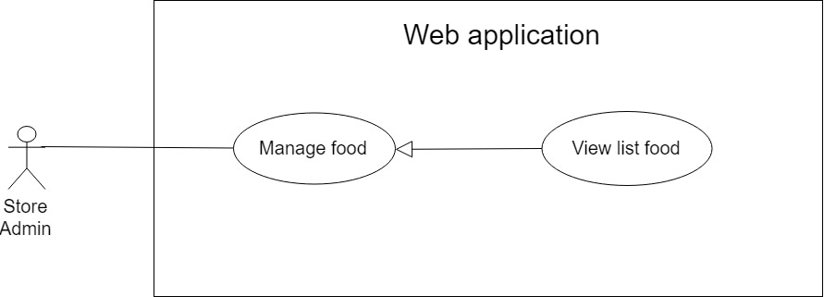

Figure 30: <Store manager> View list food

|  |  |  |  |
| --- | --- | --- | --- |
| **USE CASE – CFOS\_UC\_SM\_06** | | | |
| **Use Case No.** | CFOS\_UC\_SM\_06 | **Use Case Version** | 2.0 |
| **Use Case Name** | View list food | | |
| **Author** | HuyND | | |
| **Date** | 30/06/2019 | **Priority** | Normal |
| **Actor**:   * Store manager   **Summary**:   * This use case allows store manager to get all list food   **Goal**:   * Store manager can view list food   **Triggers**:   * From the side bar:   + Select “Manage Food” menu.  **Preconditions**:   * User has to logged in to the system as store manager role   **Post** **Conditions**:   * **Success**: Show successfully list of food * **Fail**: Show empty list and display “No data”.   **Main Success Scenario**:   |  |  |  | | --- | --- | --- | | **Step** | **Actor Action** | **System Response** | | **1** | Store manager goes to manage food page | System automatically displays list of foods  [Exceptions 1] |   **Exceptions:**   |  |  |  | | --- | --- | --- | | **No** | **Cause** | **System Response** | | **1** | Data is empty | Show error message: “No data” |   **Relationships**:N/A  **Business** **Rules**: Show the list of food owned by store manager | | | |

Table 34 <Store manager> View list food

##### **2.3.3.7. <Store manager> Edit food**

**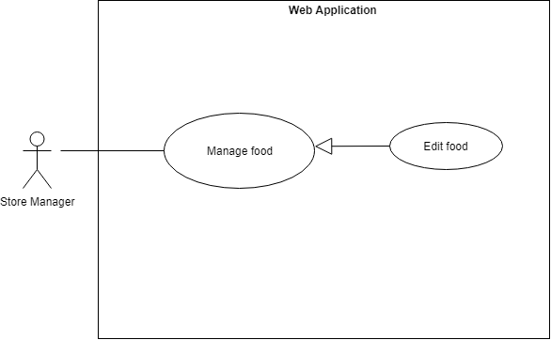**

Figure 31: <Store manager> Edit food

|  |  |  |  |
| --- | --- | --- | --- |
| **USE CASE – CFOS\_UC\_SM\_07** | | | |
| **Use Case No.** | CFOS\_UC\_SM\_07 | **Use Case Version** | 2.0 |
| **Use Case Name** | Edit food | | |
| **Author** | ThinhPH | | |
| **Date** | 23/06/2019 | **Priority** | Normal |
| **Actor**:   * Store manager   **Summary**:   * This use case allows store manager to edit food to the system.   **Goal**:   * Store manager can edit food to the system.   **Triggers**:   * From the side bar:   + Select “Manage Food” menu.  + Select “Chỉnh Sửa Món Ăn” icon change information  + Select “Ẩn Hiện Món Ăn” icon change status  **Preconditions**:   * User has to logged in to the system as Store manager role   **Post** **Conditions**:   * **Success**: Update food is added into the system * **Fail**: Show error message, no changes in database.   **Main Success Scenario:**   |  |  |  | | --- | --- | --- | | **Step** | **Actor Action** | **System Response** | | **1** | Store manager goes to manage food page and click “Chỉnh sửa món ăn” icon. | Navigate modal “Chỉnh Sửa Món Ăn” which contains:   * “Tên Món Ăn”: text, required, length 1 – 100. * “Mô Tả”: text, required, length 1 – 200. * “Hình Ảnh”: file select * “Đơn Vị Món Ăn”: text, required, length 1 – 30. * “Giá”: number, required. * “Số Lượng”: number, required. * “Danh Mục Món Ăn Thêm”: select box, required. * “Giảm Giá %”: number * “Ok”: button. * “Cancel”: button | | **2** | Store manager goes to manage food page and click “Ẩn Hiện Món Ăn” icon. | Navigate modal “Ẩn Hiện Món Ăn” which contains:   * “Content”: “Bạn có muốn thay đổi từ Hiện sang Ẩn món ăn" or “Bạn có muốn thay đổi từ Ẩn sang Hiện món ăn " * “Ok”: button. * “Cancel”: button | | **3** | Store manager edit data |  | | **4** | Store manager click “Ok” button.  [Alternative 1] | * Update food to database and close modal. * Show message: “Chỉnh sửa thành công”.   [Exception 1,2,3,4,5,6,7] |   **Alternative Scenario:**   |  |  |  | | --- | --- | --- | | No | Actor Action | System Response | | 1 | Store manager click “Cancel” button | Close modal “Chỉnh Sửa Món Ăn” or “Ẩn Hiện Món Ăn” |   **Exceptions:**   |  |  |  | | --- | --- | --- | | **Step** | **Actor Action** | **System Response** | | **1** | Length of “Tên Món Ăn” is under 1 and over 100 characters | Show error message: “Nhập từ 1-100 ký tự” | | **2** | “Tên Món Ăn” is existed in the system | Show error message: “Món Ăn Đã Tồn Tại!” | | **3** | Length of “Mô Tả” is under 1 and over 200 characters | Show error message: “Nhập từ 1-200 ký tự” | | **4** | Length of “Đơn Vị Món Ăn” is under 1 and over 30 characters | Show error message: “Nhập từ 1-30 ký tự” | | **5** | “Giá” is empty | Show error message: “Nhập Giá” | | **6** | “Số Lượng” is empty | Show error message: “Nhập Số Lượng” | | **7** | “Danh Mục Món Ăn Thêm” is empty | Show error message: “Chọn Danh Mục Món Ăn Thêm” |   **Relationships**:N/A  **Business** **Rules**:   * Edit food in the system | | | |

Table 35 <Store manager> Edit food

##### **2.3.3.8. <Store manager> Disable food**

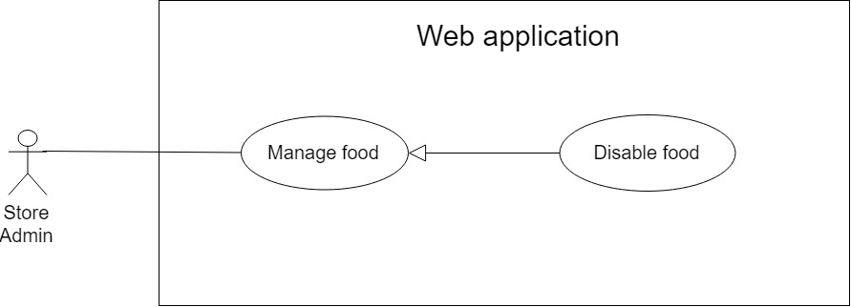

Figure 32: <Store manager> Disable food

|  |  |  |  |
| --- | --- | --- | --- |
| **USE CASE – CFOS\_UC\_SM\_08** | | | |
| **Use Case No.** | CFOS\_UC\_SM\_08 | **Use Case Version** | 2.0 |
| **Use Case Name** | Disable food | | |
| **Author** | HuyND | | |
| **Date** | 30/06/2019 | **Priority** | Normal |
| **Actor:**   * Store manager   **Summary:**   * This use case allows store manager to disable food**.**   **Goal:**   * Store manager can disable food.   **Triggers:**   * From the side bar: * + Select “Manage Food” menu. * + Select “Ẩn Hiện Món Ăn” icon change status   **Preconditions:**   * User has to logged in to the system as store manager role   **Post Conditions:**   * **Success:** Show successful message and food won’t appear in menu of order food application * **Fail:** Show error message, no changes in database.   **Main Success Scenario:**   |  |  |  | | --- | --- | --- | | **Step** | **Actor Action** | **System Response** | | **1** | Store manager goes to manage food page and click “Ẩn Hiện Món Ăn” icon. | Category is updated and disappear in menu  [Exception 1]  [Exception 2] |   **Exceptions 1:**   |  |  |  | | --- | --- | --- | | **No** | **Cause** | **System Response** | | **1** | Food isn’t exist | Show error message: “Không tìm thấy mã món ăn này” |   **Exception 2:**   |  |  |  | | --- | --- | --- | | **No** | **Cause** | **System Response** | | 1 | When the connection to the server is lost | System shows message the "Vui lòng kiểm tra kết nối của bạn. |   **Relationships**:N/A  **Business Rules:**   * Only store manager owns food that can disable. * After disable successfully, this food will disappear in order food application | | | |

Table 36 <Store manager> Disable food

##### **2.3.3.9. <Store manager> Add new food’s option**

**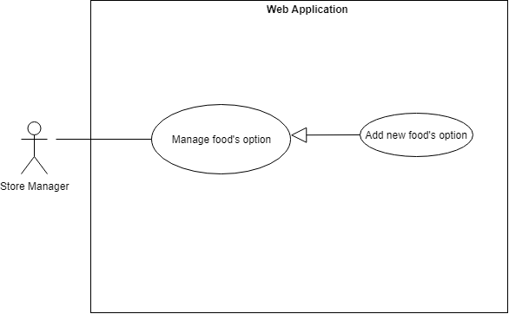**

Figure 33: <Store manager> Add food’s option

|  |  |  |  |
| --- | --- | --- | --- |
| **USE CASE – CFOS\_UC\_SM\_09** | | | |
| **Use Case No.** | CFOS\_UC\_SM\_09 | **Use Case Version** | 2.0 |
| **Use Case Name** | Add food’s option | | |
| **Author** | ThinhPH | | |
| **Date** | 23/06/2019 | **Priority** | Normal |
| **Actor**:   * Store manager   **Summary:**   * This use case allows store manager to add new food’s option to the system.   **Goal**:   * Store manager can add new food’s option to the system.   **Triggers**:   * From the side bar:   + Select “Management Food Option” menu.  + Select “Tạo Mới Danh Mục Food Option” button add new category food option.  + Select “Tạo Option” button add new option.  **Preconditions**:   * User has to logged in to the system as Store manager role.   **Post Conditions**:   * Success: New food option is added into the system * Fail: Show error message, no changes in database.   **Main Success Scenario**:   |  |  |  | | --- | --- | --- | | **Step** | **Actor Action** | **System Response** | | **1** | Store manager goes to manage food option page and click “Tạo Mới Danh Mục Food Option” button. | Navigate modal “Tạo Mới Danh Mục Food Option” which contains:   * “Danh Mục Food Option”: text, required, length 1 – 100. * “Tăng Số Lượng”: radio button. * “Cho Phép Chọn Nhiều”: radio button. * “Ok”: button. * “Cancel”: button | | **2** | Store manager goes to manage food option page and click “Tạo Option” button. | Navigate modal “Tạo Mới Option” which contains:   * “Danh Mục Food Option”: text, disabled. * “Option”: text, required, length 1 – 100. * “Giá”: number, required. * “Tùy Chọn Mặc Định”: radio button. * “Ok”: button. * “Cancel”: button. | | **3** | Store manager inputs data |  | | **4** | Store manager click “Ok” button.  [Alternative 1] | * Insert new food option to database and close modal. * Show message: “Tạo Mới Thành Công”.   [Exception 1, 2,3,4] |   **Alternative Scenario:**   |  |  |  | | --- | --- | --- | | No | Actor Action | System Response | | 1 | Store manager click “Cancel” button | Close modal “Tạo Mới Danh Mục Food Option” or “Tạo Mới Option”. |   **Exceptions**:   |  |  |  | | --- | --- | --- | | **Step** | **Cause** | **System Response** | | **1** | Length of “Danh Mục Food Option” is under 1 and over 100 characters. | Show error message: “Nhập từ 1-100 kí tự”. | | **2** | “Danh Mục Food Option” is existed in the system. | Show error message: “Tên danh mục đã tồn tại!” | | **3** | Length of “Option” is under 1 and over 100 characters. | Show error message: “Nhập từ 1-100 kí tự”. | | **4** | “Giá” is empty. | Show error message: “Nhập giá!”. |   **Relationships**:N/A  **Business Rules**:   * Create a new food option in the system | | | |

Table 37 <Store manager> Add food’s option

##### **2.3.3.10 <Store manager> View list food ‘s option**

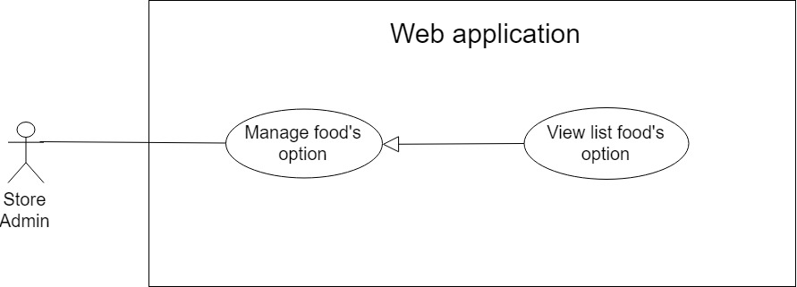

Figure 34: < Store manager> View list food’s option

|  |  |  |  |
| --- | --- | --- | --- |
| **USE CASE – CFOS\_UC\_SM\_10** | | | |
| **Use Case No.** | CFOS\_UC\_SM\_10 | **Use Case Version** | 2.0 |
| **Use Case Name** | View list food’s option | | |
| **Author** | HuyND | | |
| **Date** | 30/06/2019 | **Priority** | Normal |
| **Actor**:   * Store manager   **Summary**:   * This use case allows store manager to get all list food ‘s option   **Goal**:   * Store manager can view list food’s option   **Triggers**:   * From the side bar:   + Select “Manage Food Option” menu.  **Preconditions**:   * User has to logged in to the system as store manager role   **Post** **Conditions**:   * **Success**: Show successfully list of food’s option * **Fail**: Show empty list and display “No data”.   **Main Success Scenario**:   |  |  |  | | --- | --- | --- | | **Step** | **Actor Action** | **System Response** | | **1** | Store manager goes to manage food option page | System automatically displays list of food option  [Exceptions 1] |   **Exceptions:**   |  |  |  | | --- | --- | --- | | **No** | **Cause** | **System Response** | | **1** | Data is empty | Show error message: “No data” |   **Relationships**:N/A  **Business** **Rules**: Show the list of food option owned by store | | | |

Table 38 <Store manager> View list food’s option

##### **2.3.3.11. <Store manager> Edit food’s option**

**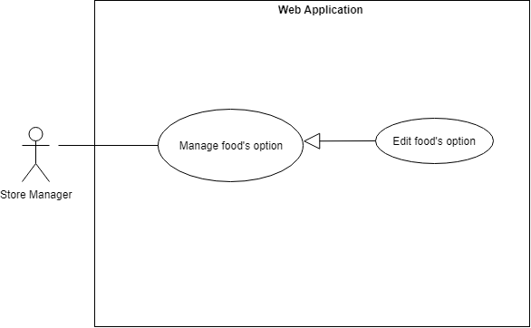**

Figure 35: <Store manager> Edit food’s option

|  |  |  |  |
| --- | --- | --- | --- |
| **USE CASE – CFOS\_UC\_SM\_11** | | | |
| **Use Case No.** | CFOS\_UC\_SM\_11 | **Use Case Version** | 2.0 |
| **Use Case Name** | Edit food’s option | | |
| **Author** | ThinhPH | | |
| **Date** | 23/06/2019 | **Priority** | Normal |
| **Actor:**   * Store manager   **Summary:**   * This use case allows store manager to edit food’s option to the system.   **Goal:**   * Store manager can edit food’s option to the system.   **Triggers:**   * From the side bar:   + Select “Management Food Option” menu.  + Select “Chỉnh Sửa Danh Mục Food Option” icon update category food option.  + Select “Chỉnh Sửa Option” icon update option**.**  **Preconditions:**   * User has to logged in to the system as Store manager role.   **Post Conditions:**   * Success: Update food option is added into the system * Fail: Show error message, no changes in database**.**   **Main Success Scenario:**   |  |  |  | | --- | --- | --- | | **Step** | **Actor Action** | **System Response** | | **1** | Store manager goes to manage food option page and click “Chỉnh Sửa Danh Mục Food Option” icon. | Navigate modal “Chỉnh Sửa Danh Mục Food Option” which contains:   * “Danh Mục Food Option”: text, required, length 1 – 100. * “Tăng Số Lượng”: radio button. * “Cho Phép Chọn Nhiều”: radio button. * “Ok”: button. * “Cancel”: button | | **2** | Store manager goes to manage food option page and click “Chỉnh Sửa Option” icon. | Navigate modal “Chỉnh Sửa Option” which contains:   * “Danh Mục Food Option”: text, disabled. * “Option”: text, required, length 1 – 100. * “Giá”: number, required. * “Tùy Chọn Mặc Định”: radio button. * “Ok”: button. * “Cancel”: button. | | **3** | Store manager edit data |  | | **4** | Store manager click “Ok” button.  [Alternative 1] | * Update food option to database and close modal. * Show message: “Chỉnh sửa thành công”.   [Exception 1, 2,3,4] |   **Alternative Scenario:**   |  |  |  | | --- | --- | --- | | No | Actor Action | System Response | | 1 | Store manager click “Cancel” button | Close modal “Chỉnh Sửa Danh Mục Food Option” or “Chỉnh Sửa Option”. |   **Exceptions:**   |  |  |  | | --- | --- | --- | | **Step** | **Actor Action** | **System Response** | | **1** | Length of “Danh Mục Food Option” is under 1 and over 100 characters. | Show error message: “Nhập từ 1-100 kí tự”. | | **2** | “Danh Mục Food Option” is existed in the system. | Show error message: “Tên danh mục đã tồn tại!” | | **3** | Length of “Option” is under 1 and over 100 characters. | Show error message: “Nhập từ 1-100 kí tự”. | | **4** | “Giá” is empty. | Show error message: “Nhập giá!”. |   **Relationships**:N/A  **Business Rules:**   * Edit food option in the system | | | |

Table 39 <Store manager> Edit food’s option

##### **2.3.3.12. <Store manager> View food’s feedback**

**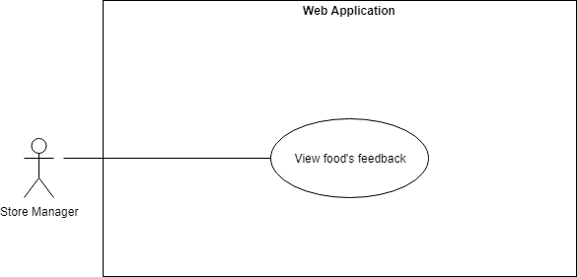**

Figure 36: <Store manager> View food’s feedback

|  |  |  |  |
| --- | --- | --- | --- |
| USE CASE – CFOS\_UC\_SM\_12 | | | |
| Use Case No. | CFOS\_UC\_SM\_12 | **Use Case Version** | 2.0 |
| Use Case Name | View food’s feedback | | |
| Author | ThinhPH | | |
| Date | 23/06/2019 | **Priority** | Normal |
| **Actor:**   * **Store manager**   **Summary:**   * **This use case allows store manager to view food’s feedback.**   **Goal:**   * **Store manager can view food’s feedback.**   **Triggers:**   * **From the side bar:**   **+ Select “View Feedback” menu.**  **Preconditions:**   * **User has to logged in to the system as Store manager role.**   **Post Conditions:**   * **Success: Store manager can view all food’s feedback.** * **Fail: Show error message.**   **Main Success Scenario:**   |  |  |  | | --- | --- | --- | | **Step** | **Actor Action** | **System Response** | | **1** | Store manager goes to manage food option page. | System show list feedback of food. |   **Alternative Scenario: N/A**  **Exceptions**: **N/A**  **Relationships**: **N/A**  **Business Rules**:   * Store manager can view all feedback of food. | | | |

Table 40 <Store manager> View food’s feedback

##### **2.3.3.13. <Store manager> View static**

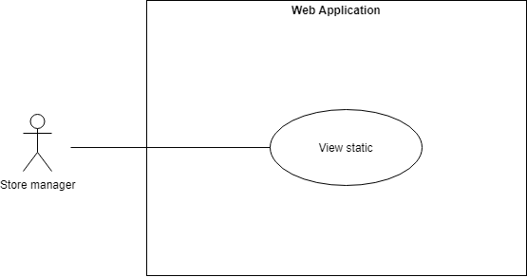

Figure 37: < Store manager> View static

|  |  |  |  |
| --- | --- | --- | --- |
| **USE CASE – CFOS\_UC\_SM\_13** | | | |
| **Use Case No.** | CFOS\_UC\_ SM \_13 | **Use Case Version** | 2.0 |
| **Use Case Name** | View static | | |
| **Author** | ThinhPH | | |
| **Date** | 23/06/2019 | **Priority** | Normal |
| **Actor:**   * Store manager   **Summary:**   * This use case allows store manager view static.   **Goal:**   * Store manager can view static.   **Triggers:**   * From the side bar:   + Select “View static” menu.  **Preconditions:**   * User has to logged in to the system as store manager role   **Post Conditions:**   * Success: Store manager can view statics. * Fail: Show error message, no changes in database**.**   **Main Success Scenario:**   |  |  |  | | --- | --- | --- | | **Step** | **Actor Action** | **System Response** | | **1** | Store manager goes to view static page. | The system displays statistics as follows:   * Total income during the day. * Order number completed. * Order number canceled. * Monthly store chart. |   **Alternative Scenario:** N/A  **Exceptions:** N/A  **Relationships:** N/A  **Business Rules:**   * Store can view list static in day and revenue chart of monthly store. | | | |

Table 41 <Store manager> View static

##### **2.3.3.14. <Store manager> Receivable**

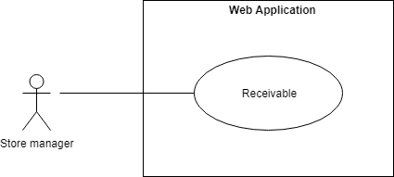

Figure 38: <Store manager> Receivable

|  |  |  |  |
| --- | --- | --- | --- |
| **USE CASE – CFOS\_UC\_SM\_14** | | | |
| **Use Case No.** | CFOS\_UC\_SM\_14 | **Use Case Version** | 2.0 |
| **Use Case Name** | Receivable | | |
| **Author** | ThinhPH | | |
| **Date** | 23/06/2019 | **Priority** | Normal |
| **Actor:**   * Store manager   **Summary:**   * This use case allows store manager to complete payment.   **Goal:**   * Store manager can complete payment.   **Triggers:**   * From the side bar:   + Select “Receivable” menu.  **Preconditions:**   * User has to logged in to the system as Store manager role   **Post Conditions:**   * Success: Store manager complete payment. * Fail: Show error message, no changes in database**.**   **Main Success Scenario:**   |  |  |  | | --- | --- | --- | | **Step** | **Actor Action** | **System Response** | | **1** | Store manager goes to receivable page and click “Xác Nhận” button. | Navigate modal “Xác Nhận Đã Nhận Tiền” which contains:   * “Ok”: button. * “Cancel”: button | | **2** | Store manager click “Ok” button.  [Alternative 1] | * Update status transaction to database and close modal. * Show message: “Tạo mới thành công”.   [Exception 1,2] |   **Alternative Scenario:**   |  |  |  | | --- | --- | --- | | No | Actor Action | System Response | | 1 | Store manager click “Cancel” button | Close modal “Xác Nhận Thanh Toán” |   **Exceptions:** N/A  **Relationships:** N/A  **Business Rules:**   * Store manager complete payment and update status transaction. | | | |

Table 42 <Store manager> Receivable

#### **2.3.4. < Chef > Overview Use Case**

**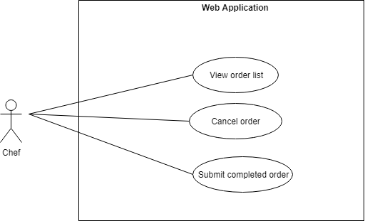**

Figure 39: <Chef> Overview use case

##### **2.3.4.1. <Chef> View order list**

**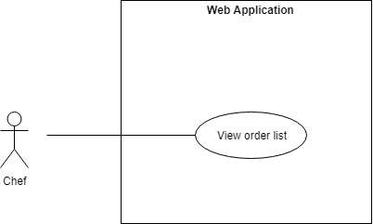**

Figure 40: <Chef> View order list

|  |  |  |  |
| --- | --- | --- | --- |
| **USE CASE – CFOS\_UC\_CHEF\_01** | | | |
| **Use Case No.** | CFOS\_UC\_CHEF\_01 | **UseCase Version** | 2.0 |
| **Use Case Name** | View order list | | |
| **Author** | ThinhPH | | |
| **Date** | 23/06/2019 | **Priority** | High |
| **Actor:**   * Chef   **Summary:**   * This use case allows chef to view list order.   **Goal:**   * Chef can view list order.   **Triggers:**   * After the chef has successfully logged in, the screen will appear.   **Preconditions:**   * User has to logged in to the system as Chef role.   **Post Conditions:**   * Success: Chef can view all list order. * Fail: Show error message.   **Main Success Scenario:**   |  |  |  | | --- | --- | --- | | **Step** | **Actor Action** | **System Response** | | **1** | After the chef has successfully logged in, the screen will appear. | System show list order. |   **Alternative Scenario:** N/A  **Exceptions:** N/A  **Relationships:** N/A  **Business Rules:**   * Chef can view all list order that the customer has successfully ordered. | | | |

Table 43 <Chef> View order list

##### **2.3.4.2. <Chef> Submit completed order**

**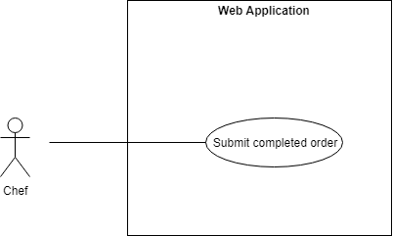**

Figure 41: <Chef> Submit completed order

|  |  |  |  |
| --- | --- | --- | --- |
| **USE CASE – CFOS\_UC\_CHEF\_02** | | | |
| **Use Case No.** | CFOS\_UC\_CHEF\_02 | **Use Case Version** | 2.0 |
| **Use Case Name** | Submit completed order | | |
| **Author** | ThinhPH | | |
| **Date** | 23/06/2019 | **Priority** | High |
| **Actor:**   * Chef   **Summary:**   * This use case allows chef to submit completed order to the system**.**   **Goal:**   * Chef can submit completed order.   **Triggers:**   * Select “Hoàn Thành Món Ăn” button**.**   **Preconditions:**   * User has to logged in to the system as Chef role.   **Post Conditions:**   * Success: Edit status order is update into the system * Fail: Show error message, no changes in database.   **Main Success Scenario:**   |  |  |  | | --- | --- | --- | | **Step** | **Actor Action** | **System Response** | | **1** | After the chef has successfully logged in and click “Hoàn Thành Món Ăn” button.  [Alternative 1] | Navigate modal “In Hóa Đơn” which contains: invoice details of the order |   **Alternative Scenario:**   |  |  |  | | --- | --- | --- | | No | Actor Action | System Response | | 1 | Chef click “Cancel” button | Close modal “In Hóa Đơn” |   **Exceptions**: N/A  **Relationships:** N/A  **Business Rules:**   * After chef submit completed order, the system will update the status of the order. * The printer will print the invoice confirm the finished dish and member will and the member will receive the notification of the finished dish. | | | |

Table 44 <Chef> Submit completed order

##### **2.3.4.3. <Chef> Cancel ordercancelorder**

Figure 42: <Chef> Cancel order

|  |  |  |  |
| --- | --- | --- | --- |
| **USE CASE – CFOS\_UC\_CHEF\_03** | | | |
| **Use Case No.** | CFOS\_UC\_CHEF\_03 | **Use Case Version** | 2.0 |
| **Use Case Name** | Cancel order | | |
| **Author** | ThinhPH | | |
| **Date** | 23/06/2019 | **Priority** | High |
| **Actor:**   * Chef   **Summary:**   * This use case allows chef to cancel order to the system.   **Goal:**   * Chef can cancel order.   **Triggers:**   * Select “Hủy Món Ăn” button**.**   **Preconditions:**   * User has to logged in to the system as Chef role.   **Post Conditions:**   * Success: Edit status order is update into the system * Fail: Show error message, no changes in database.   **Main Success Scenario:**   |  |  |  | | --- | --- | --- | | **Step** | **Actor Action** | **System Response** | | **1** | After the chef has successfully logged in and click “Hủy Món Ăn” button.  [Alternative 1] | Navigate modal “In Hóa Đơn” which contains: invoice details of the order |   **Alternative Scenario:**   |  |  |  | | --- | --- | --- | | No | Actor Action | System Response | | 1 | Chef click “Cancel” button | Close modal “In Hóa Đơn” |   **Exceptions**: N/A  **Relationships:** N/A  **Business Rules:**   * After chef cancel order, the system will update the status of the order. * The printer will print an invoice confirming that the dish has been canceled and member will and Members will receive notifications of canceled dishes. | | | |

Table 45 <Chef> Cancel order

#### **2.3.5. < Staff > Overview Use Case**

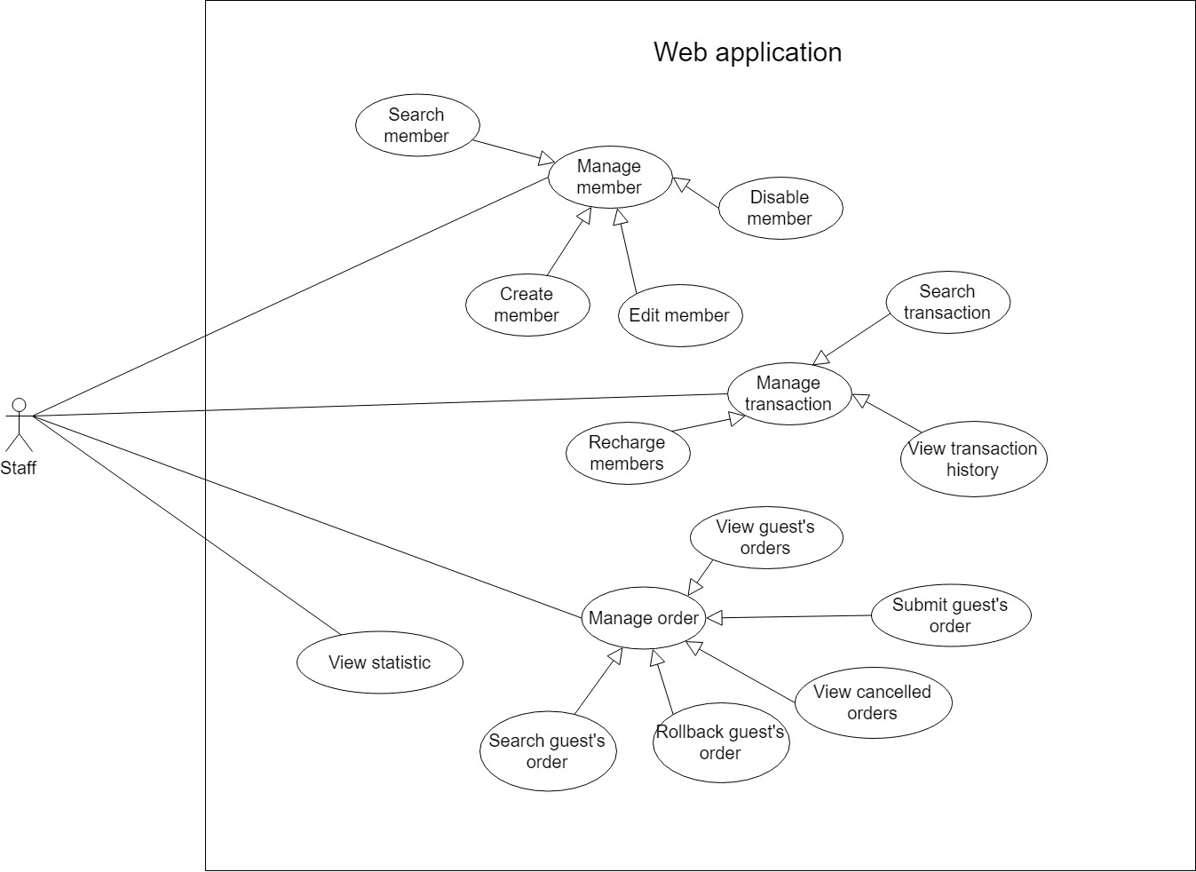

Figure 43: <Staff> Overview use case

##### **2.3.5.1. <Staff> Add new member**

**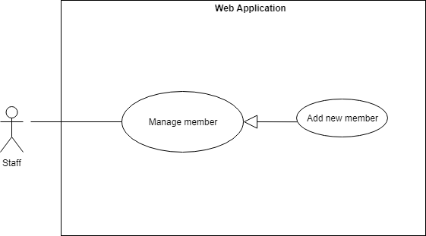**

Figure 44: <Staff> Add new member

|  |  |  |  |
| --- | --- | --- | --- |
| **USE CASE – CFOS\_UC\_STAFF\_01** | | | |
| **Use Case No.** | CFOS\_UC\_STAFF\_01 | **Use Case Version** | 2.0 |
| **Use Case Name** | Add new member | | |
| **Author** | ThinhPH | | |
| **Date** | 23/06/2019 | **Priority** | High |
| **Actor:**   * Staff   **Summary:**   * This use case allows staff to add new member to the system.   **Goal:**   * **Staff can add new member to the system.**   **Triggers:**   * From the side bar:   + Select “Manage member” menu.  + Select “Tạo Mới Thành Viên” button  **Preconditions:**   * User has to logged in to the system as staff role   **Post Conditions:**   * Success: New member is added into the system * Fail: Show error message, no changes in database.   **Main Success Scenario:**   |  |  |  | | --- | --- | --- | | **Step** | **Actor Action** | **System Response** | | **1** | Staff goes to manage member page and click “Tạo Mới Thành Viên” button. | Navigate modal “Tạo Mới Thành Viên” which contains:   * “Username”: text, required, length 1 – 50. * “Họ Và Tên”: text, required, length 1 – 200. * “Số Điện Thoại”: number, required * “Email”: email, required. * “Mã Thẻ”: number, required. * “Ok”: button. * “Cancel”: button | | **2** | Staff inputs data |  | | **3** | Staff click “Ok” button.  [Alternative 1] | * Insert new member to database and close modal. * Show message: “Tạo mới thành công”.   [Exception 1 2 3 4 5 6 7 ] |   **Alternative Scenario:**   |  |  |  | | --- | --- | --- | | No | Actor Action | System Response | | 1 | Staff click “Cancel” button | Close modal “Tạo Mới Thành Viên” |   **Exceptions:**   |  |  |  | | --- | --- | --- | | **Step** | **Cause** | **System Response** | | **1** | Length of “username” is under 1 and over 50 characters | Show error message: “Nhập từ 1-50 kí tự” | | **2** | “Username” is existed in the system. | Show error message: “Tài khoản đã tồn tại!” | | **3** | Length of “Họ Và Tên” is under 1 and over 200 characters | Show error message: “Nhập từ 1-200 kí tự” | | **4** | Length of “Số Điện Thoại” is empty and wrong format phone number | Show error message: “Nhập Số Điện Thoại” | | **5** | Length of “Email” is empty | Show error message: “Nhập Mail” | | **6** | “Email” wrong format email | Show error message: “Sai Định Dạng Mail” | | **7** | “Mã Thẻ” is empty | Show error message: “Nhập Mã Thẻ!” |   **Relationships**: N/A  **Business Rules:**   * Create a new member in the system. * Password send to mail of member. | | | |

Table 46 < Staff> Add new member

##### **2.3.5.2. <Staff> Edit member**

**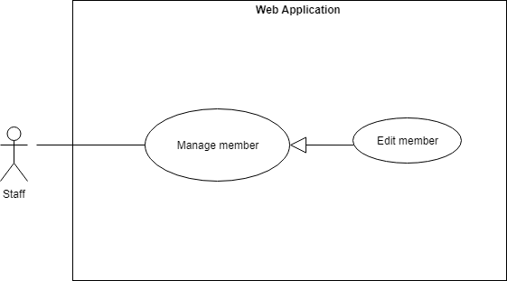**

Figure 45: <Staff> Edit member

|  |  |  |  |
| --- | --- | --- | --- |
| **USE CASE – CFOS\_UC\_STAFF\_02** | | | |
| **Use Case No.** | CFOS\_UC\_STAFF\_02 | **Use Case Version** | 2.0 |
| **Use Case Name** | Edit member | | |
| **Author** | ThinhPH | | |
| **Date** | 23/06/2019 | **Priority** | Normal |
| **Actor:**   * Staff   **Summary:**   * This use case allows staff to edit member to the system.   **Goal:**   * Staff can edit member to the system.   **Triggers:**   * From the side bar:   + Select “Manage member” menu.  + Select “Chỉnh sửa thành viên” icon  **Preconditions:**   * User has to logged in to the system as staff role   **Post Conditions:**   * Success: Edit member is update into the system * Fail: Show error message, no changes in database**.**   **Main Success Scenario:**   |  |  |  | | --- | --- | --- | | **Step** | **Actor Action** | **System Response** | | **1** | Staff goes to manage member page and click “Chỉnh sửa thành viên” icon. | Navigate modal “Chỉnh Sửa Thành Viên” which contains:   * “Mã Thẻ”: number, required. * “Trạng Thái”: radio button * “Ok”: button. * “Cancel”: button | | **2** | Staff edit data |  | | **3** | Staff click “Ok” button.  [Alternative 1] | * Update member to database and close modal. * Show message: “Chỉnh sửa thành công”.   [Exception 1] |   **Alternative Scenario:**   |  |  |  | | --- | --- | --- | | No | Actor Action | System Response | | 1 | Staff click “Cancel” button | Close modal “Chỉnh Sửa Thành Viên” |   **Exceptions:**   |  |  |  | | --- | --- | --- | | **Step** | **Cause** | **System Response** | | **1** | “Mã Thẻ” is empty | Show error message: “Nhập Mã Thẻ!” |   **Relationships:** N/A  **Business Rules:**   * Update cart ID and status of member in the system. * If the staff grants member access to the system, the member can access the system and vice versa. | | | |

Table 47 <Staff> Edit member

##### **2.3.5.2. <Staff> Disable member**

**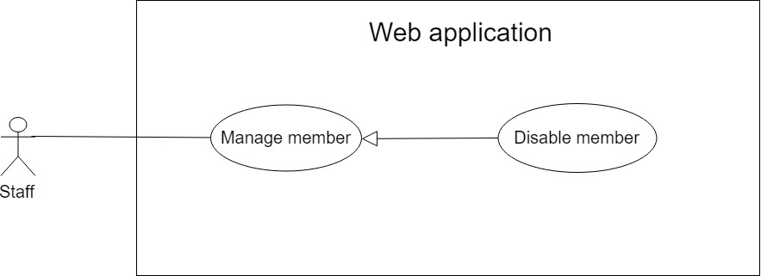**

Figure 46: <Staff> Disable member

|  |  |  |  |
| --- | --- | --- | --- |
| **USE CASE – CFOS\_UC\_STAFF\_03** | | | |
| **Use Case No.** | CFOS\_UC\_STAFF\_03 | **Use Case Version** | 2.0 |
| **Use Case Name** | Disable member | | |
| **Author** | HuyND | | |
| **Date** | 23/06/2019 | **Priority** | Normal |
| **Actor:**   * Staff   **Summary:**   * This use case allows staff to disable member.   **Goal:**   * Staff can disable member.   **Triggers:**   * From the side bar:   + Select “Manage member” menu.  + Select “Chỉnh sửa thành viên” icon  **Preconditions:**   * User has to logged in to the system as staff role   **Post Conditions:**   * Success: Disable member susccessfully. Member’s account can’t access system * Fail: Show error message, no changes in database**.**   **Main Success Scenario:**   |  |  |  | | --- | --- | --- | | **Step** | **Actor Action** | **System Response** | | **1** | Staff goes to manage member page and click “Chỉnh sửa thành viên” icon. | Navigate modal “Chỉnh Sửa Thành Viên” which contains:   * “Mã Thẻ”: number, required. * “Trạng Thái”: radio button * “Ok”: button. * “Cancel”: button | | **2** | Staff choose status “Ẩn” |  | | **3** | Staff press [OK] button. | User is updated and disappear in menu  [Exception 1]  [Exception 2] |   **Exceptions 1:**   |  |  |  | | --- | --- | --- | | **No** | **Cause** | **System Response** | | **1** | Username isn’t exist | Show error message: “Không tìm thấy tài khoản của người dùng này” |   **Exception 2:**   |  |  |  | | --- | --- | --- | | **No** | **Cause** | **System Response** | | 1 | When the connection to the server is lost | System shows message the "Vui lòng kiểm tra kết nối của bạn. |   **Relationships:** N/A  **Business Rules:**   * Staff can only be disabled for registered users in the system. * After disable successfully, member’s account can’t access system | | | |

Table 48 <Staff> Disable member

##### **2.3.5.4. <Staff> Search member**

**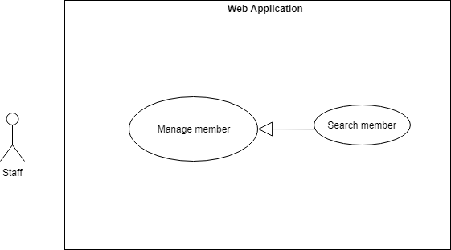**

Figure 47: <Staff> Search member

|  |  |  |  |
| --- | --- | --- | --- |
| **USE CASE – CFOS\_UC\_STAFF\_04** | | | |
| **Use Case No.** | CFOS\_UC\_STAFF\_04 | **Use Case Version** | 2.0 |
| **Use Case Name** | Search member | | |
| **Author** | ThinhPH | | |
| **Date** | 23/06/2019 | **Priority** | Normal |
| **Actor:**   * Staff   **Summary:**   * This use case allows staff to search the member in the system.   **Goal:**   * Staff view the list of food court manager.   **Triggers:**   * From the side bar:   + Select “Manage Member” menu.  + Staff input text and send the search command  **Preconditions:**   * User has to logged in to the system as staff role   **Post Conditions:**   * **Success**: Staff can view list member. * **Fail**: Show error message**.**   **Main Success Scenario:**   |  |  |  | | --- | --- | --- | | **Step** | **Actor Action** | **System Response** | | **1** | Staff goes to manage staff page. | The system requires text input from staff includes:   * “Search”: input * “Search”: button | | **2** | Staff fill data search input. | * Member name: text * Card Id: number | | **3** | Staff click “Search” button.  [Alternative 1] | * All search results will be displayed in table with information includes:   + “STT”  + “Mã Thẻ”  + “Họ Và Tên”  + “Địa Chỉ”  + “Ngày Sinh”  + “Số Điện Thoại”  + “Email”  + “Trạng Thái” |   **Alternative Scenario:**   |  |  |  | | --- | --- | --- | | No | Actor Action | System Response | | 1 | User enters the wrong equipment keyword | The system shows an warning message “Không tìm thấy kết quả!”. |   **Exceptions**: N/A  **Relationships**:N/A  **Business Rules**:   * Staff will get the search results list. * Search result list can be looked up by member name. * User can get a food court manager detail which contains:   + “STT”  + “Mã Thẻ”  + “Họ Và Tên”  + “Địa Chỉ”  + “Ngày Sinh”  + “Số Điện Thoại”  + “Email”  + “Trạng Thái” | | | |

Table 49 <Staff> Search member

##### **2.3.5.5. <Staff> Recharge member**

**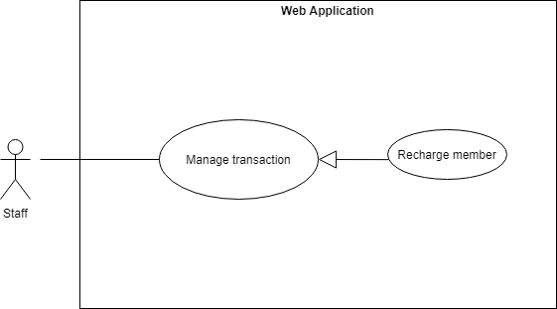**

Figure 48: <Staff> Recharge member

|  |  |  |  |
| --- | --- | --- | --- |
| **USE CASE – CFOS\_UC\_STAFF\_05** | | | |
| **Use Case No.** | CFOS\_UC\_STAFF\_05 | **Use Case Version** | 2.0 |
| **Use Case Name** | Recharge member | | |
| **Author** | ThinhPH | | |
| **Date** | 23/06/2019 | **Priority** | High |
| **Actor:**   * Staff   **Summary:**   * This use case allows staff to recharge member.   **Goal**:   * Staff can recharge member.   **Triggers**:   * From the side bar:   + Select “Manage Member” menu.  + Select “Nộp tiền” icon  **Preconditions**:   * User has to logged in to the system as staff role   **Post** **Conditions**:   * Success: Member’s wallet will be updated. * Fail: Show error message.   **Main Success Scenario:**   |  |  |  | | --- | --- | --- | | **Step** | **Actor Action** | **System Response** | | **1** | Staff goes to manage staff page and click “Nộp tiền” icon. | Navigate modal “Nộp Tiền Cho Khách Hàng” which contains:   * “Tên Khách Hàng”: text, disable. * “Số Tiền”: number, required. * “Mô Tả Giao Dịch”: text, required. * “Ok”: button. * “Cancel”: button | | **2** | Staff inputs data |  | | **3** | After inputs data into modal “Nộp Tiền Cho Khách Hàng”. | Navigate modal “Nhập Password Xác Thực” which contains:   * “Password”: text, required. * “Ok”: button. * “Cancel”: button. | | **4** | If staff enters the correct password | Navigate modal “In Hóa Đơn” which contains: detailed invoice of the transaction | | **5** | Staff click “Ok” button.  [Alternative 1] | * Member’s wallet will be updated to database and close modal. * Show message: “Nộp tiền thành công”.   [Exception 1 2 3 4 5 6 7 ] |   **Alternative Scenario:**   |  |  |  | | --- | --- | --- | | No | Actor Action | System Response | | 1 | Staff click “Cancel” button | Close modal “Nộp Tiền Cho Khách Hàng” or “Nhập Password” or “In Hóa Đơn”. |   **Exceptions**: **N/A**  **Relationships**: **N/A**  **Business** **Rules**:   * Member’s wallet will be updated and the amount of members will be added. | | | |

Table 50 <Staff> Recharge member

##### **2.3.5.6. <Staff> View transaction history**

**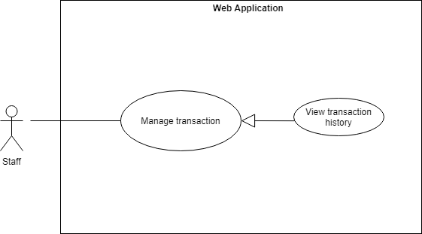**

Figure 49: <Staff> View transaction history

|  |  |  |  |
| --- | --- | --- | --- |
| **USE CASE – CFOS\_UC\_STAFF\_06** | | | |
| **Use Case No.** | CFOS\_UC\_STAFF\_06 | **Use Case Version** | 2.0 |
| **Use Case Name** | View transaction history | | |
| **Author** | ThinhPH | | |
| **Date** | 23/06/2019 | **Priority** | Normal |
| **Actor:**   * Staff   **Summary:**   * This use case allows staff to view history transaction.   **Goal:**   * Staff can view history transaction.   **Triggers:**   * From the side bar:   + Select “History Transaction” menu.  + Select “Chọn Loại Giao Dịch” select box.  **Preconditions:**   * User has to logged in to the system as staff role   **Post Conditions:**   * **Success:** Staff can view list history transaction * **Fail:** Show error message.   **Main Success Scenario:**   |  |  |  | | --- | --- | --- | | **Step** | **Actor Action** | **System Response** | | **1** | Staff goes to history transaction page. | History transaction screen is shown with following labels and fields:   * “Chọn loại giao dịch”: select box. | | **2** | Staff selects the type of transaction at the select box | System show list history transaction.  [Exception 1] |   **Alternative Scenario**:N/A  Exceptions:   |  |  |  | | --- | --- | --- | | **Step** | **Actor Action** | **System Response** | | **1** | If the staff does not select the transaction type at the select box | Show error warning: “Chọn loại giao dịch” |   **Relationships**:N/A  **Business** **Rules**:   * Staff can view list history transaction. | | | |

Table 51 <Staff> View transaction history

##### **2.3.5.7. <Staff> Search history**

**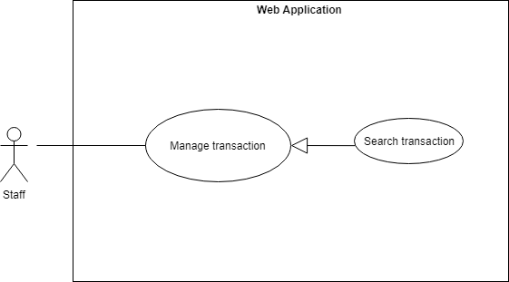**

Figure 50: <Staff> Search transaction

|  |  |  |  |
| --- | --- | --- | --- |
| **USE CASE – CFOS\_UC\_STAFF\_07** | | | |
| **Use Case No.** | CFOS\_UC\_STAFF\_07 | **Use Case Version** | 2.0 |
| **Use Case Name** | Search transaction | | |
| **Author** | ThinhPH | | |
| **Date** | 23/06/2019 | **Priority** | Normal |
| **Actor:**   * Staff   **Summary:**   * This use case allows staff to search transaction**.**   **Goal:**   * Staff view the list of history transaction.   **Triggers:**   * From the side bar:   + Select “History Transaction” menu.  + Staff input text and send the search command  **Preconditions:**   * User has to logged in to the system as staff role   **Post Conditions:**   * **Success:** Staff can view list history transaction**.** * **Fail:** Show error message**.**   **Main Success Scenario:**   |  |  |  | | --- | --- | --- | | **Step** | **Actor Action** | **System Response** | | **1** | Staff goes to history transaction page. | The system requires text input from staff includes:   * “Search”: input * “Search”: button | | **2** | Staff fill data search input. | * Trading code: number | | **3** | Staff click “Search” button.  [Alternative 1] | * All search results will be displayed in table with information includes:   + “STT”  + “Mã Giao Dịch”  + “Ngày Giao Dịch”  + “Tổng Tiền”  + “Loại Giao Dịch” |   **Alternative Scenario:**   |  |  |  | | --- | --- | --- | | No | Actor Action | System Response | | 1 | User enters the wrong equipment keyword | The system shows an warning message “Không tìm thấy kết quả!”. |   **Exceptions**: N/A  **Relationships**:N/A  **Business** **Rules**:   * Staff will get the search results list. * Staff can view list history transaction which contains:   + “STT”  + “Mã Giao Dịch”  + “Ngày Giao Dịch”  + “Tổng Tiền”  + “Loại Giao Dịch” | | | |

Table 52 <Staff> Search transaction

##### **2.3.5.8. <Staff> View guest’s orders**

**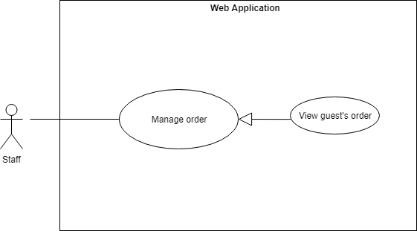**

Figure 51: <Staff> Search transaction

|  |  |  |  |
| --- | --- | --- | --- |
| **USE CASE – CFOS\_UC\_STAFF\_08** | | | |
| **Use Case No.** | CFOS\_UC\_STAFF\_08 | **Use Case Version** | 2.0 |
| **Use Case Name** | View guest’s order | | |
| **Author** | ThinhPH | | |
| **Date** | 23/06/2019 | **Priority** | High |
| **Actor:**   * Staff   **Summary:**   * This use case allows staff to view guest’s order.   **Goal:**   * Staff can view list guest’s order.   **Triggers:**   * From the side bar:   + Select “Management Order Guest” menu.  **Preconditions:**   * User has to logged in to the system as staff role   **Post Conditions:**   * Success: Staff can view list order of guest’s * Fail: Show error message.   **Main Success Scenario:**   |  |  |  | | --- | --- | --- | | **Step** | **Actor Action** | **System Response** | | **1** | Staff goes to management order guest page. | System show list order of guest’s. |   **Alternative Scenario:** N/A  **Exceptions**: N/A  **Relationships**:N/A  **Business Rules:**   * Staff will see the list of guests waiting for approval | | | |

Table 53 <Staff> View guest’s order

##### **2.3.5.9. <Staff> Submit guest’s orders**

**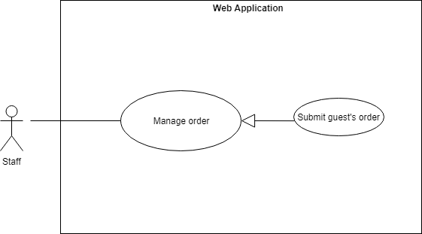**

Figure 52: <Staff> Submit guest’s order

|  |  |  |  |
| --- | --- | --- | --- |
| **USE CASE – CFOS\_UC\_STAFF\_09** | | | |
| **Use Case No.** | CFOS\_UC\_STAFF\_09 | **Use Case Version** | 2.0 |
| **Use Case Name** | Submit guest’s order | | |
| **Author** | ThinhPH | | |
| **Date** | 23/06/2019 | **Priority** | Normal |
| **Actor**:   * Staff   **Summary**:   * This use case allows staff to submit guest’s order to the system.   **Goal**:   * Staff can submit guest’s order.   **Triggers**:   * From the side bar:   + Select “Management Order Guest” menu.  + Select “Đã Nhận Tiền Từ Khách hàng” button.  **Preconditions**:   * User has to logged in to the system as Staff role.   **Post** **Conditions**:   * **Success**: Edit status order is update into the system * **Fail**: Show error message, no changes in database.   **Main Success Scenario:**   |  |  |  | | --- | --- | --- | | **Step** | **Actor Action** | **System Response** | | **1** | Staff goes to management page and click “Đã Nhận Tiền Từ Khách Hàng” button.  [Alternative 1] | Navigate modal “In Hóa Đơn” which contains: invoice details of the order |   **Alternative Scenario:**   |  |  |  | | --- | --- | --- | | No | Actor Action | System Response | | 1 | Staff click “Cancel” button | Close modal “In Hóa Đơn” |   **Exceptions**: N/A  **Relationships**:N/A  **Business** **Rules**:   * After chef submit guest’s order, the system will update the status of the order and chef will see that dish for cooking. * The printer will print an invoice confirming receipt of money from guest. | | | |

Table 54 <Staff> Submit guest’s order

##### **2.3.5.10.<Staff> Search guest’s order**

**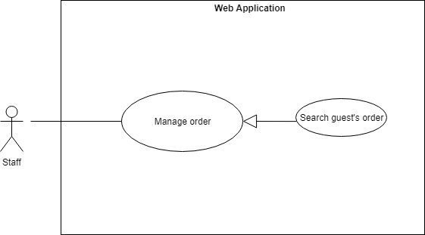**

Figure 53: < Staff> Search guest’s order

|  |  |  |  |
| --- | --- | --- | --- |
| **USE CASE – CFOS\_UC\_STAFF\_10** | | | |
| **Use Case No.** | CFOS\_UC\_STAFF\_10 | **Use Case Version** | 2.0 |
| **Use Case Name** | Search guest’s order | | |
| **Author** | ThinhPH | | |
| **Date** | 23/06/2019 | **Priority** | Normal |
| **Actor:**   * Staff   **Summary:**   * This use case allows staff to search guest’s order.   **Goal:**   * Staff can submit guest’s order.   **Triggers:**   * From the side bar:   + Select “Management Order Guest” menu.  + Staff input text and send the search command  **Preconditions:**   * User has to logged in to the system as staff role   **Post Conditions:**   * **Success:** Staff can view list order of guest’s. * **Fail:** Show error message**.**   **Main Success Scenario:**   |  |  |  | | --- | --- | --- | | **Step** | **Actor Action** | **System Response** | | **1** | Staff goes to management order guest page. | The system requires text input from staff includes:   * “Search”: input * “Search”: button | | **2** | Staff fill data search input. | * Order number: number | | **3** | Staff click “Search” button.  [Alternative 1] | * All search results will be displayed in table with information includes:   + “STT”  + “Số Order”  + “Tổng Tiền” |   **Alternative Scenario:**   |  |  |  | | --- | --- | --- | | No | Actor Action | System Response | | 1 | User enters the wrong equipment keyword | The system shows an warning message “Không tìm thấy kết quả!”. |   **Exceptions:** N/A  **Relationships:** N/A  **Business Rules:**   * Staff will get the search results list. * Staff can view list order of guest’s which contains:   + “STT”  + “Số Order”   * + “Tổng Tiền” | | | |

Table 55 <Staff> Search guest’s order

##### **2.3.5.11. <Staff> View cancelled orders**

**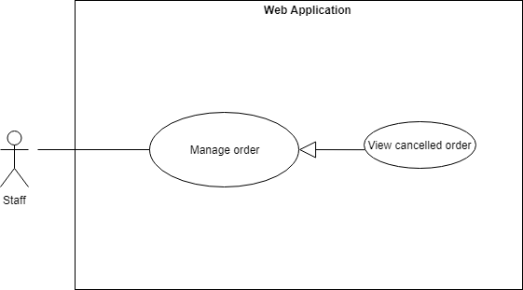**

Figure 54: <Staff> View cancelled order

|  |  |  |  |
| --- | --- | --- | --- |
| **USE CASE – CFOS\_UC\_STAFF\_11** | | | |
| **Use Case No.** | CFOS\_UC\_STAFF\_11 | **Use Case Version** | 2.0 |
| **Use Case Name** | View cancelled order | | |
| **Author** | ThinhPH | | |
| **Date** | 23/06/2019 | **Priority** | High |
| **Actor:**   * Staff   **Summary:**   * This use case allows staff to view cancelled order.   **Goal:**   * Staff can view list cancelled order.   **Triggers:**   * From the side bar:   + Select “Guest Food Cancelled” menu.  **Preconditions:**   * User has to logged in to the system as staff role   **Post Conditions:**   * **Success**: Staff can view list order cancelled of guest’s * **Fail**: Show error message.   **Main Success Scenario:**   |  |  |  | | --- | --- | --- | | **Step** | **Actor Action** | **System Response** | | **1** | Staff goes to guest food cancelled page. | System show list order cancelled of guest’s. |   **Alternative Scenario**: N/A  **Exceptions**: N/A  **Relationships**:N/A  **Business** **Rules**:   * Staff will see the list order cancelled of guests**.** | | | |

Table 56 <Staff> View cancelled order

##### **2.3.5.12. <Staff> Rollback’s guest order**

**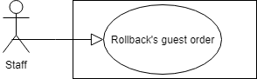**

Figure 55: <Staff> Rollback’s guest order

|  |  |  |  |
| --- | --- | --- | --- |
| **USE CASE – CFOS\_UC\_STAFF\_12** | | | |
| **Use Case No.** | CFOS\_UC\_STAFF\_12 | **Use Case Version** | 2.0 |
| **Use Case Name** | Rollback’s guest order | | |
| **Author** | ThinhPH | | |
| **Date** | 23/06/2019 | **Priority** | High |
| **Actor:**   * Staff   **Summary:**   * This use case allows staff to edit cancelled order.   **Goal:**   * Staff can edit cancelled order.   **Triggers:**   * From the side bar:   + Select “Guest Food Cancelled” menu.  + Select “Hoàn Tiền Cho Khách” button.  **Preconditions:**   * User has to logged in to the system as Staff role.   **Post Conditions:**   * Success: Edit status order is update into the system * Fail: Show error message, no changes in database.   **Main Success Scenario:**   |  |  |  | | --- | --- | --- | | **Step** | **Actor Action** | **System Response** | | **1** | Staff goes to management page and click “Hoàn Tiền Cho Khách” button.  [Alternative 1] | Navigate modal “In Hóa Đơn” which contains: invoice details of the order and description transaction. |   **Alternative Scenario:**   |  |  |  | | --- | --- | --- | | No | Actor Action | System Response | | **1** | Staff click “Cancel” button | Close modal “In Hóa Đơn” |   **Exceptions:** N/A  **Relationships:** N/A  **Business Rules:**   * After chef edit cancelled order, the system will update the status of the order and guest will receive the refund of the canceled food. * The printer will print an invoice confirming the return of money to the guest’s. | | | |

Table 57 <Staff> > Edit cancelled order

##### **2.3.5.13. <Staff> View static**

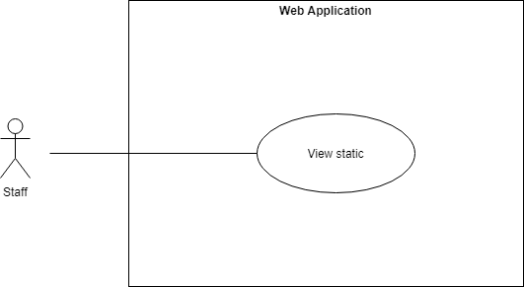

Figure 56: <Staff> View static

|  |  |  |  |
| --- | --- | --- | --- |
| **USE CASE – CFOS\_UC\_STAFF\_13** | | | |
| **Use Case No.** | CFOS\_UC\_STAFF\_13 | **Use Case Version** | 2.0 |
| **Use Case Name** | View static | | |
| **Author** | ThinhPH | | |
| Date | 23/06/2019 | **Priority** | Normal |
| **Actor:**   * Staff   **Summary:**   * This use case allows staff view static.   **Goal:**   * Staff can view static.   **Triggers:**   * From the side bar:   + Select “View static” menu.  **Preconditions:**   * User has to logged in to the system as staff role   **Post Conditions:**   * **Success:** Staff can view statics. * **Fail:** Show error message, no changes in database.   **Main Success Scenario:**   |  |  |  | | --- | --- | --- | | **Step** | **Actor Action** | **System Response** | | **1** | Store manager goes to view static page. | The system displays statistics as follows:   * Total income during the day. * Total membership loaded. * Total money from guest. * Money back for guest. |   **Alternative Scenario:** N/A  **Exceptions**: N/A  **Relationships:** N/A  **Business Rules:**   * Staff can view list static in day. | | | |

Table 58 <Staff > View static

#### **2.3.6. < Customer> Overview Use Case**

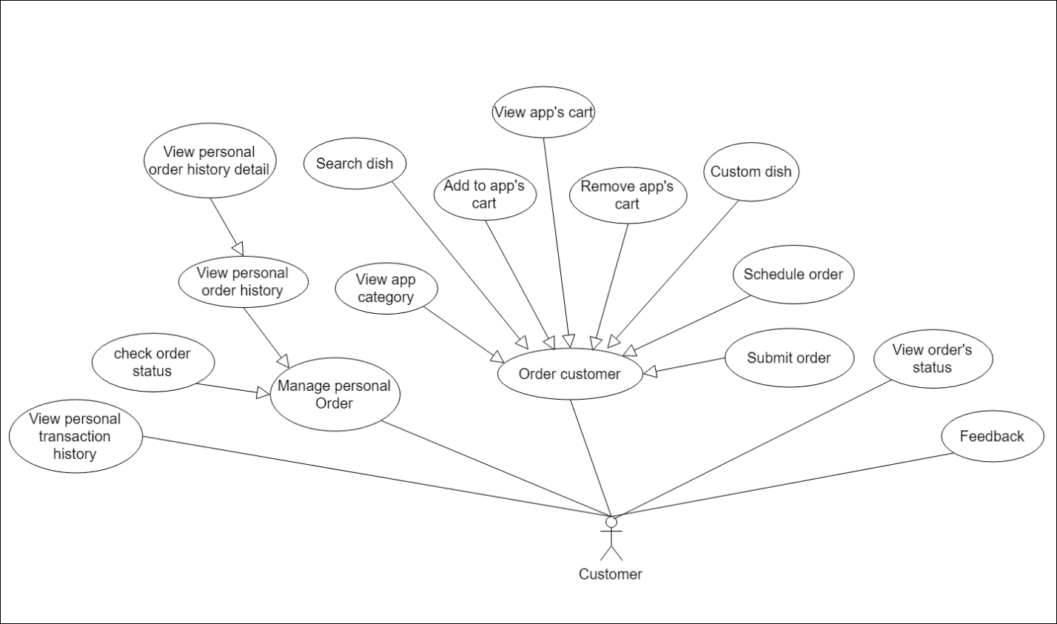

Figure 57: <Customer> Overview use case

##### **2.3.6.1. <Customer> View Personal Transaction History**

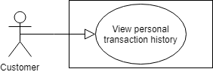

Figure 58 < Customer > View Personal Transaction History

|  |  |  |  |
| --- | --- | --- | --- |
| **USE CASE – CFOS\_UC\_ CUSTOMER \_01** | | | |
| **Use Case No.** | **CFOS\_UC\_ CUSTOMER \_01** | Use Case Version | 1.1 |
| **Use Case Name** | View Personal Transaction History | | |
| **Author** | Nguyen Manh Khang | | |
| **Date** | 15/06/2019 | **Priority** | Normal |
| **Actor:**   * Customer.   **Summary:**   * This use case allows customer to view their personal transaction.   **Goal:**   * Customer can see their transaction history.   **Trigger:**   * Customer send command to the system to view transaction history.   **Precondition:**   * Customer logged into system via mobile app by their account. * Customer is viewing the “Hộp thư” screen.   **Post Conditions:**   * Success: List of transaction will be display as the list in UI or displayed label “No Data”. * Fail: Show error messages.   **Main Success Scenario:**   |  |  |  | | --- | --- | --- | | **Step** | **Actor Action** | **System Response** | | 1 | Customer goes to “Hộp thư” screen. | * System shows the list of transactions   [Exception 1] |   **Alternative Scenario : N/A**  **Exception 1:**   |  |  |  | | --- | --- | --- | | **No** | **Cause** | **System Response** | | 1 | No internet connection | System shows message the "Kiểm tra kết nối mạng" when the internet is lost. |   **Relationship:**  When Customer deposits money, make a payment for an order or be refund because the order canceled. The transaction will be record.  **Business rule:**   * Customer will get the list of transaction. * The detail of transaction result can be a list or single record. It contains:   + Transaction type.   + Transaction id.   + Transaction date.   + Total amount of transaction.   + Transaction description. * After Customer goes to the manage transaction screen, the transaction arranged by date descending. | | | |

Table 59 < Customer > View Personal Transaction History

##### **2.3.6.2. <Customer> View Personal Order History**

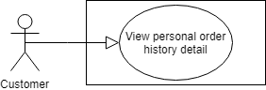

Figure 59 < Customer > View Personal Order History

|  |  |  |  |
| --- | --- | --- | --- |
| **USE CASE – CFOS\_UC\_ CUSTOMER \_02** | | | |
| **Use Case No.** | **CFOS\_UC\_ CUSTOMER \_02** | Use Case Version | 1.1 |
| **Use Case Name** | View Personal Order History | | |
| **Author** | Nguyen Manh Khang | | |
| **Date** | 15/06/2019 | **Priority** | Normal |
| **Actor:**   * Customer.   **Summary:**   * This use case allows customer to view their personal order.   **Goal:**   * Customer can see their order history.   **Trigger:**   * Customer send command to the system to view order history.   **Precondition:**   * Customer logged into system via mobile app by their account. * Customer is viewing the “Lịch sử đơn hàng” screen.   **Post Conditions:**   * Success: List of order will be display as the list in UI or displayed label “No Data”. * Fail: Show error messages.   **Main Success Scenario:**   |  |  |  | | --- | --- | --- | | **Step** | **Actor Action** | **System Response** | | 1 | Customer goes to the “Đơn hàng” screen.  The default tag is “Hôm nay” | System shows the list of order today or displayed label “No Data”.  [Exception 1] | | 2 | Customer click “Tất cả” tag. | System shows the list of order history or displayed label “No Data”. |   **Alternative Scenario : N/A**  **Exception 1:**   |  |  |  | | --- | --- | --- | | **No** | **Cause** | **System Response** | | 1 | No internet connection | System shows message the "Kiểm tra kết nối mạng" when the internet is lost. |   **Relationship:** N/A  **Business rule:**   * Customer will get the list of their order. * The detail of order result can be a list or single record. It contains:   + Order number.   + Total order detail.   + Total amount of order.   + Status of order. * After customer goes to the manage order screen, the order arranged by date descending. | | | |

Table 60 < Customer > View Personal Order History

##### **2.3.6.3. <Customer> Check order status**

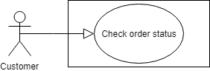

Figure 60: < Customer > Check order status

|  |  |  |  |
| --- | --- | --- | --- |
| **USE CASE – CFOS\_UC\_ CUSTOMER \_04** | | | |
| **Use Case No.** | **CFOS\_UC\_ CUSTOMER \_04** | Use Case Version | 1.1 |
| **Use Case Name** | Check order status | | |
| **Author** | Nguyen Manh Khang | | |
| **Date** | 15/06/2019 | **Priority** | Normal |
| **Actor:**   * Customer.   **Summary:**   * This use case allows customer to check their personal order.   **Goal:**   * Customer can see their order status.   **Trigger:**   * Customer input order number and send search command to the system.   **Precondition:**   * Customer logged into system via mobile app by their account. * Customer is viewing the checking order status screen.   **Post Conditions:**   * Success: Order suitable will be display. * Fail: Displayed “No Data”.   **Main Success Scenario:**   |  |  |  | | --- | --- | --- | | **Step** | **Actor Action** | **System Response** | | 1 | Customer goes to the “Home” screen. | Home screen loaded. | | 2 | Customer click “Kiểm tra” button at the top right. | A form search input number appear. | | 3 | Customer input order number. |  | | 4 | Customer finish input by click check button on keyboard. | Search results will be displayed with information includes:   * + Order number.   + Total order detail.   + Total amount of order.   + Status of order.   If not found any order suitable, display “No Data”.  [Exception1] |   **Exception 1:**   |  |  |  | | --- | --- | --- | | **No** | **Cause** | **System Response** | | 1 | No internet connection | System shows message the "Kiểm tra kết nối mạng" when the internet is lost. |     **Relationship**: **N/A**  **Business rule:**   * Customer will get one result if have order suitable. * Base on detail status, customer can take initiative in taking dish. | | | |

Table 61 < Customer > Check order status

##### **2.3.6.5. <Customer> Submit Order**

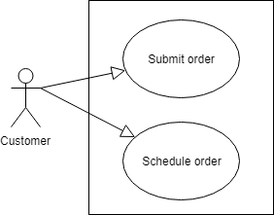

Figure 61 < Customer > Submit order – Schedule Order

|  |  |  |  |
| --- | --- | --- | --- |
| **USE CASE – CFOS\_UC\_ CUSTOMER \_05** | | | |
| **Use Case No.** | **CFOS\_UC\_ CUSTOMER \_05** | Use Case Version | 1.1 |
| **Use Case Name** | Submit order – Schedule Order | | |
| **Author** | Nguyen Manh Khang | | |
| **Date** | 15/06/2019 | **Priority** | High |
| **Actor:**   * Customer.   **Summary:**   * This use case allows customer to submit to server their personal order.   **Goal:**   * After customer chooses their food, they can submit their order to server.   **Trigger:**   * Customer chooses at least one dish and send submit command to the system.   **Precondition:**   * Customer logged into system via mobile app by their account. * Customer choose at least one dish. * Customer is viewing the submit order screen. * Balance in customer’s wallet enough to pay order.   **Post Conditions:**   * Success: Order of customer will be submitted, and server return the bill include: * Order number. * Fail: Show error messages.   **Main Success Scenario:**   |  |  |  | | --- | --- | --- | | **Step** | **Actor Action** | **System Response** | | 1 | Customer login (if not) and viewing the “Home” screen. | Main screen will include some primary information :   * Food. * Store. * Today’s promotion. * New food. * The most popular dish. | | 2 | Customer adds at least one dish to basket.  Customer can increase or decrease quantity of dish directly on the basket screen.  Customer input promotion code (if exit)  [Alternative 1] | The dish will be appear in basket.  Basket will show:   * Dish name. * Price of each dish. * Food Option * Quantity. * Store name. * Total price order. A price auto update if customer change quantity or promotion code is applied. | | 3 | User sends command to purchase. | Server will return to customer a bill include:   * Order number.   [Exception 1]  [Exception 2] |   **Alternative Scenario 1:**   |  |  |  | | --- | --- | --- | | **Step** | **Actor Action** | **System Response** | | 1 | Customer presses schedule button. | List of time have pattern “hh:mm” will show. Time frame full is also display but customer cannot choose. | | 2 | Customer chooses time. |  | | 4 | Customer presses “Thanh toán” | Back to basket screen.  [Exception 1.1]  [Exception 1.2] |   **Exception 1.1:**   |  |  |  | | --- | --- | --- | | **No** | **Cause** | **System Response** | | 1 | The block is full | System shows message the " Xin lỗi, mọi cửa hàng đều đóng, quí khách hãy quay lại vào ngày mai ". | | 2 | Customer chooses time. |  | | 3 | Customer presses “Ok” | Back to basket screen.  [Exception 1.1] |   **Exception 1.2:**   |  |  |  | | --- | --- | --- | | **No** | **Cause** | **System Response** | | 1 | Customer ordering outside of working hours. | System shows message the "Xin lỗi, mọi cửa hàng đều đóng, quí khách hãy quay lại vào ngày mai". |   **Exception 1:**   |  |  |  | | --- | --- | --- | | **No** | **Cause** | **System Response** | | 1 | No internet connection | System shows message the "Kiểm tra kết nối mạng" when the internet is lost. |   **Exception 2:**   |  |  |  | | --- | --- | --- | | **Step** | **Cause** | **System Response** | | 1 | Dish temporarily out of stock. | The system shows a message “Your dish temporarily out of stock. Please check your order again”.  Back to basket screen, |   **Relationship**:  When customer purchase their order, transaction, order history, wallet will automatically update.  **Business rule:**   * Customer will receive order number when purchase successful. * Customer must login to order. * That order number is the same in all store. That mean which one order number customer can receive multiple dish at many store. * Customer must have enough balance to order dish. * The dish must be in stock before it ordered. * Customers cannot make orders outside of working hours of food-court. * The order of customer will be save to serve for customer care of system. * Customers who reserve dish must follow some of the following rules:   + The dish may be 10 minutes earlier or later than the appointment time.   + During peak hours, reservation may not be successful.   + Customers can only cancel their food 10 minutes before the appointment time.   + In case customers order at many different stores. The time frame of an appointment is the same for each store. * Each order of the customer arranges in a way that has rules at the server. To know more about how to sort, you can look at the algorithm section. | | | |

Table 62 < Customer > Submit order – Schedule Order

##### **2.3.6.6. <Customer> Submit Feedback**

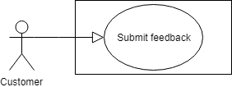

Figure 62: < Customer > Customer submit feedback

|  |  |  |  |
| --- | --- | --- | --- |
| **USE CASE – CFOS\_UC\_ CUSTOMER \_06** | | | |
| **Use Case No.** | **CFOS\_UC\_ CUSTOMER \_06** | Use Case Version | 1.1 |
| **Use Case Name** | Customer submit feedback | | |
| **Author** | Nguyen Manh Khang | | |
| **Date** | 15/06/2019 | **Priority** | Normal |
| **Actor:**   * Customer.   **Summary:**   * This use case allows customer to post their feedback.   **Goal:**   * Customer can post their feedback about dish.   **Trigger:**   * Customer ordered food, and submit their feedback to system.   **Precondition:**   * Customer logged into system via mobile app by their account. * Customer is viewing the dish review screen.   **Post Conditions:**   * Success: Customer’s feedback will submit to system. * Fail: Show error messages.   **Main Success Scenario:**   |  |  |  | | --- | --- | --- | | **Step** | **Actor Action** | **System Response** | | 1 | Customer goes to the dish review screen. | All review of food will display. | | 2 | Customer click “Viết đánh giá” | The screen “Đánh giá món ăn” will display. | | 3 | Customer type their review and choose star. |  | | 4 | Customer press “Đăng” | Back to Home screen.  [Exception 1]  [Exception 2] |   **Exception 1:**   |  |  |  | | --- | --- | --- | | **No** | **Cause** | **System Response** | | 1 | No internet connection | System shows message the "Please check your connection" when the internet is lost. |   **Exception 2:**   |  |  |  | | --- | --- | --- | | **Step** | **Cause** | **System Response** | | 1 | Customers post a review of the dish they have not ordered before. | The system shows an error message “You didn't order this food. So you can’t review this food” |   **Relationship**: **N/A**  **Business rule:**   * Customer can post feedback about dish. * Customers must have at least one order for this dish to be able to perform the review. * Customer cannot edit their feedback after post. * System have method prevent spamming feedback. Customers can only post feedback once for each food per day. * The rate star of feedback for each food will be calculate average and round to the first decimal. | | | |

Table 63 < Customer > Customer submit feedback

##### **2.3.6.7. <Customer> View app category**

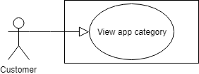

Figure 63: < Customer > View app category

|  |  |  |  |
| --- | --- | --- | --- |
| **USE CASE – CFOS\_UC\_ CUSTOMER \_07** | | | |
| **Use Case No.** | **CFOS\_UC\_ CUSTOMER \_07** | Use Case Version | 1.1 |
| **Use Case Name** | View app category | | |
| **Author** | Nguyen Manh Khang | | |
| **Date** | 15/07/2019 | **Priority** | Normal |
| **Actor:**   * Customer.   **Summary:**   * This use case allows customer view category of system.   **Goal:**   * Customer can see category help to choose food more convenient.   **Trigger:**   * Customer is view “Home” screen or press “Xem tất cả” of “Danh mục” tag.   **Precondition:**   * Customer logged into system via mobile app by their account. * Customer is viewing “Home” screen or “Danh mục” screen.   **Post Conditions:**   * Success: List of category will appear. * Fail: Displayed “No Data”.   **Main Success Scenario:**   |  |  |  | | --- | --- | --- | | **Step** | **Actor Action** | **System Response** | | 1 | Customer goes to the “Home” screen. | Home screen loaded.  Display 4 category in “Danh mục” tag. | | 2 | Customer click “Xem tất cả” at “Danh mục” tag. | List of category is loaded. |   **Exception 1:**   |  |  |  | | --- | --- | --- | | **No** | **Cause** | **System Response** | | 1 | No internet connection | System shows message the "Kiểm tra kết nối mạng" when the internet is lost. |     **Relationship**: **N/A**  **Business rule:**   * Customer will see the entire category of each food court. | | | |

Table 64 < Customer > View app category

##### **2.3.6.8. <Customer> Customer manipulate the cart**

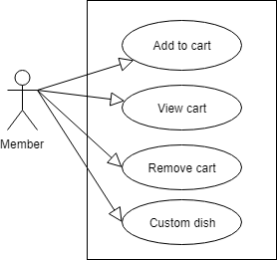

Figure 64: < Customer > Member manipulate the cart

|  |  |  |  |
| --- | --- | --- | --- |
| **USE CASE – CFOS\_UC\_CUSTOMER\_07** | | | |
| **Use Case No.** | **CFOS\_UC\_ CUSTOMER \_07** | Use Case Version | 1.1 |
| **Use Case Name** | Customer manipulate the cart | | |
| **Author** | Nguyen Manh Khang | | |
| **Date** | 15/07/2019 | **Priority** | Normal |
| **Actor:**   * Customer.   **Summary:**   * This use case allows customer manipulate with app’s cart.   **Goal:**   * Customer can see category help to choose food more convenient.   **Trigger:**   * Customer is view “Home” screen.   **Precondition:**   * Customer logged into system via mobile app by their account. * Customer is viewing “Home” screen and choose at least one dish.   **Post Conditions:**   * Success: All functions of the shopping cart work properly. * Fail: show error message.   **Main Success Scenario:**   |  |  |  | | --- | --- | --- | | **Step** | **Actor Action** | **System Response** | | 1 | Customer goes to the “Home” screen. | Home screen loaded.  Home screen include:   * Category. * Dish order near here. * Dish popular. * Promotion. * Restaurants list.   [Exception 1] | | 2 | Customer click “+” at the image of food.  Customer can click “+” to add food from :   * Home screen * Search result dish * List food in category * Promotion * Popular * Dish Detail * Dish review   [Alternative 1] | Food is added to cart.  Cart is automatic updated.  [Exception 1] | | 3 | Customer click “Xem giỏ” at bottom of screen. | If cart is empty display “Giỏ hàng trống”.  [Exception 1]  The list of dishes that customers have just ordered is displayed.  Payment information will automatic update.  [Exception 1] | | 4 | Customer click “Chỉnh sửa”  [Alternative 2] | Dish update screen loads.  [Exception 1] | | 5 | Customer click “+” to add more dish. Opposite to “-”. | Quantity of food updated.  [Exception 1] | | 6 | Customer click “<” at the upper left corner of the screen. | Basket screen loads.  [Exception 1] | | 7 | [Alternative 2] |  |   **Exception 1:**   |  |  |  | | --- | --- | --- | | **No** | **Cause** | **System Response** | | 1 | No internet connection | System shows message the "Kiểm tra kết nối mạng" when the internet is lost. |   **Alternative Scenario 1**   |  |  |  | | --- | --- | --- | | **Step** | **Actor Action** | **System Response** | | 1 | If customer choose dish from dish detail.  Customer can customize food option. | Dish Detail screen loads. Include :   * Dish information * Price * Promotion * Food option | | 2 | Customer choose food option. If not, default is chosen.  Customer click “+” | Basket updates.  [Exception 1] | | 3 | Customer click “<” at the upper left corner of the screen. | Basket screen loads.  [Exception 1] |   **Alternative Scenario 2**   |  |  |  | | --- | --- | --- | | **Step** | **Actor Action** | **System Response** | | 1 | Customer presses recycle bin at the right of each dish detail. | Dish is disappeared from the cart.  [Exception 1] |   **Business rule:**   * Request internet when customers perform actions with dishes. | | | |

Table 65 < Customer > Member manipulate the cart

#### **2.3.7. <Scheduler> Overview Use Case**

Figure 65: < Scheduler> Overview use case

##### **2.3.7.1. <Scheduler> Reset order number**

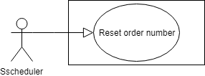

Figure 66: < Scheduler> Reset order number

|  |  |  |  |
| --- | --- | --- | --- |
| **USE CASE – CFOS\_UC\_SCHEDULER\_01** | | | |
| **Use Case No.** | **CFOS\_UC\_SCHEDULER\_01** | Use Case Version | 1.1 |
| **Use Case Name** | Timer reset order number | | |
| **Author** | Nguyen Manh Khang | | |
| **Date** | 15/07/2019 | **Priority** | Normal |
| **Actor:**   * Scheduler.   **Summary:**   * This use case show how the scheduler reset order number of the table order food.   **Goal:**   * Because of the user's experience, the number of orders needs to be reset every day.   **Trigger:**   * System server stills operate at 0 o’clock every day.   **Precondition:**   * System server is available.   **Post Conditions:**   * Success: A record will appear in the order food table with the value of order number is 0. * Fail: no update for order number.   **Main Success Scenario:**   |  |  |  | | --- | --- | --- | | **Step** | **Actor Action** | **System Response** | | 1 | At 0 o’clock scheduler send command to add a record with the value of order number is 0 into table order food. | The system will do step by step:   * Find the order with order number is 0 (order yesterday). * If found, delete it. * Create new order with order number is 0. |   **Relationship**: **N/A**  **Business rule:**   * This number will be displayed directly on the customer's bill and kitchen screen, so it needs to be reset every day. * The first order will be order number 1. | | | |

Table 66 < Scheduler> Reset order number

##### **2.3.7.2. <Scheduler> Record Statistic for store**

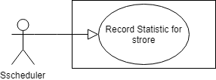

Figure 67: < Scheduler> Record statistic for each store

|  |  |  |  |
| --- | --- | --- | --- |
| **USE CASE – CFOS\_UC\_SCHEDULER\_02** | | | |
| **Use Case No.** | **CFOS\_UC\_SCHEDULER\_02** | Use Case Version | 1.1 |
| **Use Case Name** | Scheduler record statistic for each store. | | |
| **Author** | Nguyen Manh Khang | | |
| **Date** | 15/07/2019 | **Priority** | Normal |
| **Actor:**   * Scheduler.   **Summary:**   * This use case show how the scheduler record statistic for each store.   **Goal:**   * How to know the business situation of each store. The system needs to record how many products and sales each store sells each day.   **Trigger:**   * System server stills operate at 23h50 every day.   **Precondition:**   * System server is available.   **Post Conditions:**   * Success: A record will appear in Statistic table. * Fail: no statistic will record.   **Main Success Scenario:**   |  |  |  | | --- | --- | --- | | **Step** | **Actor Action** | **System Response** | | 1 | At 23h50 scheduler send command to add a record to record statistic | The system will do step by step:   * Find list of order detail with status “READY” in day for each store. * System will calculate total sales and how many products each store sells. * System save related information to database. |   **Relationship**: **N/A**  **Business rule:**   * This value of statistic table will use for admin of each store. * Data will be shown by a line graph at the web. * If status of statistic is “DAY”, it means this record is in one day. Same for the month. | | | |

Table 67 < Scheduler> Record statistic for each store.

##### **2.3.7.3. <Scheduler> Record Food popular**

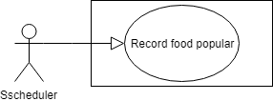

Figure 68: < Scheduler> Record food popular

|  |  |  |  |
| --- | --- | --- | --- |
| **USE CASE – CFOS\_UC\_SCHEDULER\_03** | | | |
| **Use Case No.** | **CFOS\_UC\_SCHEDULER\_03** | Use Case Version | 1.1 |
| **Use Case Name** | Scheduler record food popular. | | |
| **Author** | Nguyen Manh Khang | | |
| **Date** | 15/07/2019 | **Priority** | Normal |
| **Actor:**   * Scheduler.   **Summary:**   * This use case show how the scheduler record a count variable for each food.   **Goal:**   * To find the food that has been ordered a lot in the last 7 days. The system needs to update a count variable for each food.   **Trigger:**   * At every 3 hours from 7 am to 7 pm every day.   **Precondition:**   * System server is available.   **Post Conditions:**   * Success: A count variable will calculate and save to table food. * Fail: no count of food change.   **Main Success Scenario:**   |  |  |  | | --- | --- | --- | | **Step** | **Actor Action** | **System Response** | | 1 | At every 3 hours from 7 am to 7 pm every day scheduler send command to update count variable. | The system will do step by step:   * Find list of order detail with status “READY” in 7 day for each store. * System will calculate total food is ordered. * System save count variable to table food. |   **Relationship**: **N/A**  **Business rule:**   * This value serve API get food popular in the kiosk. | | | |

Table 68 < Scheduler> Record food popular.

##### **2.3.7.4. <Scheduler> Reset Block**

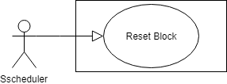

Figure 69: < Scheduler> Reset block.

|  |  |  |  |
| --- | --- | --- | --- |
| **USE CASE – CFOS\_UC\_SCHEDULER\_04** | | | |
| **Use Case No.** | **CFOS\_UC\_SCHEDULER\_04** | Use Case Version | 1.1 |
| **Use Case Name** | Scheduler reset block. | | |
| **Author** | Nguyen Manh Khang | | |
| **Date** | 15/07/2019 | **Priority** | Normal |
| **Actor:**   * Scheduler.   **Summary:**   * This use case show how the scheduler reset block.   **Goal:**   * To ensure that the order system is still working normally the next day. The blocks need to be reset.   **Trigger:**   * At 0 o’clock every day.   **Precondition:**   * System server is available.   **Post Conditions:**   * Success: Each block is reset. * Fail: no change for data of block.   **Main Success Scenario:**   |  |  |  | | --- | --- | --- | | **Step** | **Actor Action** | **System Response** | | 1 | At the end of every day scheduler send command to reset block. | The system will do step by step:   * Find all block and store is still active * System start to reset and save to table Block. |   **Relationship**: **N/A**  **Business rule:**   * The block is serve for ordering system. It have the pattern: * “storeID/<list order detail number, each of them separate by comma>-storeID/<list order detail number>...”. * Example: “1/1,2,3-2/3,4,5”. | | | |

Table 69 < Scheduler> Reset block.

#### **2.3.8. <Guest> Overview Use Case**

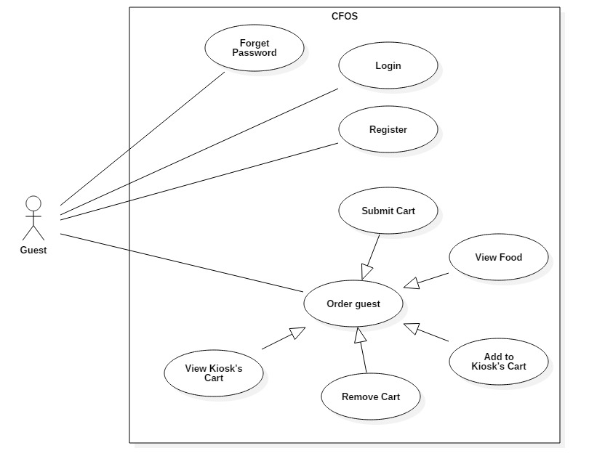

Figure 70: < Guest> Overview use case

##### **2.3.8.1. <Guest> Register**

Figure 71: < Guest> Register

|  |  |  |  |
| --- | --- | --- | --- |
| **USE CASE – CFOS\_UC\_G\_01** | | | |
| **Use Case No.** | **CFOS\_UC\_G\_01** | Use Case Version | 1.0 |
| **Use Case Name** | Register | | |
| **Author** | HuyND | | |
| **Date** | 28/06/2019 | **Priority** | Normal |
| **Actor**:   * Guest   **Summary**:   * This use case allows guest to create a new account in the system.   **Goal**:   * The account was created which recorded in the system   **Trigger**:   * Guest send the register command.   **Precondition**:   * Guest access the system   **Post Conditions:**   * Success: Guest register to the system successfully * Fail: Show error messages   **Main Success Scenario:**   |  |  |  | | --- | --- | --- | | **Step** | **Actor Action** | **System Response** | | 1 | Guest go to Login Page | * The system display form include field:   Tài khoản: Text,  Mật khẩu: Text,  [Đăng nhập] button  [Đăng ký]button | | 2 | Guest press [Đăng ký] button. | The system move guest to Register Page. The system display form include:  Tài khoản: Text,  Mật khẩu: Text,  Xác nhận mật khẩu: Text,  Họ vàn tên: Text,  Email: Text,  Số điện thoại: Text  [Đăng ký] Button,  [Hủy] Button | | 3 | User input text field and press [Đăng ký] Button | The system show message that the user has registered successfully  [Exception 1]  [Exception 2]  [Exception 3]  [Exception 4]  [Exception 5] |   Exception 1:   |  |  |  | | --- | --- | --- | | **Step** | **Cause** | **System Response** | | 1 | Input missing text field | System shows message the "Vui lòng nhập đầy đủ thông tin" |   Exception 2:   |  |  |  | | --- | --- | --- | | **Step** | **Cause** | **System Response** | | 1 | Input duplicate account | System shows message the "Tài khoản này đã tồn tại" |   Exception 3:   |  |  |  | | --- | --- | --- | | **Step** | **Cause** | **System Response** | | 1 | Enter password too short | System shows message the "Mật khẩu quá yếu" |   Exception 4:   |  |  |  | | --- | --- | --- | | **Step** | **Cause** | **System Response** | | 1 | Enter the password that does not match the confirm password | System shows message the "Mật khẩu không khớp" |   Exception 5:   |  |  |  | | --- | --- | --- | | **Step** | **Cause** | **System Response** | | 1 | When the connection to the server is lost | System shows message the " Kiểm tra kết nối của bạn " when the internet is lost. |   **Relationship**: N/A.  **Business** rule:   * The guest’s password will be encrypted before store in database * The text field must be entered correctly with format * Password has at least 8 characters * Password and Confirm should be match | | | |

Table 70 < Guest> Register

##### **2.3.8.2. <Guest> Login**

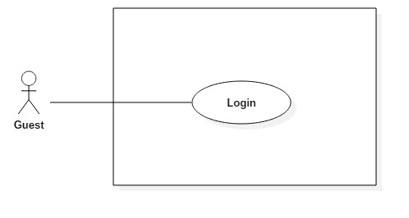

Figure 72: < Guest> Login

|  |  |  |  |
| --- | --- | --- | --- |
| **USE CASE – CFOS\_UC\_G\_02** | | | |
| **Use Case No.** | **CFOS\_UC\_G\_02** | Use Case Version | 1.0 |
| **Use Case Name** | Login | | |
| **Author** | HuyND | | |
| **Date** | 28/06/2019 | **Priority** | Normal |
| **Actor**:   * Guest   **Summary**:   * This use case allows guest to login in the system.   **Goal**:   * Guest was authenticated and authorized for access the system   **Trigger**:   * Guest send the login command.   **Precondition**:   * Guest already has an account   **Post Conditions:**   * **Success**: Guest login to the system successfully and redirect to specific role in the system * **Fail**: Show error messages   **Main Success Scenario:**   |  |  |  | | --- | --- | --- | | **Step** | **Actor Action** | **System Response** | | 1 | Guest go to Login Page | * The system display form include field:   Tài khoản : Text, required  Mật khẩu: Text, required  [Đăng nhập] button  [Đăng ký]button | | 2 | User fill out information and press [Đăng nhập] Button | The system show message “Đăng nhập thành công” and redirect user to specific role in the system.  [Exception 1]  [Exception 2]  [Exception 3] |   Exception 1:   |  |  |  | | --- | --- | --- | | **Step** | **Cause** | **System Response** | | 1 | Input incomplete required information | System shows message "Vui lòng điền đầy đủ thông tin” |   Exception 2:   |  |  |  | | --- | --- | --- | | **Step** | **Cause** | **System Response** | | 1 | Input wrong password or username | System shows message “Tài khoản hoặc mật khẩu không chính xác” |   Exception 3:   |  |  |  | | --- | --- | --- | | **Step** | **Cause** | **System Response** | | 1 | When the connection to the server is lost | System shows message the " Kiểm tra kết nối của bạn " when the internet is lost. |   **Relationship**: N/A.  **Business** rule:   * Login successful, the system will return access\_token * Redirect to specific role in the system | | | |

Table 71 < Guest> Login

##### **2.3.8.3. <Guest> View Food**

Figure 73: < Guest> View food

|  |  |  |  |
| --- | --- | --- | --- |
| **USE CASE – CFOS\_UC\_G\_03** | | | |
| **Use Case No.** | **CFOS\_UC\_G\_03** | **Use Case Version** | 1.0 |
| **Use Case Name** | View menu dishes | | |
| **Author** | HuyND | | |
| **Date** | 23/06/2019 | **Priority** | Normal |
| **Actor:**   * Guest   **Summary:**   * The use case allow guest to view list of dishes   **Goal:**   * Guest see list of dishes   **Triggers:**   * Guest send command to view list of dishes   **Preconditions:**   * Guest must use the kiosk device   **Post conditions:**   * Success: Page display the list of dishes * Fail: Show error message.   **Main Success Scenario:**   |  |  |  | | --- | --- | --- | | **Step** | **Actor Action** | **System Response** | | 1 | Guest press button [Chạm để đặt thức ăn] on Main Page | System show list of dishes. |   **Exception 1:**   |  |  |  | | --- | --- | --- | | **Step** | **Cause** | **System Response** | | 1 | When the connection to the server is lost | System shows message the " Kiểm tra kết nối của bạn " when the internet is lost. |   **Relationships:** N/A  **Business Rules:**   * The menu page will display with 6 criteria:   + Popular  + Promotion  + Meal  + Drink  + Combo  + Restaurant | | | |

Table 72 < Guest> View food.

##### **2.3.8.4. <Guest> Add to Kiosk’s cart**

Figure 74: < Guest> Add to Kiosk’s cart

|  |  |  |  |
| --- | --- | --- | --- |
| **USE CASE – CFOS\_UC\_G\_04** | | | |
| **Use Case No.** | **CFOS\_UC\_G\_04** | Use Case Version | 1.0 |
| **Use Case Name** | Add to Kiosk’s cart | | |
| **Author** | HuyND | | |
| **Date** | 22/09/2019 | **Priority** | Normal |
| **Actor:**   * Guest   **Summary:**   * This use case allows guest to add dish to cart.   **Goal:**   * New dish is added in guest’s basket. * If this dish has already existed in the basket, the quantity of dish increase by one   **Trigger:**   * Guest press [Thêm] button   **Precondition:**   * The guest is on the menu page   **Post Conditions:**   * Success: The shopping cart shows the added food * Fail: Show error messages   **Main Success Scenario:**   |  |  |  | | --- | --- | --- | | Step | Actor Action | System Response | | 1 | Guest go to the menu page | The system shows list dish | | 2 | Guest press [Thêm] button | System adds new dish to basket.  [Alternative 1]  [Alternative 2] |   **Alternative Scenario 1:**   |  |  |  | | --- | --- | --- | | **Step** | **Cause** | **System Response** | | 1 | No dish in cart | Basket and cart item display on the right screen |   **Alternative Scenario 2:**   |  |  |  | | --- | --- | --- | | **Step** | **Cause** | **System Response** | | 1 | Dish has already existed | The quantity of dish increase by one |   **Relationship:**   * <Guest> View Kiosk’s Cart. (G.4) * <Guest> Remove Cart (G.6) * <Guest> Submit Cart (G.)   **Business rule:**   * Dish still in stock or active | | | |

Table 73 < Guest> Add to Kiosk’s cart

##### **2.3.8.5. <Guest> View Kiosk’s Cart**

**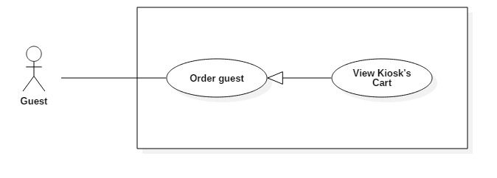**

Figure 75: < Guest> View Kiosk’s cart

|  |  |  |  |
| --- | --- | --- | --- |
| **USE CASE - CFOS\_UC\_** | | | |
| **Use Case No.** | **CFOS\_UC\_G\_05** | **Use Case Version** | 1.0 |
| **Use Case Name** | View Kiosk’s cart | | |
| **Author** | HuyND | | |
| **Date** | 23/06/2019 | **Priority** | Normal |
| **Actor:**   * Guest   **Summary:**   * This use case allows guest to view user’s cart   **Goal:**   * Guest view detail list dishes in cart   **Triggers:**   * Guest send view cart command to the system.   **Preconditions:**   * Guest must add to cart before view cart   **Post conditions:**   * Success: View list cart successful. * Fail: Show error message   **Main Success Scenario:**   |  |  |  | | --- | --- | --- | | **Step** | **Actor Action** | **System Response** | | 1 | Guest press [Xem giỏ của bạn] button on top right corner of the menu page | System show list of item and total price of cart [Exception 1] |   **Exception 1:**   |  |  |  | | --- | --- | --- | | **Step** | **Cause** | **System Response** | | 1 | Lost connection to the server | Display with mess “Check your connection” |   **Relationships:**   * <Guest> Add to Kiosk’s cart. (G.4) * <Guest> Remove Cart (G.6) * <Guest> Submit Cart (G.7)   **Business Rules:**   * [Xem giỏ của bạn] button appears only when the cart has at least 1 dish in it | | | |

Table 74 < Guest> View Kiosk’s cart

##### **2.3.8.6. <Guest> Remove Cart**

Figure 76: < Guest> Remove cart

|  |  |  |  |
| --- | --- | --- | --- |
| **USE CASE – CFOS\_UC\_** | | | |
| **Use Case No.** | **CFOS\_UC\_G\_06** | **Use Case Version** | 1.0 |
| **Use Case Name** | Remove cart | | |
| **Author** | HuyND | | |
| **Date** | 23/06/2019 | **Priority** | Normal |
| **Actor:**   * Guest   **Summary:**   * This use case allows the guest to remove dish the shopping cart.   **Goal:**   * Guest successfully remove dish.   **Triggers:**   * Guest send remove command to the system.   **Preconditions:**   * In the shopping cart must have dishes   **Post conditions:**   * Success: The dish is successfully removed. * Fail: Show error message.   **Main Success Scenario:**   |  |  |  | | --- | --- | --- | | **Step** | **Actor Action** | **System Response** | | 1 | Guest goes to basket page. | System show list of item and total price of cart | | 2 | Guest press button with trash icon in dish | The system starts removing dish  [Exception 1]  The dish was removed  [Alternative 1] |   **Alternative Scenario 1:**   |  |  |  | | --- | --- | --- | | **Step** | **Cause** | **System Response** | | 1 | No dishes in the cart | Page is displayed as “Giỏ hàng rỗng”. |   **Exception 1:**   |  |  |  | | --- | --- | --- | | **Step** | **Cause** | **System Response** | | 1 | Lost connection to the server | Display with mess “Check your connection” |   **Relationships:**   * <Guest> Add to Kiosk’s cart. (G.4) * <Guest> View Kiosk’s Cart (G.5) * <Guest> Submit Cart (G.7)   **Business Rules:**   * Must have at least 1 dish in the basket | | | |

Table 75 < Guest> Remove cart.

##### **2.3.8.7. <Guest> Submit Cart**

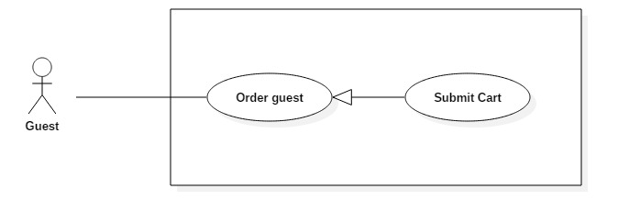

Figure 77: < Guest> Submit cart

|  |  |  |  |
| --- | --- | --- | --- |
| **USE CASE – CFOS\_UC\_** | | | |
| **Use Case No.** | **CFOS\_UC\_G\_08** | **Use Case Version** | 1.0 |
| **Use Case Name** | Submit Cart | | |
| **Author** | HuyND | | |
| **Date** | 23/06/2019 | **Priority** | High |
| **Actor:**   * Guest   **Summary:**   * This use case allows the guest to submit the shopping cart to system.   **Goal:**   * Guest successfully submit shopping cart to system.   **Triggers:**   * Guest send Purchase command to the system.   **Preconditions:**   * In the shopping cart must have dishes   **Post conditions:**   * Success: Display successful submission message and show order id. * Fail: Show error message.   **Main Success Scenario:**   |  |  |  | | --- | --- | --- | | **Step** | **Actor Action** | **System Response** | | 1 | Guest goes to basket page. | System show list of item and total price of cart | | 2 | Guest press button [Thanh toán] | The system processes order  [Exception 1]  [Exception 2]  [Exception 3]  System show order successful message and order number |   **Exception 1:**   |  |  |  | | --- | --- | --- | | **No** | **Cause** | **System Response** | | 1 | Order fails with empty cart. | Show message to notify user submit fail |   **Exception 2:**   |  |  |  | | --- | --- | --- | | **No** | **Cause** | **System Response** | | 1 | Dish is Out to stock | Display with message “Món ăn đã hết ” |   **Exception 3:**   |  |  |  | | --- | --- | --- | | **No** | **Cause** | **System Response** | | 1 | Lost connection to the server | System shows message the " Kiểm tra kết nối của bạn " when the internet is lost. |   **Relationships:**   * <Guest> Add to Kiosk’s cart. (G.4) * <Guest> View Kiosk’s Cart (G.5) * <Guest Remove Cart (G.6)   **Business Rules:**   * Must have at least 1 dish in the basket * Dish must be in stock | | | |

Table 76 < Guest> Submit cart.

#### **2.3.9. <****Authorize Guest> Overview Use Case**

Figure 78: < Authorize Guest > Overview use case

##### **2.3.9.1. <Authorize Guest> Logout**

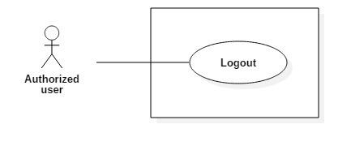

Figure 79: < Authorize Guest > Logout

|  |  |  |  |
| --- | --- | --- | --- |
| **USE CASE - CFOS\_UC\_AU\_01** | | | |
| **Use Case No.** | **CFOS\_UC\_AU\_01** | **Use Case Version** | 1.0 |
| **Use Case Name** | Logout | | |
| **Author** | HuyND | | |
| **Date** | 23/06/2019 | **Priority** | Normal |
| **Actor:**   * Authorized user   **Summary:**   * This use case allows user to logout to the system.   **Goal:**   * Successfully logout   **Trigger:**   * User send a Logout command.   **Precondition:**   * The user has logged into the system   **Post Conditions:**   * Success: User logout to the system successfully and move home page. * Fail: Show error messages   **Main Success Scenario:**   |  |  |  | | --- | --- | --- | | **Step** | **Actor Action** | **System Response** | | 1 | Users press on the user icon at the menu bar | Display functions for users | | 2 | User press [Logout] button | The system show message “Logout successfully” and redirect to home page  [Exception 1] |   **Exception 1:**   |  |  |  | | --- | --- | --- | | **Step** | **Cause** | **System Response** | | 1 | When the connection to the server is lost | System shows message the " Kiểm tra kết nối của bạn " when the internet is lost. |   **Relationship:** N/A.  **Business rule:**   * After logout, role will be guest and only use guest functions | | | |

Table 77 < Authorize Guest > Logout

##### **2.3.9.2. <Authorize Guest> Change Password**

Figure 80: < Authorize Guest > Change Password

|  |  |  |  |
| --- | --- | --- | --- |
| **USE CASE – CFOS\_UC\_ AU\_04** | | | |
| **Use Case No.** | **CFOS\_UC\_AU\_04** | **Use Case Version** | 1.0 |
| **Use Case Name** | Change password | | |
| **Author** | HuyND | | |
| **Date** | 23/06/2018 | **Priority** | Normal |
| **Actor:**   * Authorized user   **Summary:**   * This use case allows authorized user to change password.   **Goal:**   * Authorized user change password successfully.   **Triggers:**   * Authorized user sends change password command to the system.   **Preconditions:**   * The user has logged into the system   **Post conditions:**   * Success: New Password is updated in database * Fail: Show error message   **Main Success Scenario:**   |  |  |  | | --- | --- | --- | | **Step** | **Actor Action** | **System Response** | | 1 | Users press on the user icon at the menu bar | Display functions for users | | 2 | User press [View Profile] button | The system display form include field:   * Old Password: text display “\*”, required * New Password: text display “\*”, required * Confirm New Pasword: text display “\*”, required | | 2 | Authorized user input field |  | | 2 | Authorized user press [Change Password] button | System update new password  [Exception 1]  [Exception 2]  [Exception 3]  [Exception 4] |   **Exceptions 1:**   |  |  |  | | --- | --- | --- | | **No** | **Cause** | **System Response** | | 1 | Authorized user input wrong old password | Show message “Old password isn’t correct” |   **Exceptions 2:**   |  |  |  | | --- | --- | --- | | **No** | **Cause** | **System Response** | | 1 | Authorized user inputs new password that does not match with confirm new password. | Show message “New Password and Confirm New Password aren’t match” |   **Exceptions 3:**   |  |  |  | | --- | --- | --- | | **No** | **Cause** | **System Response** | | 1 | Authorized user inputs new password that match with old password. | Show message “The new password cannot be the same as the old password” |   **Exceptions 4:**   |  |  |  | | --- | --- | --- | | **No** | **Cause** | **System Response** | | 1 | When the connection to the server is lost | System shows message the " Kiểm tra kết nối của bạn " when the internet is lost. |   **Relationships:** N/A  **Business Rules:**   * New password and confirm new password must be matched. * New password must be encrypted before store in database. | | | |

Table 78 < Authorize Guest > Change Password

##### **2.3.9.3. <Authorize Guest> View Profile**

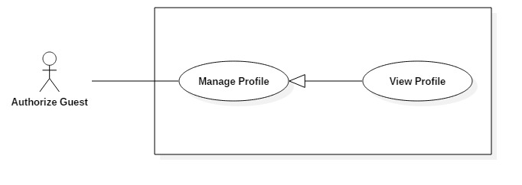

Figure 81: < Authorize Guest > View profile

|  |  |  |  |
| --- | --- | --- | --- |
| **USE CASE - CFOS\_UC\_AU\_04** | | | |
| **Use Case No.** | **CFOS\_UC\_AU\_04** | **Use Case Version** | 1.0 |
| **Use Case Name** | View Profile | | |
| **Author** | HuyND | | |
| **Date** | 23/06/2019 | **Priority** | Normal |
| **Actor:**  Authorized user  **Summary:**   * This use case allows user to view profile   **Goal:**   * Display user’s profile.   **Triggers:**   * User send view profile command to the system.   **Preconditions:**   * The user has logged into the system   **Post conditions:**   * Success: Display of full user information. * Fail: Show error message   **Main Success Scenario:**   |  |  |  | | --- | --- | --- | | **Step** | **Actor Action** | **System Response** | | 1 | Users press on the user icon at the menu bar | Display functions for users | | 2 | User press [View Profile] button | The system display form include field:   * Name: text, * Email: text, * Phone: number, * Profile’s image: image, * Password: text   [Exception 1] |   **Exception 1:**   |  |  |  | | --- | --- | --- | | **Step** | **Cause** | **System Response** | | 1 | When the connection to the server is lost | System shows message the " Kiểm tra kết nối của bạn " when the internet is lost. |   **Relationships:** N/A.  **Business Rules:**   * All field was disabled | | | |

Table 79 < Authorize Guest > View profile

##### **2.3.9.4. <Authorize Guest> Edit Profile**

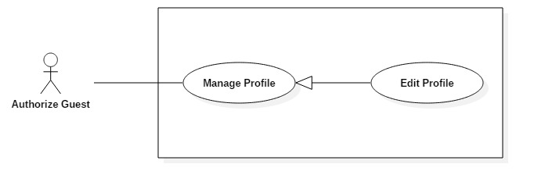

Figure 82: < Authorize Guest > Edit profile

|  |  |  |  |
| --- | --- | --- | --- |
| **USE CASE - CFOS\_UC\_** | | | |
| **Use Case No.** | **CFOS\_UC\_AU\_04** | **Use Case Version** | 1.0 |
| **Use Case Name** | Edit profile | | |
| **Author** | HuyND | | |
| **Date** | 23/06/2019 | **Priority** | Normal |
| **Actor:**   * Authorized user   **Summary:**   * This use case allows user to edit user’s profile   **Goal:**   * Edit successfully user’s profile.   **Triggers:**   * User send edit profile command to the system.   **Preconditions:**   * The user has logged into the system   **Post conditions:**   * Success: The profile was edit successfully. * Fail: Show error message   **Main Success Scenario:**   |  |  |  | | --- | --- | --- | | **Step** | **Actor Action** | **System Response** | | 1 | Users press on the user icon at the menu bar | Display functions for users | | 2 | User press [Cập nhật thông tin] button | The system display form include field:   * Text: text, * Email: text, * Điện thoại: number, * Ảnh đại diện: image, | | 3 | The user fills in the field which user wants to change the information |  | | 4 | User press [Gửi] button | System shows message “Cập nhật thành công”  [Exception 1]  [Exception 2]  [Exception 3] |   **Exception 1:**   |  |  |  | | --- | --- | --- | | **No** | **Cause** | **System Response** | | 1 | Edit profile fail. (Wrong format) | The system shows an error message “Nhập sai thông tin. Vui lòng nhập cho chính xác” |   **Exception 2:**   |  |  |  | | --- | --- | --- | | **No** | **Cause** | **System Response** | | 1 | Edit profile fail. (Does not contain special characters) | The system shows an error message “Định dạng ảnh không hợp lệ” |   **Exception 3:**   |  |  |  | | --- | --- | --- | | **Step** | **Cause** | **System Response** | | 1 | When the connection to the server is lost | System shows message the " Kiểm tra kết nối của bạn " when the internet is lost. |   **Relationships:** N/A.  **Business Rules:**   * The user must fill information with the correct character and format | | | |

Table 80 < Authorize Guest > Edit profile.

## **3. Software System Attribute**

### **3.1. Usability**

* Font style: Arial, Open Sans
* Font size: 12-46px.
* Color: black, white, green, orange, red...
* Background: white, black, green, blue...
* The Kiosk screen built for many users, so that UI-UX problem is carefully considered. Single Page Application Concept is applied.
* We design the Waiting screen so that users can easily track their orders.

### **3.2. Reliability**

* The information in the database is correctness.
* Picture of food, category is taken by graphic team.
* The functions (determined by the specifications) are low error rate.
* Third party APIs are from trusted provider (Expo)

### **3.3. Availability**

* The system server must be available 24/7.

### **3.4. Security**

* The user logging into system is authorized by an access token.
* Customer’s password is md5 encrypted before being transmitted.

### **3.5. Maintainability**

* The system is divided into separated modules suitability for debugging (localization and correction of errors) and for modification and extension of functionality.
* Apply some design patterns (Constant Data Manager, Micro Service architecture, Hibernate Architecture, Repository pattern...) to minimize code change and clearly source code.

### **3.6. Portability**

* Web application can run on Google Chrome 69 or above, Internet Explorer 9 and above...
* The application mobile is available for all smartphone running on Android Nougat and above.

### **3.7. Performance**

* We tried to limit the use of loops and declare unnecessary variables.
* StringBuilder replaces for “+” or “+=” to connect string.
* Use Primitives when possible.

## **4. Conceptual Diagram**

Figure 83: Conceptual diagram

|  |  |
| --- | --- |
| **ENTITY DATA DICTIONARY: DESCRIBE ALL CONTENT OF ALL ENTITIES** | |
| **Entity Name** | **Description** |
| Employee | Contain employee information |
| Food Court | Contain food court information |
| Store | Contain the store information |
| Category | Contain category information |
| Transaction | Contain construction information |
| User | Contain user information |
| Order | Contain order information |
| Food | Contain food information |
| Wallet | Contain wallet information of customer |
| Customer | Contain customer information |
| Feedback | Contain feedback about food of customer |

# **D. Software Design Description**

## **1.** **Design Overview**

In this document, it describes all technical and user interface of CFOS system. It includes the architectural design, the detailed design of common functions and business functions and the design of database model.

The system architectural design describes the overview architecture of the system and the architecture of each main component and subsystem.

The detailed design describes structure for each components and functions. It includes class diagrams, class diagrams explanations and interaction Diagram for each use cases.

The database design describes the relationships between entities and details of each entity.

Design overview:

* Section 2: System Architecture Design: Give an overview of the whole system. Includes both main technology and component and subsystem.
* Section 3: Component Diagram: provides component diagrams that describe the connection and integration of the system.
* Section 4: Detail Description: Provide detailed design values ​​that contain class diagram, class explanation, activity diagram and sequence diagram to details the application functions.
* Section 5: Interface: Describe screens design.
* Section 6: Database Design: ERD diagram and describe attributed of ERD.
* Section 7: Algorithms: Describe algorithms.

## **2.** **System Architecture Design**

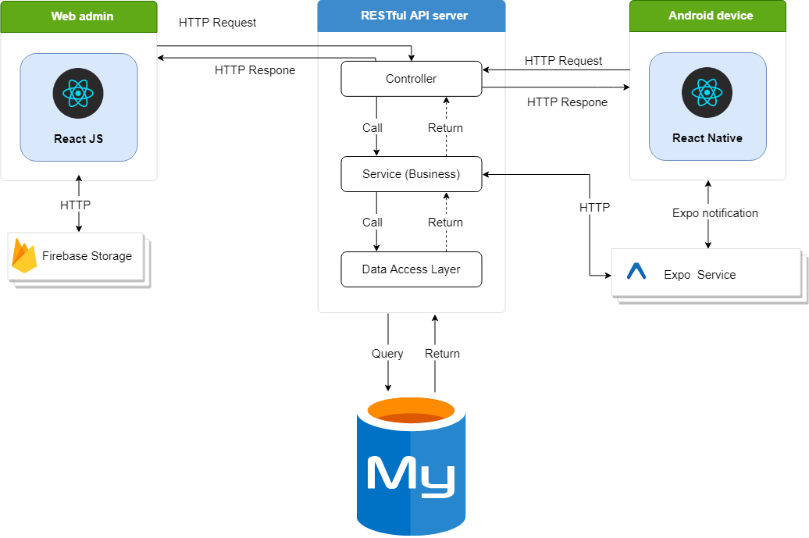

Figure 84: System Architecture Design diagram

### **2.1. Client:**

In client web application, we choose to develop the system in Single Page Application approach because of the following advantages:

* Provide rich user interface with many features, preferable for C2C or B2C products
* Better UX/UI for end users for quick data loading and background fetching
* React JS is easy to master
* It is a light-weighted framework comparing to other popular ones today

In CFOS mobile application, we choose to develop the system with React Native because of the following advantages:

* Mobile app can be built with the help of Web technology which enables any web developer to easily enhance his/her skills and create React apps.
* Saves time and cost to build mobile apps on multiple platforms.
* A React Native app ensures speed and agility for the mobile apps with responsiveness and a great native app based user experience.

#### **2.1.1. Wed admin**

Web admin is written in React JS and related support libraries. We choose to develop the system in Single Page Application approach because of the following advantages:

Better UX/UI for end users for quick data loading and background fetching

ReactJS is good choice for develop web application

Use react-to-print lib to print the receipt

Use Axios call Restful API

Use Ant Design and bootstrap build interface

#### **2.1.2. Wed order – Kiosk**

In Kiosk web application, we choose to develop the system in Single Page Application approach because of the following advantages:

Better UX/UI for end users for quick data loading and background fetching

ReactJS is good choice for develop web application

Use react-to-print lib to print the receipt

Use Axios call Restful API

Use Ant Design and bootstrap build interface

#### **2.1.3. Mobile application**

Mobile Application is written in React-Native and related support libraries. Mobile application used for customer of food court. They can order via mobile and manage personal information.

### **2.2. Server system:**

* Because web and mobile are two independent applications. So Client-Server model is most suitable for our system. By the way, MVC model is also applied. It makes building - developing - managing - operating and maintaining a project easier.
* RestApi is a very important part of the server. Changing information between clients and servers via HTTP protocol. Web API itself works on the HTTP protocol as a URL. The result returned is JSON format.
* Business Logic Layer: This is where the controller's data manipulation requirements meet. handle data source from controller before passing Data Access Layer and save to database. This is also a place to check data binding, integrity and validity, perform calculations and handle business requests, before returning the results to client.
* Data access Layer: It has the function of communicating with the database management system such as performing tasks related to data storage and querying (searching, adding, deleting, editing, ...).
* MySQL: Is has many advantaged. MySQL is the most popular open source database due to its stability and fast processing mechanism, is widely used and trusted.

## **3.** **Component Diagram**

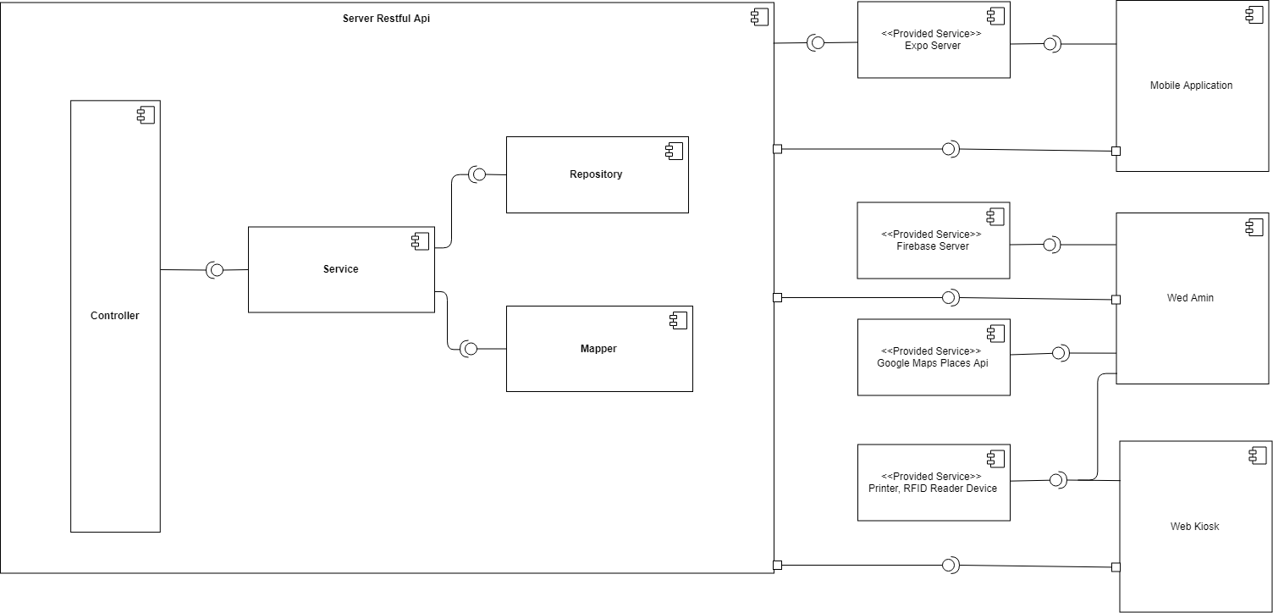

Figure 85: Component Diagram

All of service in Service restful API have dependence with each other.

|  |  |
| --- | --- |
| **Component dictionary** | |
| **Component name** | **Description** |
| Controller | Handle requests and responses; accept input and convert it to commands for model and view. |
| Service | Services are responsible for managing the business model of the system |
| Repository | A service responsible for interaction of data. |
| Mapper | A service responsible for interaction between view model and model. |
| Expo notification Service | A service responsible for interaction between server and mobile application via notification. |
| Firebase Storage Service | A service responsible for managing image of data system. |
| Mobile Application | A mobile Application use for customer. |
| Wed Admin | A wed use for system admin, employee, manger. |
| Web Kiosk | A web use for visitor and customer. |
| Google Maps Places API | The Places API is a service that returns information about places using HTTP requests. Places are defined within this API as establishments, geographic locations, or prominent points of interest. |
| Printer, RFID reader device | Print bill from Kiosk and web-admin, RFID reader get customer information. |

Table 81 Component dictionary

## **4.** **Detailed Description**

### **4.1. Class Diagram**

**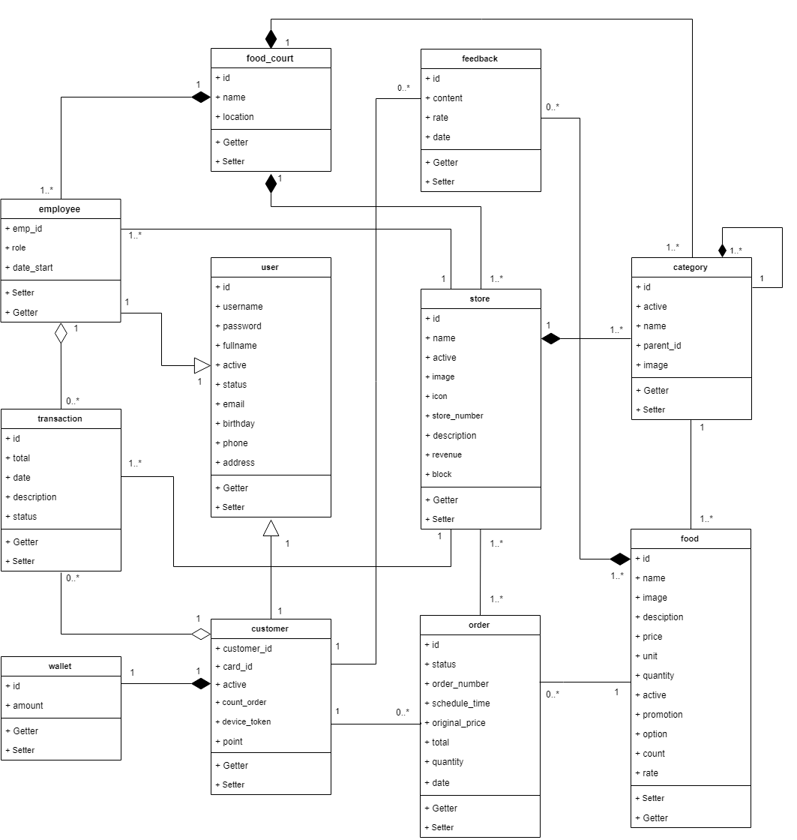**

Figure 86: Class Diagram

### **4.2. Class Diagram Explanation**

|  |  |  |
| --- | --- | --- |
| **CLASS DICTIONARY: DESCRIBE CLASS** | | |
| **Class Name** | **Mapping column with Conceptual diagram** | **Description** |
| food\_court | food\_court | Contain the food court information. |
| employee | employee | Contain the employee information. |
| user | user | Contain more information of customer and employee. |
| customer | customer | Contain the customer information. |
| wallet | wallet | Contain the wallet information of customer. |
| transaction | transaction | Contain the transaction information. |
| store | store | Contain the store information. |
| category | category | Contain the category information. |
| food | food | Contain the food information. |
| feedback | feedback | Contain the feedback information. |
| order | order | Contain the order information. |

Table 82 Class dictionary: describe class

#### **4.2.1.** **Food\_court**

|  |  |  |  |
| --- | --- | --- | --- |
| **Attribute** | **Type** | **Visibility** | **Description** |
| Id | Long | private | Unique identity key of a food court |
| Name | String | private | Name of this food court |
| Location | String | private | Location of this food court |

Table 83 Class diagram – Food court attribute

|  |  |  |  |
| --- | --- | --- | --- |
| **Method** | **Return Type** | **Visibility** | **Description** |
| Getter | Attribute type | Public | Get attribute value |
| Setter | Void | Public | Set value of attribute |

Table 84 Class diagram – Food court method

#### **4.2.2.** **Employee**

|  |  |  |  |
| --- | --- | --- | --- |
| **Attribute** | **Type** | **Visibility** | **Description** |
| Emp\_id | String | private | Unique identity key of a employee |
| Role | String | private | Role of this employee |
| Date\_start | Date time | private | Date this employee start |

Table 85 Class diagram – Employee attribute

|  |  |  |  |
| --- | --- | --- | --- |
| **Method** | **Return Type** | **Visibility** | **Description** |
| Getter | Attribute type | Public | Get attribute value |
| Setter | Void | Public | Set value of attribute |

Table 86 Class diagram – Employee method

#### **4.2.3.** **User**

|  |  |  |  |
| --- | --- | --- | --- |
| **Attribute** | **Type** | **Visibility** | **Description** |
| id | Long | private | Unique identity key of a User |
| Username | String | private | Username of this user |
| Password | String | private | Password of this user |
| Fullname | String | private | Full name of this user |
| Active | Boolean | private | This user is active or not active |
| Status | String | private | Status of this user: initial, block, “” |
| Email | String | private | Email of this user |
| Birthday | Date time | private | Birthday of this user |
| Phone | String | private | Phone of this user |
| Address | String | private | Address of this user |

Table 87 Class diagram – User attribute

|  |  |  |  |
| --- | --- | --- | --- |
| **Method** | **Return Type** | **Visibility** | **Description** |
| Getter | Attribute type | Public | Get attribute value |
| Setter | Void | Public | Set value of attribute |

Table 88 Class diagram – User method

#### **4.2.4.** **Customer**

|  |  |  |  |
| --- | --- | --- | --- |
| **Attribute** | **Type** | **Visibility** | **Description** |
| Customer\_id | Long | private | Unique identity key of a Customer |
| Card\_id | String | private | Card id of this customer |
| Active | Boolean | private | This customer is active or not |
| Count\_order | Integer | private | Total number of customer’s order |
| Device\_token | String | private | Device token of customer |
| Point | Double | private | Point of customer |

Table 89 Class diagram – Customer attribute

|  |  |  |  |
| --- | --- | --- | --- |
| **Method** | **Return Type** | **Visibility** | **Description** |
| Getter | Attribute type | Public | Get attribute value |
| Setter | Void | Public | Set value of attribute |

Table 90 Class diagram – Customer method

#### **4.2.5.** **Wallet**

|  |  |  |  |
| --- | --- | --- | --- |
| **Attribute** | **Type** | **Visibility** | **Description** |
| Id | Long | private | Unique identity key of a Wallet |
| Amount | double | private | Current customer’s balance |

Table 91 Class diagram – Wallet attribute

|  |  |  |  |
| --- | --- | --- | --- |
| **Method** | **Return Type** | **Visibility** | **Description** |
| Getter | Attribute type | Public | Get attribute value |
| Setter | Void | Public | Set value of attribute |

Table 92 Class diagram – Wallet method

#### **4.2.6.** **Transaction**

|  |  |  |  |
| --- | --- | --- | --- |
| **Attribute** | **Type** | **Visibility** | **Description** |
| Id | Long | private | Unique identity key of a Transaction |
| Total | Double | private | Total money of this transaction |
| Date | Date time | private | Date implement this transaction |
| Description | String | private | Description of this transaction |
| Status | String | private | Status of this transaction |

Table 93 Class diagram – Transaction attribute

|  |  |  |  |
| --- | --- | --- | --- |
| **Method** | **Return Type** | **Visibility** | **Description** |
| Getter | Attribute type | Public | Get attribute value |
| Setter | Void | Public | Set value of attribute |

Table 94 Class diagram – Transaction method

#### **4.2.7.** **Store**

|  |  |  |  |
| --- | --- | --- | --- |
| **Attribute** | **Type** | **Visibility** | **Description** |
| Id | Long | private | Unique identity key of a Store |
| Name | String | private | Store’s name |
| Active |  | private | Store is active or not |
| Image | String | private | Image of this store |
| Icon | String | private | Logo of this store |
| Store\_number | Integer | private | Number of store in food court |
| Description | String | private | Description about store |
| Revenue | Double | private | Revenue of this store |
| block |  | private | Block of this store |

Table 95 Class diagram – Store attribute

|  |  |  |  |
| --- | --- | --- | --- |
| **Method** | **Return Type** | **Visibility** | **Description** |
| Getter | Attribute type | Public | Get attribute value |
| Setter | Void | Public | Set value of attribute |

Table 96 Class diagram – Store method

#### **4.2.8.** **Category**

|  |  |  |  |
| --- | --- | --- | --- |
| **Attribute** | **Type** | **Visibility** | **Description** |
| Id | Long | private | Unique identity key of a Category |
| Name | String | private | Category’s name |
| Active | Boolean | private | Category is active or not |
| Image | String | private | Category’s image |
| Parent\_id | Long | private | Parent id of this category |

Table 97 Class diagram – Category attribute

|  |  |  |  |
| --- | --- | --- | --- |
| **Method** | **Return Type** | **Visibility** | **Description** |
| Getter | Attribute type | Public | Get attribute value |
| Setter | Void | Public | Set value of attribute |

Table 98 Class diagram – Category method

#### **4.2.9.** **Food**

|  |  |  |  |
| --- | --- | --- | --- |
| **Attribute** | **Type** | **Visibility** | **Description** |
| Id | Long | private | Unique identity key of a Food |
| Name | String | private | Food’s name |
| Image | String | private | Image of this food |
| Description | String | private | Description about this food |
| Price | Double | private | Price of this food |
| Unit | String | private | Unit of this food |
| Quantity | Integer | private | Quantity food |
| Active | Boolean | private | Food is active or not |
| Promotion | Double | private | Promotion of this food |
| Option | String | private | Option of this food |
| Count | Integer | private | The number of food |
| Rate | Double | private | Total rating of this food |

Table 99 Class diagram – Food attribute

|  |  |  |  |
| --- | --- | --- | --- |
| **Method** | **Return Type** | **Visibility** | **Description** |
| Getter | Attribute type | Public | Get attribute value |
| Setter | Void | Public | Set value of attribute |

Table 100 Class diagram – Food method

#### **4.2.10.** **Feedback**

|  |  |  |  |
| --- | --- | --- | --- |
| **Attribute** | **Type** | **Visibility** | **Description** |
| Id | Long | private | Unique identity key of a Feedback |
| Content | String | private | Content of this feedback |
| Rate | Double | private | Rate of this feedback |
| Date | Date time | private | Date write this feedback |

Table 101 Class diagram – Feedback attribute

|  |  |  |  |
| --- | --- | --- | --- |
| **Method** | **Return Type** | **Visibility** | **Description** |
| Getter | Attribute type | Public | Get attribute value |
| Setter | Void | Public | Set value of attribute |

Table 102 Class diagram – Feedback method

#### **4.2.11.** **Order**

|  |  |  |  |
| --- | --- | --- | --- |
| **Attribute** | **Type** | **Visibility** | **Description** |
| Id | Long | private | Unique identity key of a Order |
| Order\_number | Integer | private | Order number of this order |
| Status | String | private | Status of this order |
| Schedule\_time | String | private | Schedule time of this order |
| Original\_price | Double | private | Original of this order |
| Total | Double | private | Total money of this order |
| Quantity | Integer | private | Quantity dish of this order |
| Date | Date time | private | Date submit order |

Table 103 Class diagram – Order attribute

|  |  |  |  |
| --- | --- | --- | --- |
| **Method** | **Return Type** | **Visibility** | **Description** |
| Getter | Attribute type | Public | Get attribute value |
| Setter | Void | Public | Set value of attribute |

Table 104 Class diagram – Order method

### **4.3 Interaction Diagram**

#### **4.3.1.** **Web admin**

##### **4.3.1.1.** **<STORE\_MANAGER> Create food**

Summary: This diagram shows process of store manager create new food for store

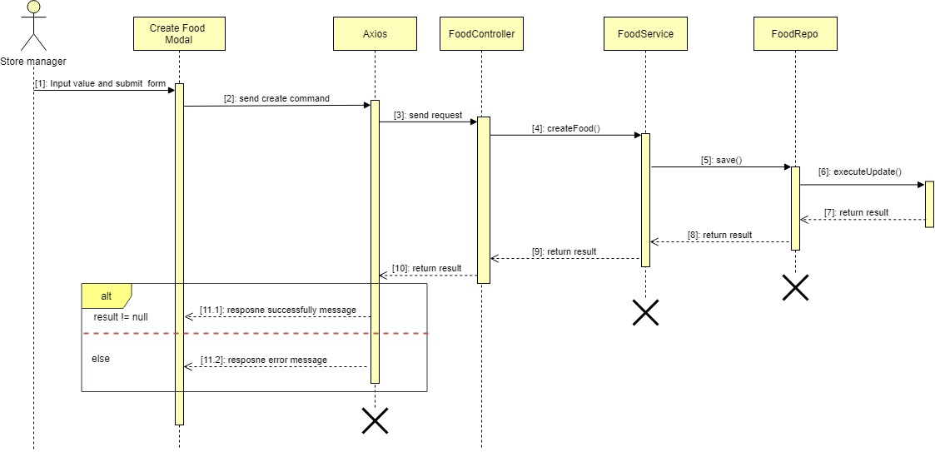

Figure 87: <Store\_Manager> Create food – Sequence diagram – Sequence diagram

##### **4.3.1.2.** **<STORE\_MANAGER>** **Get detail food**

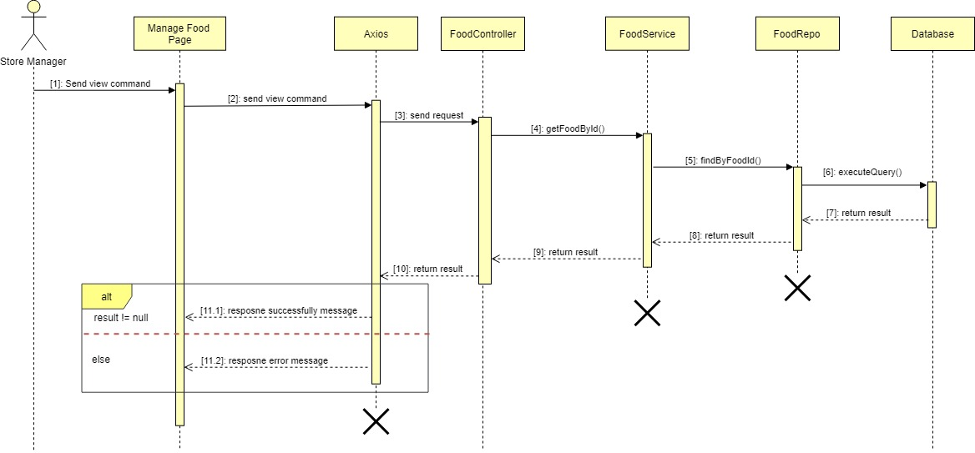Summary: This diagram shows process of store manager view detail food

Figure 88: <Store\_Manager> Get detail food – Sequence diagram

**4.3.1.3.**  **<STORE\_MANAGER>** **Update food**

**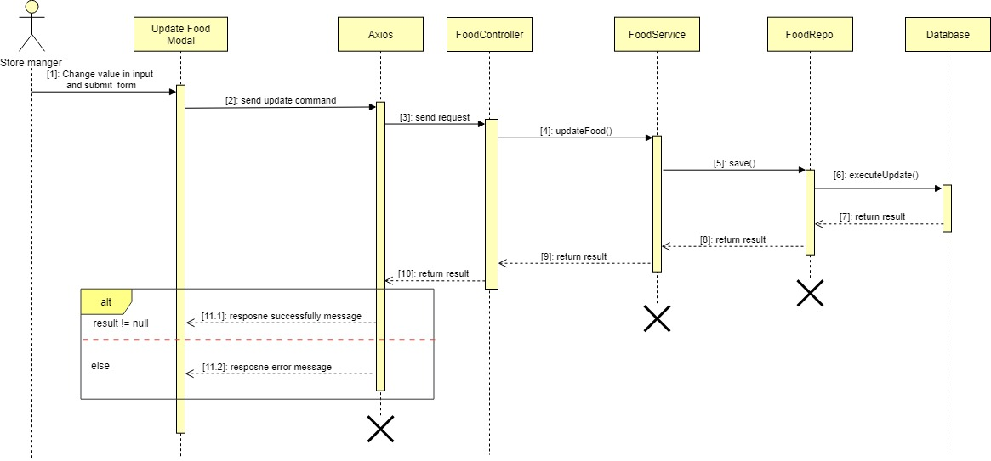**Summary: This diagram shows process of store manager update information for food

Figure 89: <Store\_Manager> Update food– Sequence diagram

**4.3.1.4.**  **<STORE\_MANAGER>** **Delete food**

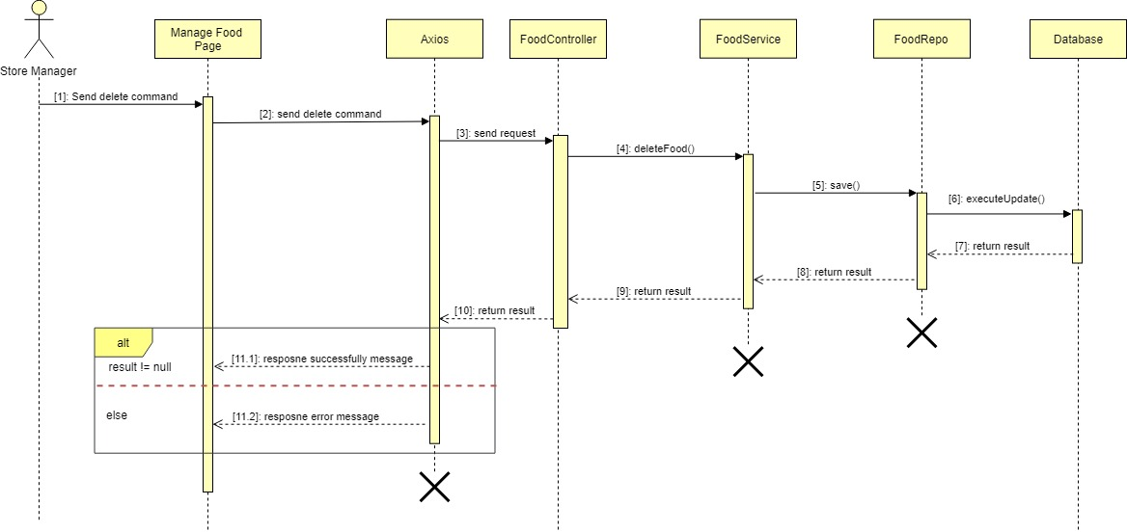Summary: This diagram shows process of store manager hide food from the category

Figure 90: <Store\_Manager> Delete food – Sequence diagram

#### **4.3.2.** **Mobile application**

##### **4.3.2.1.** **Authentication**

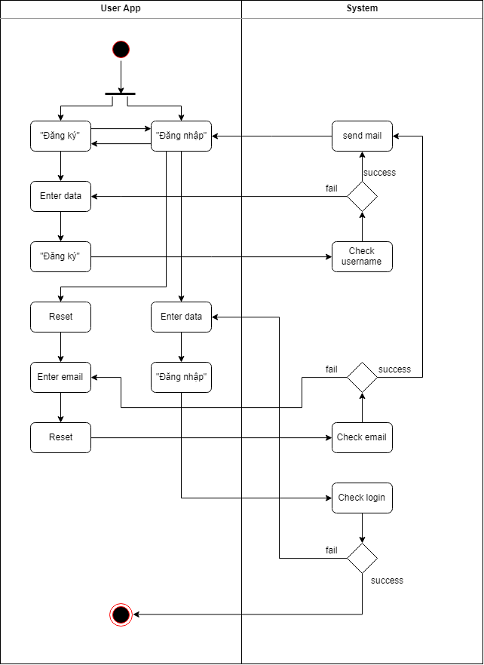

Figure 91: Authencation – Activity diagram

##### C:\Users\Admin\Desktop\Capstone\CFOS\OrderActivityDiagram.png**4.3.2.1.** **Order**

Figure 92: Order - Activity diagram

##### **4.3.2.1.** **Account**

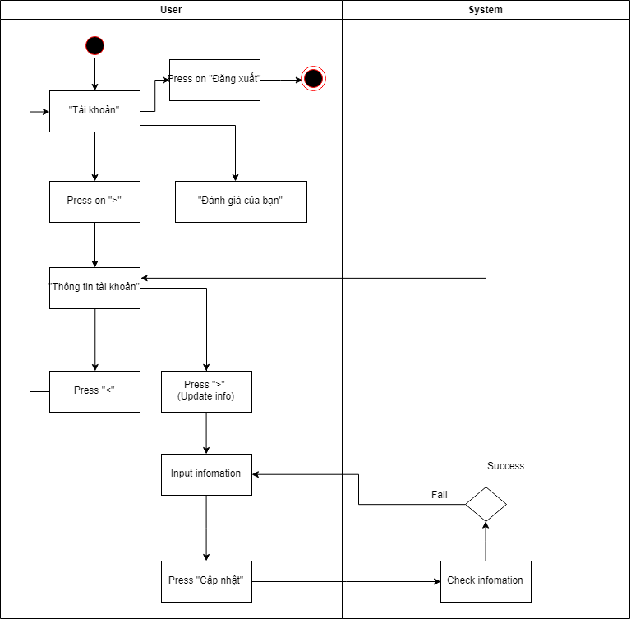

Figure 93: Account - Activity diagram

#### **4.3.3..** **Kiosk** - **Web application**

##### **4.3.3.1.** **<GUEST>** **View list food by category**

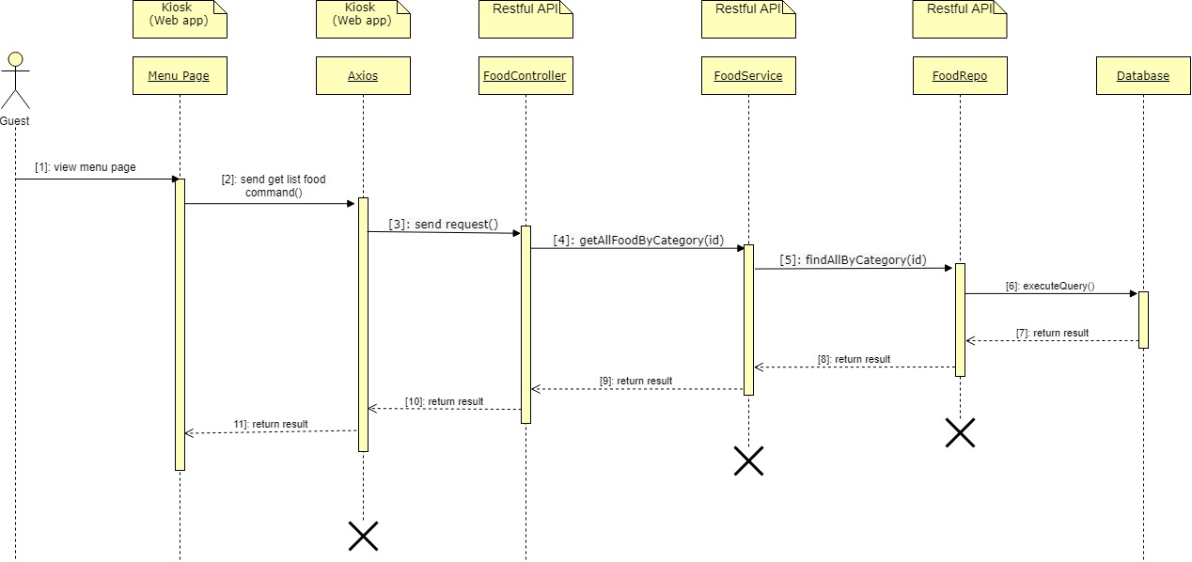Summary: This diagram shows the process of guest view list food by category

Figure 94: <Guest> View list food by category – Sequence diagram

##### **4.3.3.2.** **<GUEST> Order food**

Summary: From the list of food based on the diagram [**View list food by category**], this diagram shows the process of guest ordering food and payment

**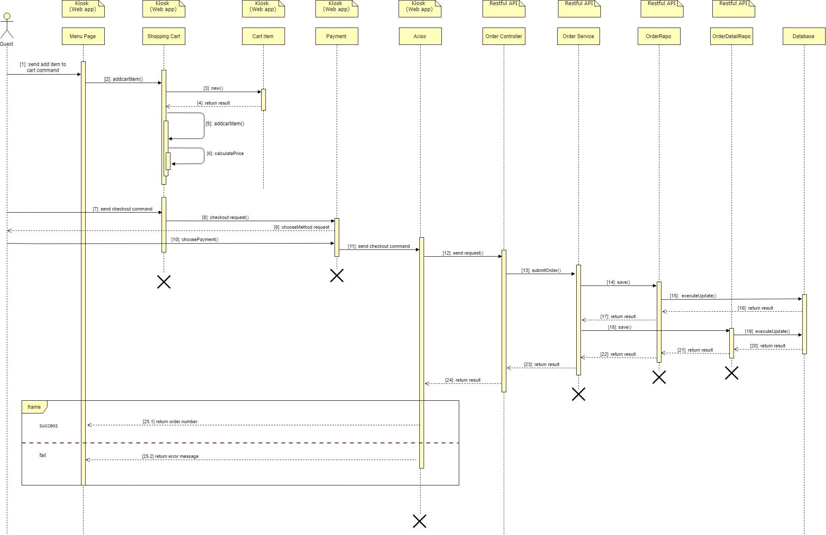**

Figure 95: < Guest > Order kiosk processing – Sequence diagram

##### **4.3.3.2.** **<GUEST> Check status of each food by order number**

Summary: This diagram shows the process of guest check the status of each dish according to the order number

**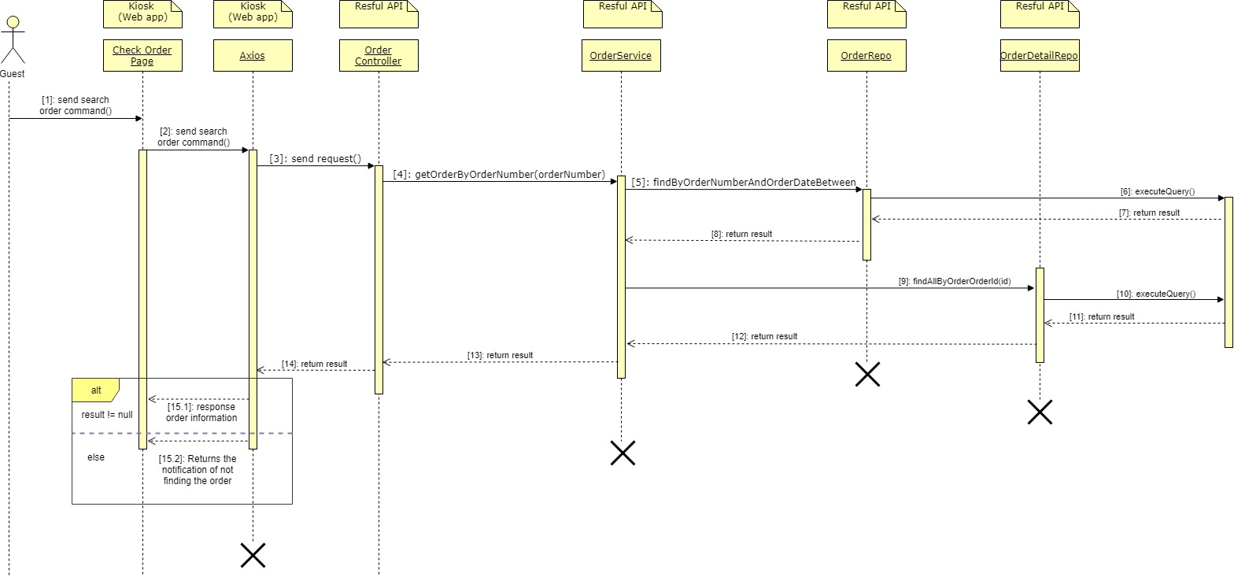**

Figure 96: < Guest > Get detail food – Sequence diagram

### **4.4 State chart diagram**

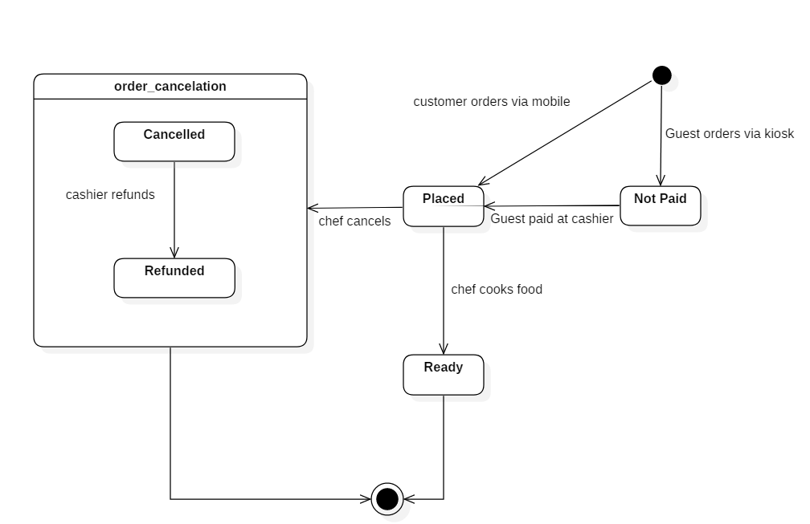

Figure 97: State chart of order detail.

## **5. Interface**

### **5.1.Component Interface**

### **5.2. User Interface Design**

#### **5.2.1.** **Web admin**

##### **5.2.1.1.** **Login**

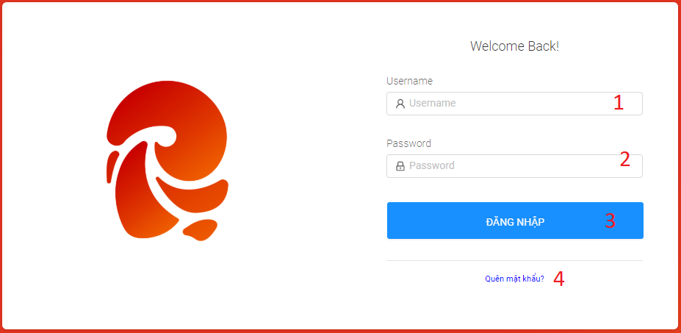

Figure 98: < UI Interface > Login

**Fields**

|  |  |  |  |  |  |  |
| --- | --- | --- | --- | --- | --- | --- |
| **No** | **Field Name** | **Description** | **Read only** | **Mandatory** | **Control Type** | **Data Type** |
| 1 | Username | Username to login | No | Yes | Text Box | String |
| 2 | Password | Password to login | No | Yes | Text Box | String |

Table 105 <Fields> Login

**Buttons/Hyperlinks:**

|  |  |  |  |  |
| --- | --- | --- | --- | --- |
| **No** | **Function** | **Description** | **Validation** | **Outcome** |
| 3 | Login | Login into the system | Required | User logged in into the system |
| 4 | Forgot password | Open modal forgot password | N/A | Open modal forgot password |

Table 106 < Buttons/Hyperlinks > Login

##### **5.2.1.2.** **Forgot password**

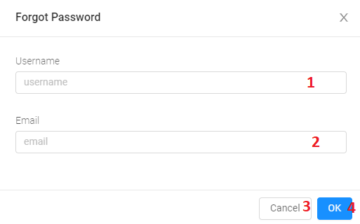

Figure 99: < UI Interface > Forget password

**Fields**

|  |  |  |  |  |  |  |
| --- | --- | --- | --- | --- | --- | --- |
| **No** | **Field Name** | **Description** | **Read only** | **Mandatory** | **Control Type** | **Data Type** |
| 1 | Username | Username to reset password | No | Yes | TextBox | String |
| 2 | Email | Email to reset password | No | Yes | TextBox | String |

Table 107 <Fields> Forget password

**Buttons/Hyperlinks:**

|  |  |  |  |  |
| --- | --- | --- | --- | --- |
| **No** | **Function** | **Description** | **Validation** | **Outcome** |
| 3 | Cancel | Close modal | N/A | Close modal forgot password |
| 4 | Ok | New password is sent to the mail user | Required | New password is sent to the mail user successfully |

Table 108 < Buttons/Hyperlinks > Forget password

##### **5.2.1.3.** **Header Web Admin**



Figure 100: < UI Interface > Header Web Admin

**Fields**

|  |  |  |  |  |  |  |
| --- | --- | --- | --- | --- | --- | --- |
| **No** | **Field Name** | **Description** | **Read only** | **Mandatory** | **Control Type** | **Data Type** |
| 1 | Title | Page’s title | Yes | Yes | Text | String |

Table 109 <Fields> Header Web Admin

**Buttons/Hyperlinks:**

|  |  |  |  |  |
| --- | --- | --- | --- | --- |
| **No** | **Function** | **Description** | **Validation** | **Outcome** |
| 2 | Account | Select function for account | N/A | Choose the method according to the user want |
| 3 | Profile | Update profile | N/A | Open update form ‘s modal for updating account |
| 4 | Change Password | Change password for account | N/A | Open change password form ‘s modal for update password |
| 5 | Logout | Logout account of the system | N/A | Exist system |

Table 110 < Buttons/Hyperlinks > Header Web Admin

##### **5.2.1.4.** **Profile**

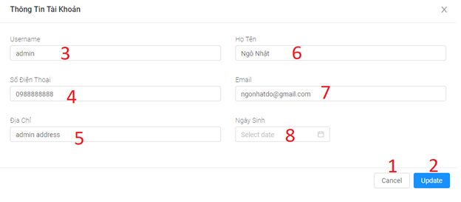

Figure 101: < UI Interface > Profile

**Fields**

|  |  |  |  |  |  |  |
| --- | --- | --- | --- | --- | --- | --- |
| **No** | **Field Name** | **Description** | **Read only** | **Mandatory** | **Control Type** | **Data Type** |
| 3 | Username | User’s username | Yes | Yes | Textbox | String |
| 4 | Số điện thoại | User’s phone | No | Yes | Textbox | Number |
| 5 | Địa chỉ | User’s address | No | Yes | Textbox | String |
| 6 | Họ và tên | User’s fullname | No | Yes | Textbox | String |
| 7 | Email | User’s email | No | Yes | Textbox | String |
| 8 | Ngày sinh | User’s date of birth | No | Yes | Date range picker | Date range |

Table 111 <Fields> Profile

**Buttons/Hyperlinks:**

|  |  |  |  |  |
| --- | --- | --- | --- | --- |
| **No** | **Function** | **Description** | **Validation** | **Outcome** |
| 1 | Cancel | Button for closing update form’s modal | N/A | Close modal |
| 2 | Ok | Submit form | N/A | Create new food court |

Table 112 < Buttons/Hyperlinks > Profile

##### **5.2.1.5. Change Password**

Figure 102: < UI Interface > Change Password

**Fields**

|  |  |  |  |  |  |  |
| --- | --- | --- | --- | --- | --- | --- |
| **No** | **Field Name** | **Description** | **Read only** | **Mandatory** | **Control Type** | **Data Type** |
| 3 | Username | User’s username | Yes | Yes | Textbox | String |
| 4 | Mật khẩu cũ | Account’s old password | No | Yes | Textbox | String |
| 5 | Mật khẩu mới | Account’s new password | No | Yes | Textbox | String |
| 6 | Nhập lại mật khẩu | Check the user to enter the correct password | No | Yes | Textbox | String |

Table 113 <Fields> Change Password

**Buttons/Hyperlinks:**

|  |  |  |  |  |
| --- | --- | --- | --- | --- |
| **No** | **Function** | **Description** | **Validation** | **Outcome** |
| 1 | Cancel | Button for closing update form’s modal | N/A | Close modal |
| 2 | Ok | Submit form | N/A | Create new food court |

Table 114 < Buttons/Hyperlinks > Change Password

##### **5.2.1.6.** **System admin menu**

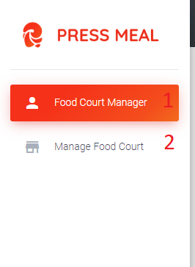

Figure 103: < UI Interface > System admin menu

**Buttons/Hyperlinks:**

|  |  |  |  |  |
| --- | --- | --- | --- | --- |
| **No** | **Function** | **Description** | **Validation** | **Outcome** |
| 1 | Food Court Manager | Manage food court manager link | N/A | Redirect to manage food court manager page |
| 2 | Manage Food Court | Manage food court link | N/A | Redirect to manage food court page |

Table 115 < Buttons/Hyperlinks > System admin menu

**5.2.1.6.1. Manage Food Court Manager**

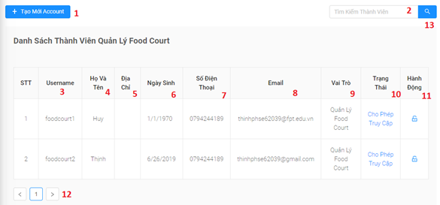

Figure 104: < UI Interface > Manage Food Court Manager

**Fields**

|  |  |  |  |  |  |  |
| --- | --- | --- | --- | --- | --- | --- |
| **No** | **Field Name** | **Description** | **Read only** | **Mandatory** | **Control Type** | **Data Type** |
| 2 | Search | Search value | No | No | Text | String |
| 3 | Username | Food court admin username | No | Yes | Text | String |
| 4 | Họ Và Tên | Food court admin fullname | No | Yes | Text | String |
| 5 | Địa Chỉ | Food court admin address | No | Yes | Text | String |
| 6 | Ngày Sinh | Food court admin birthday | No | Yes | Date | String |
| 7 | Số Điện Thoại | Food court admin phone number | No | Yes | Number | String |
| 8 | Email | Food court admin email | No | Yes | Text | String |
| 9 | Vai trò | Food court admin role | No | Yes | Text | String |
| 10 | Trạng Thái | Food court admin status | No | Yes | Text | String |

Table 116 <Fields> Manage Food Court Manager

**Buttons/Hyperlinks:**

|  |  |  |  |  |
| --- | --- | --- | --- | --- |
| **No** | **Function** | **Description** | **Validation** | **Outcome** |
| 1 | Tạo Mới Account | Open modal create food court manager | N/A | Redirect to modal create food court manager |
| 11 | Hành Động | Update status of food court manager | N/A | Update status of food court manager successfully |
| 12 | Pagination | Pagination for manage staff | N/A | Switch to respective page based on user clicked |
| 13 | Search | Search for food court manager by name | N/A | Update the data on the table and return the search results |

Table 117 < Buttons/Hyperlinks > Manage Food Court Manager

**5.2.1.6.2. Create food court manager**

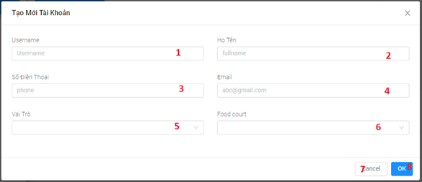

Figure 105: < UI Interface > Create food court manager

**Fields**

|  |  |  |  |  |  |  |
| --- | --- | --- | --- | --- | --- | --- |
| **No** | **Field Name** | **Description** | **Read only** | **Mandatory** | **Control Type** | **Data Type** |
| 1 | Username | Food court admin username | No | Yes | Text Box | String |
| 2 | Họ Tên | Food court admin fullname | No | Yes | Text Box | String |
| 3 | Số Điện Thoại | Food court admin phone number | No | Yes | Text Box | Integer |
| 4 | Email | Food court admin email | No | Yes | Text Box | String |
| 5 | Vai trò | Food court admin role | No | Yes | Select Box | String |
| 6 | Food court | Food court admin location | No | Yes | Select Box | String |

Table 118 <Fields> Create food court manager

**Buttons/Hyperlinks:**

|  |  |  |  |  |
| --- | --- | --- | --- | --- |
| **No** | **Function** | **Description** | **Validation** | **Outcome** |
| 7 | Cancel | Close modal | N/A | Close modal create food court manager |
| 8 | Ok | Add new food court manager | N/A | Add new food court manager successfully |

Table 119 < Buttons/Hyperlinks > Create food court manager

**5.2.1.6.3. Update food court manager**

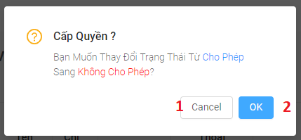

Figure 106: < UI Interface > Update food court manager

**Buttons/Hyperlinks:**

|  |  |  |  |  |
| --- | --- | --- | --- | --- |
| **No** | **Function** | **Description** | **Validation** | **Outcome** |
| 1 | Cancel | Close modal | N/A | Close modal update food court manager |
| 2 | Ok | Update status food court manager | N/A | Update status food court manager successfully |

Table 120 < Buttons/Hyperlinks > Update food court manager

**5.2.1.6.4. Manage food court****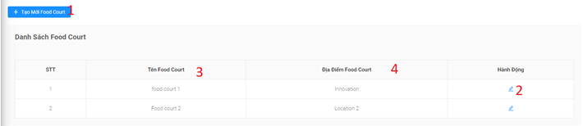**

Figure 107: < UI Interface > Manage food court

**Fields**

|  |  |  |  |  |  |  |
| --- | --- | --- | --- | --- | --- | --- |
| **No** | **Field Name** | **Description** | **Read only** | **Mandatory** | **Control Type** | **Data Type** |
| 3 | Name | Food court’s name | Yes | Yes | Text | String |
| 4 | Location | Food court’s location | Yes | No | Text | String |

Table 121 <Fields> Manage food court

**Buttons/Hyperlinks:**

|  |  |  |  |  |
| --- | --- | --- | --- | --- |
| **No** | **Function** | **Description** | **Validation** | **Outcome** |
| 1 | Create Food Court | Button for create new food court | N/A | Open create form ‘s modal for creating a new food court |
| 2 | Update | Button to update food court | N/A | Open update form ‘s modal for updating food court |

Table 122 < Buttons/Hyperlinks > Manage food court

**5.2.1.6.5. Create food court****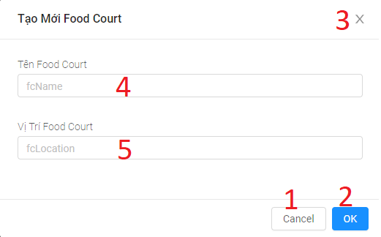**

Figure 108: < UI Interface > Create food court

**Fields**

|  |  |  |  |  |  |  |
| --- | --- | --- | --- | --- | --- | --- |
| **No** | **Field Name** | **Description** | **Read only** | **Mandatory** | **Control Type** | **Data Type** |
| 3 | Name | Food court’s name | No | Yes | Text | String |
| 4 | Location | Food court’s location | No | No | Text | String |

Table 123 <Fields> Create food court

**Buttons/Hyperlinks:**

|  |  |  |  |  |
| --- | --- | --- | --- | --- |
| **No** | **Function** | **Description** | **Validation** | **Outcome** |
| 1 | Cancel | Button for closing create form’s modal | N/A | Close modal |
| 2 | Ok | Submit form | N/A | Create new food court |
| 3 | X | Button for closing create form’s modal | N/A | Close modal |

Table 124 < Buttons/Hyperlinks > Create food court

**5.2.1.6.6. Update food court**

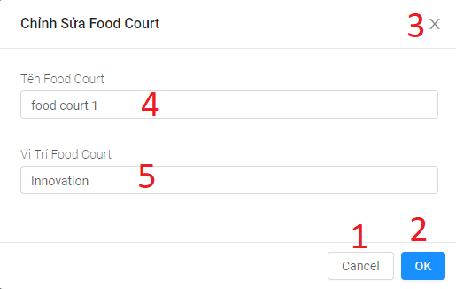

Figure 109: < UI Interface > Update food court

**Fields**

|  |  |  |  |  |  |  |
| --- | --- | --- | --- | --- | --- | --- |
| **No** | **Field Name** | **Description** | **Read only** | **Mandatory** | **Control Type** | **Data Type** |
| 3 | Name | Food court’s name | No | Yes | Text | String |
| 4 | Location | Food court’s location | No | No | Text | String |

Table 125 <Fields> Update food court

**Buttons/Hyperlinks:**

|  |  |  |  |  |
| --- | --- | --- | --- | --- |
| **No** | **Function** | **Description** | **Validation** | **Outcome** |
| 1 | Cancel | Button for closing create form’s modal | N/A | Close modal |
| 2 | Ok | Submit form | N/A | Create new food court |
| 3 | X | Button for closing create form’s modal | N/A | Close modal |

Table 126 < Buttons/Hyperlinks > Update food court

##### **5.2.1.7.** **Menu food court admin**

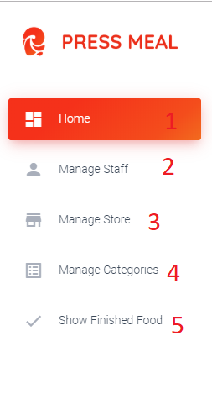

Figure 110: < UI Interface > Menu food court admin

**Buttons/Hyperlinks:**

|  |  |  |  |  |
| --- | --- | --- | --- | --- |
| **No** | **Function** | **Description** | **Validation** | **Outcome** |
| 1 | View static | View static link | N/A | Redirect to view static page |
| 2 | Manage Staff | Manage staff link | N/A | Redirect to manage staff page |
| 3 | Manage Store | Manage Store link | N/A | Redirect to manage store page |
| 4 | Manage Categories | Manage Categories link | N/A | Redirect to manage categories page |
| 5 | Show Finished food | Show Finished food link | N/A | Redirect to the screen of finished dishes page |

Table 127 < Buttons/Hyperlinks > Menu food court admin

**5.2.1.7.1. Manage staff**

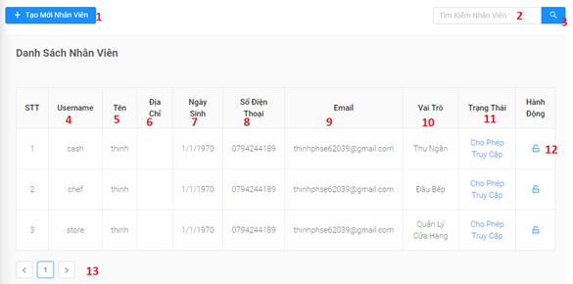

Figure 111: < UI Interface > Manage staff

**Fields**

|  |  |  |  |  |  |  |
| --- | --- | --- | --- | --- | --- | --- |
| **No** | **Field Name** | **Description** | **Read only** | **Mandatory** | **Control Type** | **Data Type** |
| 2 | Search | Search value | No | No | Text | String |
| 4 | Username | Staff’s username | Yes | Yes | Text | String |
| 5 | Tên | Staff’s fullname | Yes | Yes | Text | String |
| 6 | Địa Chỉ | Staff’s address | Yes | Yes | Text | String |
| 7 | Ngày Sinh | Staff’s birthday | Yes | Yes | Text | Date |
| 8 | Số Điện Thoại | Staff’s phone number | Yes | Yes | Text | Integer |
| 9 | Email | Staff’s email | Yes | Yes | Text | String |
| 10 | Vai trò | Staff’s role | Yes | Yes | Text | String |
| 11 | Trạng Thái | Food court admin status | No | Yes | Text | String |

Table 128 <Fields> Manage staff

**Buttons/Hyperlinks:**

|  |  |  |  |  |
| --- | --- | --- | --- | --- |
| **No** | **Function** | **Description** | **Validation** | **Outcome** |
| 1 | Tạo Mới Nhân Viên | Open modal create staff | N/A | Redirect to modal create staff |
| 12 | Chỉnh Sửa Quyền Truy Cập | Update status of staff | N/A | Update status of food court manager successfully |
| 13 | Pagination | Pagination for manage staff | N/A | Switch to respective page based on user clicked |
| 3 | Search | Search for staff by name | N/A | Update the data on the table and return the search results |

Table 129 < Buttons/Hyperlinks > Manage staff

5.2.1.7.2. Create staff**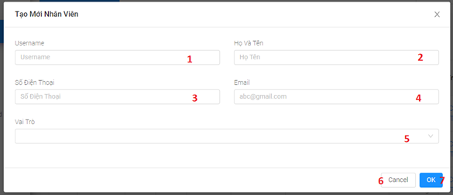**

Figure 112: < UI Interface > Create staff

**Fields**

|  |  |  |  |  |  |  |
| --- | --- | --- | --- | --- | --- | --- |
| **No** | **Field Name** | **Description** | **Read only** | **Mandatory** | **Control Type** | **Data Type** |
| 1 | Username | Staff’s username | No | Yes | Text Box | String |
| 2 | Họ Tên | Staff’s fullname | No | Yes | Text Box | String |
| 3 | Số Điện Thoại | Staff’s phone number | No | Yes | Text Box | Integer |
| 4 | Email | Staff’s email | No | Yes | Text Box | String |
| 5 | Vai trò | Staff’s role | No | Yes | Select Box | String |

Table 130 <Fields> Create staff

**Buttons/Hyperlinks:**

|  |  |  |  |  |
| --- | --- | --- | --- | --- |
| **No** | **Function** | **Description** | **Validation** | **Outcome** |
| 6 | Cancel | Close modal | N/A | Close modal create staff |
| 7 | Ok | Add new staff | N/A | Add new staff successfully |

Table 131 < Buttons/Hyperlinks > Create staff

**5.2.1.7.3. Update staff**

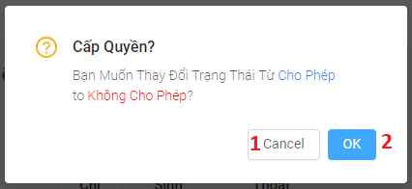

Figure 113: < UI Interface > Update staff

**Buttons/Hyperlinks:**

|  |  |  |  |  |
| --- | --- | --- | --- | --- |
| **No** | **Function** | **Description** | **Validation** | **Outcome** |
| 1 | Cancel | Close modal | N/A | Close modal update staff |
| 2 | Ok | Update status staff | N/A | Update status staff successfully |

Table 132 < Buttons/Hyperlinks > Update staff

**5.2.1.7.4. Manage store****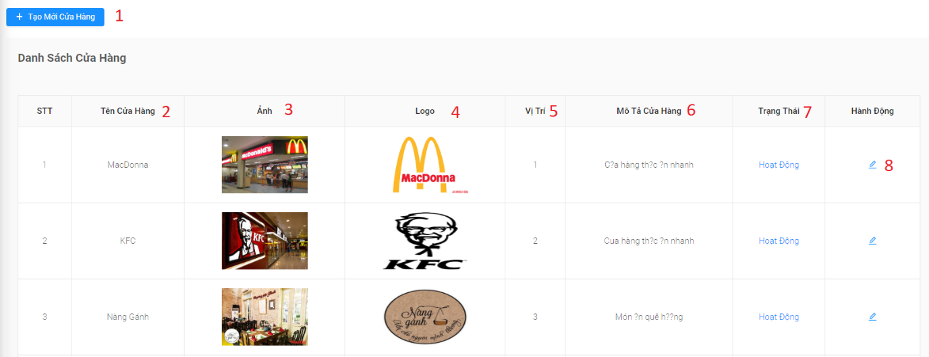**

Figure 114: < UI Interface > Manage store

**Fields**

|  |  |  |  |  |  |  |
| --- | --- | --- | --- | --- | --- | --- |
| **No** | **Field Name** | **Description** | **Read only** | **Mandatory** | **Control Type** | **Data Type** |
| 2 | Tên Cửa Hàng | Store name | Yes | Yes | Text | String |
| 3 | Ảnh | Store image | Yes | Yes | Text | Image |
| 4 | Logo | Store logo | Yes | Yes | Text | Image |
| 5 | Vị Trí | Store location | Yes | Yes | Text | String |
| 6 | Mô Tả Cửa Hàng | Store description | Yes | Yes | Text | String |
| 7 | Trạng Thái | Store status | Yes | Yes | Text | String |

Table 133 <Fields> Manage store

**Buttons/Hyperlinks:**

|  |  |  |  |  |
| --- | --- | --- | --- | --- |
| **No** | **Function** | **Description** | **Validation** | **Outcome** |
| 1 | Tạo Mới Cửa Hàng | Open modal create store | N/A | Redirect to modal create store |
| 8 | Chỉnh Sửa Trạng Thái | Update status of store | N/A | Update status of store successfully |

Table 134 < Buttons/Hyperlinks > Manage store

**5.2.1.7.5. Create store**

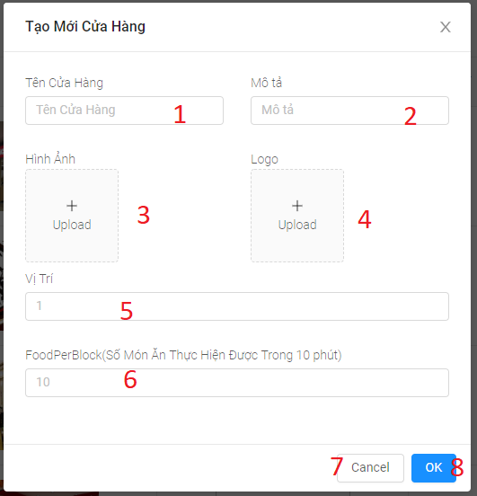

Figure 115: < UI Interface > Create store

**Fields**

|  |  |  |  |  |  |  |
| --- | --- | --- | --- | --- | --- | --- |
|  | **Field Name** | **Description** | **Read only** | **Mandatory** | **Control Type** | **Data Type** |
| 1 | Tên Cửa Hàng | Store name | No | Yes | Text Box | String |
| 2 | Mô Tả | Store description | No | Yes | Text Box | String |
| 3 | Hình Ảnh | Store Image | No | Yes | File input | Image |
| 4 | Logo | Store logo | No | Yes | File input | Image |
| 5 | Vị trí | Store location | No | Yes | Text Box | String |
| 6 | FoodPerBlock | Store block | No | No | Text Box | Integer |

Table 135 <Fields> Create store

**Buttons/Hyperlinks:**

|  |  |  |  |  |
| --- | --- | --- | --- | --- |
| **No** | **Function** | **Description** | **Validation** | **Outcome** |
| 7 | Cancel | Close modal | N/A | Close modal create store |
| 8 | Ok | Add new store | N/A | Add new store successfully |

Table 136 < Buttons/Hyperlinks > Create store

**5.2.1.7.6. Update store**

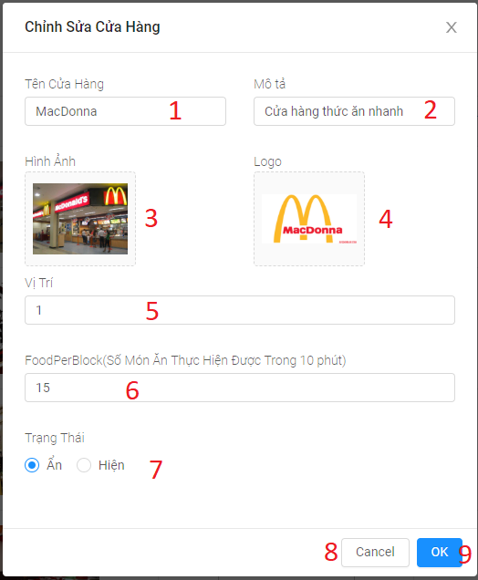

Figure 116: < UI Interface > Update store

**Fields**

|  |  |  |  |  |  |  |
| --- | --- | --- | --- | --- | --- | --- |
| **No** | **Field Name** | **Description** | **Read only** | **Mandatory** | **Control Type** | **Data Type** |
| 1 | Tên Cửa Hàng | Store name | No | Yes | Text Box | String |
| 2 | Mô Tả | Store description | No | Yes | Text Box | String |
| 3 | Hình Ảnh | Store Image | No | Yes | File input | Image |
| 4 | Logo | Store logo | No | Yes | File input | Image |
| 5 | Vị trí | Store location | No | Yes | Text Box | String |
| 6 | FoodPerBlock | Store block | No | No | Text Box | Integer |
| 7 | Trạng Thái | Store status | No | Yes | Check Box | Boolean |

Table 137 <Fields> Update store

**Buttons/Hyperlinks:**

|  |  |  |  |  |
| --- | --- | --- | --- | --- |
| **No** | **Function** | **Description** | **Validation** | **Outcome** |
| 8 | Cancel | Close modal | N/A | Close modal update store |
| 9 | Ok | Update store | N/A | Update store successfully |

Table 138 < Buttons/Hyperlinks > Update store

**5.2.1.7.7. Manage categories**

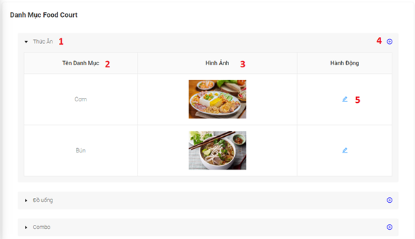

Figure 117: < UI Interface > Manage categories

**Fields**

|  |  |  |  |  |  |  |
| --- | --- | --- | --- | --- | --- | --- |
| **No** | **Field Name** | **Description** | **Read only** | **Mandatory** | **Control Type** | **Data Type** |
| 1 | Thức Ăn | Category name parents | Yes | Yes | Text | String |
| 2 | Tên Danh Mục | Category name | Yes | Yes | Text | String |
| 3 | Hình Ảnh | Store image | Yes | Yes | Image | Image |

Table 139 <Fields> Manage categories

**Buttons/Hyperlinks:**

|  |  |  |  |  |
| --- | --- | --- | --- | --- |
| **No** | **Function** | **Description** | **Validation** | **Outcome** |
| 4 | Tạo Danh Mục Món Ăn | Open modal create category | N/A | Redirect to modal create category |
| 6 | Chỉnh Sửa Danh Mục | Update category | N/A | Update category successfully |

Table 140 < Buttons/Hyperlinks > Manage categories

**5.2.1.7.8 Create categories**

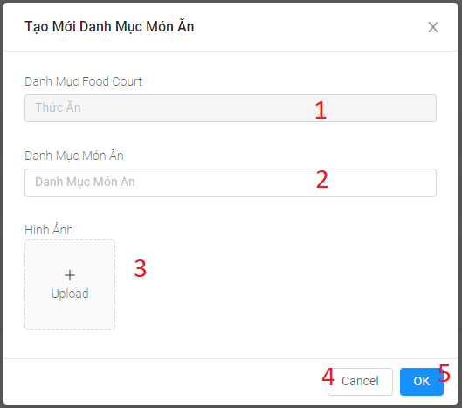

Figure 118: < UI Interface > Create categories

**Fields**

|  |  |  |  |  |  |  |
| --- | --- | --- | --- | --- | --- | --- |
| **No** | **Field Name** | **Description** | **Read only** | **Mandatory** | **Control Type** | **Data Type** |
| 1 | Danh Mục Food Court | Category name parents | Yes | Yes | Text | String |
| 2 | Danh Mục Món Ăn | Category name | No | Yes | Text | String |
| 3 | Hình Ảnh | Store image | No | Yes | File Input | Image |

Table 141 <Fields> Create categories

**Buttons/Hyperlinks:**

|  |  |  |  |  |
| --- | --- | --- | --- | --- |
| **No** | **Function** | **Description** | **Validation** | **Outcome** |
| 4 | Cancle | Close modal create category | N/A | Close modal create category |
| 6 | OK | Create new category | N/A | Create category successfully |

Table 142 < Buttons/Hyperlinks > Create categories

**5.2.1.7.9 Update categories**

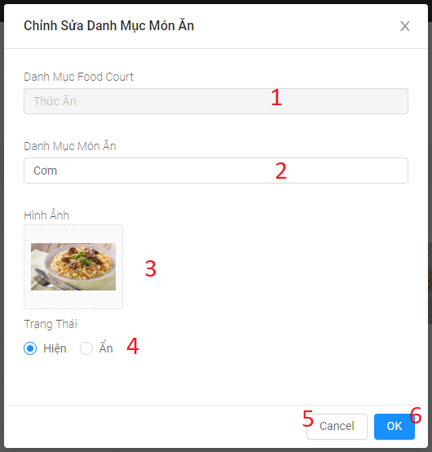

Figure 119: < UI Interface > Update categories

**Fields**

|  |  |  |  |  |  |  |
| --- | --- | --- | --- | --- | --- | --- |
| **No** | **Field Name** | **Description** | **Read only** | **Mandatory** | **Control Type** | **Data Type** |
| 1 | Danh Mục Food Court | Category name parents | Yes | Yes | Text | String |
| 2 | Danh Mục Món Ăn | Category name | No | Yes | Text | String |
| 3 | Hình Ảnh | Category image | No | Yes | File Input | Image |
| 4 | Trạng Thái | Category status | No | Yes | Check Box | Boolean |

Table 143 <Fields> Update categories

**Buttons/Hyperlinks:**

|  |  |  |  |  |
| --- | --- | --- | --- | --- |
| **No** | **Function** | **Description** | **Validation** | **Outcome** |
| 5 | Cancle | Close modal update category | N/A | Close modal update category |
| 6 | OK | Create new category | N/A | Create category successfully |

Table 144 < Buttons/Hyperlinks > Update categories

5.2.1.7.10 Home



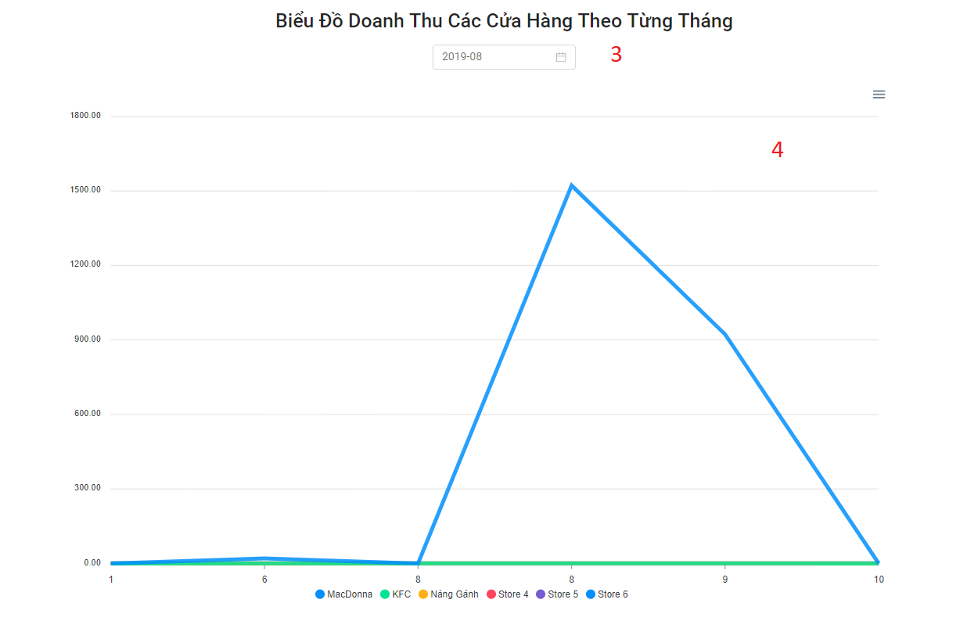

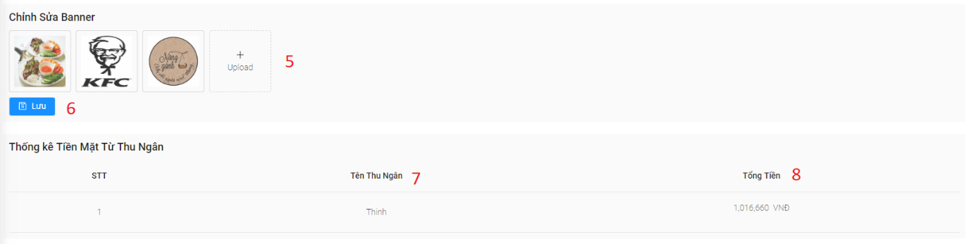

Figure 120: < UI Interface > Home page

**Fields**

|  |  |  |  |  |  |  |
| --- | --- | --- | --- | --- | --- | --- |
| **No** | **Field Name** | **Description** | **Read only** | **Mandatory** | **Control Type** | **Data Type** |
| 1 | Total number of members | Total number of members | Yes | Yes | Textbox | String |
| 2 | Total revenue for the day | Total revenue for the day | Yes | Yes | Textbox | String |
| 3 | Date time picker | Date time picker | Yes | Yes | Select box | String |
| 4 | Revenue chart of monthly stores | Revenue chart of monthly stores | Yes | Yes | Chart | Chart |
| 5 | Food court banner | Food court banner | Yes | Yes | Image | String |
| 7 | Tên thu ngân | Cashier name | Yes | Yes | Textbox | String |
| 8 | Tổng tiền | Cashier revenue | Yes | Yes | Number | Double |

Table 145 <Fields> Home page

**Buttons/Hyperlinks:**

|  |  |  |  |  |
| --- | --- | --- | --- | --- |
| **No** | **Function** | **Description** | **Validation** | **Outcome** |
| 6 | Lưu | Create or update banner food court | N/A | Create or update banner food court successfully. |

Table 146 < Buttons/Hyperlinks > Home page

##### **5.2.1.8.** **Menu store manager**

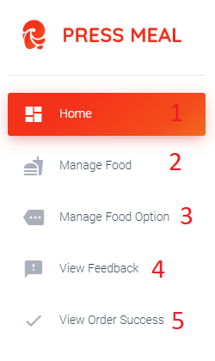

Figure 121: < UI Interface > Menu store manager

**Buttons/Hyperlinks:**

|  |  |  |  |  |
| --- | --- | --- | --- | --- |
| **No** | **Function** | **Description** | **Validation** | **Outcome** |
| 1 | Hone | View static link | N/A | Redirect to view static page |
| 2 | Manage Food | Manage food | N/A | Redirect to manage food page |
| 3 | Manage Food Option | Manage Food Option link | N/A | Redirect to manage food option page |
| 4 | View Feedback | View feedback link | N/A | Redirect to view feedback page |
| 5 | View Order Success | Show order food link | N/A | Redirect to the screen of finished food page |

Table 147 < Buttons/Hyperlinks > Menu store manager

**5.2.1.8.1. Manage food**

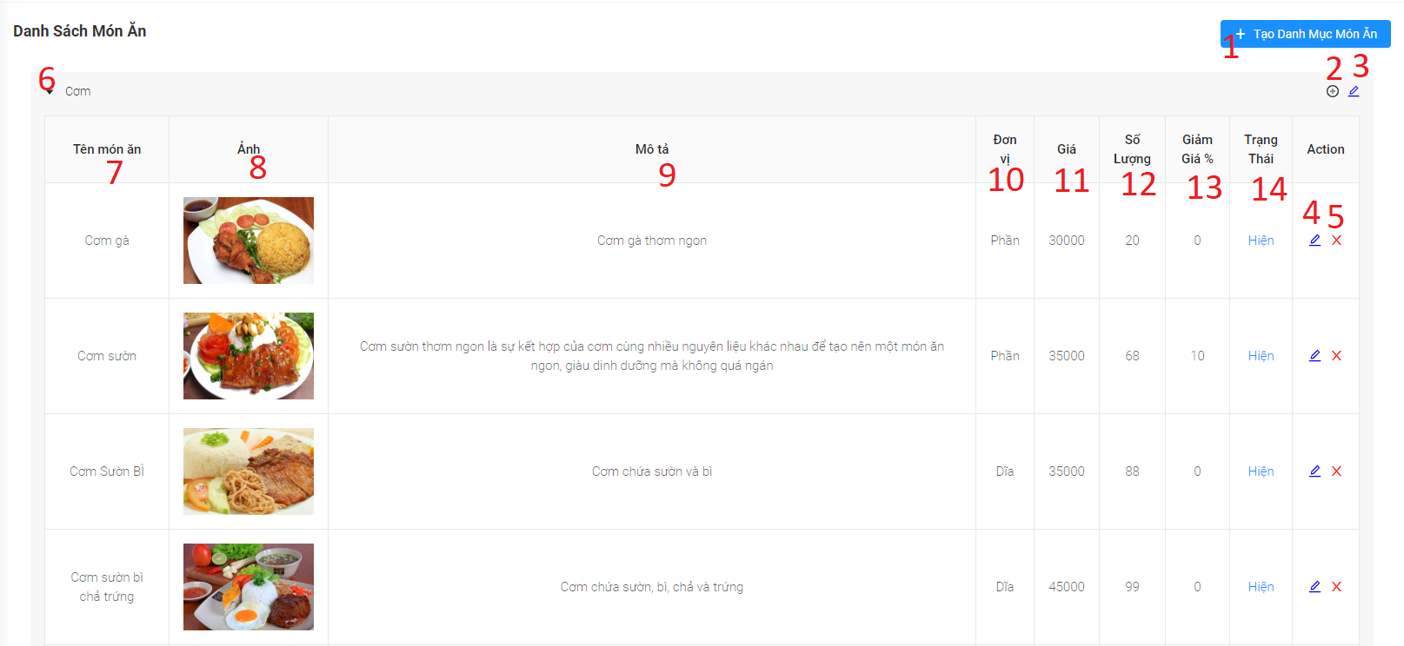

Figure 122: < UI Interface > Manage food

**Fields**

|  |  |  |  |  |  |  |
| --- | --- | --- | --- | --- | --- | --- |
| **No** | **Field Name** | **Description** | **Read only** | **Mandatory** | **Control Type** | **Data Type** |
| 7 | Name | Dish’s name | Yes | Yes | Textbox | String |
| 8 | Image | Dish’s image | Yes | Yes | Image | N/A |
| 9 | Description | Dish’s description | Yes | Yes | Textbox | String |
| 10 | Unit | Dish’s unit | Yes | Yes | Textbox | String |
| 11 | Price | Dish’s price | Yes | Yes | Textbox | String |
| 12 | Quantity | Dish’s quantity | Yes | Yes | Textbox | Number |
| 13 | Discount rate | Dish’s discount rate | Yes | Yes | Textbox | Number |
| 14 | Status | Dish’s status | Yes | Yes | Textbox | String |

Table 148 <Fields> Manage food

**Buttons/Hyperlinks:**

|  |  |  |  |  |
| --- | --- | --- | --- | --- |
| **No** | **Function** | **Description** | **Validation** | **Outcome** |
| 1 | Create new category | Open create new category form’s modal | N/A | Display create category form’s modal |
| 2 | Create new dish | Open create new dish form’s modal | N/A | Display create dish form’s modal |
| 3 | Edit category | Open edit category form’s modal | N/A | Display edit category form’s modal |
| 4 | Edit dish | Open edit dish form’s modal | N/A | Display edit dish form’s modal |
| 5 | Delete dish | Remove the dish from the menu | N/A | Delete successfully |
| 6 | Show more/ Collapse | Show/hide list of category’s food | N/A | Displau successfully |

Table 149 < Buttons/Hyperlinks > Manage food

**5.2.1.8.2. Create category**

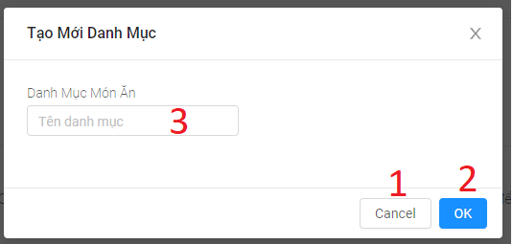

Figure 123: < UI Interface > Create category

**Fields**

|  |  |  |  |  |  |  |
| --- | --- | --- | --- | --- | --- | --- |
| **No** | **Field Name** | **Description** | **Read only** | **Mandatory** | **Control Type** | **Data Type** |
| 3 | Name | Category name | No | Yes | Text | String |

Table 150 <Fields> Create category

**Buttons/Hyperlinks:**

|  |  |  |  |  |
| --- | --- | --- | --- | --- |
| **No** | **Function** | **Description** | **Validation** | **Outcome** |
| 1 | Cancel | Button for closing create form’s modal | N/A | Close modal |
| 2 | Ok | Submit form | N/A | Create category |

Table 151 < Buttons/Hyperlinks > Create category

**5.2.1.8.2. Update category**

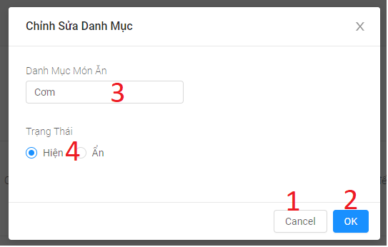

Figure 124: < UI Interface > Update category

**Fields**

|  |  |  |  |  |  |  |
| --- | --- | --- | --- | --- | --- | --- |
| **No** | **Field Name** | **Description** | **Read only** | **Mandatory** | **Control Type** | **Data Type** |
| 3 | Name | Category’s name | No | Yes | Textbox | String |
| 4 | Status | Category’s status | No | Yes | Check box | String |

Table 152 <Fields> Update category

**Buttons/Hyperlinks:**

|  |  |  |  |  |
| --- | --- | --- | --- | --- |
| **No** | **Function** | **Description** | **Validation** | **Outcome** |
| 1 | Cancel | Button for closing edit form’s modal | N/A | Close modal |
| 2 | Ok | Submit form | N/A | Edit category |

Table 153 < Buttons/Hyperlinks > Update category

**5.2.1.8.3. Create food**

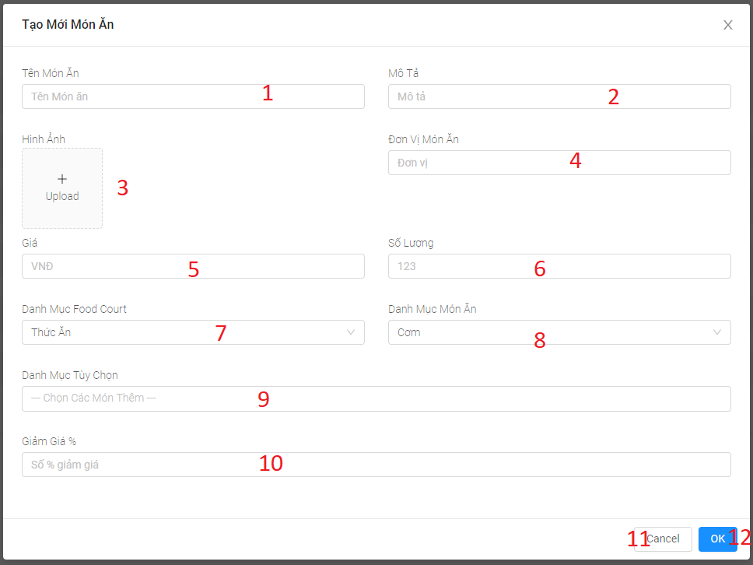

Figure 125: < UI Interface > Create food

**Fields**

|  |  |  |  |  |  |  |
| --- | --- | --- | --- | --- | --- | --- |
| **No** | **Field Name** | **Description** | **Read only** | **Mandatory** | **Control Type** | **Data Type** |
| 1 | Tên món ăn | Dish’s name | No | Yes | Textbox | String |
| 2 | Mô tả | Dish’s description | No | Yes | Textbox | String |
| 3 | Image | Dish’s image | No | Yes | Image | N/A |
| 4 | Đơn vị món ăn | Dish’s unit | No | Yes | Textbox | String |
| 5 | Giá | Dish’s price | No | Yes | Textbox | String |
| 6 | Số lượng | Dish’s quantity | No | Yes | Textbox | Number |
| 7 | Danh mục food court | Food court category | No | Yes | Select box | String |
| 8 | Danh mục món ăn | Dish’s category | No | Yes | Select box | String |
| 9 | Danh mục tùy chọn | Food option category | No | Yes | Select box | String |
| 10 | Giảm giá | Dish’s discount rate | No | Yes | Textbox | Number |

Table 154 <Fields> Create food

**Buttons/Hyperlinks:**

|  |  |  |  |  |
| --- | --- | --- | --- | --- |
| **No** | **Function** | **Description** | **Validation** | **Outcome** |
| 11 | Cancel | Button for closing create form’s modal | N/A | Close modal |
| 2 | Ok | Submit form | N/A | Create dish |

Table 155 < Buttons/Hyperlinks > Create food

**5.2.1.8.4. Update food**

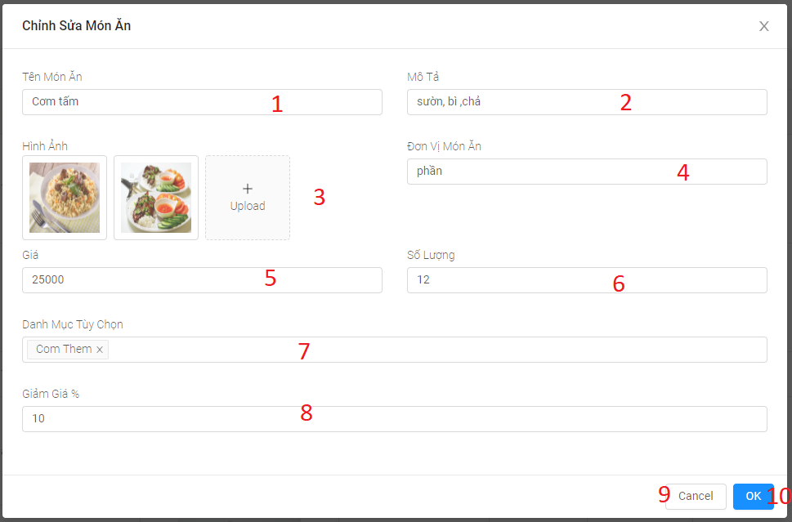

Figure 126: < UI Interface > Update food

**Fields**

|  |  |  |  |  |  |  |
| --- | --- | --- | --- | --- | --- | --- |
| **No** | **Field Name** | **Description** | **Read only** | **Mandatory** | **Control Type** | **Data Type** |
| 1 | Tên món ăn | Dish’s name | No | Yes | Textbox | String |
| 2 | Mô tả | Dish’s description | No | Yes | Textbox | String |
| 3 | Image | Dish’s image | No | Yes | Image | N/A |
| 4 | Đơn vị món ăn | Dish’s unit | No | Yes | Textbox | String |
| 5 | Giá | Dish’s price | No | Yes | Textbox | String |
| 6 | Số lượng | Dish’s quantity | No | Yes | Textbox | Number |
| 7 | Danh mục tùy chọn | Food option category | No | Yes | Select box | String |
| 8 | Giảm giá | Dish’s discount rate | No | Yes | Textbox | Number |

Table 156 <Fields> Update food

**Buttons/Hyperlinks:**

|  |  |  |  |  |
| --- | --- | --- | --- | --- |
| **No** | **Function** | **Description** | **Validation** | **Outcome** |
| 9 | Cancel | Button for closing update form’s modal | N/A | Close modal |
| 10 | Ok | Submit form | N/A | Update dish |

Table 157 < Buttons/Hyperlinks > Update food

**5.2.1.8.5. Manage food option**

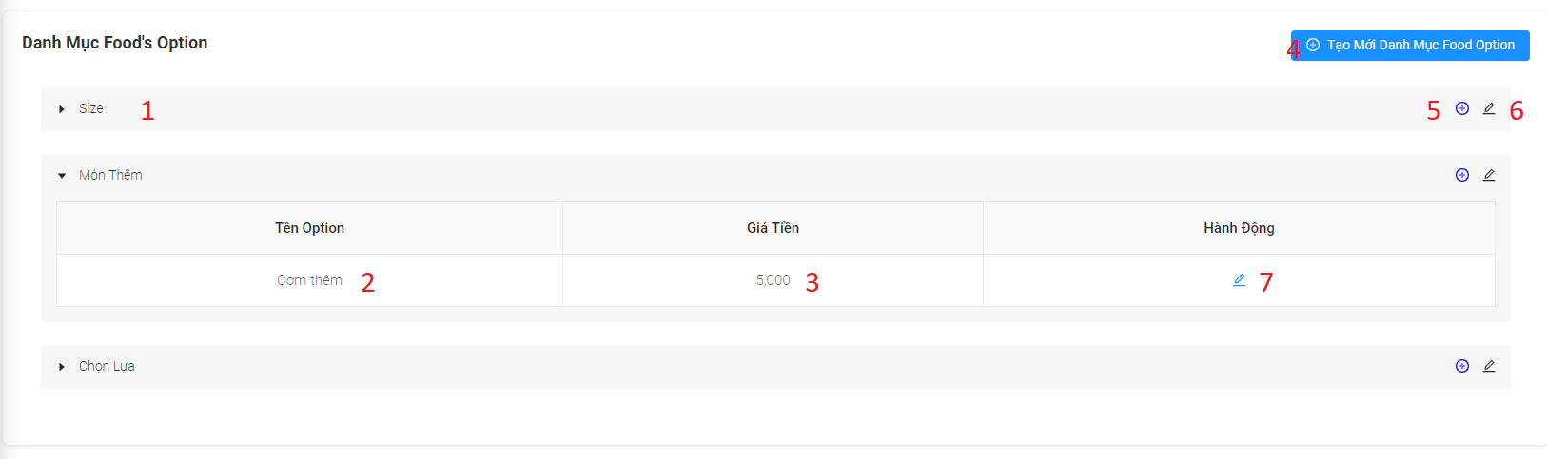

Figure 127: < UI Interface > Manage food option

**Fields**

|  |  |  |  |  |  |  |
| --- | --- | --- | --- | --- | --- | --- |
| **No** | **Field Name** | **Description** | **Read only** | **Mandatory** | **Control Type** | **Data Type** |
| 1 | Food option category | Food option category | Yes | Yes | Textbox | String |
| 2 | Tên Option | Food option name | Yes | Yes | Textbox | String |
| 3 | Giá tiền | Food option price | Yes | Yes | Number | Integer |

Table 158 <Fields> Manage food option

**Buttons/Hyperlinks:**

|  |  |  |  |  |
| --- | --- | --- | --- | --- |
| **No** | **Function** | **Description** | **Validation** | **Outcome** |
| 4 | Tạo mới danh mục food option | Button for create food option category | N/A | Create food option category |
| 5 | Create option | Button for create option | N/A | Create option |
| 6 | Update food option category | Button for update food option category | N/A | Update food option category |
| 7 | Update option | Button for update food option | N/A | Update food option |

Table 159 < Buttons/Hyperlinks > Manage food option

**5.2.1.8.6. Create food option category**

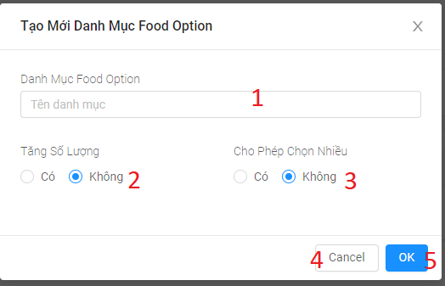

Figure 128: < UI Interface > Create food option category

**Fields**

|  |  |  |  |  |  |  |
| --- | --- | --- | --- | --- | --- | --- |
| No | Field Name | Description | Read only | Mandatory | Control Type | Data Type |
| 1 | Food option category | Food option category | No | Yes | Textbox | String |
| 2 | Tăng số lượng | Food option court | No | Yes | Checkbox | Boolean |
| 3 | Cho phép chọn nhiều | Food option select | No | Yes | Checkbox | Boolean |

Table 160 <Fields> Create food option category

**Buttons/Hyperlinks:**

|  |  |  |  |  |
| --- | --- | --- | --- | --- |
| No | Function | Description | Validation | Outcome |
| 4 | Cancel | Button for closing create form’s modal | N/A | Close modal |
| 5 | Ok | Submit form | N/A | Create food option category |

Table 161 < Buttons/Hyperlinks > Create food option category

**5.2.1.8.7. Update food option category**

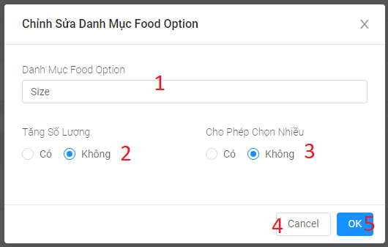

Figure 129: < UI Interface > Update food option category

**Fields**

|  |  |  |  |  |  |  |
| --- | --- | --- | --- | --- | --- | --- |
| No | Field Name | Description | Read only | Mandatory | Control Type | Data Type |
| 1 | Food option category | Food option category | No | Yes | Textbox | String |
| 2 | Tăng số lượng | Food option court | No | Yes | Checkbox | Boolean |
| 3 | Cho phép chọn nhiều | Food option select | No | Yes | Checkbox | Boolean |

Table 162 <Fields> Update food option category

**Buttons/Hyperlinks:**

|  |  |  |  |  |
| --- | --- | --- | --- | --- |
| No | Function | Description | Validation | Outcome |
| 4 | Cancel | Button for closing update form’s modal | N/A | Close modal |
| 5 | Ok | Submit form | N/A | Update food option category |

Table 163 < Buttons/Hyperlinks > Update food option category

**5.2.1.8.8. Create option**

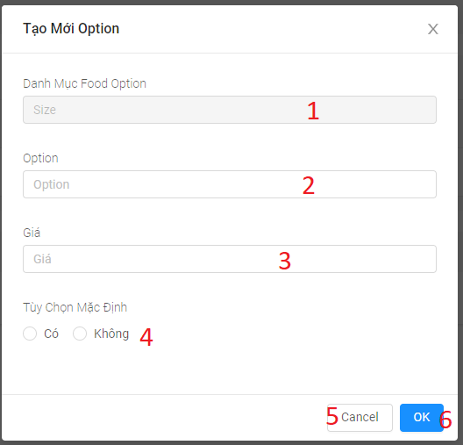

Figure 130: < UI Interface > Create option

**Fields**

|  |  |  |  |  |  |  |
| --- | --- | --- | --- | --- | --- | --- |
| **No** | **Field Name** | **Description** | **Read only** | **Mandatory** | **Control Type** | **Data Type** |
| 1 | Food option category | Food option category | No | Yes | Textbox | String |
| 2 | Option | Option name | No | Yes | Textbox | String |
| 3 | Giá | Pption price | No | Yes | Number | Integer |
| 4 | Tùy chọn mặc định | Food option default | No | Yes | Checkbox | Boolean |

Table 164 <Fields> Create option

**Buttons/Hyperlinks:**

|  |  |  |  |  |
| --- | --- | --- | --- | --- |
| **No** | **Function** | **Description** | **Validation** | **Outcome** |
| 5 | Cancel | Button for closing create form’s modal | N/A | Close modal |
| 6 | Ok | Submit form | N/A | Create option |

Table 165 < Buttons/Hyperlinks > Create option

**5.2.1.8.9. Update option**

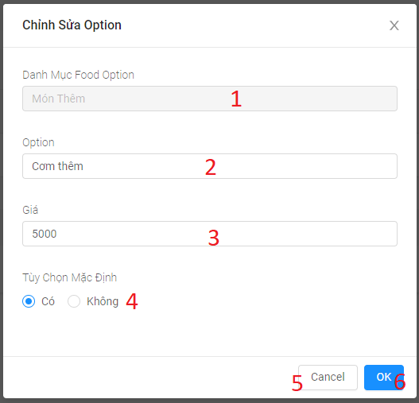

Figure 131: < UI Interface > Update option

**Fields**

|  |  |  |  |  |  |  |
| --- | --- | --- | --- | --- | --- | --- |
| **No** | **Field Name** | **Description** | **Read only** | **Mandatory** | **Control Type** | **Data Type** |
| 1 | Food option category | Food option category | No | Yes | Textbox | String |
| 2 | Option | Option name | No | Yes | Textbox | String |
| 3 | Giá | Pption price | No | Yes | Number | Integer |
| 4 | Tùy chọn mặc định | Food option default | No | Yes | Checkbox | Boolean |

Table 166 <Fields> Update option

**Buttons/Hyperlinks:**

|  |  |  |  |  |
| --- | --- | --- | --- | --- |
| **No** | **Function** | **Description** | **Validation** | **Outcome** |
| 5 | Cancel | Button for closing update form’s modal | N/A | Close modal |
| 6 | Ok | Submit form | N/A | Update option |

Table 167 < Buttons/Hyperlinks > Update option

5**.2.1.8.10. View feedback**

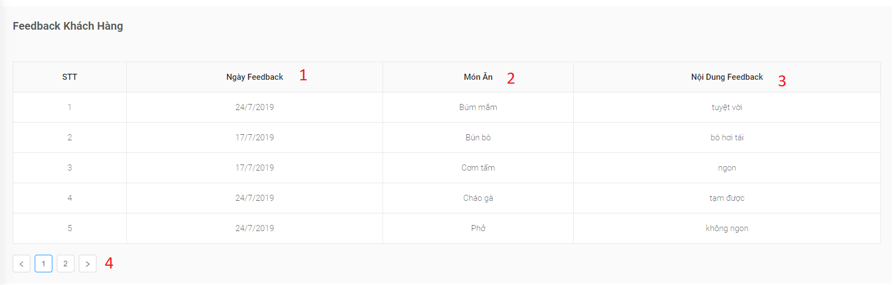

Figure 132: < UI Interface > View feedback

**Fields**

|  |  |  |  |  |  |  |
| --- | --- | --- | --- | --- | --- | --- |
| **No** | **Field Name** | **Description** | **Read only** | **Mandatory** | **Control Type** | **Data Type** |
| 1 | Ngày feedback | Feedback date | Yes | Yes | Textbox | String |
| 2 | Món Ăn | Dish name | Yes | Yes | Textbox | String |
| 3 | Nội dung feedback | Feedback description | Yes | Yes | Textbox | String |

Table 168 <Fields> View feedback

**Buttons/Hyperlinks:**

|  |  |  |  |  |
| --- | --- | --- | --- | --- |
| **No** | **Function** | **Description** | **Validation** | **Outcome** |
| 4 | Pagination | Pagination for manage staff | N/A | Switch to respective page based on user clicked |

Table 169 < Buttons/Hyperlinks > View feedback

5.2.1.8.11. Home

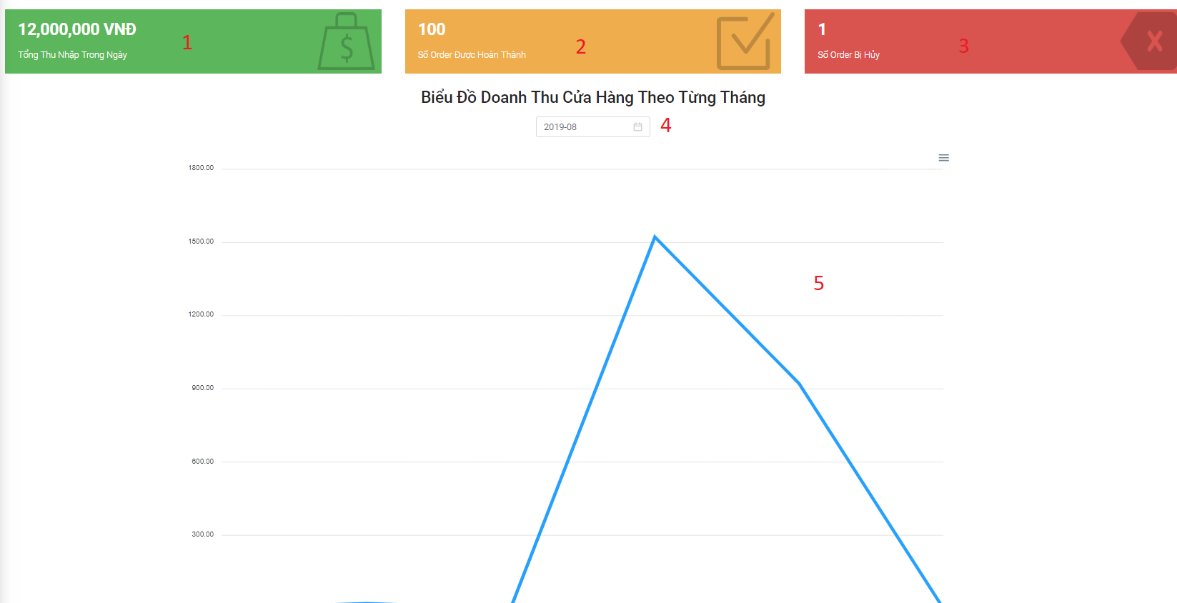

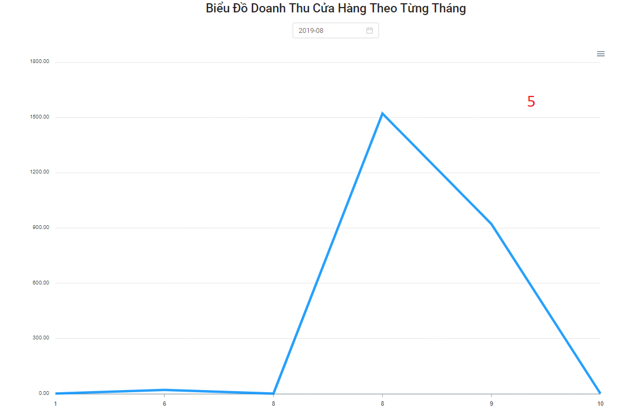

Figure 133: < UI Interface > Home Page

**Fields**

|  |  |  |  |  |  |  |
| --- | --- | --- | --- | --- | --- | --- |
| **No** | **Field Name** | **Description** | **Read only** | **Mandatory** | **Control Type** | **Data Type** |
| 1 | Total income during the day | Total income during the day | Yes | Yes | Textbox | String |
| 2 | Order number completed | Order number completed | Yes | Yes | Textbox | String |
| 3 | Order number canceled | Order number canceled | Yes | Yes | Textbox | String |
| 4 | Date time picker | Date time picker | Yes | Yes | select box |  |
| 5 | Monthly shop chart | Monthly shop chart | Yes | Yes | Chart | Chart |

Table 170 <Fields> Home Page

##### **5.2.1.9.** **Menu staff**

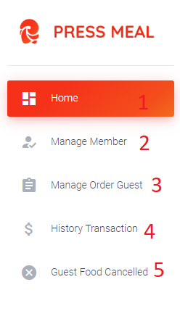

Figure 134: < UI Interface > Menu staff

**Buttons/Hyperlinks:**

|  |  |  |  |  |
| --- | --- | --- | --- | --- |
| **No** | **Function** | **Description** | **Validation** | **Outcome** |
| 1 | Hone | View static link | N/A | Redirect to view static page |
| 2 | Manage Member | Manage member | N/A | Redirect to manage member page |
| 3 | Manage Order Guest | Manage Order Guest link | N/A | Redirect to manage order guest page |
| 4 | History Transaction | View history transaction | N/A | Redirect to view history transaction |
| 5 | Guest food cancelled | Show list food cancelled | N/A | Redirect to the screen of guest food cancelled page |

Table 171 < Buttons/Hyperlinks > Menu staff

**5.2.1.9.1. Manage member**

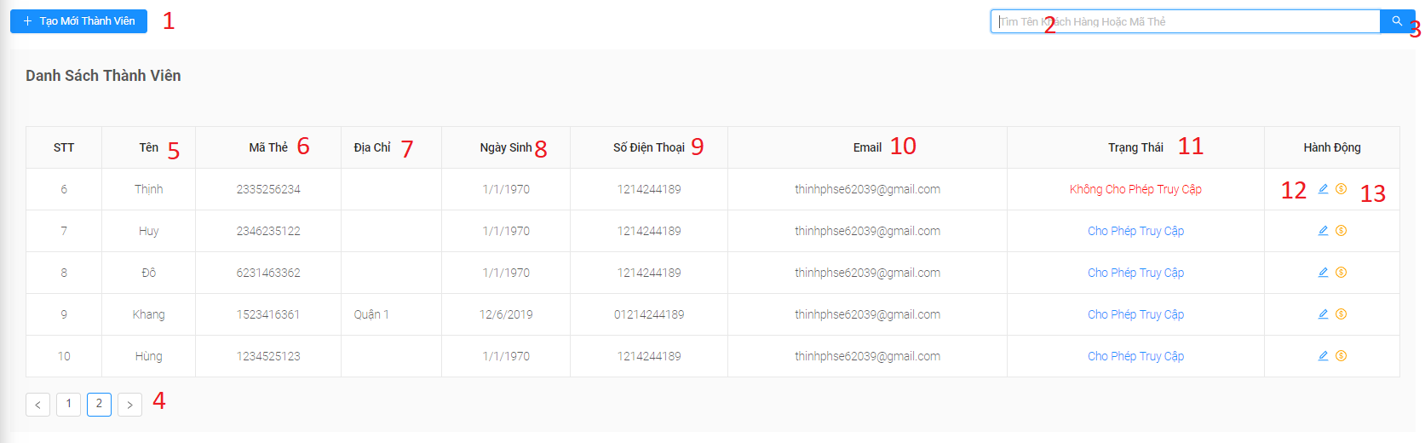

Figure 135: < UI Interface > Manage member

**Fields**

|  |  |  |  |  |  |  |
| --- | --- | --- | --- | --- | --- | --- |
| **No** | **Field Name** | **Description** | **Read only** | **Mandatory** | **Control Type** | **Data Type** |
| 2 | Search | Search value | No | No | Text | String |
| 5 | Tên | Member’s fullname | Yes | Yes | Text | String |
| 6 | Mã Thẻ | Member’s cart | Yes | Yes | Text | String |
| 7 | Địa Chỉ | Member’s address | Yes | Yes | Text | String |
| 8 | Ngày Sinh | Member’s birthday | Yes | Yes | Text | Date |
| 9 | Số Điện Thoại | Member’s phone number | Yes | Yes | Text | Integer |
| 10 | Email | Member’s email | Yes | Yes | Text | String |
| 11 | Trạng Thái | Member status | No | Yes | Text | Boolean |

Table 172 <Fields> Manage member

**Buttons/Hyperlinks:**

|  |  |  |  |  |
| --- | --- | --- | --- | --- |
| **No** | **Function** | **Description** | **Validation** | **Outcome** |
| 1 | Tạo Mới Thành Viên | Open modal create member | N/A | Redirect to modal create member |
| 12 | Chỉnh Sửa Thành Viên | Update status and card id of member | N/A | Update status and card id of member successfully |
| 13 | Deposit money to customers | Deposit money to customers | N/A | Deposit money to customers successfully |
| 4 | Pagination | Pagination for manage staff | N/A | Switch to respective page based on user clicked |
| 3 | Search | Search for member by name and card id | N/A | Update the data on the table and return the search results |

Table 173 < Buttons/Hyperlinks > Manage member

**5.2.1.9.2. Create member**

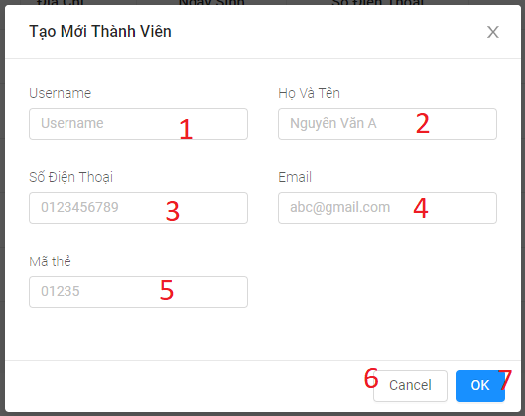

Figure 136: < UI Interface > Create member

**Fields**

|  |  |  |  |  |  |  |
| --- | --- | --- | --- | --- | --- | --- |
| **No** | **Field Name** | **Description** | **Read only** | **Mandatory** | **Control Type** | **Data Type** |
| 1 | Username | Member username | No | Yes | Text Box | String |
| 2 | Họ Tên | Member fullname | No | Yes | Text Box | String |
| 3 | Số Điện Thoại | Member phone number | No | Yes | Text Box | Integer |
| 4 | Email | Member email | No | Yes | Text Box | String |
| 5 | Mã Thẻ | Member cart | No | Yes | Select Box | String |

Table 174 <Fields> Create member

**Buttons/Hyperlinks:**

|  |  |  |  |  |
| --- | --- | --- | --- | --- |
| **No** | **Function** | **Description** | **Validation** | **Outcome** |
| 6 | Cancel | Close modal | N/A | Close modal create member |
| 7 | Ok | Add new member | N/A | Add new member successfully |

Table 175 < Buttons/Hyperlinks > Create member

**5.2.1.9.3. Update member**

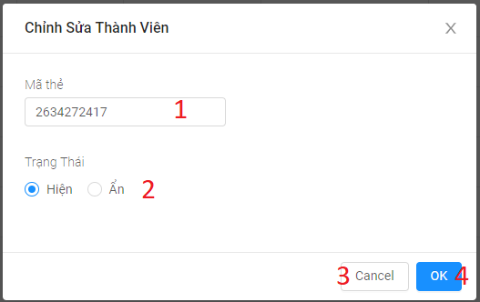

Figure 137: < UI Interface > Update member

**Fields**

|  |  |  |  |  |  |  |
| --- | --- | --- | --- | --- | --- | --- |
| **No** | **Field Name** | **Description** | **Read only** | **Mandatory** | **Control Type** | **Data Type** |
| 1 | Mã Thẻ | Member cart | No | Yes | Number | String |
| 2 | Trạng Thái | Member status | No | Yes | Checkbox | Boolean |

Table 176 <Fields> Update member

**Buttons/Hyperlinks:**

|  |  |  |  |  |
| --- | --- | --- | --- | --- |
| **No** | **Function** | **Description** | **Validation** | **Outcome** |
| 3 | Cancel | Close modal | N/A | Close modal update member |
| 7 | Ok | Update member | N/A | Update member successfully |

Table 177 < Buttons/Hyperlinks > Update member

**5.2.1.9.4. Deposit**

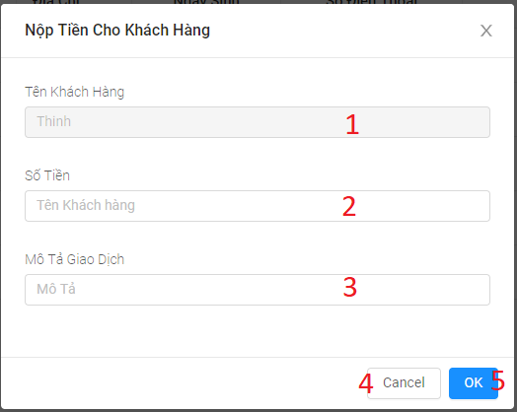

Figure 138: < UI Interface > Deposit

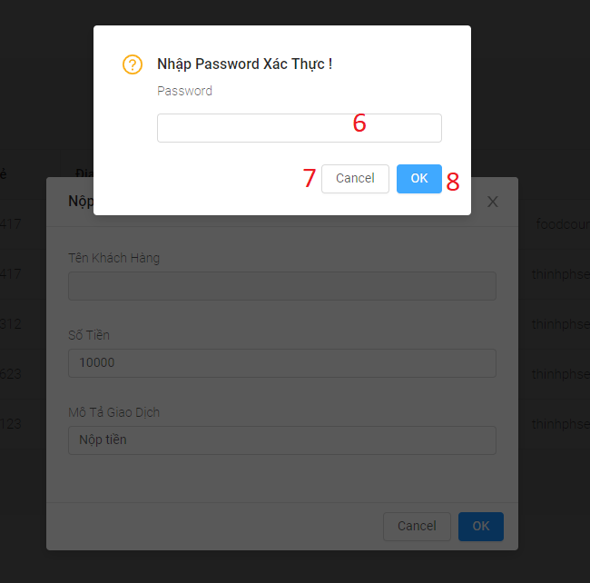

Figure 139: < UI Interface > Confirm Password - Deposit

**Fields**

|  |  |  |  |  |  |  |
| --- | --- | --- | --- | --- | --- | --- |
| **No** | **Field Name** | **Description** | **Read only** | **Mandatory** | **Control Type** | **Data Type** |
| 1 | Tên khách hàng | Member name | No | Yes | Textbox | String |
| 2 | Số tiền | Recharge amount for customers | No | Yes | Textbox | Boolean |
| 3 | Mô tả giao dịch | Transaction description | No | Yes | Textbox | String |
| 6 | Password | Password staff | No | Yes | Textbox | Password |

Table 178 <Fields> Deposit

**Buttons/Hyperlinks:**

|  |  |  |  |  |
| --- | --- | --- | --- | --- |
| **No** | **Function** | **Description** | **Validation** | **Outcome** |
| 4 | Cancel | Close modal | N/A | Close modal deposit member |
| 5 | Ok | Open modal input password | N/A | Open modal input password |
| 7 | Cancel | Close modal | N/A | Close modal input password |
| 8 | Ok | Deposit member | N/A | Deposit member successfully |

Table 179 < Buttons/Hyperlinks > Deposit

**5.2.1.9.4. Mange Order Guest**

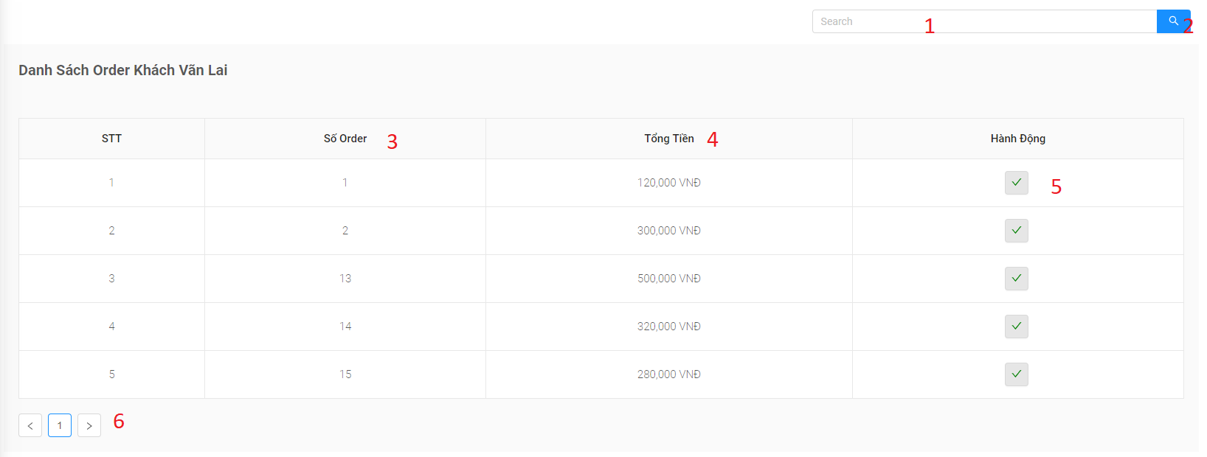

Figure 140: < UI Interface > Mange Order Guest

**Fields**

|  |  |  |  |  |  |  |
| --- | --- | --- | --- | --- | --- | --- |
| **No** | **Field Name** | **Description** | **Read only** | **Mandatory** | **Control Type** | **Data Type** |
| 1 | Search | Search value | No | No | Text | String |
| 3 | Số Order | Order Number | No | Yes | Text | String |
| 4 | Tổng Tiền | Amount order | No | Yes | Text | Number |

Table 180 <Fields> Mange Order Guest

**Buttons/Hyperlinks:**

|  |  |  |  |  |
| --- | --- | --- | --- | --- |
| **No** | **Function** | **Description** | **Validation** | **Outcome** |
| 5 | Submit order | Submit order | N/A | Submit order |
| 6 | Pagination | Pagination for manage staff | N/A | Switch to respective page based on user clicked |
| 2 | Search | Search for member by name and card id | N/A | Update the data on the table and return the search results |

Table 181 < Buttons/Hyperlinks > Mange Order Guest

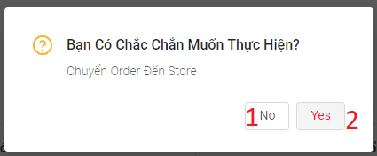**5.2.1.9.5. Submit Order Guest**

Figure 141: < UI Interface > Submit Order Guest

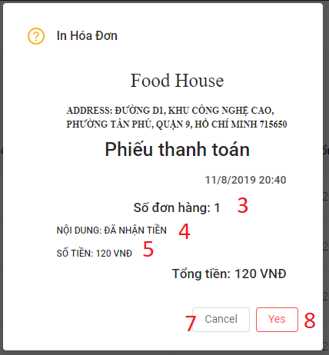

Figure 142: < UI Interface > Confirm print bill for guest

**Fields**

|  |  |  |  |  |  |  |
| --- | --- | --- | --- | --- | --- | --- |
| **No** | **Field Name** | **Description** | **Read only** | **Mandatory** | **Control Type** | **Data Type** |
| 3 | Số đơn hàng | Order number | Yes | Yes | Text | String |
| 4 | Nội dung | Order description | Yes | Yes | Text | String |
| 5 | Số tiền | Amount order | Yes | Yes | Text | Number |

Table 182 <Fields> Submit Order Guest

**Buttons/Hyperlinks:**

|  |  |  |  |  |
| --- | --- | --- | --- | --- |
| **No** | **Function** | **Description** | **Validation** | **Outcome** |
| 1 | No | Close modal | N/A | Close modal submit guest order |
| 2 | Yes | Submit order guest | N/A | Submit order guest successfully |
| 7 | Cancel | Close modal | N/A | Close modal print bill |
| 8 | Yes | Print bill | N/A | Print bill |

Table 183 < Buttons/Hyperlinks > Submit Order Guest

**5.2.1.9.6. History transaction**

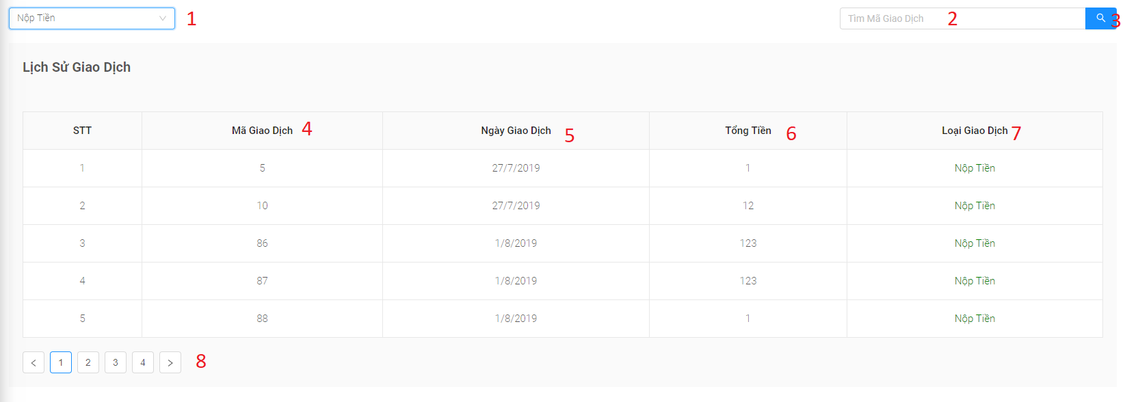

Figure 143: < UI Interface > History transaction

**Fields**

|  |  |  |  |  |  |  |
| --- | --- | --- | --- | --- | --- | --- |
| **No** | **Field Name** | **Description** | **Read only** | **Mandatory** | **Control Type** | **Data Type** |
| 1 | Type transaction | Type transaction | No | Yes | Select box | String |
| 2 | Search | Search value | No | No | Text | String |
| 4 | Mã giao dịch | Transaction id | Yes | Yes | Number | Long |
| 5 | Ngày giao dịch | Transaction date | Yes | Yes | Text | Date |
| 6 | Tổng tiền | Amount transaction | Yes | Yes | Text | String |
| 7 | Loại giao dịch | Type transaction | Yes | Yes | Text | String |

Table 184 <Fields> History transaction

**Buttons/Hyperlinks:**

|  |  |  |  |  |
| --- | --- | --- | --- | --- |
| **No** | **Function** | **Description** | **Validation** | **Outcome** |
| 8 | Pagination | Pagination for manage staff | N/A | Switch to respective page based on user clicked |
| 3 | Search | Search for member by name and card id | N/A | Update the data on the table and return the search results |

Table 185 < Buttons/Hyperlinks > History transaction

**5.2.1.9.7. Guest food cancelled**

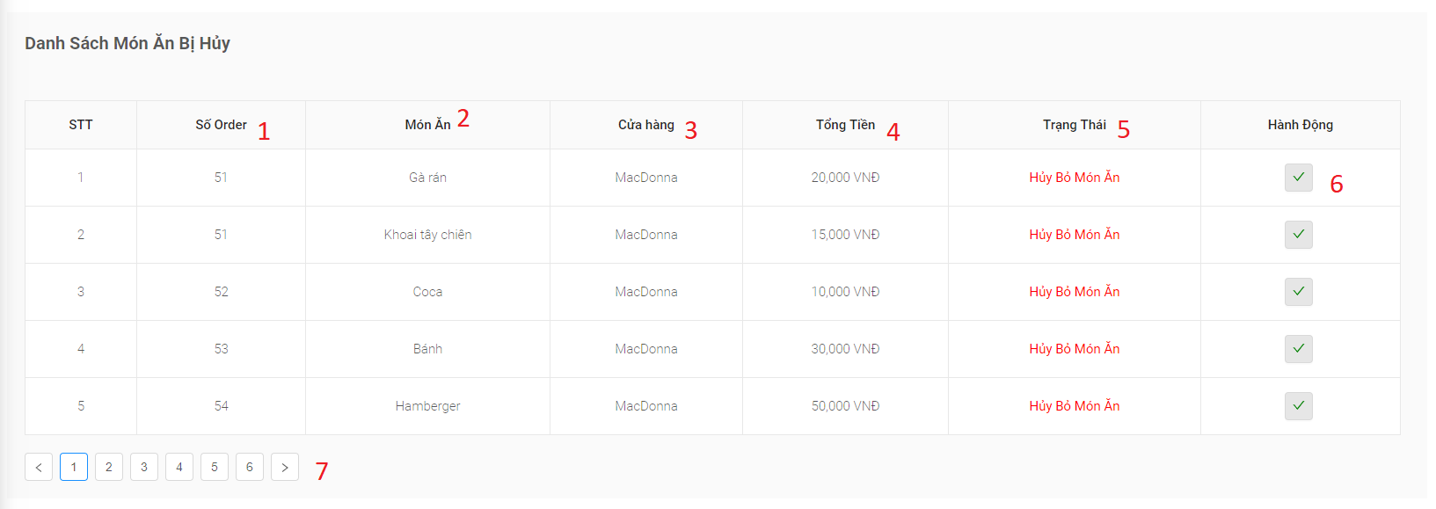

Figure 144: < UI Interface > Guest food cancelled

**Fields**

|  |  |  |  |  |  |  |
| --- | --- | --- | --- | --- | --- | --- |
| **No** | **Field Name** | **Description** | **Read only** | **Mandatory** | **Control Type** | **Data Type** |
| 1 | Số order | Order number | Yes | Yes | Text | String |
| 2 | Món ăn | Dish name | Yes | No | Text | String |
| 3 | Cửa hàng | Store name | Yes | Yes | Text | String |
| 4 | Tổng tiền | Amount order | Yes | Yes | Text | String |
| 5 | Trạng thái | Type transaction | Yes | Yes | Text | String |

Table 186 <Fields> Guest food cancelled

**Buttons/Hyperlinks:**

|  |  |  |  |  |
| --- | --- | --- | --- | --- |
| **No** | **Function** | **Description** | **Validation** | **Outcome** |
| 7 | Pagination | Pagination for manage staff | N/A | Switch to respective page based on user clicked |
| 6 | Pay back to guests | Pay back to guests | N/A | Pay back to guests |

Table 187 < Buttons/Hyperlinks > Guest food cancelled

5.2.1.9.8. Pay back to guests

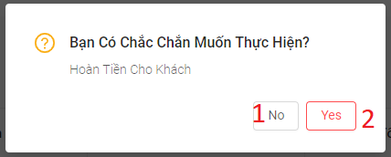

Figure 145: < UI Interface > Pay back to guests

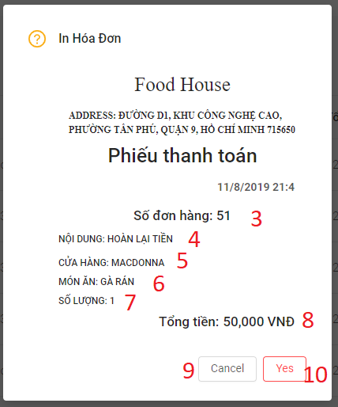

Figure 146: < UI Interface > Confirm invoice pay back to guests

**Fields**

|  |  |  |  |  |  |  |
| --- | --- | --- | --- | --- | --- | --- |
| **No** | **Field Name** | **Description** | **Read only** | **Mandatory** | **Control Type** | **Data Type** |
| 3 | Số đơn hàng | Order number | Yes | Yes | Text | String |
| 4 | Nội dung | Order description | Yes | Yes | Text | String |
| 5 | Cửa hàng | Store name | Yes | Yes | Text | String |
| 6 | Món ăn | Dish name | Yes | Yes | Text | String |
| 7 | Số lượng | Dish quantity | Yes | Yes | Text | String |
| 4 | Tổng tiền | Amount order | Yes | Yes | Text | Number |

Table 188 <Fields> Pay back to guests

**Buttons/Hyperlinks:**

|  |  |  |  |  |
| --- | --- | --- | --- | --- |
| **No** | **Function** | **Description** | **Validation** | **Outcome** |
| 1 | No | Close modal | N/A | Close modal pay back to guests |
| 2 | Yes | Submit order guest | N/A | Pay back to guests successfully |
| 7 | Cancel | Close modal | N/A | Close modal print bill |
| 8 | Yes | Print bill | N/A | Print bill |

Table 189 <Fields> Pay back to guests

**5.2.1.9.8. Home**

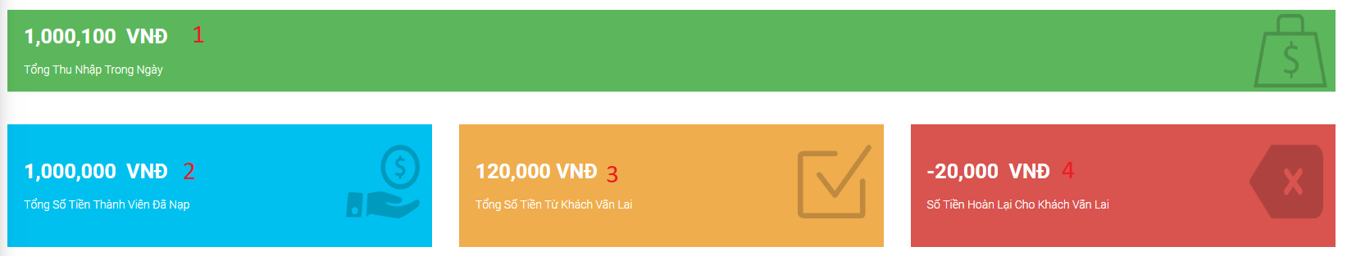

Figure 147: < UI Interface > Home page

**Fields**

|  |  |  |  |  |  |  |
| --- | --- | --- | --- | --- | --- | --- |
| **No** | **Field Name** | **Description** | **Read only** | **Mandatory** | **Control Type** | **Data Type** |
| 1 | Total income during the day | Total income during the day | Yes | Yes | Number | Double |
| 2 | the total amount of money the member has deposited | the total amount of money the member has deposited | Yes | Yes | Number | Double |
| 3 | Total money from guest | Total money from guest | Yes | Yes | Number | Double |
| 4 | Money back for guest | Money back for guest | Yes | Yes | Number | Double |

Table 190 <Fields> Home page

##### **5.2.1.10.** **Chef**

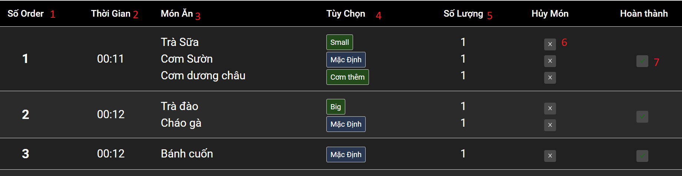

Figure 148: < UI Interface > Chef screen

**Fields**

|  |  |  |  |  |  |  |
| --- | --- | --- | --- | --- | --- | --- |
| **No** | **Field Name** | **Description** | **Read only** | **Mandatory** | **Control Type** | **Data Type** |
| 1 | Số order | Order number | Yes | Yes | Number | Integer |
| 2 | Thời gian | Time customer submit order | Yes | Yes | Date time | Date time |
| 3 | Món ăn | Dish name | Yes | Yes | Text | String |
| 4 | Tùy chọn | Food option | Yes | Yes | Text | String |
| 5 | Số lương | Dish quantity | Yes | Yes | Number | Integer |

Table 191 <Fields> Chef screen

**Buttons/Hyperlinks:**

|  |  |  |  |  |
| --- | --- | --- | --- | --- |
| **No** | **Function** | **Description** | **Validation** | **Outcome** |
| 6 | Cancel dish | Cancel dish | N/A | Cancel dish |
| 7 | Submit order | Submit order | N/A | Submit order successfully |

Table 192 < Buttons/Hyperlinks > Chef screen

**5.2.1.10.1. Cancel dish**

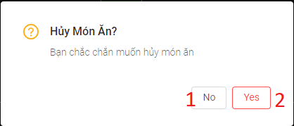

Figure 149: < UI Interface > Cancel dish

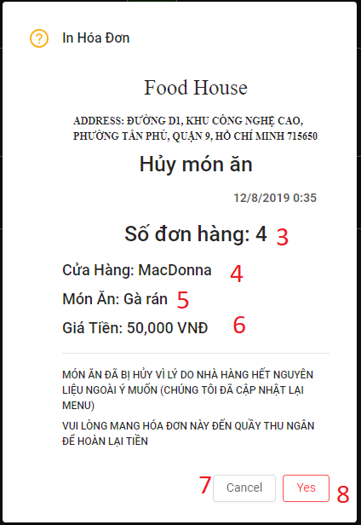

Figure 150: < UI Interface > Confirm print invoice for cancel dish

**Fields**

|  |  |  |  |  |  |  |
| --- | --- | --- | --- | --- | --- | --- |
| **No** | **Field Name** | **Description** | **Read only** | **Mandatory** | **Control Type** | **Data Type** |
| 3 | Số đơn hàng | Order number | Yes | Yes | Number | Integer |
| 4 | Cửa Hàng | Store name | Yes | Yes | Text | String |
| 5 | Món ăn | Dish name | Yes | Yes | Text | String |
| 6 | Giá tiền | Dish price | Yes | Yes | Number | Double |

Table 193 <Fields> Cancel dish

**Buttons/Hyperlinks:**

|  |  |  |  |  |
| --- | --- | --- | --- | --- |
| **No** | **Function** | **Description** | **Validation** | **Outcome** |
| 1 | No | Close modal cancel dish | N/A | Close modal cancel dish |
| 2 | Yes | Cancel dish | N/A | Cancel dish successfully |
| 7 | Cancel | Close modal print bill | N/A | Close modal print bill |
| 8 | Yes | Print bill | N/A | Print bill |

Table 194 < Buttons/Hyperlinks > Cancel dish

**5.2.1.10.2. Submit order**

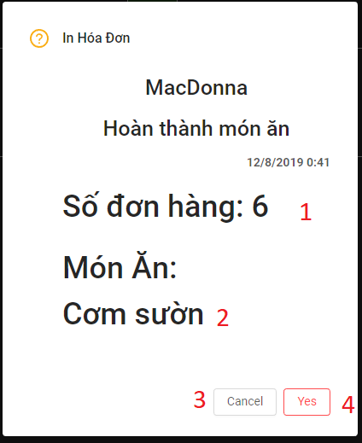

Figure 151: < UI Interface > Submit order

**Fields**

|  |  |  |  |  |  |  |
| --- | --- | --- | --- | --- | --- | --- |
| **No** | **Field Name** | **Description** | **Read only** | **Mandatory** | **Control Type** | **Data Type** |
| 1 | Số đơn hàng | Order number | Yes | Yes | Number | Integer |
| 2 | Món ăn | Dish name | Yes | Yes | Text | String |

Table 195 <Fields> Submit order

**Buttons/Hyperlinks:**

|  |  |  |  |  |
| --- | --- | --- | --- | --- |
| **No** | **Function** | **Description** | **Validation** | **Outcome** |
| 3 | Cancel | Close modal print bill | N/A | Close modal print bill |
| 4 | Yes | Print bill | N/A | Print bill |

Table 196 < Buttons/Hyperlinks > Submit order

#### **5.2.2.** **Kiosk web application**

##### **5.2.2.1. Main page**

**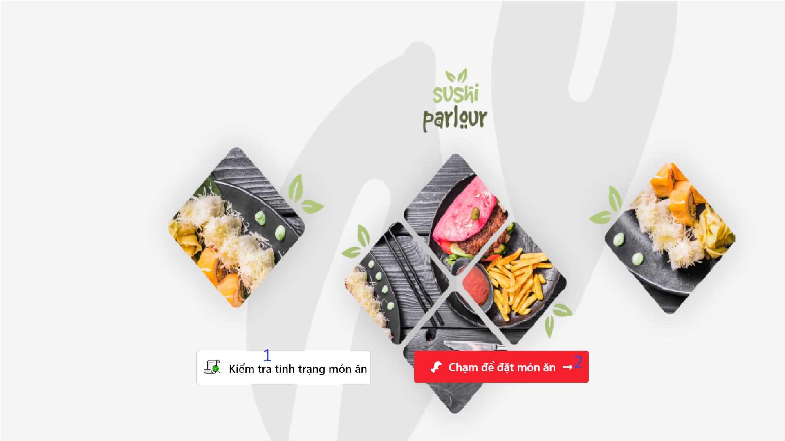**

Figure 152: < UI Interface > Kiosk – Home Page

**Buttons/Hyperlinks:**

|  |  |  |  |  |
| --- | --- | --- | --- | --- |
| **No** | **Function** | **Description** | **Validation** | **Outcome** |
| 1 | Check order’s status | Check the status of each dish of the paid order | N/A | Check order succesfully |
| 2 | Touch to order dish | View menu dish for order | N/A | Add dishes to the cart successfully |

Table 197 < Buttons/Hyperlinks > Kiosk – Home Page

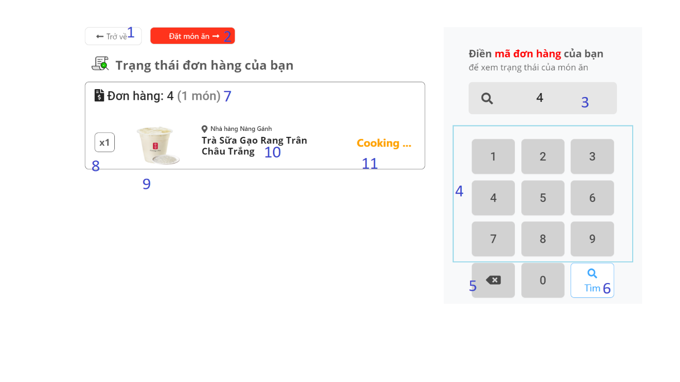**5.2.2.2. Check order page**

Figure 153: < UI Interface > Kiosk - Check order

**Buttons/Hyperlinks:**

|  |  |  |  |  |
| --- | --- | --- | --- | --- |
| **No** | **Function** | **Description** | **Validation** | **Outcome** |
| 1 | Back | Back to main page | N/A | Return to main page |
| 2 | Order dish | View menu dish for order | N/A | Add dishes to the cart successfully |
| 4 | Number Group | Enter the number to search for an order | N/A | Display number in order number successfully |
| 5 | Delete | Delete the last number of the order number | N/A | Delete the last number successfully |
| 6 | Search | Submit the order number to search for an order | N/A | Search order successfully |

Table 198 < Buttons/Hyperlinks > Kiosk - Check order

**Fields**

|  |  |  |  |  |  |  |
| --- | --- | --- | --- | --- | --- | --- |
| **No** | **Field Name** | **Description** | **Read only** | **Mandatory** | **Control Type** | **Data Type** |
| 3 | Order number | Display numbers from the numeric keypad | Yes | Yes | Text | String |
| 7 | Number of dish | Number of dish of order | Yes | Yes | Text | String |
| 8 | Quantity | Quantity of dish | Yes | Yes | Text | String |
| 9 | Image | Image of dish | Yes | Yes | Text | String |
| 10 | Dish name | Name of dish | Yes | Yes | Text | String |
| 11 | Status | Status of the dish | Yes | Yes | Text | String |

Table 199 < Field > Kiosk - Check order

**5.2.2.3. View list food**

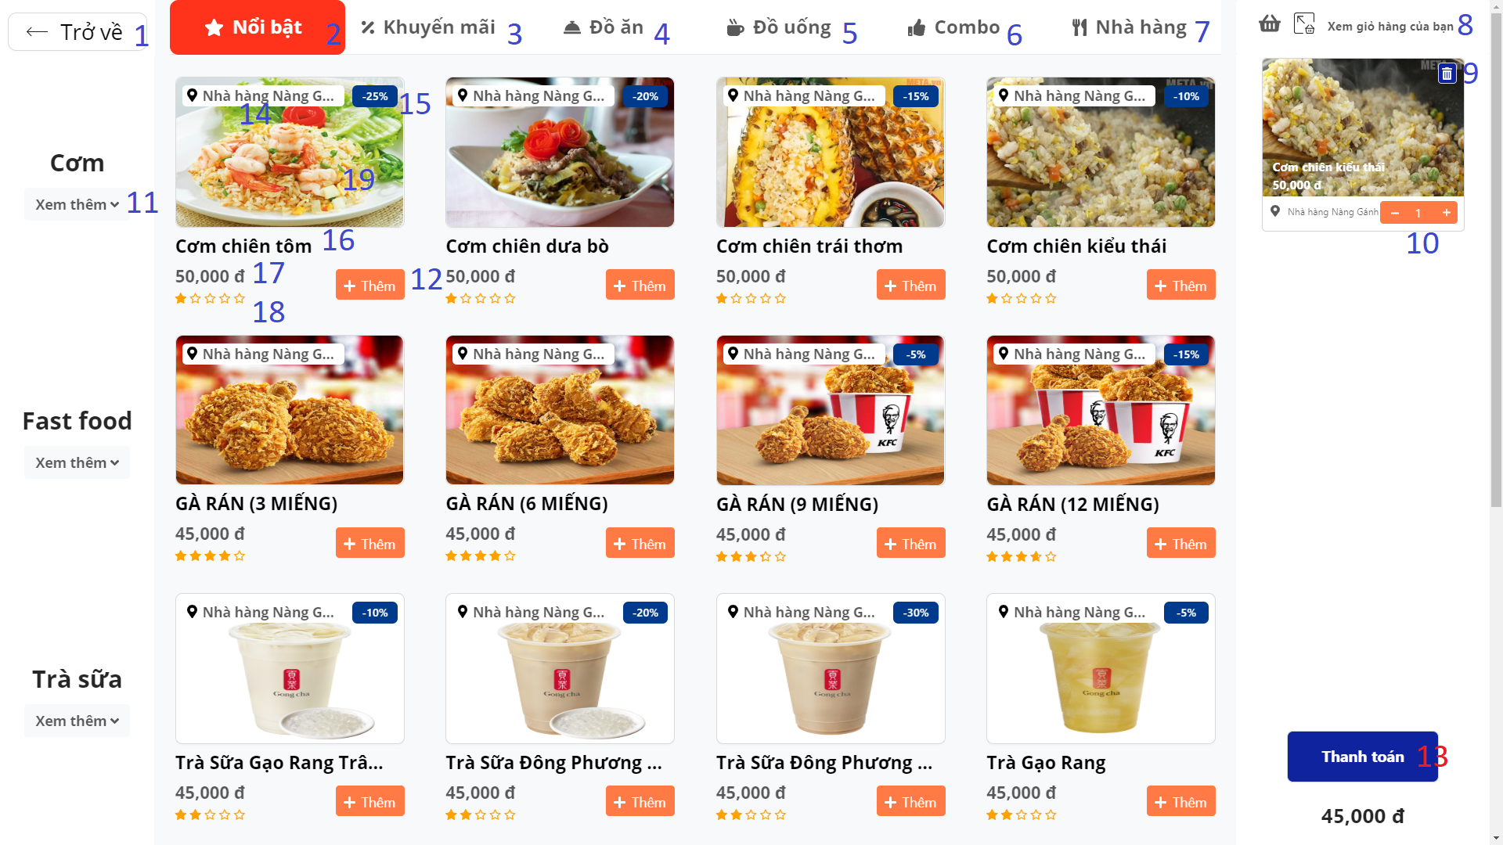

Figure 154: < UI Interface > Kiosk - View list food

**Buttons/Hyperlinks:**

|  |  |  |  |  |
| --- | --- | --- | --- | --- |
| **No** | **Function** | **Description** | **Validation** | **Outcome** |
| 1 | Back | Back to main page | N/A | Return to main page |
| 2 | Popular | View the list of "Popular" dishes of the system | N/A | Display list of dishes |
| 3 | Promotion | View list of dishes having the promotion | N/A | Display list of dishes |
| 4 | Dish | View list of dishes with type “Food” | N/A | Display list of dishes |
| 5 | Drink | View list of dishes with type “Drink” | N/A | Display list of dishes |
| 6 | Combo | View list of combo | N/A | Display list of dishes |
| 7 | Restaurant | View list of dishes sort type by “Restaurant” | N/A | Display list of dishes |
| 8 | View your basket | View list of dishes which have been add to cart | N/A | Display list of dishes which have been add to cart |
| 9 | Remove dish | Remove the dish from the cart | N/A | Remove successfully |
| 10 | Increase /decrease the quantity | Increase /decrease the quantity of dishes in the cart | N/A | Quantity is change |
| 11 | Show more / Collapse | Show more dishes of that type of dish / Collapse dishes | N/A | Display successfully |
| 12 | Add | Add dish to cart | N/A | Add successfully |
| 13 | Order | Redirect to payment page which user choose to payment type | N/A | Users can choose the form they want |

Table 200 < Buttons/Hyperlinks > Kiosk - View list food

**Fields**

|  |  |  |  |  |  |  |
| --- | --- | --- | --- | --- | --- | --- |
| **No** | **Field Name** | **Description** | **Read only** | **Mandatory** | **Control Type** | **Data Type** |
| 14 | Store name | Name of restaurant selling dishes | Yes | Yes | Text | String |
| 15 | Discount rate | Discount rate of dish which was promotion | Yes | No | Text | String |
| 16 | Dish name | Name of dish | Yes | Yes | Text | String |
| 17 | Price | Price of dish | Yes | Yes | Text | String |
| 18 | Rate | Rate of dish | Yes | No | Text | String |
| 19 | Image | Image of dish | Yes | Yes |  |  |

Table 201 <Fields> Kiosk - View list food

**5.2.2.4. View list store with food**

**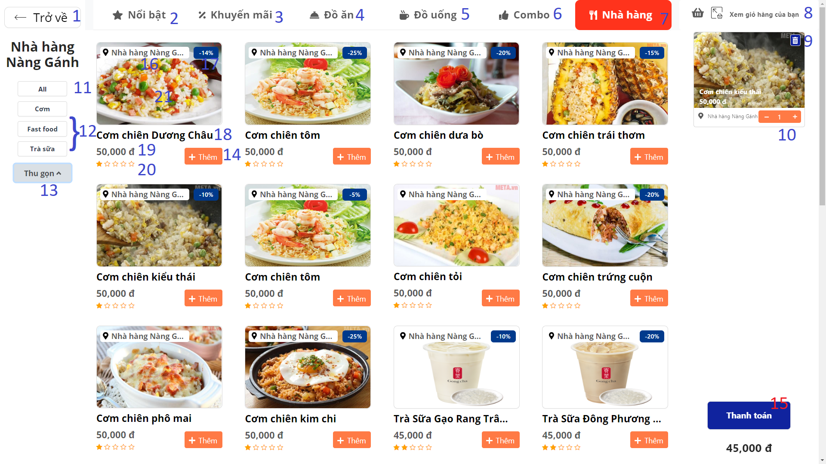**

Figure 155: < UI Interface > Kiosk - View each store with food

**Buttons/Hyperlinks:**

|  |  |  |  |  |
| --- | --- | --- | --- | --- |
| **No** | **Function** | **Description** | **Validation** | **Outcome** |
| 1 | Back | Back to main page | N/A | Return to main page |
| 2 | Popular | View the list of "Popular" dishes of the system | N/A | Display list of dishes |
| 3 | Promotion | View list of dishes having the promotion | N/A | Display list of dishes |
| 4 | Dish | View list of dishes with type “Food” | N/A | Display list of dishes |
| 5 | Drink | View list of dishes with type “Drink” | N/A | Display list of dishes |
| 6 | Combo | View list of combo | N/A | Display list of dishes |
| 7 | Restaurant | View list of dishes sort type by “Restaurant” | N/A | Display list of dishes |
| 8 | View your basket | View list of dishes which have been add to cart | N/A | Display list of dishes which have been add to cart |
| 9 | Remove dish | Remove the dish from the cart | N/A | Remove successfully |
| 10 | Increase /decrease quantity | Increase /decrease quantity of dishes in the cart | N/A | Quantity is change |
| 11 | Show all | Show all the food that the restaurant sells | N/A | Display successfully |
| 12 | Find by category | Find dishes by category | N/A | Display successfully |
| 13 | Show more / Collapse | Show more dishes of that type of dish / Collapse dishes | N/A | Display successfully |
| 14 | Add | Add dish to cart | N/A | Add successfully |
| 15 | Order | Redirect to payment page which user choose to payment type | N/A | Users can choose the form they want |

Table 202 < Buttons/Hyperlinks > Kiosk - View list food

**Fields**

|  |  |  |  |  |  |  |
| --- | --- | --- | --- | --- | --- | --- |
| **No** | **Field Name** | **Description** | **Read only** | **Mandatory** | **Control Type** | **Data Type** |
| 16 | Store name | Name of restaurant selling dishes | Yes | Yes | Text | String |
| 17 | Discount rate | Discount rate of dish which was promotion | Yes | No | Text | String |
| 18 | Dish name | Name of dish | Yes | Yes | Text | String |
| 19 | Price | Price of dish | Yes | Yes | Text | String |
| 20 | Rate | Rate of dish | Yes | No | Text | String |
| 21 | Image | Image of dish | Yes | Yes | Image | Image |

Table 203 <Fields> Kiosk - View list food

**5.2.2.5. View bastket**

**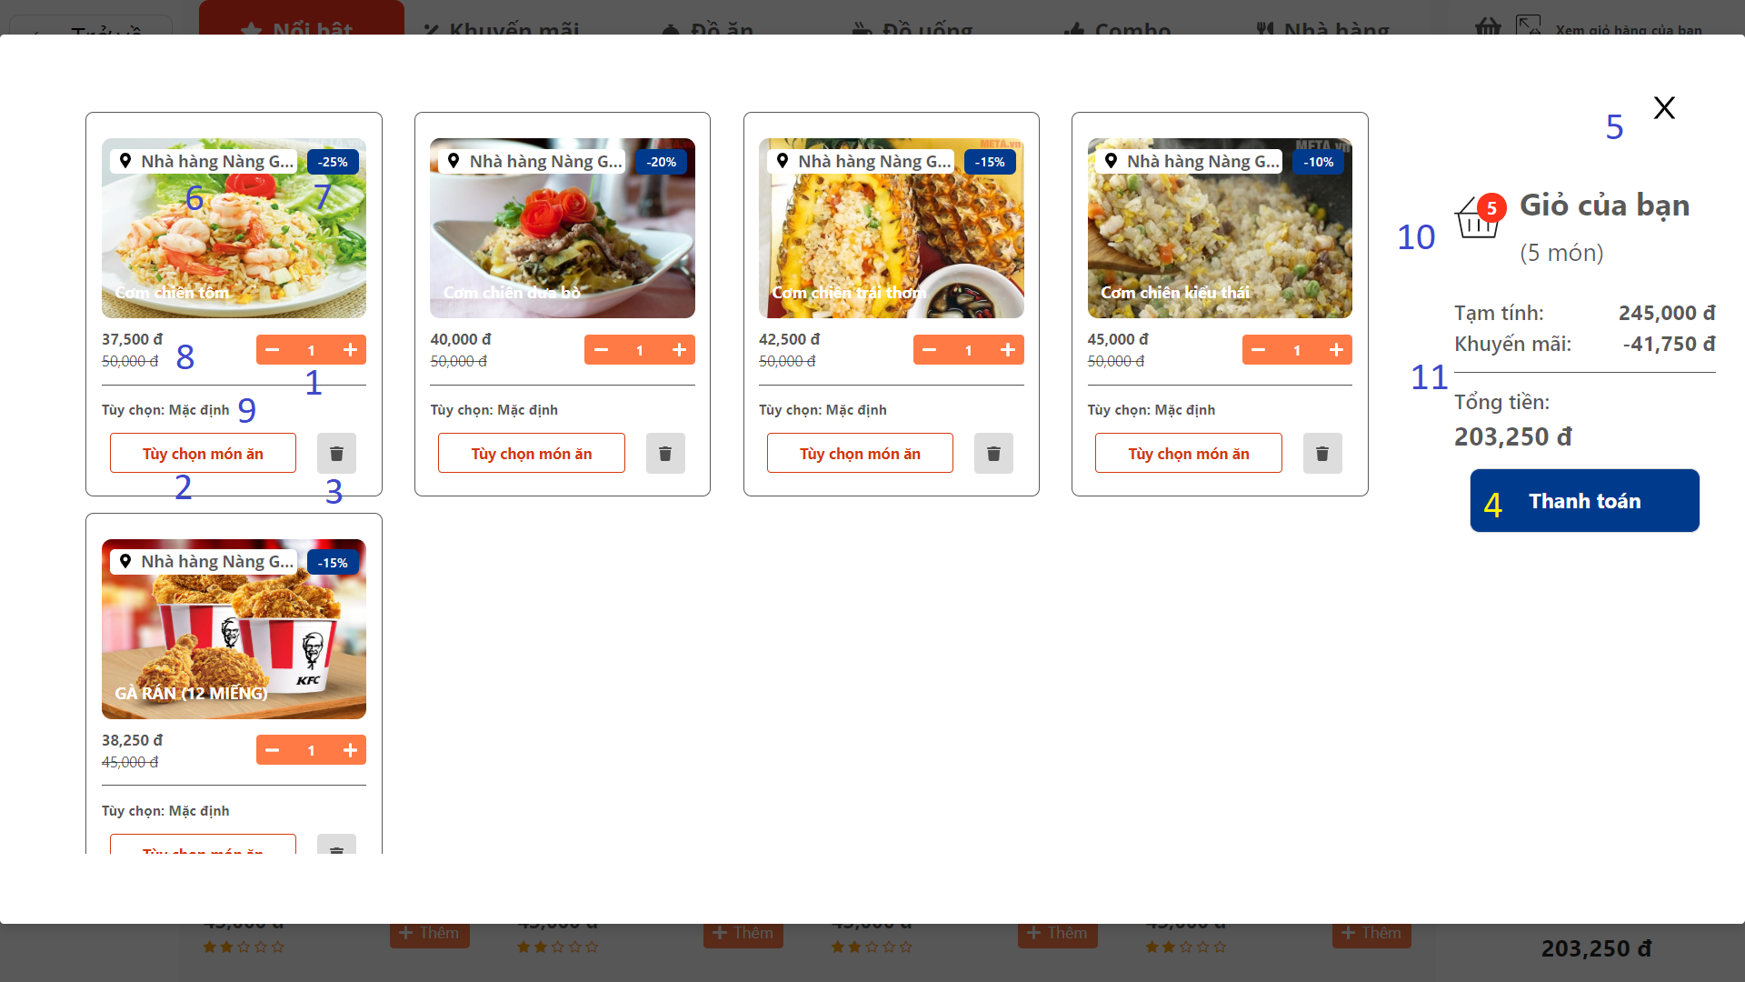**

Figure 156: < UI Interface > Kiosk - View bastket

**Buttons/Hyperlinks:**

|  |  |  |  |  |
| --- | --- | --- | --- | --- |
| **No** | **Function** | **Description** | **Validation** | **Outcome** |
| 1 | Increase /decrease quantity | Increase /decrease the quantity of dishes in the cart | N/A | Quantity is change |
| 2 | Customize dish | Display information of dish with all dish option | N/A | Display all information |
| 3 | Remove dish | Remove the dish from the cart | N/A | Remove successfully |
| 4 | Payment | Redirect to payment page which user choose to payment type | N/A | Users can choose the form they want |
| 5 | Close modal | Hide "view basket" modal | N/A | Close modal |

Table 204 < Buttons/Hyperlinks > Kiosk - View bastket

**Fields**

|  |  |  |  |  |  |  |
| --- | --- | --- | --- | --- | --- | --- |
| **No** | **Field Name** | **Description** | **Read only** | **Mandatory** | **Control Type** | **Data Type** |
| 6 | Store name | Name of restaurant selling dishes | Yes | No | Text | String |
| 7 | Discount rate | Discount rate of dish which was promotion | Yes | No | Text | String |
| 8 | Price | Price of dish | Yes | No | Text | String |
| 9 | Food option | Food option type of dish | Yes | No | Text | String |
| 10 | Number of dish | Number of dishes of order | Yes | Yes | Text | String |
| 11 | Total price | Total price of the cart | Yes | Yes | Text | Number |

Table 205 <Fields> Kiosk - View bastket

**5.2.2.6. View dish info**

**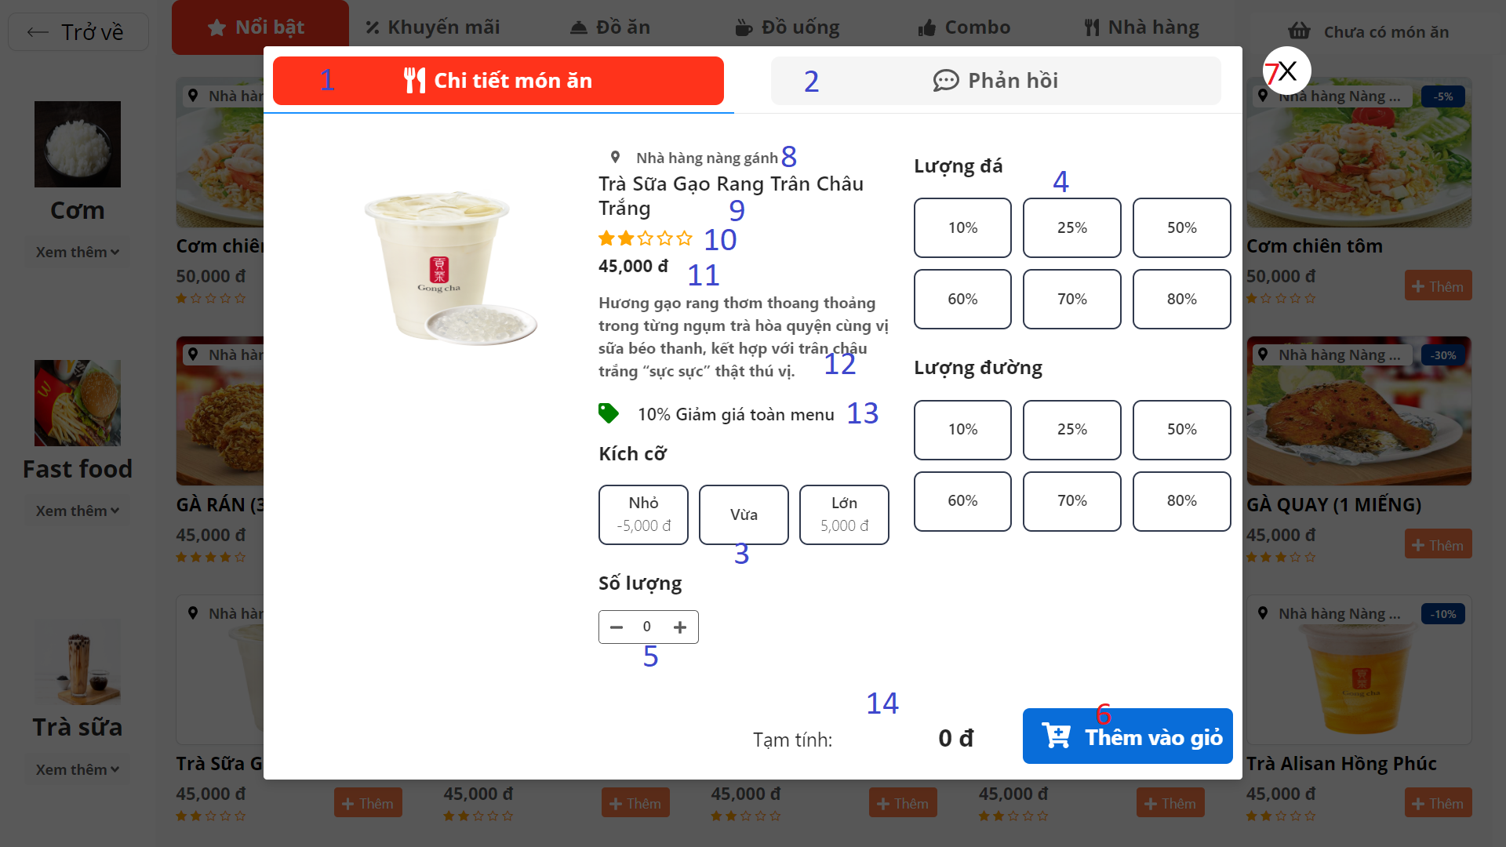**

Figure 157: < UI Interface > Kiosk - View dish info

**Buttons/Hyperlinks:**

|  |  |  |  |  |
| --- | --- | --- | --- | --- |
| **No** | **Function** | **Description** | **Validation** | **Outcome** |
| 1 | View info | Switch to the "Dish info" tab | N/A | Display information of dish |
| 2 | View feedback | Switch to the "Feedback" tab | N/A | Display feedback of dish |
| 3 | Size group | Select size of dish | N/A | Price change |
| 4 | Percent of ingredients | Select the desired rate | N/A | Selection is recorded |
| 5 | Increase /decrease quantity | Increase /decrease the quantity of dishes in the cart | N/A | Quantity is change |
| 6 | Add | Add dish to cart | N/A | Add successfully |
| 7 | Close modal | Hide "view basket" modal | N/A | Close modal |

Table 206 < Buttons/Hyperlinks > Kiosk - View dish info

**Fields**

|  |  |  |  |  |  |  |
| --- | --- | --- | --- | --- | --- | --- |
| **No** | **Field Name** | **Description** | **Read only** | **Mandatory** | **Control Type** | **Data Type** |
| 8 | Store name | Name of restaurant selling dishes | Yes | No | Text | String |
| 9 | Dish name | Name of dish | Yes | No | Text | String |
| 10 | Rate | Rate of dish | Yes | No | Icon | Icon |
| 11 | Price | Price of dish | Yes | No | Text | Number |
| 12 | Description | More information about dishes | Yes | Yes | Text | String |
| 13 | Discount rate | Discount rate of dish which was promotion | Yes | No | Text | String |
| 14 | Total price | Total price include option | Yes | Yes | Text | Number |

Table 207 <Fields> Kiosk - View dish info

**5.2.2.7. View dish feedback**

**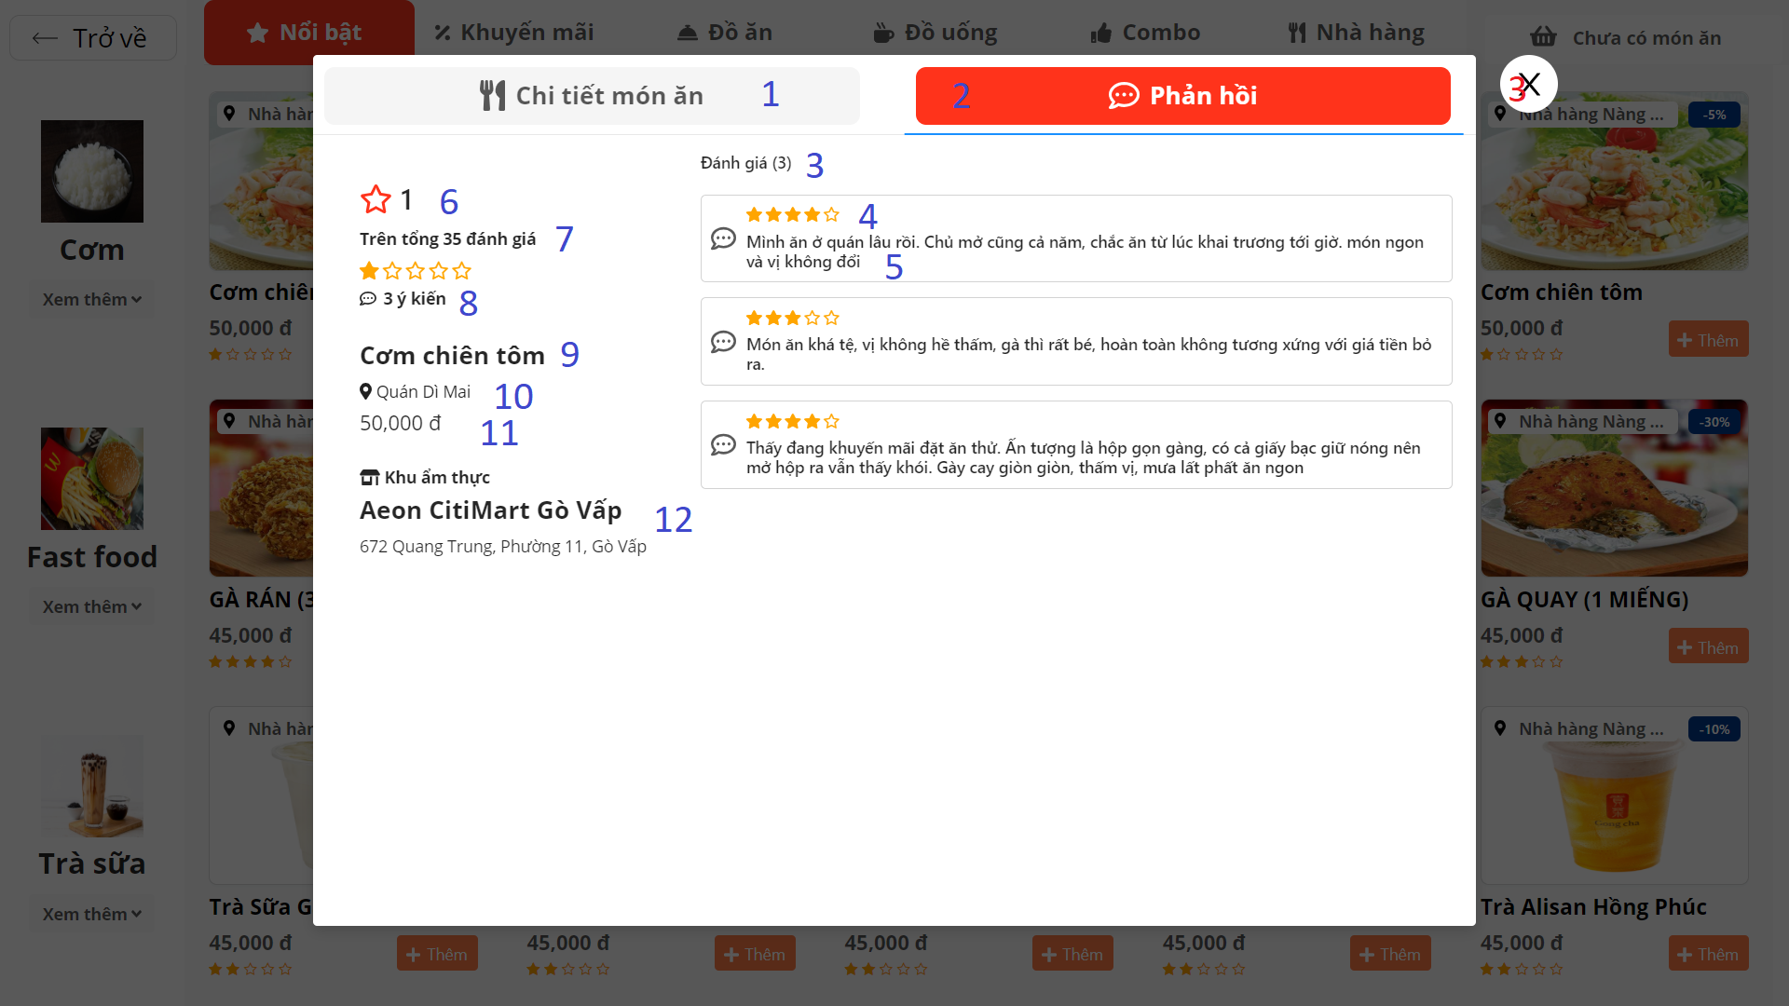**

Figure 158: < UI Interface > Kiosk - View dish feedback

**Buttons/Hyperlinks:**

|  |  |  |  |  |
| --- | --- | --- | --- | --- |
| **No** | **Function** | **Description** | **Validation** | **Outcome** |
| 1 | View info | Switch to the "Dish info" tab | N/A | Display information of dish |
| 2 | View feedback | Switch to the "Feedback" tab | N/A | Display feedback of dish |
| 3 | Close modal | Hide "view basket" modal | N/A | Close modal |

Table 208 < Buttons/Hyperlinks > Kiosk - View dish feedback

**Fields**

|  |  |  |  |  |  |  |
| --- | --- | --- | --- | --- | --- | --- |
| **No** | **Field Name** | **Description** | **Read only** | **Mandatory** | **Control Type** | **Data Type** |
| 4 | Amount of feedback | The amount of feedback for food | Yes | No | Text | Number |
| 5 | Rate of comment | Rate of comment for dish | Yes | No | Icon | Icon |
| 6 | Comment | Comment of feedback | Yes | No | Text | String |
| 7 | Avarage Rate | Average rating for food | Yes | Yes | Text | Number |
| 8 | Number of feedback review | Number of feedback reviews for dish | Yes | Yes | Text | Number |
| 8 | Store name | Name of restaurant selling dishes | Yes | No | Text | String |
| 9 | Number of comment | Number of comment for feedback | Yes | No | Text | String |
| 10 | Dish name | Name of dish | Yes | No | Text | String |
| 11 | Store name | Name of restaurant selling dishes | Yes | No | Text | String |
| 12 | Price | Price of dish | Yes | No | Text | Number |
| 13 | Food court info | Information of foodcourt | Yes | No | Text | String |

Table 209 <Fields> Kiosk - View dish feedback

**5.2.2.8. Choose payment method**

**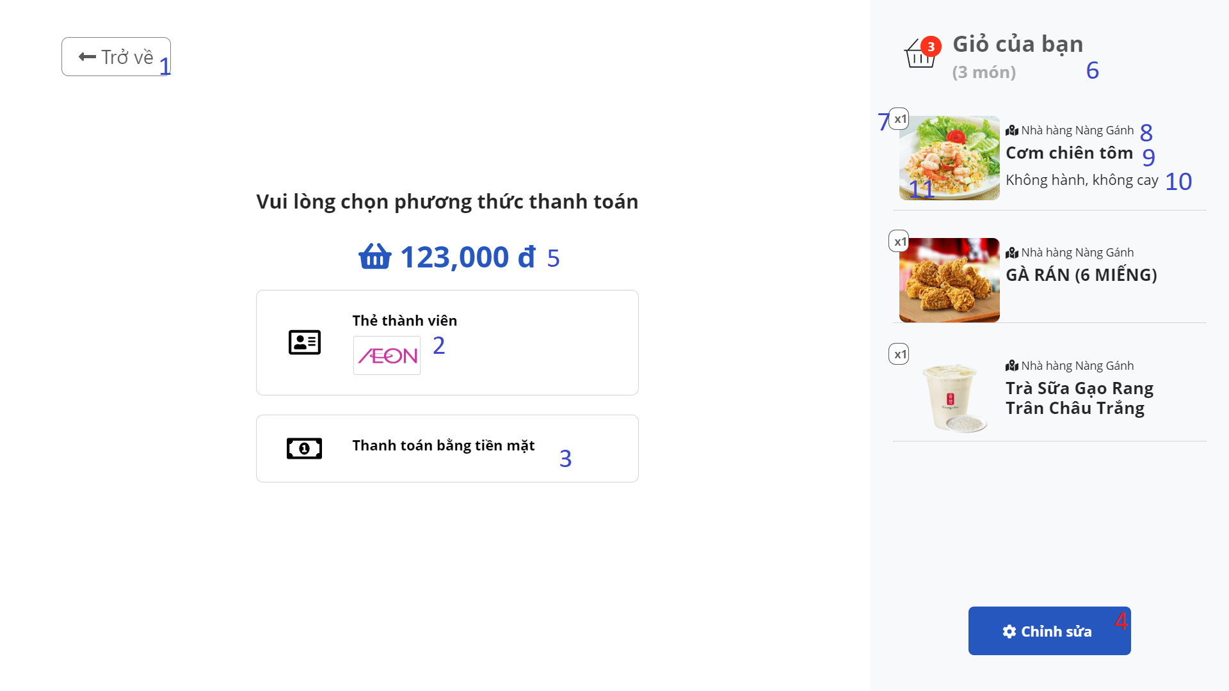**

Figure 159: < UI Interface > Kiosk - Choose payment method

**Buttons/Hyperlinks:**

|  |  |  |  |  |
| --- | --- | --- | --- | --- |
| **No** | **Function** | **Description** | **Validation** | **Outcome** |
| 1 | Back | Back to menu page | N/A | Return to menu page |
| 2 | Pay by membership | Choose payment method by membership card | N/A | Move to swipe membership card screen |
| 3 | Pay by on cash | Choose payment method by on cash | N/A | Move to the page that displays the order number and prints the invoice |
| 4 | Customize | View list of dishes which have been add to cart | N/A | Display list of dishes which have been add to cart |

Table 210 < Buttons/Hyperlinks > Kiosk - Choose payment method

**Fields**

|  |  |  |  |  |  |  |
| --- | --- | --- | --- | --- | --- | --- |
| **No** | **Field Name** | **Description** | **Read only** | **Mandatory** | **Control Type** | **Data Type** |
| 5 | Total price | The total amount that users will pay | Yes | Yes | Text | Number |
| 6 | Number of dish | Number of dishes of order | Yes | Yes | Text | String |
| 7 | Quantity | Quantity of dish | Yes | Yes | Text | String |
| 8 | Store name | Name of restaurant selling dishes | Yes | No | Text | String |
| 9 | Dish name | Name of dish | Yes | No | Text | String |
| 10 | Food option | Information of the dish option that the user has selected | Yes | No | Text | String |

Table 211 <Fields> Kiosk - Choose payment method

**5.2.2.9. Payment by membership card**

**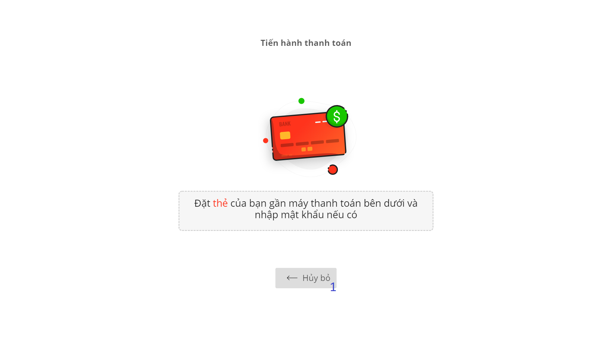**

Figure 160: < UI Interface > Kiosk - Payment by membership card

**Buttons/Hyperlinks:**

|  |  |  |  |  |
| --- | --- | --- | --- | --- |
| **No** | **Function** | **Description** | **Validation** | **Outcome** |
| 1 | Cancel | Back to the screen for selecting payment methods | N/A | Return to the screen for selecting payment methods |

Table 212 < Buttons/Hyperlinks > Kiosk - Payment by membership card

**5.2.2.10. Complete order**

**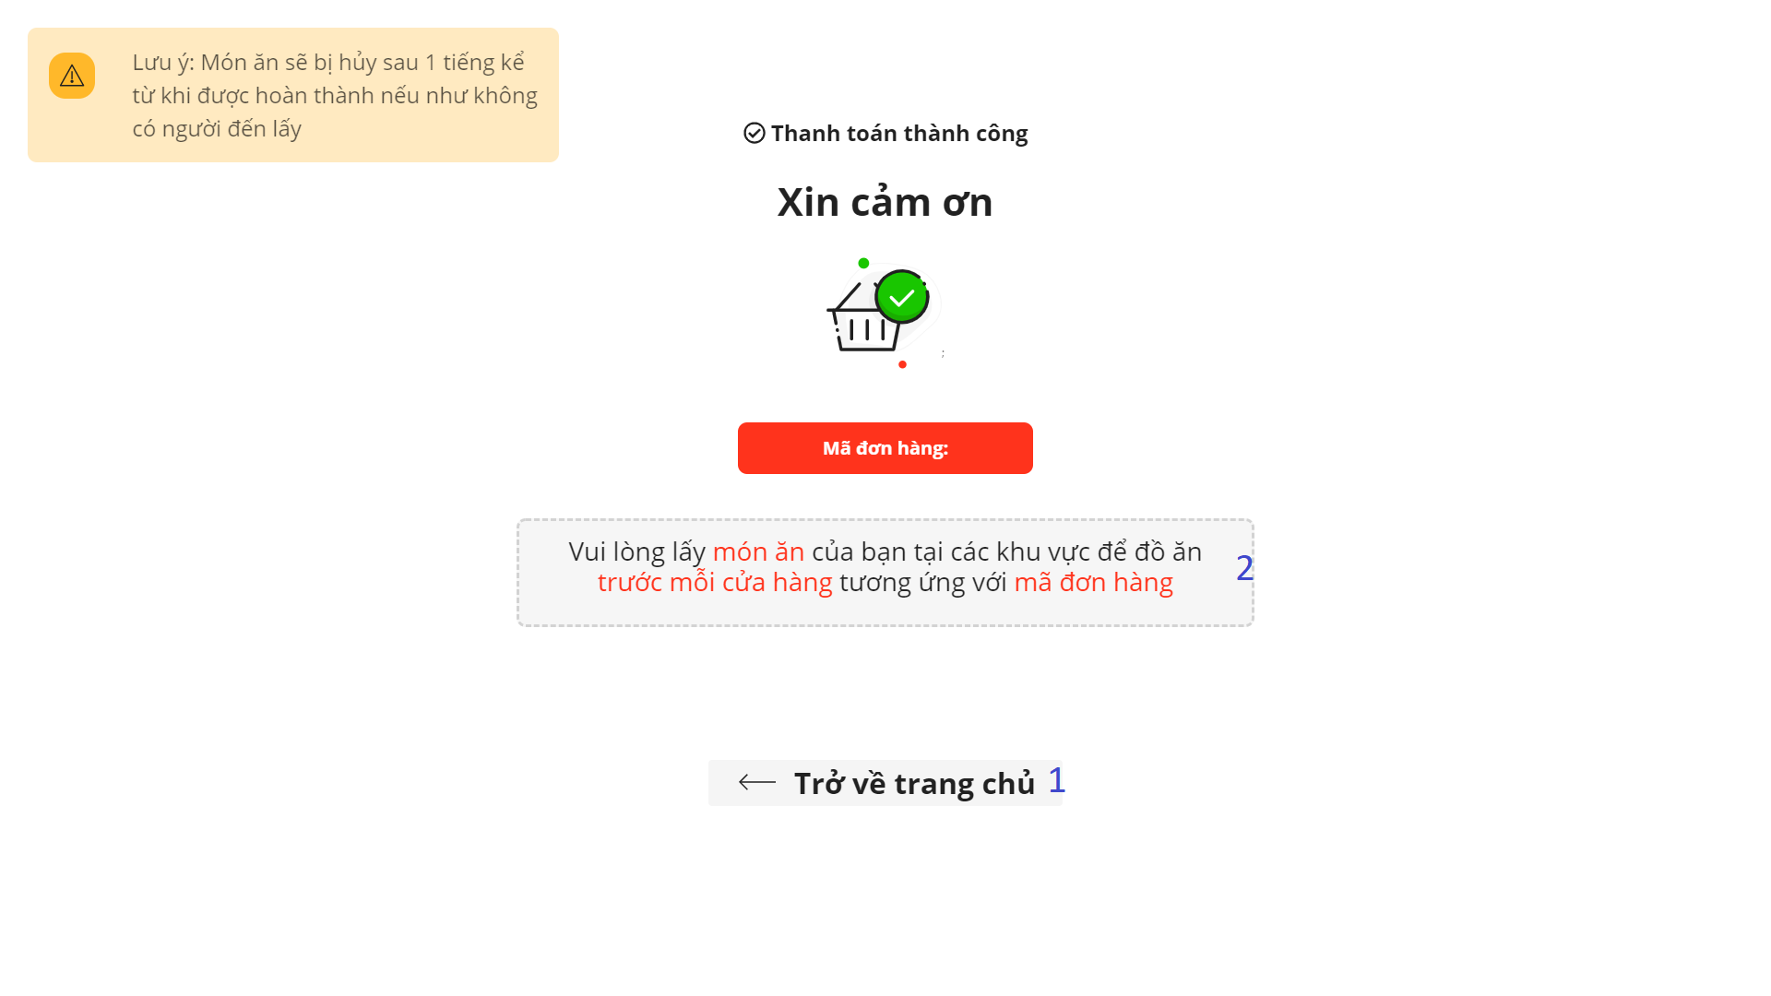**

Figure 161: < UI Interface > Kiosk - Complete order

**Buttons/Hyperlinks:**

|  |  |  |  |  |
| --- | --- | --- | --- | --- |
| **No** | **Function** | **Description** | **Validation** | **Outcome** |
| 1 | Back to home | Back to main page | N/A | Return to main page |

Table 213 < Buttons/Hyperlinks > Kiosk - Complete order

**Fields**

|  |  |  |  |  |  |  |
| --- | --- | --- | --- | --- | --- | --- |
| **No** | **Field Name** | **Description** | **Read only** | **Mandatory** | **Control Type** | **Data Type** |
| 2 | Order number | Order number of the order | Yes | Yes | Text | Number |

Table 214 <Fields> Kiosk - Complete order

#### **5.2.3.** **Application**

##### **5.2.3.1.** **Flash**



Figure 162: Flash screen

**Buttons:**

|  |  |  |  |  |
| --- | --- | --- | --- | --- |
| **No** | **Function** | **Description** | **Validation** | **Outcome** |
| 1 | Press Meal | Press to navigate to onboarding 1 | Required | Navigate to onboarding 1 |

Table 215 Flash

##### **5.2.3.2.** **Onboarding**

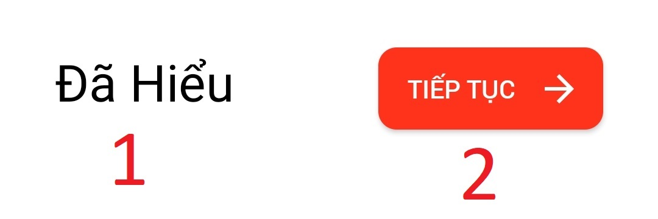

Figure 163: Onboarding 1 screen

**Buttons/Hyperlinks:**

|  |  |  |  |  |
| --- | --- | --- | --- | --- |
| **No** | **Function** | **Description** | **Validation** | **Outcome** |
| 1 | “Đã hiểu” | Press it if you understood application |  | Navigate to login page |
| 2 | “Tiếp tục” | Press to navigate next onboarding |  | Navigate to next onboarding |

Table 216 Onboaring

##### **5.2.3.3.** **Last onboarding**



Figure 164: Button "Bắt đầu bửa ăn"

**Buttons/Hyperlinks:**

|  |  |  |  |  |
| --- | --- | --- | --- | --- |
| **No** | **Function** | **Description** | **Validation** | **Outcome** |
| 1 | Next page | Press to navigate to login page |  | Navigate to login page |

Table 217 Last onboarding

##### **5.2.3.4.** **Welcome**

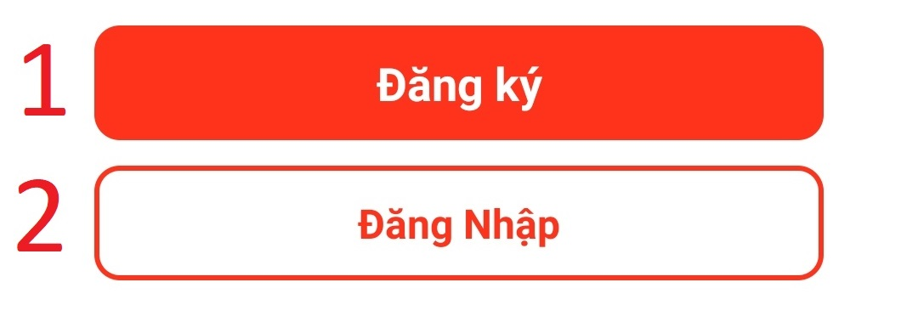

Figure 165: Sign Up

**Buttons/Hyperlinks:**

|  |  |  |  |  |
| --- | --- | --- | --- | --- |
| **No** | **Function** | **Description** | **Validation** | **Outcome** |
| 1 | “Đăng ký” | Press to navigate to register account page |  | Navigate to register account page |
| 2 | “Đăng nhập” | Press to navigate to login page |  | Navigate to login page |

Table 218 Welcome

##### **5.2.3.5.** **Register**

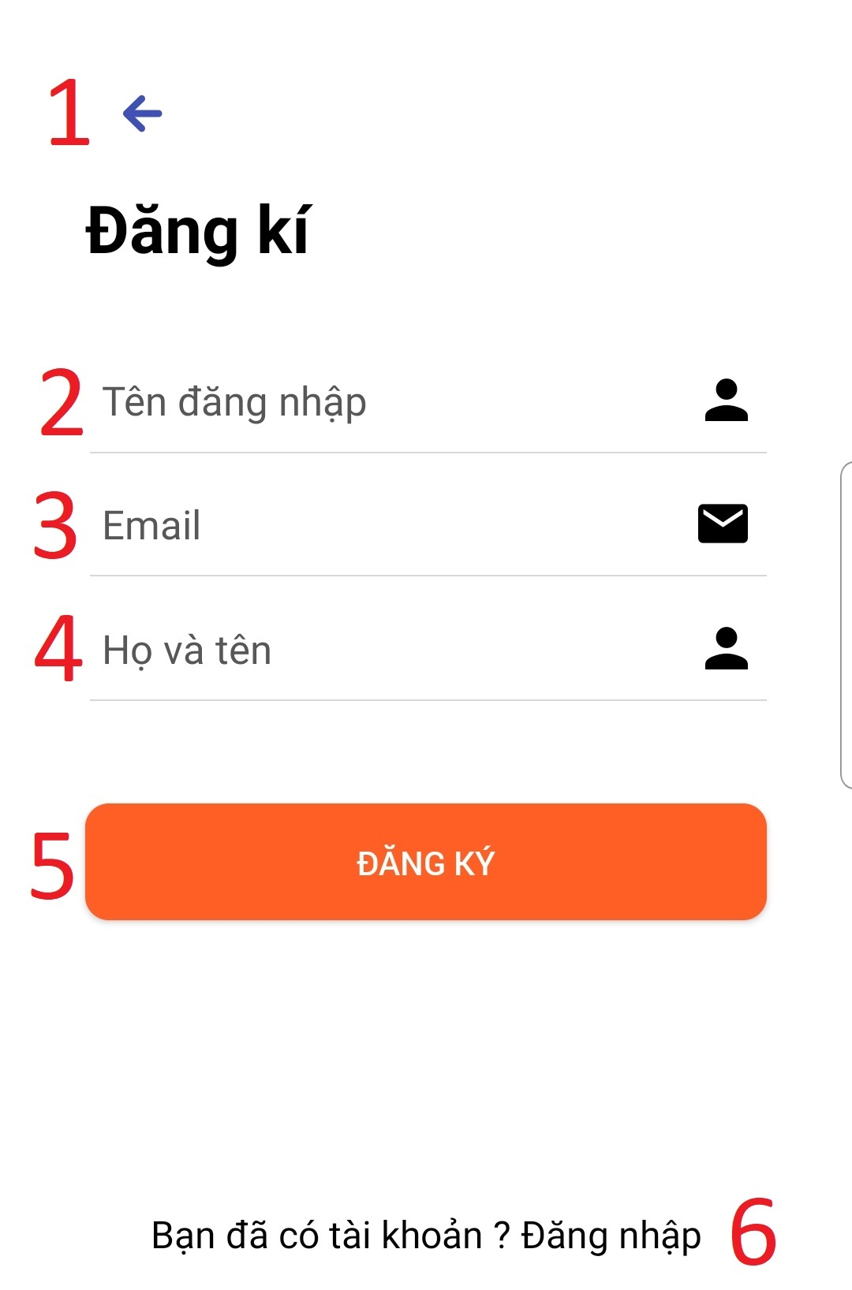

Figure 166 Sign Up

**Fields**

|  |  |  |  |  |  |  |
| --- | --- | --- | --- | --- | --- | --- |
| **No** | **Field Name** | **Description** | **Read only** | **Mandatory** | **Control Type** | **Data Type** |
| 2 | “Tên đăng nhập” | Input username to register | No | Yes | Input Text | String |
| 3 | “Email” | Input Email to register | No | Yes | Input Text | String |
| 4 | “Họ và tên” | Input full name to register | No | No | Input Text | String |

Table 219 Field Login

**Buttons/Hyperlinks:**

|  |  |  |  |  |
| --- | --- | --- | --- | --- |
| **No** | **Function** | **Description** | **Validation** | **Outcome** |
| 1 | GoBack | Press to go back welcome page |  | Go back welcome page |
| 5 | “Đăng ký” | Press to register account | Required | Register account success  Password in your mail  Navigate to login page |
| 6 | “Đăng nhập” | Press to navigate to login page |  | Navigate to login page |

Table 220 Button sign up

##### **5.2.3.6.** **Login**

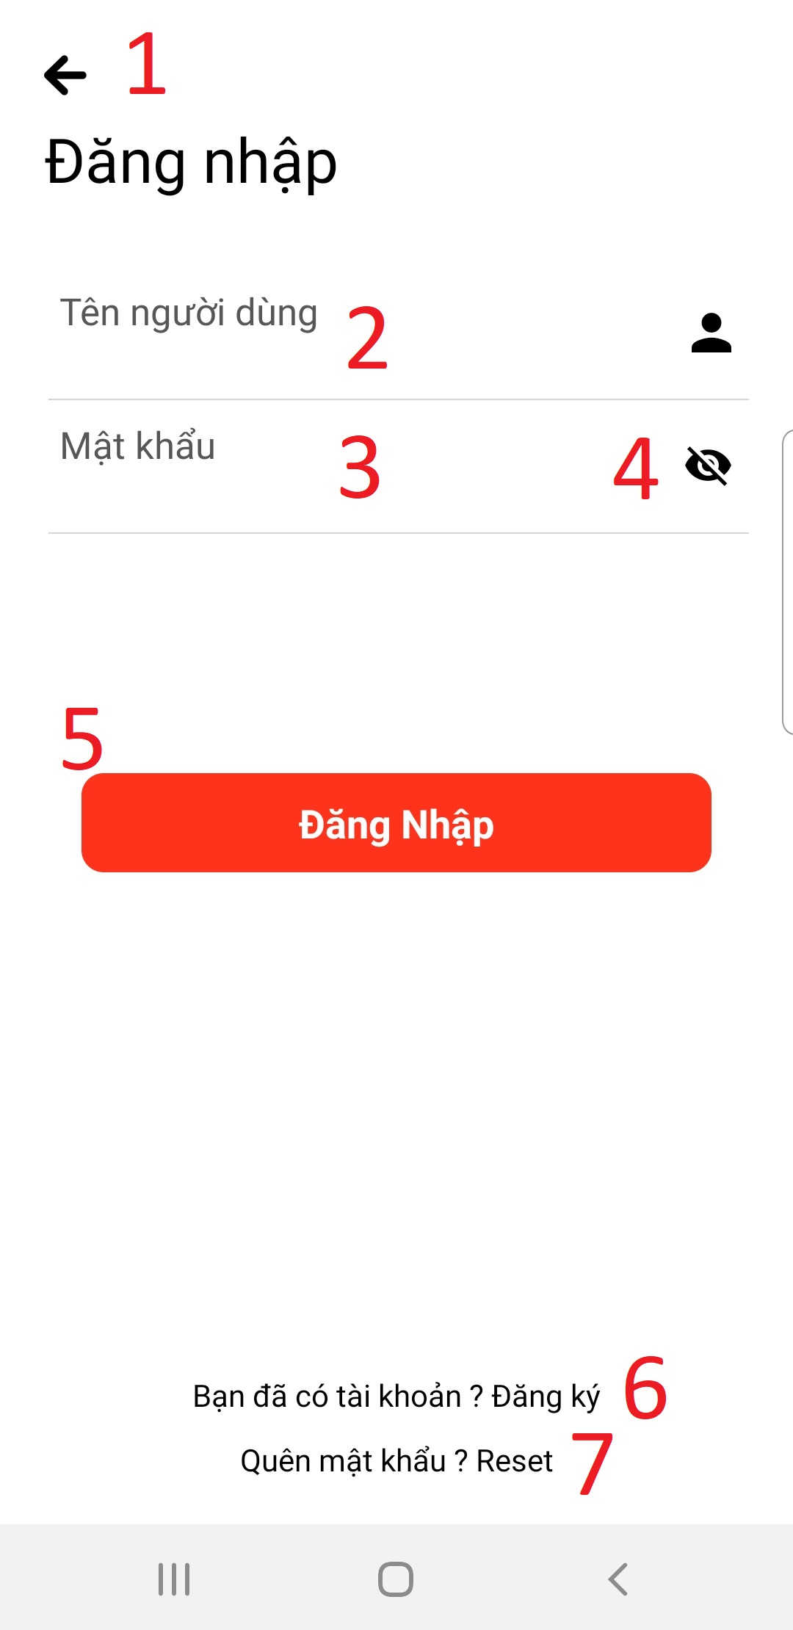

Figure 167 Login

**Fields**

|  |  |  |  |  |  |  |
| --- | --- | --- | --- | --- | --- | --- |
| **No** | **Field Name** | **Description** | **Read only** | **Mandatory** | **Control Type** | **Data Type** |
| 2 | “Tên đăng nhập | Input your username to login | No | Yes | Input text | String |
| 3 | “Mật khẩu” | Input your password to login | No | Yes | Password | String |

Table 221 Field ‘Đăng nhập’

**Buttons/Hyperlinks:**

|  |  |  |  |  |
| --- | --- | --- | --- | --- |
| **No** | **Function** | **Description** | **Validation** | **Outcome** |
| 4 | show/hide | Click to show/hide your password |  | Show/hide your password |
| 5 | “Đăng nhập” | Click to check login | Required | if true navigate to home page else show message |
| 6 | “Đăng ký” | Click to navigate to register page |  | Navigate to register page |
| 7 | Reset password | Click to navigate to reset password page |  | Navigate to reset password page |

Table 222 Button Login

##### **5.2.3.7.** **Reset password**

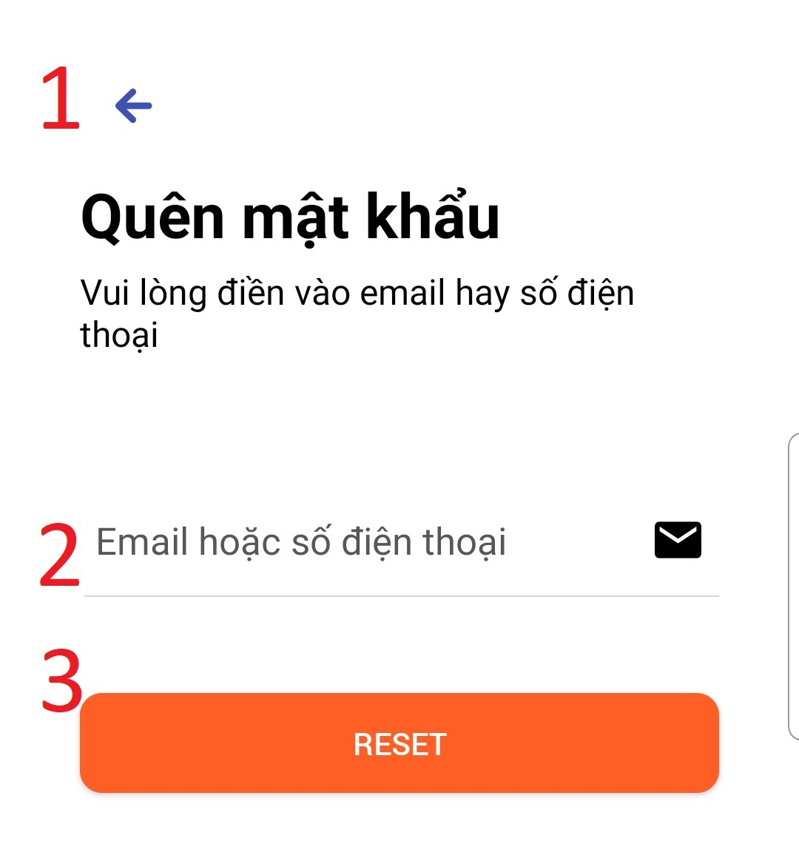

Figure 168 Forget screen

**Fields**

|  |  |  |  |  |  |  |
| --- | --- | --- | --- | --- | --- | --- |
| **No** | **Field Name** | **Description** | **Read only** | **Mandatory** | **Control Type** | **Data Type** |
| 2 | Email | Input your email to get new password | No | Yes | Input text | String |

Table 223 Field Forget Password

**Buttons/Hyperlinks:**

|  |  |  |  |  |
| --- | --- | --- | --- | --- |
| **No** | **Function** | **Description** | **Validation** | **Outcome** |
| 3 | Reset password | Press to get new password | Required | Your new password sent to your email |

Table 224 Button Reset Password

##### **5.2.3.8.** **Home header**

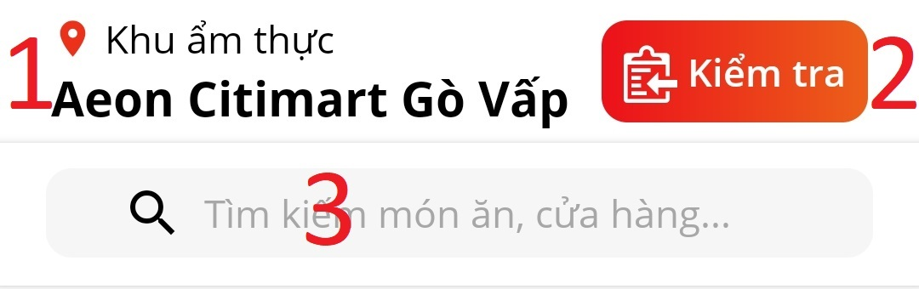

Figure 169 Search

**Buttons/Hyperlinks:**

|  |  |  |  |  |
| --- | --- | --- | --- | --- |
| **No** | **Function** | **Description** | **Validation** | **Outcome** |
| 1 | Select food court | Press to select other food court |  | Navigate to select food court page |
| 2 | “kiểm tra” | Press to check order status |  | Navigate to check order status page |
| 3 | “Tìm kiếm món ăn,...” | Press to search order |  | Navigate to search dishs page |

Table 225 Butoon “Kiểm tra”

##### **5.2.3.9.** **Category**

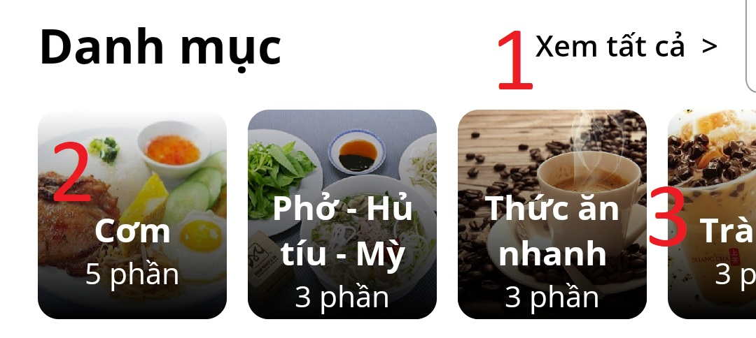

Figure 170 Danh mục

**Buttons/Hyperlinks:**

|  |  |  |  |  |
| --- | --- | --- | --- | --- |
| **No** | **Function** | **Description** | **Validation** | **Outcome** |
| 1 | “Xem tất cả” | Press to see all category of food court |  | Navigate to list category page |
| 2 | See list food | Press to see list dish by category |  | Navigate to list dish of category “cơm” |
| 3 | “Scroll” | Scroll left/right to see more food |  | Show more dish |

Table 226 Buttons “danh mục”

##### **5.2.3.10.** **Stores**

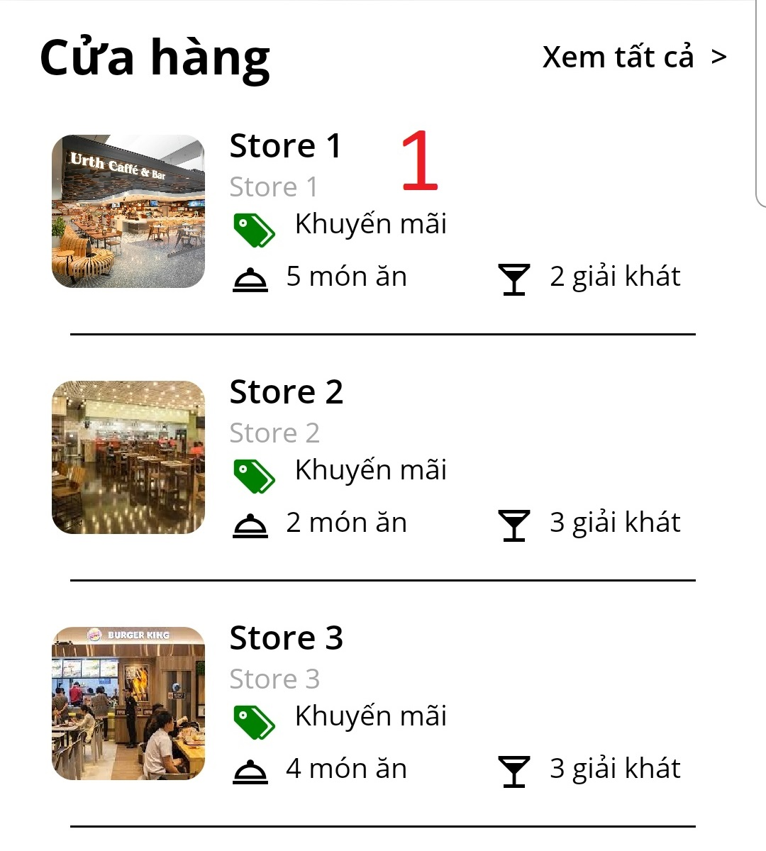

Figure 171: List store

**Buttons/Hyperlinks:**

|  |  |  |  |  |
| --- | --- | --- | --- | --- |
| **No** | **Function** | **Description** | **Validation** | **Outcome** |
| 1 | See store detail | Press to see store detail |  | Navigate to store detail page |

Table 227 Button Strores

##### **5.2.3.11.** **Bottom tab bar**

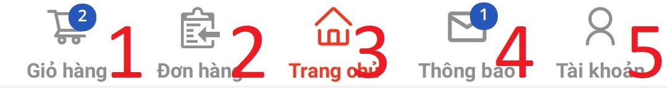

Figure 172: Bottom tab bar

**Buttons/Hyperlinks:**

|  |  |  |  |  |
| --- | --- | --- | --- | --- |
| **No** | **Function** | **Description** | **Validation** | **Outcome** |
| 1 | See cart | Press to see your cart |  | Navigate to cart page |
| 2 | See order | Press to your order history |  | Navigate to history order page |
| 3 | Home | Press to show home page |  | Navigate to home page |
| 4 | See notification | Press to see your notification |  | Navigate to notification page |
| 5 | See information | Press to your information |  | Navigate to your information page |

Table 228 Button tab bar

##### **5.2.3.12.** **Search food**

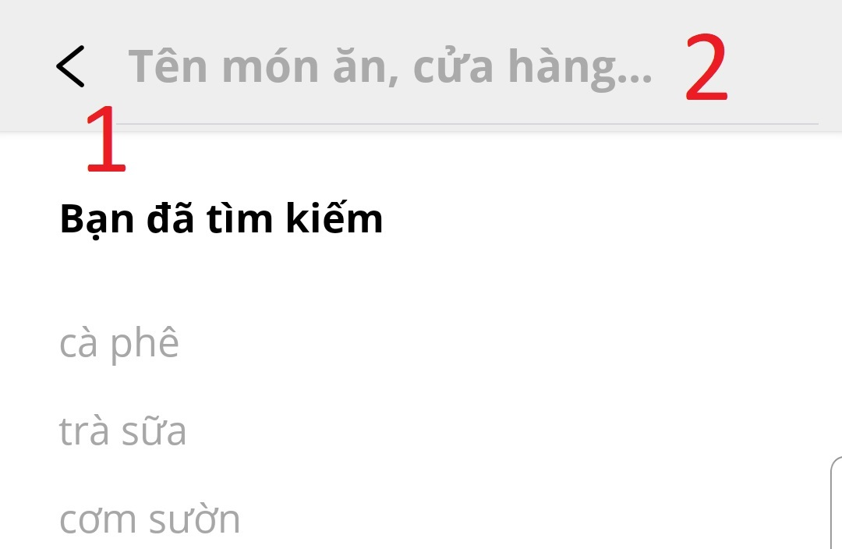

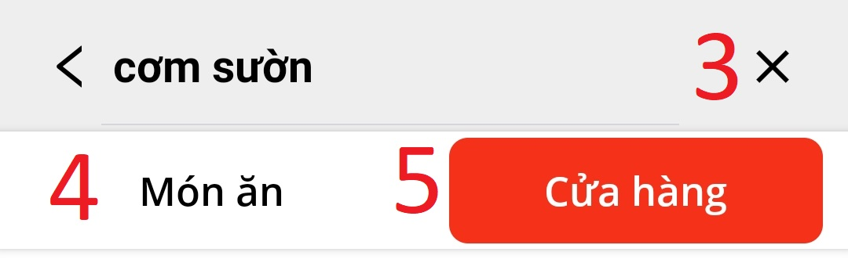

Figure 173 Search Food

**Fields**

|  |  |  |  |  |  |  |
| --- | --- | --- | --- | --- | --- | --- |
| **No** | **Field Name** | **Description** | **Read only** | **Mandatory** | **Control Type** | **Data Type** |
| 2 | search value | Input dish’s name to search | No | No | Input text | String |

Table 229 Search Food

**Buttons/Hyperlinks:**

|  |  |  |  |  |
| --- | --- | --- | --- | --- |
| **No** | **Function** | **Description** | **Validation** | **Outcome** |
| 1 | go back | Press to go back home page |  | Go back home page |
| 3 | Clear | Press to clear search value |  | Clear search value |
| 4 | See list dish result | Press to see list dish result |  | Show list dish result |
| 5 | See list store of dish result | Press to see list store of dish result |  | Show list store of dish result |

Table 230 Button Search food

##### **5.2.3.13.** **Search order**



Figure 174: Search Order

**Buttons/Hyperlinks:**

|  |  |  |  |  |
| --- | --- | --- | --- | --- |
| **No** | **Function** | **Description** | **Validation** | **Outcome** |
| 1 | Search order number | Input your order number to search |  | Show list dish and store |

Table 231 Button Search Order

##### **5.2.3.14.** **Add cart**

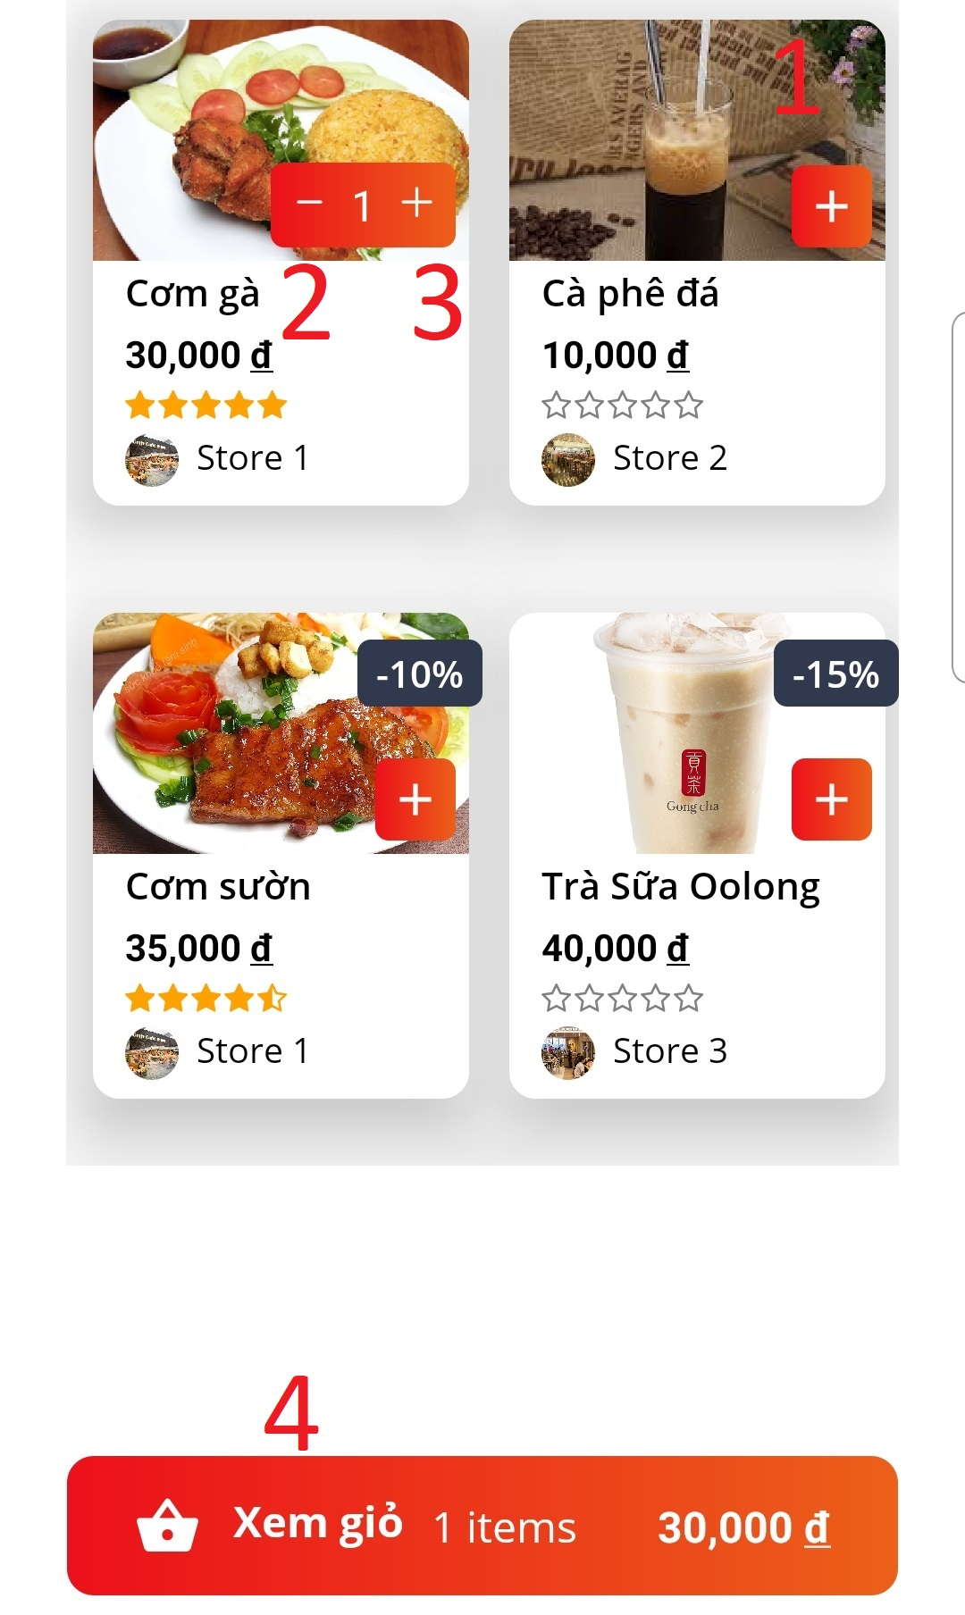

Figure 175: Add cart

**Buttons/Hyperlinks:**

|  |  |  |  |  |
| --- | --- | --- | --- | --- |
| **No** | **Function** | **Description** | **Validation** | **Outcome** |
| 1 | View Food detail | Press to navigate to food deatil screen |  | Navigate to food deatil screen |
| 2 | Minus from cart | Minus food from cart |  | Food minussed from cart |
| 3 | Add to cart | Add food to cart |  | Food added to cart |
| 4 | View cart | Press to navigate to cart screen |  | Navigate to cart screen |

Table 232 Add cart

##### **5.2.3.15.** **Cart**

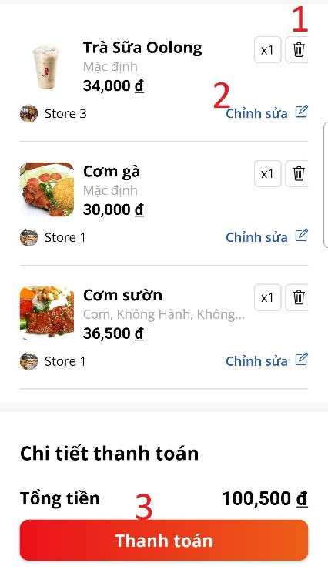

Figure 176: Cart screen

**Buttons/Hyperlinks:**

|  |  |  |  |  |
| --- | --- | --- | --- | --- |
| **No** | **Function** | **Description** | **Validation** | **Outcome** |
| 1 | Delete food | Delete food from cart |  | Food deleted from cart |
| 2 | “Chỉnh sửa” | Custome food |  | Naviate to custome food screen |
| 3 | “Thanh toán” | Payment |  | Payment order |

Table 233 Cart Screen

##### **5.2.3.16.** **FeedBack**

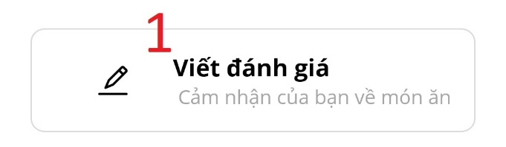

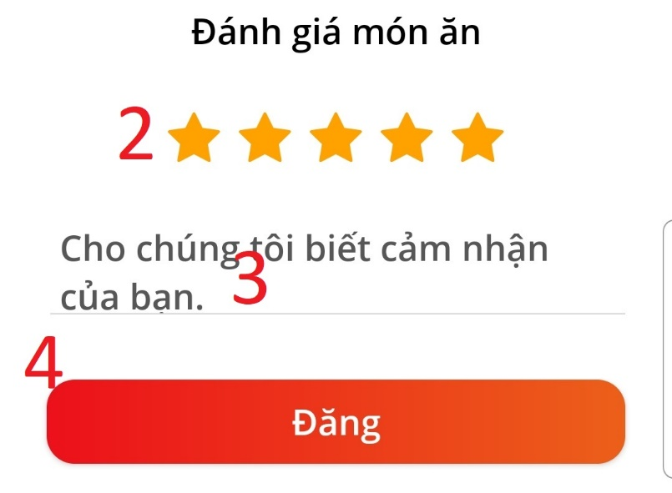

Figure 177: Feed back

**Fields**

|  |  |  |  |  |  |  |
| --- | --- | --- | --- | --- | --- | --- |
| **No** | **Field Name** | **Description** | **Read only** | **Mandatory** | **Control Type** | **Data Type** |
| 3 | Review content | Input content of review | No | No | Input text | String |

Table 234 Fileds Feedback

**Buttons/Hyperlinks:**

|  |  |  |  |  |
| --- | --- | --- | --- | --- |
| **No** | **Function** | **Description** | **Validation** | **Outcome** |
| 1 | “Viết đánh giá” | Press to write review |  | Navigate to review screen |
| 2 | Rate star | Choose star to review |  | Show number start |
| 4 | “Đăng” | Post review |  | Post review success |

Table 235 Button Post Feedback

##### **5.2.3.17.** **Food detail**

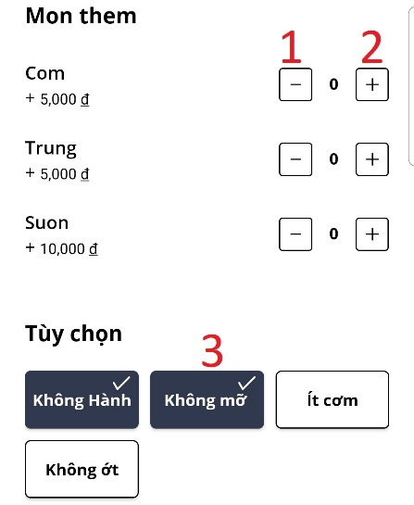

Figure 178: Food Option

**Buttons/Hyperlinks:**

|  |  |  |  |  |
| --- | --- | --- | --- | --- |
| **No** | **Function** | **Description** | **Validation** | **Outcome** |
| 1 | Minus option | Minus option |  | Minus option |
| 2 | Plus option | Plus option |  | Plus option |
| 3 | Choose option | Choose option |  | Choose option |

Table 236 Food option

##### **5.2.3.****18. Order history**

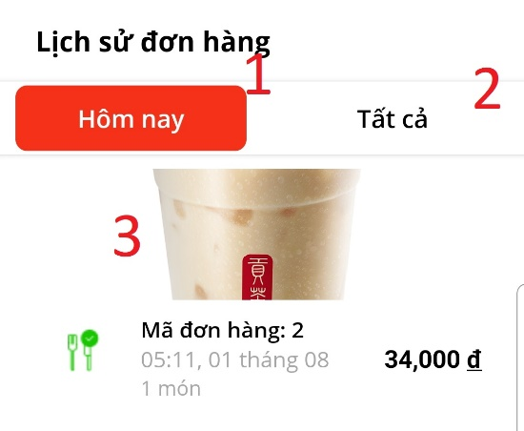

Figure 179: Order History

**Buttons/Hyperlinks:**

|  |  |  |  |  |
| --- | --- | --- | --- | --- |
| **No** | **Function** | **Description** | **Validation** | **Outcome** |
| 1 | “Hôm nay” | View list order of today |  | Display list order of todat |
| 2 | “Tất cả” | View all history order |  | Display all history order |
| 3 | View order detail | View order detail |  | Navigate to order detail screen |

Table 237 Order History

##### **5.2.3.19. Account**

**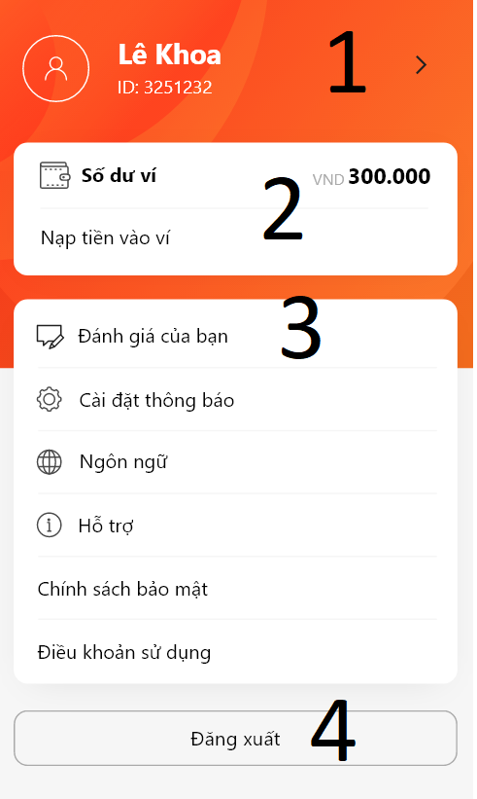**

Figure 180: Account

**Buttons/Hyperlinks:**

|  |  |  |  |  |
| --- | --- | --- | --- | --- |
| **No** | **Function** | **Description** | **Validation** | **Outcome** |
| 1 | “>” | View customer infomation |  | Display customer infomation |
| 2 | “Nạp Tiền vào ví” | View top up wallet |  | Display function top up wallet |
| 3 | “Đánh giá của bạn” | View all feedback of customer |  | Display all feedback of customer. |
| 4 | “Đăng xuất” | Customer Log out |  | Delete asyn storage token. |

Table 238 Account Screen

## **6. Database Design**

### **6.1. Entity Relationship Diagram (ERD)**

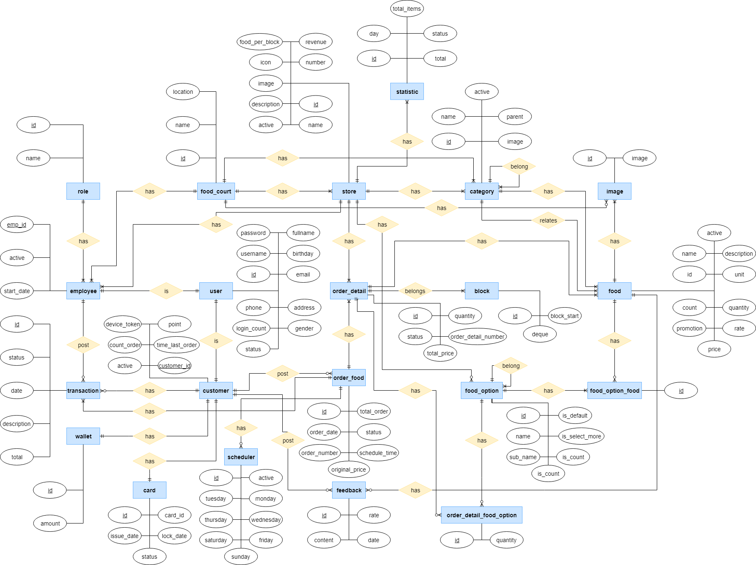

Figure 181: Entity Relation Diagram

### **6.2.Data Dictionary**

|  |  |
| --- | --- |
| Entity Data Dictionary: describe content of all entities | |
| **Entity Name** | **Description** |
| Food\_court | Contain the food court information. |
| User | Contain the user information. |
| Employee | Contain the employee information. |
| Role | Contain the role information. |
| Customer | Contain the customer information. |
| Card | Contain the customer’s card information. |
| Wallet | Contain the customer’s balance information. |
| Transaction | Contain the transaction information. |
| Store | Contain the store information. |
| Statistic | Contain the statistic information. |
| Category | Contain the category information. |
| Food | Contain the food information. |
| Image | Contain the image information. |
| Food\_option\_food | Contain the food’ option information. |
| Food\_option | Contain the option information. |
| Feedback | Contain the feedback information. |
| Order\_food | Contain the order information. |
| Scheduler | Contain the order’s scheduler information. |
| Order\_detail | Contain the order detail information. |
| Order\_detail\_food\_option | Contain the order detail’s food’s option information. |
| Block | Contain the block information. |

|  |  |  |  |  |
| --- | --- | --- | --- | --- |
| Entity Name | Attributes | Description | Domain | Null |
| Food\_court | id | Id of food court | BIGINT(20) | No |
| location | Location of food court | VARCHAR(255) | No |
| name | Name of food court | VARCHAR(255) | No |
| User | id | Id of user | BIGINT(20) | No |
| username | Username of user | VARCHAR(255) | No |
| password | Password of user | VARCHAR(255) | No |
| fullname | Full name off user | VARCHAR(255) | No |
| address | Address of user | VARCHAR(255) | Yes |
| birthday | Birthday of user | DATETIME(6) | Yes |
| email | Email of user | VARCHAR(255) | No |
| gender | Gender of user | VARCHAR(255) | Yes |
| phone | Phone number of user | VARCHAR(255) | Yes |
| login\_count | Count number login fail | INT(11) | Yes |
| status | Status of user | VARCHAR(255) | No |
| Employee | emp\_id | Id of employee | VARCHAR(255) | No |
| active | Status of employee | BIT(1) | No |
| start\_date | Date employee start | DATETIME(6) | Yes |
| Role | id | Id of role | BIGINT(20) | No |
| name | Role name | VARCHAR(255) | No |
| Customer | customer\_id | Id of customer | VARCHAR(255) | No |
| card\_id | Card id of customer | VARCHAR(255) | Yes |
| active | Status of customer | BIT(1) | No |
| count\_order | Count number of order of customer | INT(11) | Yes |
| device\_token | Device token of user | VARCHAR(255) | Yes |
| time\_last\_order | Time of last order of user | DATETIME(6) | Yes |
| point | Point of user | DOUBLE | Yes |
| Card | id | Id of card | BIGINT(20) | No |
| card\_id | Card id | VARCHAR(255) | No |
| issue\_date | Issue date | DATETIME(6) | No |
| lock\_date | Date card is locked | DATETIME(6) | Yes |
| status | Status of card | VARCHAR(255) | No |
| Wallet | id | Id of wallet | BIGINT(20) | No |
| amount | Balance of wallet | DOUBLE | No |
| Transaction | id | Id of transaction | BIGINT(20) | No |
| description | Description of transaction | VARCHAR(255) | No |
| date | Date implement transaction | DATETIME(6) | No |
| status | Status of transaction | VARCHAR(255) | No |
| total | Total money of transaction | DOUBLE | No |
| Store | id | Id of store | BIGINT(20) | No |
| name | Store’s name | VARCHAR(255) | No |
| description | Description of store | VARCHAR(255) | Yes |
| image | Image of store | VARCHAR(255) | No |
| icon | Icon of store | VARCHAR(255) | No |
| number | Store number | INT(11) | No |
| active | Status of store | BIT(1) | No |
| food\_per\_block | Number limit food in a block | INT(11) | No |
| revenue | Revenue of store | DOUBLE | No |
| Statistic | id | Id of statistic | BIGINT(20) | No |
| day | Day of record in statistic | DATETIME(6) | No |
| total\_items | Total item in a statistic | INT(11) | Yes |
| status | Status of statistic | VARCHAR(255) | No |
| total | Total money of statistic | DOUBLE | No |
| Category | id | Id of category | BIGINT(20) | No |
| name | Category’s name | VARCHAR(255) | No |
| image | Image of category | VARCHAR(255) | No |
| active | Status of category | BIT(1) | No |
| parent\_id | Parent of category | BIGINT(20) | Yes |
| Food | id | Id of food | BIGINT(20) | No |
| name | Food’s name | VARCHAR(255) | No |
| description | Description of food | VARCHAR(255) | Yes |
| quantity | Quantity of food | INT(11) | No |
| promotion | Promotion of food | DOUBLE | Yes |
| price | Price of food | DOUBLE | No |
| rate | Total rate of food | DOUBLE | Yes |
| unit | Unit of food | VARCHAR(255) | No |
| count | Count number food in 7 day near | INT(11) | Yes |
| active | Status of food | BIT(1) | No |
| Image | id | Id of image | BIGINT(20) | No |
| image | Uri of image | VARCHAR(255) | No |
| Food\_option\_food | id | Id of food option food | BIGINT(20) | No |
| Food\_option | id | Id of food option | BIGINT(20) | No |
| name | Food option’s name | VARCHAR(255) | No |
| Sub\_name | Sub name of food’s option | VARCHAR(255) | Yes |
| option\_price | Price of food option | DOUBLE | No |
| is\_count | Food option can count or not | BIT(1) | No |
| is\_default | Food option is default or not | BIT(1) | No |
| is\_select\_more | Food option can select more or not | BIT(1) | No |
| Feedback | id | Id of feedback | BIGINT(20) | No |
| content | Content of feedback | VARCHAR(255) | No |
| rate | Rate of food in feedback | DOUBLE | No |
| date | Date post feedback | DATETIME(6) | No |
| Order\_food | id | Id of order | BIGINT(20) | No |
| order\_number | Order’s number | INT(11) | No |
| schedule\_time | Time of schedule | VARCHAR(255) | Yes |
| status | Status of order | VARCHAR(255) | No |
| total\_order | Total money of order | DOUBLE | No |
| original\_price | Original price of total order | DOUBLE | No |
| order\_date | Date post order | DATETIME(6) | No |
| Scheduler | id | Id of schduler | BIGINT(20) | No |
| active | Status of scheduler | BIT(1) | No |
| monday | Has scheduler in monday or not | BIT(1) | Yes |
| tuesday | Has scheduler in tuesday or not | BIT(1) | Yes |
| wednesday | Has scheduler in wednesday or not | BIT(1) | Yes |
| thursday | Has scheduler in thursday or not | BIT(1) | Yes |
| friday | Has scheduler in friday or not | BIT(1) | Yes |
| saturday | Has scheduler in saturday or not | BIT(1) | Yes |
| sunday | Has scheduler in sunday or not | BIT(1) | Yes |
| Order\_detail | id | Id of order detail | BIGINT(20) | No |
| order\_detail\_number | Order detail’s number | INT(11) | No |
| quantity | Quantity food in order detail | INT(11) | No |
| total\_price | Total price of order detail | DOUBLE | No |
| status | Status of order detail | VARCHAR(255) | No |
| Order\_detail\_food\_option | id | Id of order detail – food optio | BIGINT(20) | No |
| quantity | Quantity of food option | INT(11) | No |
| Block | id | Id of block | BIGINT(20) | No |
| block\_start | Time start of block | TIME | No |
| deque | List order detail of each store | VARCHAR(800) | No |

Table 239 Entity Relationship Diagram Dictionary

## **7.** **Algorithms**

Order sort algorithm.

***Definition******:***

This algorithm helps to arrange orders in our system. Including customer orders over mobile, visitors booking through kiosk and even scheduled.

***Problem:***

Our system before applying this algorithm has some problems with the arrangement:

+ All orders are pushed into a queue over time:

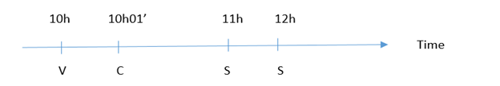

**V:** Visitors order via kiosk

**C:** Customer order via app mobile.

**S**: Sheduled order (via app mobile).

+ Everything is normal until we find an unusually large number of tourists at rush hour:

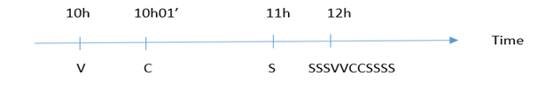

* If a customer A booked a meal at 12:00, and at the same time or sooner there is a customer of the same order, customers' orders will be pushed back. Makes customer A unable to receive food on time.
* If customers order dishes located in different shops. It is very difficult for active customers to receive many dishes in one go.

***Solution:***

* Regulating the order of orders at peak hours with the following criteria: the lowest limit for customers receiving delays over 10 minutes. Create conditions for customers to be proactive in booking appointments in advance.
* To fulfill the above requirement:
  + Need a queue to manage the order of orders at a given time frame. We named that queue "Block".

|  |
| --- |
| Block |
| + blockId : long+ blockStart : Time+ deque : String |

* + - BlockId: Identifier id of that block. Auto increment.
    - BlockStart: Start time of a block.
    - Deque: The start time of a block is a String, re-implement the queue "double ended queue" - the same Queue but it supports both removed and added elements in both head...
  + We set the time for each Block to be 10 minutes. We choose 10 minutes because of the "minimum restriction that customers receive late for more than 10 minutes". Equally, each customer receives his food no later than 1 Block.
  + Rules of queues:

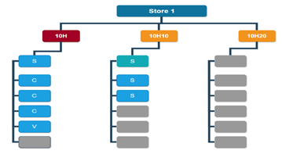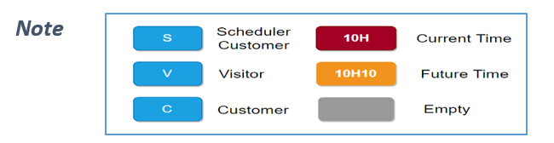

* + Case 1: The following figure is an example for Store 1, assuming Store 1 each Block makes 6 dishes (the number of these dishes depends on each store). Looking at the picture below, we can understand: The current time is 10H, there is an order 1 of the reservation (S), 3 of guests booked directly via mobile app (C), 1 of visitor (V). Because 1 Block can contain 6 orders, so there is currently 1 slot left (gray box). In 10h10 frame, there were 3 pre-booked guests (S).
  + 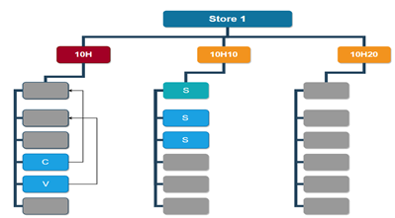Case 2: At 10am, the kitchen completed 3 first orders. The remaining 2 orders will be in the first position
  + Case 3: At 10H10, all order of 10H time frame has been completed. The kitchen continues to make orders of 10H10 frame. 10H17 1 visitor to order 2 dishes at Store 1.

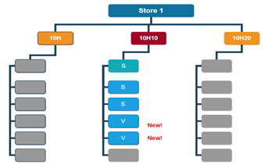

* + Case 4: At 12H, this is the peak time. Customers who pre-order via mobile app can only reserve 70% of the total number of slots in Block. When the block is full of 70%, the customer who sets the calendar (S) will be notified, the customer will have to actively set in another time frame. The remaining 30% will be for visitor or customer.
    - 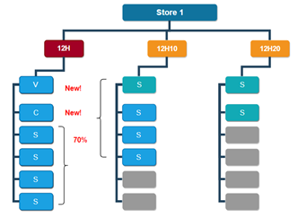Case 4.1: If the visitor or customer order is at 12H00-12H04. Then they will be pushed up before the booking.

Figure 182: Block algorithm 5

* + - Case 4.2: If visitor or customer order is at 12H05-12H09. Then they will be in the back of the customer booking schedule.

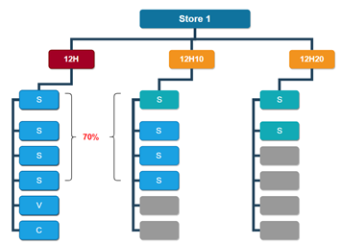

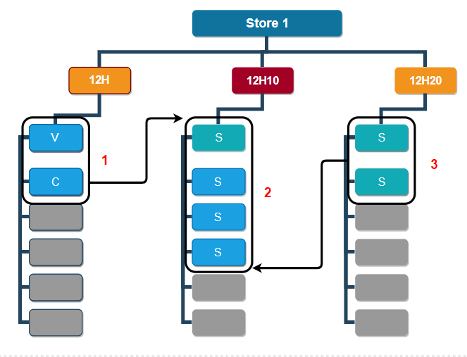Order of appearing orders in the kitchen screen: At the start of each block. The system will show orders in that block. If the previous block has no orders yet made, then those orders will appear at the top of the list, if the following block has orders of customers who place the calendar, those orders will be tailed at the end of the list...

# **E. System implementation & Test**

## **1.** **Introduction**

### **1.1. Overview**

This section provides in detail all necessary information about implementation information and testing procedure of CFOS includes test plans, test cases, test result and risks estimations.

### **1.2. Test Approach**

* Goal: To test the whole system based on the core workflow.
* Method: System Testing, Black-box testing.

## **2. Data Relationship Diagram**

### **2.1. Physical Diagram**

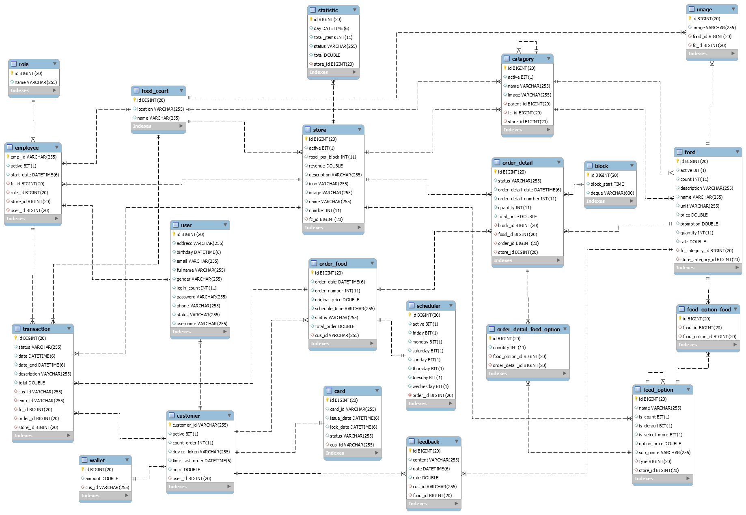Figure 183: Physical Diagram

|  |  |  |
| --- | --- | --- |
| **Data Dictionary: Describe content of all table** | | |
| **No** | **Table Name** | **Description** |
| 1 | Food\_court | Contain the food court information. |
| 2 | User | Contain the user information. |
| 3 | Employee | Contain the employee information. |
| 4 | Role | Contain the role information. |
| 5 | Customer | Contain the customer information. |
| 6 | Card | Contain the customer’s card information. |
| 7 | Wallet | Contain the customer’s balance information. |
| 8 | Transaction | Contain the transaction information. |
| 9 | Store | Contain the store information. |
| 10 | Statistic | Contain the statistic information. |
| 11 | Category | Contain the category information. |
| 12 | Food | Contain the food information. |
| 13 | Image | Contain the image information. |
| 14 | Food\_option\_food | Contain the food’ option information. |
| 15 | Food\_option | Contain the option information. |
| 16 | Feedback | Contain the feedback information. |
| 17 | Order\_food | Contain the order information. |
| 18 | Scheduler | Contain the order’s scheduler information. |
| 19 | Order\_detail | Contain the order detail information. |
| 20 | Order\_detail\_food\_option | Contain the order detail’s food’s option information. |
| 21 | Block | Contain the block information. |

Table 239 Physical Diagram Dictionary

### **2.1. Data Dictionary**

|  |  |  |  |  |
| --- | --- | --- | --- | --- |
| Entity Name | Attributes | Description | Domain | Null |
| Food\_court | id | Id of food court | BIGINT(20) | No |
| location | Location of food court | VARCHAR(255) | No |
| name | Name of food court | VARCHAR(255) | No |
| User | id | Id of user | BIGINT(20) | No |
| username | Username of user | VARCHAR(255) | No |
| password | Password of user | VARCHAR(255) | No |
| fullname | Full name off user | VARCHAR(255) | No |
| address | Address of user | VARCHAR(255) | Yes |
| birthday | Birthday of user | DATETIME(6) | Yes |
| email | Email of user | VARCHAR(255) | No |
| gender | Gender of user | VARCHAR(255) | Yes |
| phone | Phone number of user | VARCHAR(255) | Yes |
| login\_count | Count number login fail | INT(11) | Yes |
| status | Status of user | VARCHAR(255) | No |
| Employee | emp\_id | Id of employee | VARCHAR(255) | No |
| active | Status of employee | BIT(1) | No |
| start\_date | Date employee start | DATETIME(6) | Yes |
| fc\_id | Food court id, foreign key with table food court | BIGINT(20) | Yes |
| role\_id | Role id, foreign key with table role | BIGINT(20) | No |
| store\_id | Store id, foreign key with table store | BIGINT(20) | Yes |
| user\_id | User id, foreign key with table user | BIGINT(20) | No |
| Role | id | Id of role | BIGINT(20) | No |
| name | Role name | VARCHAR(255) | No |
| Customer | customer\_id | Id of customer | VARCHAR(255) | No |
| card\_id | Card id of customer | VARCHAR(255) | Yes |
| active | Status of customer | BIT(1) | No |
| count\_order | Count number of order of customer | INT(11) | Yes |
| device\_token | Device token of user | VARCHAR(255) | Yes |
| time\_last\_order | Time of last order of user | DATETIME(6) | Yes |
| point | Point of user | DOUBLE | Yes |
| user\_id | User id, foreign key with table user | BIGINT(20) | No |
| Card | id | Id of card | BIGINT(20) | No |
| card\_id | Card id | VARCHAR(255) | No |
| issue\_date | Issue date | DATETIME(6) | No |
| lock\_date | Date card is locked | DATETIME(6) | Yes |
| status | Status of card | VARCHAR(255) | No |
| cus\_id | Customer id, foreign key with table customer | VARCHAR(255) | No |
| Wallet | id | Id of wallet | BIGINT(20) | No |
| amount | Balance of wallet | DOUBLE | No |
| cus\_id | Customer id, foreign key with table customer | VARCHAR(255) | No |
| Transaction | id | Id of transaction | BIGINT(20) | No |
| description | Description of transaction | VARCHAR(255) | No |
| date | Date implement transaction | DATETIME(6) | No |
| status | Status of transaction | VARCHAR(255) | No |
| total | Total money of transaction | DOUBLE | No |
| fc\_id | Food court id, foreign key with table food court | BIGINT(20) | Yes |
| cus\_id | Customer id, foreign key with table customer | VARCHAR(255) | Yes |
| store\_id | Store id, foreign key with table store | BIGINT(20) | Yes |
| emp\_id | Employee id, foreign key with table employee | VARCHAR(255) | No |
| order\_id | Order id, foreign key with table order | BIGINT(20) | Yes |
| Store | id | Id of store | BIGINT(20) | No |
| name | Store’s name | VARCHAR(255) | No |
| description | Description of store | VARCHAR(255) | Yes |
| image | Image of store | VARCHAR(255) | No |
| icon | Icon of store | VARCHAR(255) | No |
| number | Store number | INT(11) | No |
| active | Status of store | BIT(1) | No |
| food\_per\_block | Number limit food in a block | INT(11) | No |
| revenue | Revenue of store | DOUBLE | No |
| fc\_id | Food court id, foreign key with table food court | BIGINT(20) | No |
| Statistic | id | Id of statistic | BIGINT(20) | No |
| day | Day of record in statistic | DATETIME(6) | No |
| total\_items | Total item in a statistic | INT(11) | Yes |
| status | Status of statistic | VARCHAR(255) | No |
| total | Total money of statistic | DOUBLE | No |
| store\_id | Store id, foreign key with table store | BIGINT(20) | No |
| Category | id | Id of category | BIGINT(20) | No |
| name | Category’s name | VARCHAR(255) | No |
| image | Image of category | VARCHAR(255) | No |
| active | Status of category | BIT(1) | No |
| parent\_id | Parent id, foreign key with table category | BIGINT(20) | Yes |
| fc\_id | Food court id, foreign key with table food court | BIGINT(20) | Yes |
| store\_id | Store id, foreign key with table store | BIGINT(20) | Yes |
| Food | id | Id of food | BIGINT(20) | No |
| name | Food’s name | VARCHAR(255) | No |
| description | Description of food | VARCHAR(255) | Yes |
| quantity | Quantity of food | INT(11) | No |
| promotion | Promotion of food | DOUBLE | Yes |
| price | Price of food | DOUBLE | No |
| rate | Total rate of food | DOUBLE | Yes |
| unit | Unit of food | VARCHAR(255) | No |
| count | Count number food in 7 day near | INT(11) | Yes |
| active | Status of food | BIT(1) | No |
| fc\_category\_id | Food court’s category id, foreign key with table category | BIGINT(20) | Yes |
| store\_category\_id | Store’s category id, foreign key with table category | BIGINT(20) | Yes |
| Image | id | Id of image | BIGINT(20) | No |
| image | Uri of image | VARCHAR(255) | No |
| food\_id | Food id, foreign key with table food | BIGINT(20) | Yes |
| fc\_id | Food court id, foreign key with table food court | BIGINT(20) | Yes |
| Food\_option\_food | id | Id of food option food | BIGINT(20) | No |
| food\_id | Food id, foreign key with table food | BIGINT(20) | No |
| food\_option\_id | Food’s option id, foreign key with table food option | BIGINT(20) | No |
| Food\_option | id | Id of food option | BIGINT(20) | No |
| name | Food option’s name | VARCHAR(255) | No |
| sub\_name | Sub name of food’s option | BIT(1) | Yes |
| option\_price | Price of food option | DOUBLE | No |
| is\_count | Food option can count or not | BIT(1) | No |
| is\_default | Food option is default or not | BIT(1) | No |
| is\_select\_more | Food option can select more or not | BIT(1) | No |
| type | Type option, foreign key with table food option | BIGINT(20) | Yes |
| store\_id | Store id, foreign key with table store | BIGINT(20) | Yes |
| Feedback | id | Id of feedback | BIGINT(20) | No |
| content | Content of feedback | VARCHAR(255) | No |
| rate | Rate of food in feedback | DOUBLE | No |
| date | Date post feedback | DATETIME(6) | No |
| food\_id | Food id, foreign key with table food | BIGINT(20) | No |
| cus\_id | Customer id, foreign key with table customer | VARCHAR(255) | No |
| Order\_food | id | Id of order | BIGINT(20) | No |
| order\_number | Order’s number | INT(11) | No |
| schedule\_time | Time of schedule | VARCHAR(255) | Yes |
| status | Status of order | VARCHAR(255) | No |
| total\_order | Total money of order | DOUBLE | No |
| original\_price | Original price of total order | DOUBLE | No |
| order\_date | Date post order | DATETIME(6) | No |
| cus\_id | Customer id, foreign key with table customer | VARCHAR(255) | Yes |
| Scheduler | id | Id of schduler | BIGINT(20) | No |
| active | Status of scheduler | BIT(1) | No |
| monday | Has scheduler in monday or not | BIT(1) | Yes |
| tuesday | Has scheduler in tuesday or not | BIT(1) | Yes |
| wednesday | Has scheduler in wednesday or not | BIT(1) | Yes |
| thursday | Has scheduler in thursday or not | BIT(1) | Yes |
| friday | Has scheduler in friday or not | BIT(1) | Yes |
| saturday | Has scheduler in saturday or not | BIT(1) | Yes |
| sunday | Has scheduler in sunday or not | BIT(1) | Yes |
| order\_id | Order id, foreign key with table order | BIGINT(20) | No |
| Order\_detail | id | Id of order detail | BIGINT(20) | No |
| order\_detail\_number | Order detail’s number | INT(11) | No |
| quantity | Quantity food in order detail | INT(11) | No |
| total\_price | Total price of order detail | DOUBLE | No |
| status | Status of order detail | VARCHAR(255) | No |
| block\_id | Block id, foreign key with table block | BIGINT(20) | No |
| order\_id | Order id, foreign key with table order | BIGINT(20) | No |
| food\_id | Food id, foreign key with table food | BIGINT(20) | No |
| store\_id | Store id, foreign key with table store | BIGINT(20) | No |
| Order\_detail\_food\_option | id | Id of order detail – food option | BIGINT(20) | No |
| quantity | Quantity of food option | INT(11) | No |
| food\_option\_id | Food’s option id, foreign key with table food option | BIGINT(20) | No |
| order\_detail\_id | Order detail id, foreign key with table order detail | BIGINT(20) | No |
| Block | id | Id of block | BIGINT(20) | No |
| block\_start | Time start of block | TIME | No |
| deque | List order detail of each store | VARCHAR(800) | No |

Table 240 - Attribute Data Dictionary

## **3.** **Test Plan**

The purpose of this section is to verify and ensure that CFOS meets its design specification and other requirements from user. The following part will describe which features to be tested and which will not.

### **3.1.** **Features to be tested**

* Login
* Order food kiosk
* Order food mobile
* Recharge member
* Request a guest's transaction
* Confirm orders in the kitchen
* Notification test
* Check order status
* Send password to email

### **3.2. Features not to be tested**

* **Admin**
* Logout
* Change password
* Profile
* Manage food court manager
* Manage food court
* View Static
* Manage staff
* Manage store
* Manage category
* Show Finished and Cancelled Food
* Manage category
* Manage Food
* Manage Food Option
* View Feedback
* Show Finished and Cancelled Food
* Manage Member
* History Transaction
* Management debt
* Receivable
* Payable
* **Customer**
* View list dishes
* View basket
* View feedback
* Choose payment method
* View list category
* View dish near
* View popular dish
* View promotion dish
* View list store
* Search dish by name
* View all inbox
* Remove inbox
* Edit account
* View wallet
* Search store result
* Search dish by name
* Logout
* Change password
* View Account profile

## **4. System Testing Test Case**

### **4.1. Test case:**

#### **4.1.1. Login**

|  |  |  |  |  |  |  |  |
| --- | --- | --- | --- | --- | --- | --- | --- |
| **ID** | **Test case description** | **Test case procedure** | **Expected output** | **Inter-dependence test case** | **Result** | **Test date** | **Note** |
| LI\_01 | Admin logins online with correct username, password has internet connection. | 1. On the start screen of web application, admin inputs correct  username or password.  2. Click “Đăng Nhập” button. | After performing step 2, the results displayed will depend on the respective roles. | N/A | Pass | 01/08/2019 |  |
| LI\_02 | Admin logins online with wrong username or password has internet connection. | 1. On the start screen of web application, admin inputs wrong  Username and password.  2. Click “Đăng Nhập” button. | After performing step 2, hiển thị message "Username hoặc Password sai". | N/A | Pass | 01/08/2019 |  |
| LI\_03 | Member logins  online with  correct  username,  password, and  cellphone has  internet  connection | 1. On the start screen of mobile, Member touches  “Đăng nhập” button.  2. On the start screen of mobile application, members inputs correct  username or password and touches “Đăng Nhập” button. | After performing step 2, the member can access the ordering screen. | N/A | Pass | 01/08/2019 |  |
| LI\_04 | Member logins  online with  wrong  username,  password, and  cellphone has  internet  connection | 1. On the start screen of mobile, Member touches  “Đăng nhập” button.  2. On the start screen of mobile application, members inputs wrong  username or password and touches “Đăng Nhập” button. | After performing step 2, hiển thị message "wrong password". | N/A | Pass | 01/08/2019 |  |

Table 241 - Test case login

#### **4.1.2. Order food kiosk**

|  |  |  |  |  |  |  |  |
| --- | --- | --- | --- | --- | --- | --- | --- |
| **ID** | **Test case description** | **Test case procedure** | **Expected output** | **Inter-dependence test case** | **Result** | **Test date** | **Note** |
| OFK\_01 | Guest order food at kiosk when the machine is connected to the internet. | 1. On the start screen, guest's touches "Chạm để đặt món ăn" button.  2. Guest's select the dish and touches on the "Thêm" button or touches dish image customize dishes according to customers' preferences and click the "Thêm vào giỏ" button.  3. At the cart, the guest confirms the order and touches the “Thanh toán” button.  4. Guest touches "Thanh toán bằng tiền mặt" button to pay. | After performing step 4, kiosk will issue invoice confirming the order placed successfully | N/A | Pass | 01/08/2019 |  |
| OFK\_02 | Member order food at kiosk when the machine is connected to the internet. | 1. On the start screen, member’s touches "Chạm để đặt món ăn" button.  2. Member’s select the dish and touches on the "Thêm" button or touches dish image customize dishes according to customers' preferences and click the "Thêm vào giỏ" button.  3. At the cart, the member’s confirms the order and touches the “Thanh toán” button.  4. Member’s touches "Thanh toán bằng tiền mặt" button to pay. | After performing step 4, kiosk will issue invoice confirming the order placed successfully | N/A | Pass | 01/08/2019 |  |
| OFK\_03 | The member ordering with the card has enough balance. | 1. On the start screen, member’s touches "Chạm để đặt món ăn" button.  2. Member’s select the dish and touches on the "Thêm" button or touches dish image customize dishes according to customers' preferences and click the "Thêm vào giỏ" button.  3. At the cart, the member’s confirms the order and touches the “Thanh toán” button.  4. Member’s touches "Thẻ Thành Viên" button to pay.  5. Member’s place their cards on the RFID reader.  6. The payment confirmation screen is displayed, the member touches the "Xác Nhận và Thanh Toán" button. | After performing step 6, the member can access the ordering screen. | N/A | Pass | 01/08/2019 |  |
| OFK\_04 | Member ordering with card does not have enough balance. | 1. On the start screen, member’s touches "Chạm để đặt món ăn" button.  2. Member’s select the dish and touches on the "Thêm" button or touches dish image customize dishes according to customers' preferences and click the "Thêm vào giỏ" button.  3. At the cart, the member’s confirms the order and touches the “Thanh toán” button.  4. Member’s touches "Thẻ Thành Viên" button to pay.  5. Member’s place their cards on the RFID reader. | After performing step 6, the payment confirmation screen is displayed, the member cannot touch the " Xác Nhận và Thanh Toán " button. | N/A | Pass | 01/08/2019 |  |

Table 242 Order food Kiosk

#### **4.1.3. Order food mobile**

|  |  |  |  |  |  |  |
| --- | --- | --- | --- | --- | --- | --- |
| **ID** | **Test case description** | **Test case procedure** | **Expected output** | **Inter-dependence test case** | **Result** | **Test date** |
| OFM\_01 | Member order food in the mobile app with enough balance. | 1. Member’s select the dish and touches on the "Plus" button or touches dish image customize dishes according to customers' preferences and click the "Thêm vào giỏ" button.  2. At the cart, the member’s confirms the order and touches the “Thanh toán” button. | After performing step 2, the successful ordering screen will appear. | N/A | Pass | 01/08/2019 |
| OFM\_02 | Member order food in the mobile app with not enough balance. | 1. Member’s select the dish and touches on the "Plus" button or touches dish image customize dishes according to customers' preferences and click the "Thêm vào giỏ" button.  2. At the cart, the member’s confirms the order and touches the “Thanh toán” button. | After performing step 2, the screen will show a notification "Your wallet isn't enough money". | N/A | Pass | 01/08/2019 |
| OFM\_03 | Member sets a dish schedule in the mobile app with enough balance. | 1. Member’s select the dish and touches on the "Plus" button or touches dish image customize dishes according to customers' preferences  and click the "Thêm vào giỏ" button.  2. Member’s touches "Đặt lịch" button and selects time interval.  3. At the cart, the member’s confirms the order and touches the “Thanh toán” button. | After performing step 3, the successful ordering screen will appear. | N/A | Pass | 01/08/2019 |
| OFM\_04 | Member sets a dish schedule in the mobile app with not enough balance. | 1. Member’s select the dish and touches on the "Plus" button or touches dish image customize dishes according to customers' preferences  and click the "Thêm vào giỏ" button.  2. Member’s touches "Đặt lịch" button and selects time interval.  3. At the cart, the member’s confirms the order and touches the “Thanh toán” button. | After performing step 3, The screen will show a notification "Your wallet isn't enough money". | N/A | Pass | 01/08/2019 |

Table 243 - Order food mobile

#### **4.1.4. Recharge member**

|  |  |  |  |  |  |  |  |
| --- | --- | --- | --- | --- | --- | --- | --- |
| **ID** | **Test case description** | **Test case procedure** | **Expected output** | **Inter-dependence test case** | **Result** | **Test date** | **Note** |
| RM\_01 | The cashier recharge for member and confirmed the correct password. | 1. Sign in with a cashier account.  2. Click “Nộp Tiền” button.  3. Input the amount and click “Ok” button.  4. Input password and click “Ok” button. | After performing step 4, recharge for member success. | N/A | Pass | 01/08/2019 |  |
| RM\_02 | The cashier recharges the member and confirms the password incorrectly. | 1. Sign in with a cashier account.  2. Click “Nộp Tiền” button.  3. Input the amount and click “Ok” button.  4. Input password and click “Ok” button. | After performing step 4, system show message “Giao dịch thất bại”. | N/A | Pass | 01/08/2019 |  |

Table 244 - Recharge member

#### **4.1.5. Request a guest's transaction**

|  |  |  |  |  |  |  |  |  |  |  |  |  |  |  |  |  |  |  |  |  |  |  |  |  |  |  |  |  |  |  |  |
| --- | --- | --- | --- | --- | --- | --- | --- | --- | --- | --- | --- | --- | --- | --- | --- | --- | --- | --- | --- | --- | --- | --- | --- | --- | --- | --- | --- | --- | --- | --- | --- |
|  | |  |  |  |  |  |  |  |  | | --- | --- | --- | --- | --- | --- | --- | --- | | **ID** | **Test case description** | **Test case procedure** | **Expected output** | **Inter-dependence test case** | **Result** | **Test date** | **Note** | | RGT\_01 | Staff receive money from guest and submit order. | 1. Sign in with a cashier account.  2. Click “Đã Nhận Tiền Từ Khách Hàng” button.  3. Staff click “Ok” button. | After performing step 3, the system will issue invoices received from guest and orders are accepted. | N/A | Pass | 01/08/2019 |  | | RGT\_02 | Staff refund money to customers when the dish is canceled. | 1. Sign in with a cashier account.  2. Click “Hoàn Tiền Cho Khách” button.  3. Staff click “Ok” button. | After performing step 3, the system will issue a confirmation of refund to the guest. | N/A | Pass | 01/08/2019 |  |   Table 245 - Request a guest’s transaction |  |  |  |  |  |  |
|  |  |  |  |  |  |  |  |
|  |  |  |  |  |  |  |  |

#### **4.1.6. Confirm orders in the kitchen**

|  |  |  |  |  |  |  |  |
| --- | --- | --- | --- | --- | --- | --- | --- |
| **ID** | **Test case description** | **Test case procedure** | **Expected output** | **Inter-dependence test case** | **Result** | **Test date** | **Note** |
| COK\_01 | The chef confirms the completed order | 1. Sign in with a chef account.  2. Click “Hoàn Thành Món Ăn” button. | After performing step 2, the system will print the completed food bill and notify the customer. | N/A | Pass | 01/08/2019 |  |
| COK\_02 | The chef confirmed that the dish was canceled. | 1. Sign in with a chef account.  2. Click “Hủy Món Ăn” button.  3. Staff click “Ok” button. | After performing step 3, the system informs customers that the food has been canceled. | N/A | Pass | 01/08/2019 |  |

Table 246 - Test case confirm order in kitchen

#### **4.1.7. Notification test**

|  |  |  |  |  |  |  |  |
| --- | --- | --- | --- | --- | --- | --- | --- |
| **ID** | **Test case description** | **Test case procedure** | **Expected output** | **Inter-dependence test case** | **Result** | **Test date** | **Note** |
| NT\_01 | Member pays successfully and has a notification to the member's phone. | 1. Sign in with a cashier account.  2. Click “Nộp Tiền” button.  3. Input the amount and click “Ok” button.  4. Input correct password and click “Ok” button. | After performing step 4, the system will send a notice of successful payment to that member's phone. | N/A | Pass | 01/08/2019 |  |
| NT\_02 | The member receives the order notification that has been successfully completed. | 1. Sign in with a chef account.  2. Click “Hoàn Thành Món Ăn” button.  “Ok” button. | After performing step 2, the system will send notice of the order completed successfully to that member's phone. | N/A | Pass | 01/08/2019 |  |
| NT\_03 | Member received the food notification has been canceled. | 1. Sign in with a chef account.  2. Click “Hủy Món Ăn” button.  3. Staff click “Ok” button. | After performing step 3, the system sends a notice to the customer that the food has been canceled. | N/A | Pass | 01/08/2019 |  |

Table 247 - Test case notification

#### **4.1.8. Check order status**

|  |  |  |  |  |  |  |  |
| --- | --- | --- | --- | --- | --- | --- | --- |
| **ID** | **Test case description** | **Test case procedure** | **Expected output** | **Inter-dependence test case** | **Result** | **Test date** | **Note** |
| COS\_01 | Customers enter the correct order number and check the order status on the kiosk. | 1. At the main screen, customers touch "Kiểm tra tình trạng món ăn".  2. Customers input the order number.  3. Customer click “Tìm” button. | After performing step 3, order status will appear on the screen. | N/A | Pass | 01/08/2019 |  |
| COS\_02 | Customers enter the wrong order number and check the order status on the kiosk. | 1. At the main screen, customers touch "Check food status".  2. Customers input the order number.  3. Customer click “Tìm” button. | After performing step 2, the system show message no order number found. | N/A | Pass | 01/08/2019 |  |
| COS\_03 | Customers enter the correct order number and check the order status on the mobile app. | 1. At the home screen, customers touch "Kiểm tra".  2. Customers input the order number.  3. Customer click “Tìm” button. | After performing step 3, order status will appear on the screen. | N/A | Pass | 01/08/2019 |  |
| COS\_04 | Customers enter the wrong order number and check the order status on the mobile app. | 1. At the home screen, customers touch "Kiểm tra".  2. Customers input the order number.  3. Customer click “Tìm” button. | After performing step 2, the system show message no order number found. | N/A | Pass | 01/08/2019 |  |

Table 248 - Test case check order status

#### **4.1.9. Send password to email**

|  |  |  |  |  |  |  |  |
| --- | --- | --- | --- | --- | --- | --- | --- |
| **ID** | **Test case description** | **Test case procedure** | **Expected output** | **Inter-dependence test case** | **Result** | **Test date** | **Note** |
| SPM\_01 | Create a new manger or staff | 1. Log in to the management account.  2. Click “Tạo Mới Account” button.  3. Input information manager or staff.  4. Click “Ok” button. | After performing step 4, the system will send password to the email of that account. | N/A | Pass | 01/08/2019 |  |
| SPM\_02 | Create a new member | 1. Log in to the cashier account.  2. Click “Tạo Mới Thành Viên” button.  3. Input information manager or staff.  4. Click “Ok” button. | After performing step 4, the system will send password to the email of that account. | N/A | Pass | 01/08/2019 |  |
| SPM\_03 | Reset password | 1. when user uses password reset function | The system will send password to the email of that account. | N/A | Pass | 01/08/2019 |  |
| SPM\_04 | Members register for an account on mobile | 1. On the start screen of mobile, Member touches  “Đăng ký” button.  2. Members inputs information.  3. Member click “Đăng ký” button. | After performing step 3, the system will send password to the email of that account. | N/A | Pass | 01/08/2019 |  |

Table 249 - Test case send password to email

# **F. Software User’s Manual**

## **1. Installation Guide**

### **1.1 Setting up environment at server**

#### **1.1.1 Hardware requirements**

**For server**

|  |  |  |
| --- | --- | --- |
| Hardware | Minimum Requirement | Recommended |
| Internet Connection | Cable, Wi-Fi (50 Mbps) | Cable, Wi-Fi (120 Mbps or more) |
| Operation System | XP, Vista, 7, 10, Window Server 2012, Linux | Window 10, Window server 2016 |
| Computer Processor | Intel® Xeon ® 1.4GHz 64-bit Processor | Intel® Xeon® Quad Core Nehalem-EP X5550 2.66GHz 8MB cache, 6.4GT/s Intel QPI, Turbo Boost, Hyper-Threading. |
| Computer memory | 4GB RAM | 16 GB RAM or more |
| Storage space | 32GB | 256GB |

Table 250 - Hardware Requirements for Server

**For web admin**

|  |  |  |
| --- | --- | --- |
| PC | Minimum Requirements | Recommended |
| Internet Connection | Cable, Wi-Fi (4 Mbps) | Cable, Wi-Fi (16 Mbps) |
| Operating System | Window 7 | Window 7 or more. |
| Computer Processor | Intel® Core i3 1.4GHz | Intel® Core i5 2.50GHz |
| Computer Memory | 1GB RAM | 2GB RAM or more |
| Web Browser | Chromes (v69 or higher) | Chrome latest stable version |

Table 251 - Hardware requirement for web admin

**For Mobile application**

|  |  |  |
| --- | --- | --- |
| PC | Minimum Requirements | Recommended |
| Internet Connection | 2 Mbps | 4 Mbps |
| Operating System | Android 5.0 | Android 7.0 or above |
| Memory | 1 GB | 2 GB or more |

Table 252 - Hardware requirement for the mobile

**For Kiosk’s web ordering application**

|  |  |  |
| --- | --- | --- |
| PC | Minimum Requirements | Recommended |
| Internet Connection | 2 Mbps | 4 Mbps |
| Operating System | Window 10 | Window 10 |
| Memory | 4 GB | 8 GB or more |
| Monitor | FHD Touch screen | FHD Touch screen |
| Printer |  |  |
| RFID reader |  |  |

Table 253 Hardware requirement for Kiosk’s web ordering application

#### **1.1.2 Software requirement**

|  |  |  |
| --- | --- | --- |
| Software | Name / Version | Description |
| Operation System | Windows Server 2016 | Operating system and platform for development |
| Environment | Java EE 8.0, Node v10, expo 33.0.7, | Specification for developing web application |
| Modeling tool | StarUML, Draw.io, miro.com | Used to design diagram |
| IDE | IntelliJ IDEA 2018.1.3, Visual Studio Code 1.36.1 | Programming tools |
| DBMS | MYSQL 8.0 | Used to create & manage the database for system |
| Source control | Git (Github server) | Used for source control |
| Web browser | Chrome 69 or above | Testing and running browser |

Table 254 - Software requirement

### **1.2 Deployment at server side**

#### **1.2.1 Prepare deployment package**

* Environment
* Java

Download and install java <https://www.oracle.com/technetwork/java/javase/downloads/jdk8-downloads-2133151.html>

* Nodejs

Download and install Nodejs

<https://nodejs.org/en/>

* IDE
* IntelliJ IDEA

Download and install IntelliJ IDEA

<https://www.jetbrains.com/idea/download/#section=windows>

* Database Management System
* MySQL

Download and install MySQL

<https://dev.mysql.com/downloads/mysql/>

#### **1.2.2 Configure Server before deploy**

* Development:
  + MySQL 8.0: create new database with name cfos\_capstone and new user and grant all privileges on the new database to the new user.
  + Web API application: Edit username and password of datasource in application.properties

#### **1.2.3 Deploy web application on server**

##### **1.2.3.1 Web Server Deployment Process**

Use IntelliJ IDEA (IDE) and open CFOS\_Capstone project. After loading the project successfully, we will open the link as follows, find file CfosCapstoneApplication.java and right-click it and select [Run’ CfosCapstoneApplication’]. Connect to Web server via host address: http://localhost:8080/ with port 8080

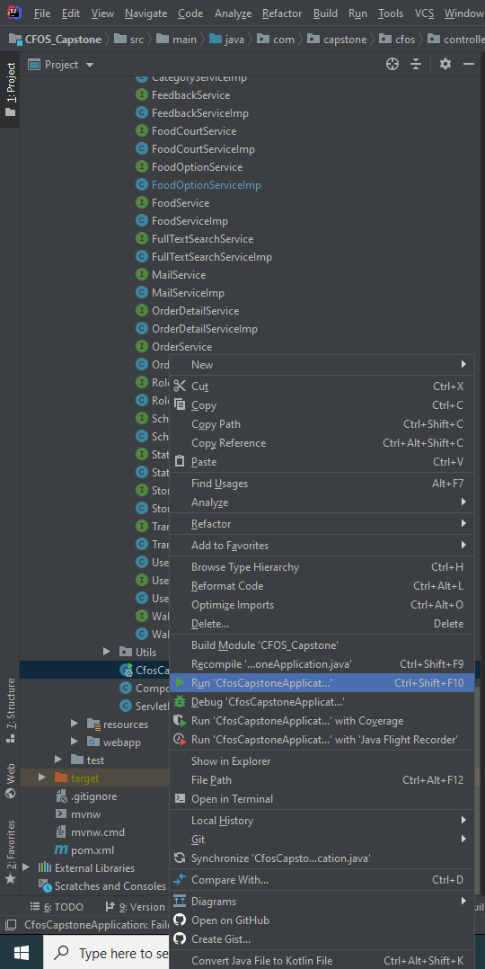

Figure 184: Web Server Deployment Process

##### **1.2.3.2 Web admin & Kiosk’s web ordering application Deployment Process**

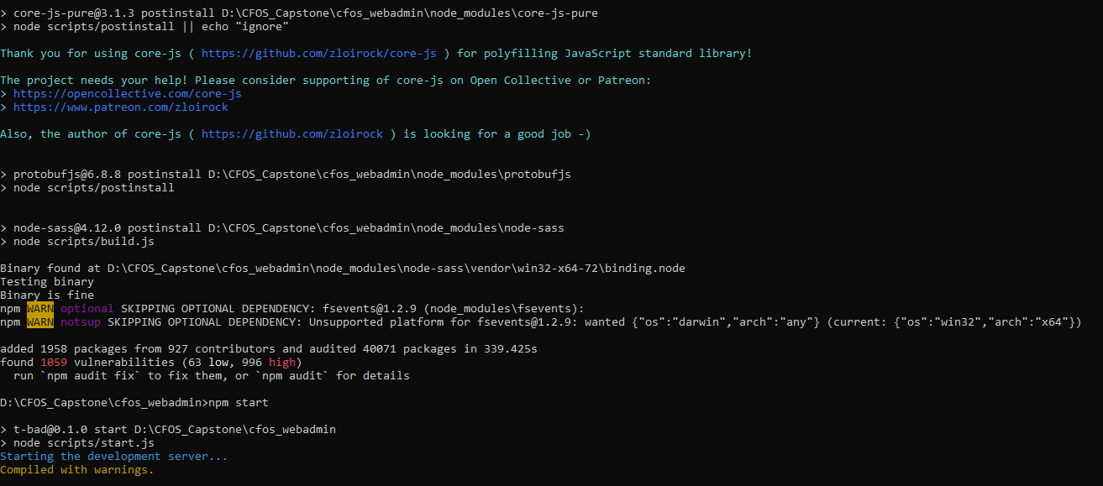In root folder of Web admin project and Kiosk, run command line and first type **npm install** for installation library and after installation successful, we continue to type **npm start** for starting application. Connect to Web admin via host address: http://localhost:80/ with port 80 and kiosk via host address: http://localhost:4000/ with port 4000

Figure 183 Deployment web application Process

Figure 185: Web admin & Kiosk’s web ordering application deployment prrocess

## 2**. User Guide**

### **2.1 Web Application**

##### **View menu dish**

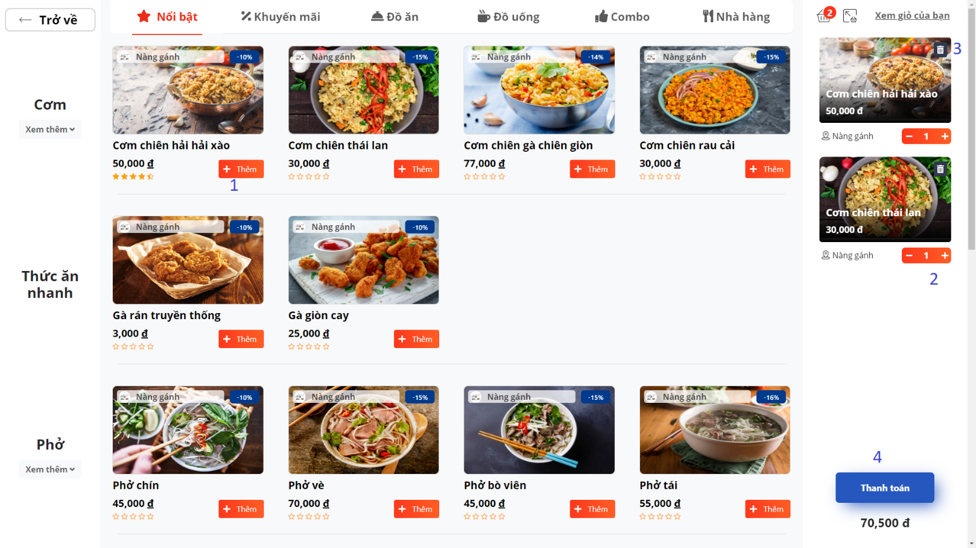

Figure 186: View menu

|  |  |
| --- | --- |
| **Step** | **Description** |
| 1 | Add dish to basket |
| 2 | Increase/ Decrease quantity of cart item |
| 3 | Remove cart item |
| 4 | Move to payment |

##### **Choose payment method**

Figure 187: Choose payment method

|  |  |
| --- | --- |
| **Step** | **Description** |
| **1** | **Choose to payment by membership card or on cash** |

###### **Confirm payment when payment by membership card**

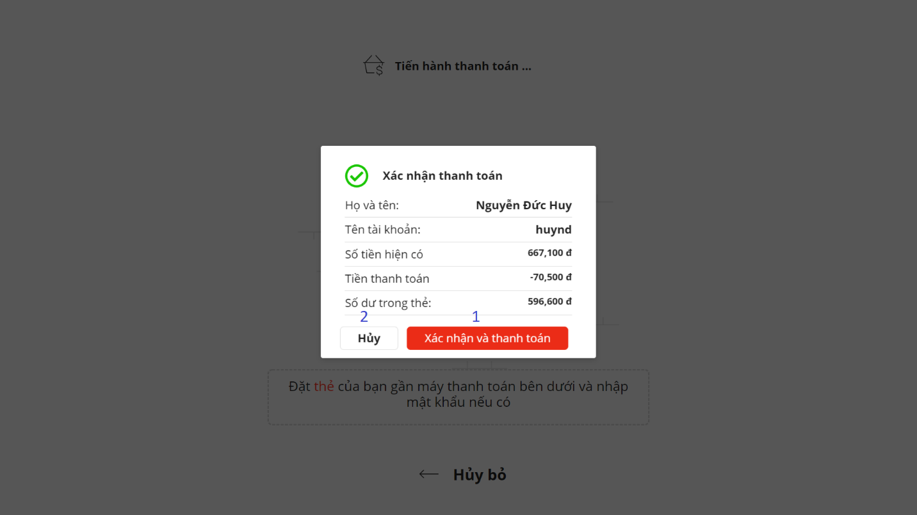

Figure 188: Confirm payment when payment by membership card

|  |  |
| --- | --- |
| **Step** | **Description** |
| 1 | Confirm payment and submit cart |
| 2 | Cancel payment |

### **Android Application**

#### **Order**

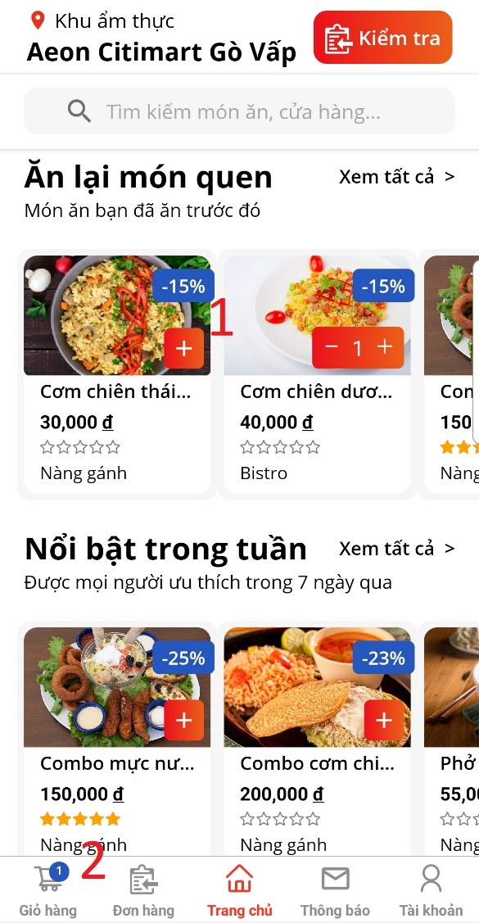 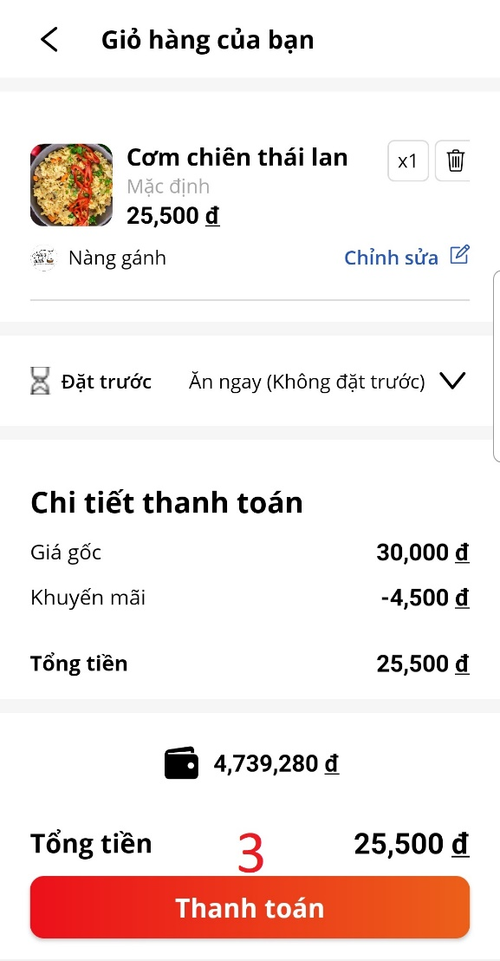

Figure 189: Android Application

|  |  |
| --- | --- |
| **Step** | **Description** |
| 1 | Add food to cart |
| 2 | See cart |
| 3 | Payment |